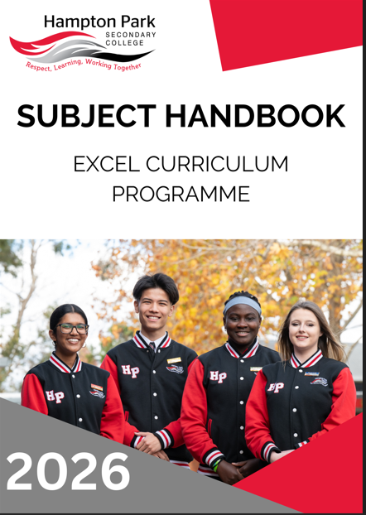

Hampton Park Secondary College
58-96 Fordholm Road
(P.O. Box 480)
Hampton Park Vic 3976 Ph: 03 8795 9400
Fax: 03 8795 9455

Email: hampton.park.sc@education.vic.gov.au
Website: http://www.hpsc.vic.edu.au
Compass: http://hpsc-vic.compass.education

PROPERTY OF AND COPYRIGHTED TO HAMPTON PARK SECONDARY COLLEGE. NOT TO BE DISTRIBUTED OR SHARED WITHOUT PERMISSION.
VERSION 5
LAST UPDATED November 2025

PRINCIPAL’S INTRODUCTION
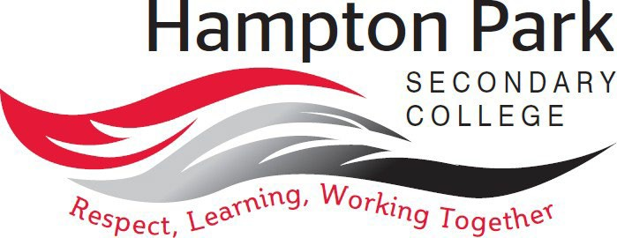

“At Hampton Park Secondary College, we are rich in diversity, and through empowering and engaging students, we remain wholehearted in our pursuit of excellence.”

Our values are Respect, Learning and Working Together
We Respect ourselves, each other, and our school environment and understand that our attitudes and behaviours have an impact on the people around us.
Our key focus is on Learning, improving each day. We acknowledge and celebrate both learning growth and excellence.
By Working Together, we can learn from each other and build skills to achieve our best.
Hampton Park Secondary College is committed to providing education that is student-centered and where students are empowered with their learning. Our learning program enables students to have more voice, choice and agency in their learning. In line with this approach is our recognition that all students are unique, and that each student brings their own distinct and individual passions, interests, skills, and knowledge into our learning ecosystem.
We recognise that our young people are entering into a world that is changing at a faster rate than ever before and is posing new environmental, political, societal, economic, and technological challenges and complexities that were never imaginable. We believe that by empowering students, we create a learning environment where learning is with students, rather than to students. Our approach to learning supports students regardless of their level of learning and understanding, ensuring that no student is left behind from reaching their full potential. Through professional learning, individual reflections, learning walks and coaching, teaching staff aim to create optimal conditions for learning.

Wayne Haworth
Principal

COLLEGE VALUES

Respect, Learning, and Working Together
Our vision of learning excellence is underpinned by the Hampton Park Secondary College values of Respect, Learning, and Working Together. Informing our daily interactions and decisions, these values are embedded in our whole school practice and are supported by our Berry Street and Positive Behaviours for Learning approach. We strive to build students who are life-long learners, with high levels of empathy and are always critical and creative problem solvers.
Our values of Respect, Learning, and Working Together guide our educational programmes within the community in the following ways:

- I respect myself and other people.
- I actively listen to others with an open mind.
- I respect other people’s different perspectives.
- I am inclusive.
- I respect school property and the property of others.
- I wear my school uniform with pride.
- I set personal goals and have high expectations of myself and others to continually improve.
- I have a positive attitude and enthusiasm for learning.
- I strive to achieve my personal best.
- I take pride in the achievements of myself and others.
- I am willing to share ideas, resources, and skills.
- I am helpful and approachable.
- I contribute positively to class, group activities, and the school community.
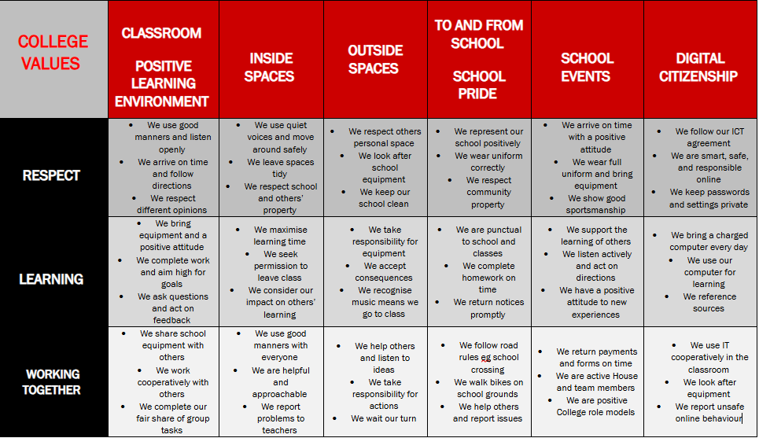
LEARNING AT HAMPTON PARK SECONDARY COLLEGE

College Vison for Teaching and Learning: At Hampton Park Secondary College every student achieves personalised success through the delivery of consistent high quality teaching practice.

Our Teaching and Learning Framework captures our whole school areas of focus, aligned with the priorities of the Department, VTLM 2.0 and the Victorian Curriculum 2.0. Our framework is used by all teachers as a reflective tool and supports teacher clarity and consistency of practice.

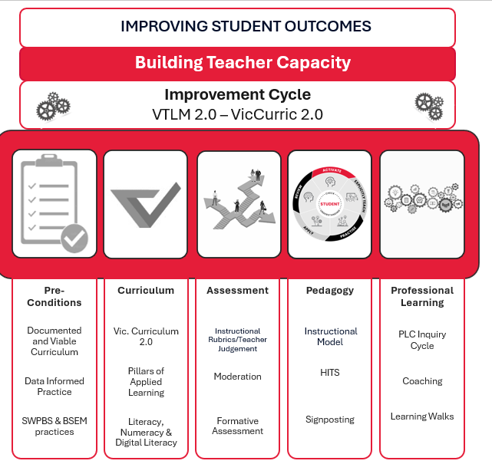
Our Instructional Model brings to life our pedagogical approach and has 5 phases of learning – Activate, Explicitly Teach, Practice, Apply and Review.
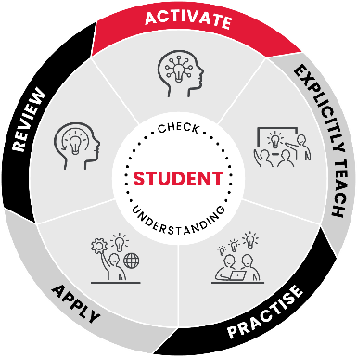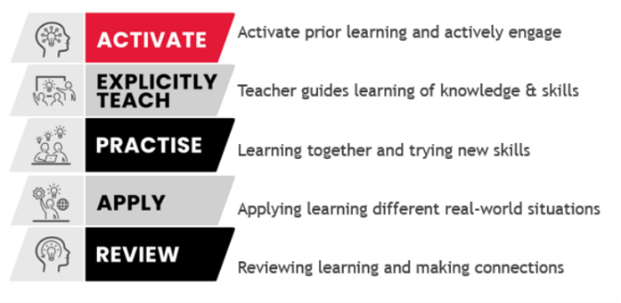

Curriculum Design and Implementation

Hampton Park Secondary College structures its curriculum into three stages or ‘programmes’:

- Explore (Year 7)
- Enhance (Year 8 and 9), and
- Excel (Year 10, 11 and 12)

In Years 7-10, students undertake a combination of core subjects, guided choice (required to choose subjects from specified domain areas) and free choice subjects (except in Year 7, where our focus is on building a strong transition into the College and the skills required for development across the curriculum areas).

EXCEL PROGRAMME
Ex
Hampton Park Secondary College understands that educational experiences have the capacity to shape the degree of happiness and success experienced by everyone, as well as to influence humanity’s collective capacity to navigate and solve the unprecedented challenges and complexities of the present moment, and of the near future. We understand our role in supporting our students to become informed global citizens who are prepared for, and well- versed in, civic, social, and economic engagement with the world in which they live. That is, in line with our future focused educational model, we see the ‘fathomless capacities’ of each student entering our grounds, and we challenge and support each student in their cultivation and realisation of these capacities.

It is in the senior years of schooling where this cultivation becomes most intense, and this realisation becomes most prominent. Students studying in the Excel programme have a range of pathway options available to them that are dependent on their aspirations, interests, literacy and numeracy skills, and their preferred mode of learning.
Hampton Park Secondary College has fervently and earnestly embraced the Victorian Government’s Senior Secondary Reform, being one of the first schools in Victoria to implement full VCE VM and VPC programmes. The Senior Secondary Reform recognises an equal and overarching VCE where students can choose to undertake a Vocational Major (VCE VM) or General VCE, both of equal importance and value. The VCE VM sits within VCE, not alongside. The reform aims to celebrate student pathway and career choices equally. Students enrolled in the General VCE will be able to add Vocational Major Subjects Personal Development Skills and Work-Related Skills to their subject selection. In addition, students in the VCE VM can select subjects from General VCE based on strength, interest, and pathway. Similarly, students engaging in the VPC can also select from the General VCE or Vocational Major subjects – again, depending on strength and interest.
Any remaining differences imagined will continue to dissipate as we hold the same high expectations for all our VCE and Year 11 and 12 students. Our teaching and learning curriculum documents, followed by teachers from years 7 to 10, have an equal emphasis on preparing students for VCE, VCE VM and the VPC. We understand that the VCE VM and the VPC require even more dedication and maturity from students as they need to have a clear understanding of their career pathway and are often required to work in adult learning environments through their VET course or SBAT. We expect and encourage all our senior students to excel in their learning and in their interactions with the world outside of school.
The process of selecting a pathway can be exciting but also challenging. For each individual, research, planning, and reflection are essential if they are to find their own passion and hence, commence a pathway that will meet their individual ambitions. Some students may have already selected a career pathway, however, for many students, this decision is yet to be made. It is also not unusual for goals to change over time because of individual experiences and each student’s growing insight into their skills and interests. Thus, it is important to remember that there are many ways to achieve a goal. Our role as educators at Hampton Park Secondary College is to guide each student, with the support of their parents/carers, to make informed choices and fulfil their desired pathway.
The Excel instalment of the HPSC Subject Handbook contains information and unit descriptions about the Victorian Certificate of Education (VCE), which includes the General Victorian Certificate of Education (General VCE), the Victorian Certificate of Education – Vocational Major (VCE VM), as well as the Victorian Pathways Certificate (VPC and Vocational Education and Training (VET) in Schools (VETiS).
Ex

Students intending to undertake their studies at Hampton Park Secondary College are recommended, along with their parents or carers, to read the information and advice provided about the available courses and subjects. This information will assist in making an informed choice about the Excel programme and the students’ future pathway prior to course counselling.
To ensure all students select and undertake appropriate programmes, our students participate in a range of information sessions and course counselling sessions, including completing careers surveys, developing a career action plan, undertaking work experience, attending subject, career, and industry expositions, and engaging in informative sessions. We have a highly qualified and dedicated Careers Education Team, who support students to understand the various pathways, industry experiences, and careers that are available, as well as the courses students can study to reach their chosen destination. Moreover, senior students engage in Destination Conversations each Semester with the Careers Education Team. Through these conversations, student progress and pathway choices are discussed with the aim of assisting students to engage in the most appropriate pathway for their chosen career destination. The conversation takes place with the Senior SLL, together with the Careers Team and parents/guardians. Student learning data is reviewed, and strengths identified, to further support subject selection and pathways choices.
Along with reading this handbook, students are strongly encouraged to visit the following websites to discover further information that will help guide their decision making:
Victorian Curriculum and Assessment Authority (VCAA):
The VCAA is an independent statutory body responsible for education in Victoria. Its website provides access to a wide range of information relating to VCE, VCE VM, VPC, and VET units. Visit VCAA at www.vcaa.vic.edu.au.

To read about the rules and regulations of VCE and VET, visit Pages - VCE Administrative Handbook (vcaa.vic.edu.au).

Victorian Tertiary Admissions Centre (VTAC):

VTAC is the central office that administers the application processes for scholarships, places in tertiary courses, and special entry access schemes for universities, TAFE institutes, and independent tertiary colleges in Victoria for year 12 students. VTAC receives and forwards application information and supporting documentation to the relevant authorities and institutions. This means that before applying for courses or scholarships, or booking an admission test, students will need to register for a VTAC user account. The VTAC website enables students to search for courses, find information about the Australian Tertiary Admission Rank (ATAR), and set up an account in CourseLink that will help them keep track of courses that interest them. Visit VTAC at www.vtac.edu.au.

What is the VCE?
The Victorian Certificate of Education (VCE) is a senior secondary certificate of education recognised within the Australian Qualifications Framework (AQF). The VCE includes VCE curriculum components and programmes from VET qualifications and is designed to be completed over a minimum of two years.
Students have two enrolment options:
- The General VCE, which includes studies with school-based and external assessments that can provide a study score towards an Australian Tertiary Admissions Rank (ATAR).
- The VCE VM, which includes studies with school-based assessments that do not provide a study score towards an ATAR.
Each VCE unit involves at least 50 hours of scheduled classroom instruction. Students also undertake up to 50 hours of self-directed learning for each unit. Satisfactory completion of a VCE unit is based on successfully completing all outcomes within the unit. The school determines satisfactory unit completion in accordance with VCAA requirements.
Ex
The VCE is awarded based on satisfactory completion of units. The award of satisfactory completion for a unit is based on the teacher’s decision that the student has demonstrated achievement of the set of outcomes specified for the unit in the study design. Demonstration of achievement of outcomes and satisfactory completion of a unit are determined by evidence gained through the assessment of a range of set work (learning activities) and assessment tasks (including school-based assessments). If graded assessments are not provided, an eligible VCE student will not receive a study score. Students must consider satisfactory completion requirements when making their enrolment selection as not undertaking graded assessments may limit their pathway options.

What is the VPC?
The Victorian Pathways Certificate (VPC) is an accredited foundation secondary qualification under the Education and Training Reform Act 2006 (Vic) and aligned to Level 1 in the Australian Qualifications Framework (AQF). The VPC is a foundation secondary qualification designed for students in Years 11 and 12 who would benefit from a more individualised programme at a more accessible level than a senior secondary certificate.

The VPC curriculum provides learning based on applied learning principles and serves as a practical pathway into further education, employment, and training. The VPC is designed to engage students through applied learning and provide flexibility to meet an individual’s learning needs. The VPC aims to build the skills, knowledge, values, and capabilities that enable students to make informed choices about pathways into further education, training, and/or employment. Students who participate in the VPC will gain the necessary foundation skills to allow them to make a successful post-schooling transition.

We wish you well in your journey as you investigate, discover, and make exciting choices about your future pathways.

GENERAL VICTORIAN CERTIFICATE OF EDUCATION (VCE)
Ex

What is General VCE?
The General VCE is a senior secondary certificate that provides pathways to tertiary education, advanced certificate courses, and the workforce. It is an internationally recognised certificate that is normally studied over a two-year period; however, it can take longer for some students to complete the certificate. Students typically study Units 1 & 2 in their first year and Units 3 & 4 in their second year of the VCE. Students can study Units 1 & 2 of a subject as stand-alone units. However, students must enrol in Units 3 & 4 of a subject as a sequence, which needs to be completed in the same year if a study score is to be calculated. Students typically study between 20 and 24 units (five or six studies) during years 11 and 12, with the option of accelerating into a VCE subject at year 10.

Satisfactory Completion of the General VCE:
Students must satisfactorily complete at least 16 units in order to be awarded the General Victorian Certificate of Education (VCE). These 16 units must include:
- At least three English related units, two of which must be a Units 3 & 4 sequence.
- At least four sequences of units 3 & 4, including English. NOTE: students must satisfactorily complete Units 3 & 4 of English to receive a VCE qualification.

Satisfactory Completion of a Unit:
Satisfactory completion of a General VCE unit depends on the successful completion of each of the outcomes that make up that unit. Each General VCE unit has at least two to four outcomes. Successful completion of each outcome is based on a teacher’s assessment of a student’s performance in School Assessed Coursework (SACs), School Assessed Tasks (SATs), and on the student’s satisfactory completion of all set coursework.
Hampton Park Secondary College, in accordance with VCAA (Victorian Curriculum and Assessment Authority) requirements, determines satisfactory completion of units. If students satisfactorily complete the work requirements and assessments set for each outcome, then the student will gain credit for the unit, and this will be reported on the end-of semester report as an ‘S’ (Satisfactory Completion). A student who does not meet the requirements will not gain a credit for the unit and this will be reported as an ‘N’ (Not Satisfactory Completion).

Selecting a General VCE Programme:
In selecting subjects, it is important for students to consider the following:
- Choose subjects you will most likely succeed in; these are usually subjects of INTEREST.
- Choose subjects that you are most likely to enjoy, you will be INTERESTED in these.
- Check the prerequisites for university or TAFE courses of INTEREST to you. When selecting YOUR individual programme:
- DO NOT select a programme based on what your friends are choosing, they have different strengths, aptitudes, and interests to you.
- DO NOT select a programme based on a teacher who you like, there are NO guarantees that they will be your teacher.
- DO NOT choose a subject based on whether it will be scaled up, if you cannot complete the subject, this will impact on your results in a negative way. Select subjects that do interest you and that you can do successfully.

What is a Prerequisite?
Ex
A prerequisite is a General VCE unit or sequence of units that a student must successfully complete to be eligible to apply for a particular tertiary course. For example, an Engineering course might list that Mathematics and Physics Units 3 & 4 are prerequisites. This means that if a student has not successfully completed these units they will not be considered for entry into the course.
In some cases, the prerequisite may require not only the subject, but also the lowest acceptable study score. For example, a medical course might require a minimum study score of 30 in Chemistry as a prerequisite. In this circumstance, regardless of how successful a student is in all other subjects, their placement will not be considered if their study score is less than 30 in Chemistry.
Where a career pathway involves a university or TAFE course, students should check whether there are any General VCE prerequisites before finalising their VCE course. If students discover they need to take subjects in which they have little or no interest, or with which they are likely to struggle, students must consider whether they are prepared and able to put in the work and effort necessary to achieve success in those subjects.

Why do Courses have Prerequisites?
The most common reasons for a prerequisite are that:
- The course will involve studying in that particular area.
- The course is designed on the assumption that students have already achieved a certain standard in the prerequisite study.

Where to Find Information on General VCE Prerequisites:
Each year the Victorian Tertiary Admissions Centre (VTAC) publishes a list of prerequisite subjects for that year’s group of Year 10 students. Prerequisites lists and further information can be found at Prerequisites and selection criteria (vtac.edu.au). This is an invaluable resource, not only for choosing a VCE course, but also for checking which courses can be applied for at the end of Year 12.

Mathematics in the General VCE:
Many students, along with their parents or carers, may be concerned about completing Mathematics as a part of the General VCE, and, indeed, about which specific Mathematics subject/s they should complete.
Firstly, the best advice that can be given to future Senior School students is to complete the highest level of Mathematics of which they are capable. There is no question that completing Mathematics at VCE opens many future options for students, ranging from some pre-apprenticeship TAFE courses through to all Primary Teaching qualifications. Specific courses do have prerequisite Mathematics subjects, and students should ensure that they inform themselves of what will be required for their intended future courses through the relevant literature.
It is highly recommended that students select a Math. It is most definitely in the best interest of students to finish at least one Unit 1 & 2 in Mathematics, but it is not mandatory. For example, if a student cannot do Mathematics, then it is not in their best interest to complete the study as they may not be successful. However, students need to be very aware of potential maths requirements in their future career or study aspirations.
Moreover, it should be remembered that all students must complete the General Achievement Test (GAT) where they will be assessed on their literacy and numeracy skills to achieve competency in each. Therefore, it is highly recommended that students complete a maths sequence in Year 11 and Year 12.
Finally, students intending to study Mathematics subjects in year 12 will need to select the appropriate prerequisite Mathematics units in year 11 to allow them to enter their selections the following year.
Ex

VICTORIAN CERTIFICATE OF EDUCATION VOCATIONAL MAJOR (VCE VM)
Ex

What is VCE VM?
The Victorian Certificate of Education – Vocational Major (VCE VM) is a senior secondary certificate in applied learning. The VCE VM provides students with practical work-related experience as well as literacy and numeracy skills that are important for life and work. The VCE VM prepares students to move successfully into apprenticeships, traineeships, further education and training or university through alternative entry programmes, or the workforce. The course enables students to undertake a study programme that suits their interests and learning needs in a variety of settings.

Satisfactory Completion of the VCE VM:
Students must satisfactorily complete a minimum of 16 units to be awarded the Victorian Certificate of Education – Vocational Major (VCE VM), including:
- Three VCE VM Literacy or VCE English units (including a Units 3 & 4 sequence).
- Two VCE VM Numeracy or General VCE Mathematics units.
- Two VCE VM Work Related Skills units.
- Two VCE VM Personal Development Skills units.
- Two VET credits at Certificate II level or above (180 nominal hours).
- At least four sequences of Units 3 & 4 including VCE VM Literacy or a General VCE equivalent.
Most students will undertake between 16-22 units over two years. Students must complete a minimum of four Units 3 & 4 sequences. Students can complete General VCE subjects as well as receive Structured Workplace Learning recognition.
The House Leadership Teams, along with the Senior Studies Team, monitor VCE VM students very carefully to ensure that the minimum requirements are being met by the student. Students and their parents or carers will be a part of discussions if a student is at risk of not attaining the minimum requirements.

What does a VCE VM Course Look Like?
  - Four to five days a week studying in the classroom (VM Literacy, VM Numeracy, VM Work Related Skills, VM Personal Development Skills, one VCE subject).
  - One day a week in the Vocational Education and Training in the VET programme.
  - If the student selects an internal VET option, then the VET forms a part of the student’s regular school timetable.
Sample VCE VM Timetable:
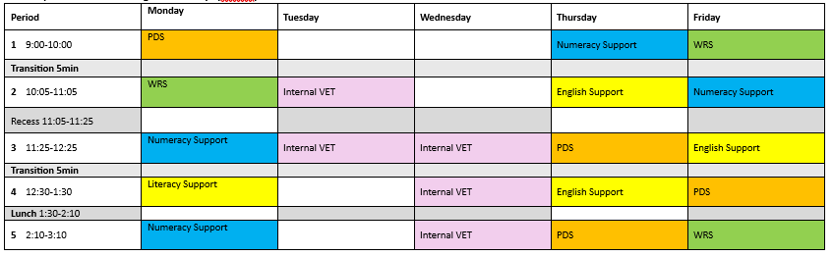

CHECKLIST: IS VCE VM FOR ME?
Ex
If you are seriously considering VCE VM as an option for you, it is vital that you read the statements below to check that you are making the right decision. You need to be able to confidently tick each point. If you need more information, please speak to Ms Tregidga, Ms Kios, or the Careers Education Team.

I have investigated courses (including TAFE courses) that I would like to do in the future,
and I do not need an ATAR.
I have investigated future employment opportunities, and I do not require a General
VCE completion (but require a Year 12 completion).
I am interested in gaining an apprenticeship or traineeship.
I can complete a VET/TAFE course as a part of my VCE VM completion.
- I can get to my VET placement (public transport, parent/carer drop-off, etc).
- I am willing to be at my placement early or finish late (for example, to start at 7am or finish at 5pm).
I enjoy learning in practical ways, and I would enjoy the opportunity to learn new skills ‘on the job’.
I am aware that the VET/TAFE component of the VCE VM and VPC programmes is heavily subsidised by Government funding, and I am aware that I may have to pay costs of $500 or more per year, depending on my chosen VET/TAFE course.
For example, a specialist make-up course can be close to $2000.
My attendance at school and my VET will be above 95%, and I will ensure that I can make my own way to my VET/TAFE and Work Placement on �me and meet their attendance requirements.
Attendance requirements at school, VET programmes, and Work Placements must be met to complete your VCE VM or VPC qualiﬁcation (95% attendance requirement).
I am aware that I need to meet the expenses of organising transportation to my VET/TAFE course.
I am aware that my Structured Workplace Learning must be linked to the VET/TAFE course that I am enrolled in.
I can work independently to complete the required VET/TAFE work in an adult learning environment.
I can work independent of teacher assistance.

VICTORIAN PATHWAYS CERTIFICATE (VPC)
Ex

What is VPC?
The Victorian Pathways Certificate (VPC) is a standards-based certificate that is suited to students who are not able to, or are not yet ready to, complete a General VCE or VCE VM. The VPC provides a curriculum that supports students to develop skills and capabilities that will enable them to be successful in their personal and civic life.
The VPC is an accredited foundation secondary qualification. It is important to note that the VPC is not a senior secondary qualification but is a fantastic opportunity to extend pathways for young people and to further develop their abilities and skills in a school environment.
The VPC is suitable for students whose schooling experience may have been disrupted for a variety of reasons. For example, students who need additional support in their learning and/or have had significant absences from school. Through the VPC, students will gain the skills, knowledge, values, and capabilities to make informed choices about pathways into a senior secondary qualification, an entry level Vocational Education and Training (VET) course, or employment.

Satisfactory Completion of VPC:
Students must satisfactorily complete a minimum of 12 units to be awarded a Victorian Pathways Certificate, including:
- At least two units of VPC Literacy.
- At least two units of VPC Numeracy.
- At least two units of VPC Personal Development Skills.
- At least two units of VPC Work Related Skills.
Students can also obtain credits through completion of units from VCE Vocational Major studies, Structured Workplace Learning, and VET units of competency (Certificate I level or above).

What does a VPC Course Look Like?
The VPC is a flexible programme that is tailored to meet the needs of individual students. Students can take up to three years to complete a VPC and may complete it in as little as 12 months. It may include a combination of VPC units, VCE VM units, SWL, and VET.
Sample VPC Timetable:
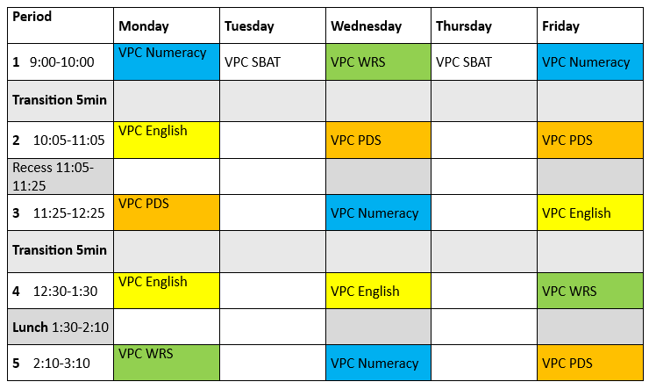

VOCATIONAL EDUCATION AND TRAINING (VET)
Ex
Students interested in a VET programme should complete and return a VET Expression of Interest Form, available from the VET Administrator (Freeman Office), as soon as possible.

What is VET?
Vocational Education and Training (VET) programmes assist students in making the transition to further education, training, and employment. Vocational Education and Training programmes run for secondary students, known as VETiS, give students the opportunity to complete a nationally recognised vocational qualification whilst attending secondary school.
These programmes are designed for students to develop general work-related competencies, along with the skills and knowledge they will require, through:
- Enabling students to gain their General VCE or VCE VM and a VET qualification.
- Enabling students to gain qualifications in a recognised TAFE Certificate course at a Certificate II or III level.
- Promoting an awareness of the world of work through work placement.
- Developing skills in communication, teamwork, technology, problem-solving, mathematical ideas and concepts, planning, and organising activities, gathering and analysing information, and occupational health and safety.
- Developing the skills and knowledge required to work in an industry.
- Giving students a competitive edge in looking for both casual and full-time employment.
- Providing a qualification that can lead to further study, including further TAFE studies and university.

What to Consider When Selecting a VET Course
VET programmes involve significant commitment from students and should not be considered an ‘easy’ option. A VET course contains a full study workload alongside the other General VCE/VCE VM studies. There is a major theoretical element to all VET and TAFE programmes, it is not all hands-on practical work, not even in certificates such as Automotive Technology, Building and Construction, or Hospitality. Students are often required to work through self-paced modules.
Students can study an internal VET course at HPSC, or travel to a TAFE institute or another secondary college, one day per week to study an external VET course. In some circumstances, students will miss classes at school. It is the student’s responsibility to catch up on all missed work in their own time.
Students undertaking a VET programme may choose to undertake Structured Workplace Learning in the industry area that aligns with their VET programme. The exception to this is for students undertaking Early Childhood Education Cert III. For students enrolled in this Early Childhood Education Cert III, Structured Workplace Learning is compulsory, students must complete 80 hours of work placement; the TAFE will organise this work placement in consultation with the student.
The Department will reimburse VET material fees to government schools to address the cost barrier for families. This funding covers the cost of:
- Materials required for training and assessment that are consumed and cannot be recycled. Please note students may wish to upgrade materials for certain projects (i.e. upgrade from pine to mahogany). Any upgrade from the materials provided by HPSC is considered an OPTIONAL ITEM, as per the description above.
- Safety items worn or used by the student including safety glasses, hearing protection, gloves, hair nets.

  - Workbooks, handouts, photocopying, online learning resources.
Ex
  - Class sets intended to be returned, and retained by the school, such as textbooks, tools, tool belts, specialist knives, and aprons.
However, this funding does not cover all costs associated with the facilitation of VET classes. The payment of the following costs, as an example, are supported by contributions from families:
- Transport costs and hire of specialised facilities required for training or assessment. PPE worn and retained by the student.
- Online registration/subscription fees, platform charges, software. Tuition fees, registration, and administration fees.
- Tools upgrade or purchase initiated by the parent.
- Information will be provided to students enrolled in the VET program.
Note: Should students change their mind and withdraw from the course before the course begins or change their VET enrolment after the final withdrawal without fees date, there is a $50 administrative charge by the Institute. Institutions will not allow refunds to students who withdraw from a programme once it has commenced. Students need to fully understand the course they are choosing and must be committed to completing the course.

SCHOOL BASED APPRENTICESHIPS & TRAINING (SBAT)
Ex
Students interested in an SBAT programme should complete and return a VET Expression of Interest Form, available from our VET Coordinator (Senior Study Space), as soon as possible.

What is SBAT?
School Based Apprenticeships or Traineeships (SBATs) are another way vocational training can contribute towards a VCE VM or VPC Certificate. A student completing an SBAT as part of their VCE VM or VPC qualification will have the following programme:
- VCE VM or VPC studies at school.
- External VET at a Registered Training Organisation (RTO), such as a TAFE institute, or internal VET at HPSC.
- Part-time paid work in the industry in which the student is doing their training.
A school-based apprenticeship or traineeship (SBAT) qualification contributes to satisfactory completion of the VCE VM or VPC in the same way that VET programmes contribute, by giving credit for Units 1 to 4.
To become an apprentice or trainee students must be in paid work and sign a contract of training, which must be registered with the Department of Education and Training (DET) and the Victorian Registration and Qualifications Authority (VRQA).
National Foods is HPCS’s main SBAT provider. To find out more about these courses, please speak with our VET Coordinator. There is an enrolment process that forms part of Course Counselling that students must go through to be accepted.
SBATs may involve a small fee. SBAT fees will be deducted each fortnight as a small percentage of the student’s wage.
Currently there are many industries in which a student can undertake a school-based apprenticeship or traineeship as part of their VCE VM or VPC. These are subject to change, depending on work placement availability. Some examples include:
- Certificate II Automotive.
- Certificate II Hospitality.
- Certificate II Warehousing.
- Certificate II Baking.
- Certificate II Conservation and Ecosystems Management.
- Certificate III Food Processing.

Are there Special Requirements in Undertaking a SBAT?
SBATs are targeted at students who are committed to vocational education and have a clear idea of the career they want to pursue. Students must be 15 to enter into an SBAT. Students undertaking an SBAT will be absent from school two days per week. It is the student’s responsibility to keep up with any class work missed. For these reasons, an SBAT is not available to students undertaking a General VCE programme in most cases.
CENTRE FOR HIGHER EDUCATION STUDIES (CHES)

What is CHES?
The Centre for Higher Education Studies (CHES) programme is offered by universities and the VCAA. Two types of study, Extension and Advanced Standing, are offered through this programme. A Higher Education Study may contribute towards satisfactory completion of the VCE as an unscored Unit 3 & 4 sequence. Students who successfully complete a Higher Education Study have the title of the study, the year of enrolment, and the name of the Higher Education institution reported on their VCE Statement of Results.

An Extension Study:
- Is equivalent in content and assessment in every respect to one or more current first-year Higher Education studies.
- Constitutes at least 20 percent of a full-time first year university course.
- Is targeted at high-achieving students.
- Is a clear advance on an identified VCE Units 3 & 4 study, matching in workload with an additional VCE study of a level that will normally allow the student, on successful completion, to proceed to second year study at the Higher Education institution in that discipline.

An Advanced Standing Study:
- Is equivalent in content and assessment in every respect to one or more current first-year Higher Education studies.
- Constitutes at least 20 percent of a full-time first year university course.
- Is comprised of curriculum not available in any current VCE studies and therefore not linked to any current VCE Units 3 & 4 study of a level that will normally allow the student, on successful completion, to proceed to second year study at the Higher Education institution in that discipline.

Why do a Higher Education Study?
Centre for Higher Education studies offers students access to a range of potential benefits, including:

- Academic challenge in a broader range of studies.
- Credit towards an undergraduate qualification at the institution where the study was satisfactorily completed.
- Contribution towards satisfactory completion for the award of the VCE as a Units 3–4 sequence without a study score.
- Contribution to the calculation of the ATAR via an increment for a fifth or sixth study.

Note: Only one Higher Education Study may contribute towards satisfactory completion for the award of the VCE.

Does CHES Contribute to the ATAR?
VTAC advises that where a student successfully completes a Higher Education Study, and where applicable conditions were met, and subject to the restricted combinations outlined in Victorian Tertiary Entrance Requirements (VICTER), the study can contribute to the student’s ATAR as a fifth or sixth study via an increment.

Where students withdraw from or fail to satisfactorily complete the VCE preparatory study either as a prerequisite or concurrently, which is a requirement of the Higher Education Study, they will not be eligible for a Higher Education Study increment in their ATAR calculation regardless of their performance in the Higher Education Study.

Who is Eligible for CHES?
Higher Education Studies are designed for high achieving, interested, and able VCE students. There are many prerequisite requirements for each Higher Education Study. Where students have completed the VCE preparatory study and/or any other prerequisite requirement of the Higher Education Study in a previous year, they are required to have an active enrolment and satisfactorily complete at least one Units 3 & 4 sequence towards the VCE in the same year in which they are enrolled in the Higher Education Study.

The Senior Studies Team and the Course Counselling team will recommend students who are suitable to participate in the programme. A student must be approved to undertake a Higher Education Study by the school principal. It is recommended that the student has:

- A high standard of literacy.
- An overall academic strength across all areas of study.
- Excellent results in the subject related to the chosen HES.
- Excellent time management and organisational skills.
- A high degree of autonomy.
- An appropriately selected Higher Education Study that relates to their career pathway choice.

Further information about the principles and procedures for the inclusion of Higher Education Studies in the VCE and a summary of the VCAA approved Higher Education Studies offered by participating universities is available at https://www.vcaa.vic.edu.au/curriculum/vce/Pages/HigherEdStudiesVCE.aspx.

UNIVERSITY PARTNERSHIPS
Ex
Hampton Park Secondary College has existing partnerships with tertiary institutions, and we are always working to build and extend these partnerships. Below are our most prominent current programmes:

Deakin Accelerate
Deakin Accelerate Program
Deakin Accelerate is a distinctive VCE extension studies programme offering high-achieving students university-level learning opportunities. In this programme, students complete two units of a first-year university subject at the same time as their Year 12 studies, either at one of Deakin's four vibrant locations or at the Cloud Campus, their innovative online learning environment.

Destination Federation
https://federation.edu.au/future-students/study-at-federation/destination-federation
In this programme, students complete first-year university units that can be included as units for the VCE, contributing to the ATAR whilst gaining credit towards a university degree. There is an extensive list of first- year units across a range of study areas available for you to choose from such as: Marketing, Accounting, Philosophy of Learning and Knowledge, and Health and Physical Education.

Access Monash Programme
https://www.monash.edu/access/outreach/schools-access-monash
Schools Access Monash (SAM) is a programme with in-school and on-campus activities for students. Activities are designed to inform students’ decision-making and support their engagement and knowledge of university and student life. Access Monash assists students from diverse backgrounds to access, participate in, and succeed in higher education. This programme encourages and informs students’ aspirations to higher education by offering outreach activities, special entry schemes, and pathways to Monash University. Monash programmes aim to encourage participation in higher education and provide academic enrichment.

TUTORING
We also offer tutoring opportunities for our senior students through our Alumni Programme and through our strong relationship with Monash University. Tutors are available for small-group and individual support for our VCE students after school and during homework club. Tutors are also available, where possible, during study periods and within Year 12 English and Maths classes. We encourage our senior students to take advantage of this amazing opportunity and organise to connect with tutors during their available times.

HEAD START
Ex

What is Head Start?
Head Start is an apprenticeship and traineeship model for school students who are over 15 years of age. Head Start students spend time doing paid on-the-job training in priority industries whilst completing their VCE VM or VPC at school. A Head Start apprenticeship or traineeship provides:
- Quality training delivered in a way that is aligned with time on the job to support achievement of competencies.
- Maximised time in employment, with time on the job increasing each year to support genuine progression through the apprenticeship or traineeship.
Depending on the requirement of the employer, it is expected that, at a minimum, students will undertake:
  - One day per week paid employment in Year 10.
  - Two days per week paid employment in Year 11.
  - Three days per week of paid employment in Year 12 (which may be undertaken over two years).
Head Start staff based in schools work with the apprentice or trainee, employer, school, and TAFE institute or RTO to develop a tailored Head Start pathway plan. This plan outlines how the apprentice or trainee will complete their VCE VM or VPC and their apprenticeship or traineeship.

What are the Beneﬁts of Head Start?
  - Students can spend a significant amount of time on-the-job training whilst still completing their senior secondary qualification.
  - Employers can train and mentor young apprentices and trainees who are ready for work and who have higher levels of literacy, numeracy, and employability skills.
  - Students undertake high quality apprenticeships and traineeships with genuine employers in an environment where continuous and dedicated support is provided to all parties with the purpose of helping students progress to completion.
INDUSTRY AREA | OCCUPATION
Building, Construction, & Manufacturing Technologies | Bricklaying, Painting, Carpentry, Plumbing, Electrotechnology, Civil  Construc�on, Automotive, & Engineering
Community Services & Health | Early Childhood, Health Services, Dental Assisting, Community Services, & Pharmacy Assistance
Business Services | Telecommunications, Information Technology, & Business
Service | Commercial Cookery, Baking
Primary Industry | Agriculture, Horticulture, Arboriculture

Who is Eligible for Head Start?
Head Start’s success depends on the careful selection and matching of students, qualifications, training providers, and employers, as well as the collective goodwill and the commitment of all parties towards the best possible outcomes for students and employers. A Head Start programme is specifically for students who are highly focused on an industry career and have good skills in literacy and numeracy. For more information about Head Start, please speak with the Careers Education Team or visit: www.education.vic.gov.au/headstart.

STRUCTURED WORKPLACE LEARNING (SWL)
Ex

What is SWL?
Structured Workplace Learning (SWL) is an option for VCE VM/VPC and VCE students. Structured Workplace Learning provides students with the opportunity to practise existing skills and acquire new skills and knowledge in a supervised workplace setting. During SWL, students complete a Workplace Learning Record, which is assessed by teachers at Hampton Park Secondary College. Work placements must be completed with an employer in the industry area relevant to the students’ VET programme. Structured Workplace Learning is optional, and it is the student’s responsibility to secure work placement. Work placements sought outside of the student’s VET industry area will NOT be approved.
Ensuring the workplace is in the same or similar industry area as the student’s VET is the best way of determining if a SWL placement is suitable for the student to undertake. It is important that students use the same skills and knowledge in the workplace as they are learning within their VET. The skills and knowledge must be transferable, and students must be able to reflect on these within the assessment tasks set. Schools are best placed to make decisions on SWL work placements based on their knowledge of the students and their VET programme.

VIRTUAL SCHOOL VICTORIA (VSV)
Ex

What is VSV?
Virtual School Victoria (VSV) exists to meet the educational needs of Victorian students whose circumstances prevent them from accessing mainstream schooling. To enroll directly with VSV, students must fall under one of the five enrolment categories: medical (physical), medical (social and emotional), travel, sports/performance, distance, or young adults.
Virtual School Victoria is also for students wishing to maintain their current enrolment in a mainstream school. At VSV, students can complete one subject that is unavailable at their school or not available due to timetabling clashes or other issues.

Where can I find more information about this?
Students can go to https://www.distance.vic.edu.au/ to read more information or students can speak to the Careers Education Team.

Who is Eligible for VSV?
To be successful in Virtual School Victoria studies, students need to be able to work independently and to have regular and reliable access to a computer/device and the internet. Students need to be able to communicate with their teachers using the online portal and submit work online weekly. Students are also expected to participate in multiple areas of their online course, including online lessons, forums, and interactive activities.
Online applications open in late October, with the school year and terms coinciding with the Victorian School term dates.
Students must have their application to enrol in Virtual School Victoria approved PRIOR to online enrolment and must meet the following criteria:
  - Enrolment in only one Virtual School Victoria subject is permitted at Hampton Park Secondary College, ensuring that students have a balanced programme, and that their learning progress can be effectively monitored.
  - Students must have an attendance rate of above 90% for the school year.
  - Student progress reports must consistently be at or above 3.5 across the school year.
  - Student assessment grades must consistently be at medium or higher across all subjects.

VICTORIAN SCHOOL OF LANGUAGES (VSL)
Ex

What is VSL?
The Victorian School of Languages (VSL) is a government school in Victoria. It provides access to language programmes for students in years 11 to 12 who do not have access to the study of different languages in their mainstream school.

What is the Beneﬁt of Studying a Language?
A considerable proportion of our students are migrants or come from migrant families, with many students and their families speaking a language other than English. It can be extremely challenging for a newly arrived migrant to undertake their studies in English when it is not their preferred language. Enrolling in a language study may be beneficial to some of our students. Learning a language can reduce the pressure of students learning all their subjects in English, it can continue to build skills in their native language and can support them in successfully completing units that contribute to their VCE studies.

What Languages are Available to Study?
The VSL offers a broad range of language studies accredited by the VCAA for VCE. These languages include, but are not limited to:
  - Arabic
  - Armenian
  - Chinese (Mandarin)
  - Croatian
  - Filipino (Tagalog)
  - French
  - Khmer
  - Persian
  - Punjabi
  - Russian
  - Serbian
  - Sinhala
  - Spanish
  - Vietnamese

For more information about VSL studies and locations/centres, visit https://www.vsl.vic.edu.au/.

EXCEL SUBJECTS
Ex
The following is a list of General VCE, VCE VM and VPC studies offered at Hampton Park Secondary College. Please refer to the relevant information about each study in this handbook, speak to the nominated staff listed in the subject description, or view more detailed information at: https://www.vcaa.vic.edu.au/curriculum/vce/vce-study- designs/Pages/vce-study-designs.aspx.

VISUAL & PERFORMING ARTS
Art Making and Exhibiting (Previously Studio Arts) Units 1 - 4
Drama Units 1 – 4
Media Units 1 – 4
Music Units 1 & 2
Music Performance Repertoire Unit 3 &4
Visual Communication Design Units 1 - 4
ENGLISH & EAL
Bridging English as an Additional Language (BEAL) Units 1 & 2
Foundation English Units 1 & 2
VCE VM Literacy Units 1 - 4
VPC Literacy Units 1-4
English & English as an Additional Language (EAL) Units 1 - 4
English Language Units 1 - 4
Literature Units 1 - 4
HEALTH & PHYSICAL EDUCATION
Health and Human Development Units 1 - 4
VCE VM Personal Development Skills Units 1 - 4
VPC Personal Development Skills Units 1 - 4
Physical Education Units 1 - 4
HUMANITIES
Accounting Units 1 - 4
Business Management Units 1 - 4
Geography Units 1 - 4
History – Modern Units 1 & 2
History – Revolutions Units 3 & 4
Legal Studies Units 1 - 4
Philosophy Units 1 - 4

Ex
Politics Units 1 - 4
VCE VM Work Related Skills Units 1 - 4
VPC Work Related Skills Units 1 – 4
LANGUAGES
Not offered on site in 2025 – See VSL https://www.vsl.vic.edu.au/
MATHEMATICS
VCE VM Numeracy Units 1 - 4
VPC Numeracy Units 1 - 4
Foundation Mathematics Units 1 - 4
General Mathematics Units 1 - 4
Mathematical Methods Units 1 - 4
Specialist Mathematics Units 1 - 4
SCIENCE
Biology Units 1 - 4
Chemistry Units 1 - 4
Environmental Science Units 1 - 4
Physics Units 1 - 4
Psychology Units 1 - 4
STEAM
Applied Computing Units 1 & 2
Data Analytics Units 3 & 4
Software Development Units 3 & 4
Food Studies Units 1 - 4
Product Design and Technology: Mixed Materials/Textiles Units 1 - 4
Systems Engineering Units 1 - 4

VISUAL AND PERFORMING ARTS

The Arts include Dance, Drama, Media Arts, Music, Visual Arts, and Visual Communication Design.

The Arts enable students to develop their creative and expressive capacities by learning about the different practices, disciplines, and traditions that have shaped the expression of culture locally, nationally, and globally. Students are both artists and audience in the Arts. They make, respond, and learn to appreciate the specific ways this process occurs in different disciplines.

The Arts present ideas that are dynamic as well as rich in tradition. Through engaging in The Arts, students are entertained, challenged, and provoked to respond to questions and assumptions about individual and community identity, considering different histories and cultures. The Arts contribute to the development of confident and creative individuals and enrich Australian society. Students express, represent, and communicate ideas in contemporary, traditional, and emerging art forms. In Dance, Drama, and Music students explore the performing arts, whilst in Media, Visual Arts, and Visual Communication Design students explore the world of visual representation and expression.

The significant contributions of Aboriginal and Torres Strait Islander peoples to Australia’s arts heritage and contemporary arts practices are explored across The Arts, and students are encouraged to respect and value these unique and evolving traditions.

PATHWAYS MAP FOR VISUAL AND PERFORMING ARTS
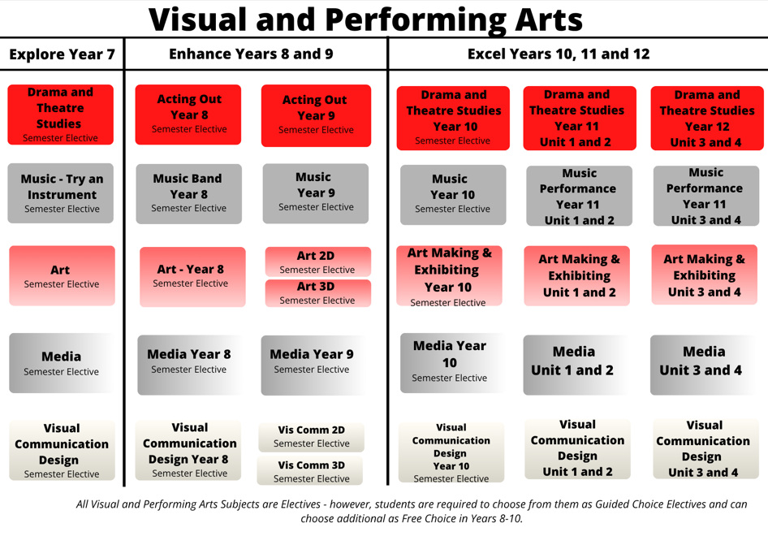

ART MAKING AND EXHIBITING UNITS 1 & 2

Subject Description:
VCE Art Making and Exhibiting introduces students to the methods used to make artworks and the ways in which artworks are presented and exhibited. It provides students with opportunities to recognise their individual potential as practicing and exhibiting artists and encourages self-expression, creativity, and a sense of individual identity.

Unit 1: Explore, Expand, and Investigate
In this unit, students explore materials, techniques, and processes in a range of art forms. They expand their knowledge and understanding of the characteristics, properties, and application of materials used in art making. Students also explore the historical development of specific art forms. Students explore the ways artists use materials, techniques, and processes. They document their exploration and experimentation in a Visual Arts journal.

Unit 2: Understand, Develop, and Resolve
In Unit 2, students research how artworks are made by investigating how artists use aesthetic qualities to represent ideas in artworks. They broaden their investigation to understand how artworks are displayed to audiences, and how ideas are represented to communicate meaning. They examine how art elements and art principles can be combined to convey emotions and expression in their own and others’ artworks. Students respond to a set theme and develop their own ideas and consolidate these ideas to plan in their Visual Arts journal and make finished artworks.

Assessment:
- Visual art journal, finished artworks, and written, collated Information for an exhibition.
- Thematic exhibition, experimental artworks and documentation, and finished artworks.

Advice to Students:
It is strongly recommended that students undertake this subject in order to study VCE Art Making and Exhibiting Units 3 & 4. Students considering these units should be confident, independent, and self-managed learners.

Teachers to see for advice regarding this subject:
Ms. Fee and Mr. Horsfall



ART MAKING AND EXHIBITING UNITS 3 & 4

Subject Description:
In VCE Art Making and Exhibiting Units 3 & 4, students explore, and master methods used to make artworks and grow in their understanding of how artworks are presented and exhibited. This subject provides students with opportunities to recognise their individual potential as artists, encourages self-expression and creativity, and provides the opportunity to exhibit completed artworks at the end of the creative process.

Unit 3: Collect, Extend, and Connect
In this unit, students are actively engaged in art making using a variety of materials, techniques, and processes. They explore contexts, subject matter, and ideas to develop artworks in imaginative and creative ways. They investigate how artists use visual language to represent ideas and meaning in artworks. Students use their Visual Arts journal to document their exploration of, and experimentation with, materials, techniques, and processes, as well as to record inspiration and ideas. Students will visit an exhibition in either a gallery, museum or other exhibition space.

Unit 4: Consolidate, Present, and Conserve
In Unit 4, students make connections to the artworks they have made in Unit 3, consolidating and extending their ideas and art making skills to further refine and resolve artworks in specific art forms. The progressive resolution of these artworks is documented in the student’s Visual Arts journal, demonstrating their developing technical skills in a specific art form as well as their refinement and resolution of subject matter, ideas, visual language, aesthetic qualities, and style. Students continue to engage with exhibitions.

Assessment:
- Folio: Including the Visual Art Journal process, finished artworks, and the presentation and critique of artworks.
- Coursework: Including research, presentation of an exhibition proposal, and case studies on art conservation.
- Examination: Includes short and extended answer questions relating to unseen artworks and other topics.

Advice to Students:
Art Making and Exhibiting gives students the opportunity to investigate and experience the role of artists in the studio and in other art contexts. Students are encouraged to recognise their individual potential as artists and develop their understanding and ability in art making and exhibiting in a range of media and contexts.

Teachers to see for advice regarding this subject:
Ms. Fee and Mr. Horsfall

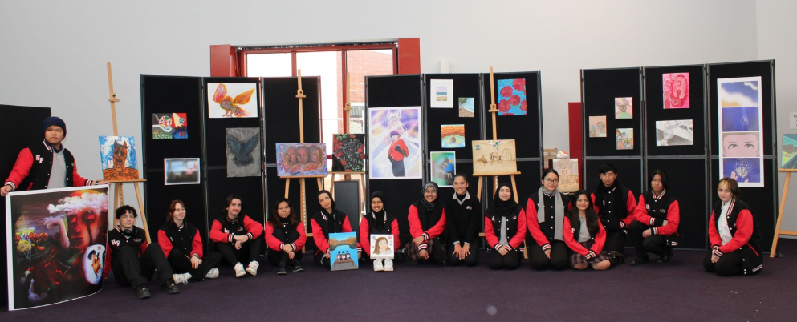

DRAMA UNITS 1 & 2

Subject Description:
VCE Drama equips students with the knowledge, skills, and confidence to communicate as individuals, as well as collaboratively, in a broad range of social, cultural, and work-related contexts. The study of drama can provide pathways to training and tertiary study in acting, theatre-making, script writing, communication, and drama criticism.

Unit 1: Introducing Performance Styles and Contemporary Drama Practices
In this unit, students use play-making techniques to devise, create, and perform solo and ensemble works. In Unit 1 the performances are based on the student’s personal, cultural, and/or community experiences and stories. Students analyse and evaluate their own and a professional drama performance.

Unit 2: Contemporary Drama Practices and Australian Identity
In Unit 2, the performances are based on a person, an event, an issue, a place, an artwork, a text, and/or an icon from a contemporary or historical Australian context. Students will record and document the play-making techniques used in the development of this performance work and evaluate their own and others’ work.
Students will have the opportunity to go to the theatre to watch professional actors at work and to analyse what they observe.

Assessment:
- Practical drama activities, exercises, and presentations.
- Creating a devised performance.
- Presenting a devised performance.
- Analysis and evaluation of their own and of professional work.

Advice to Students:
There are no prerequisites for undertaking this subject, however students must be willing to participate in all activities, work with others, and bring positive energy!

Students must undertake this subject in order to study VCE Drama Units 3 & 4. Students considering undertaking these units should be confident, independent, and self-managed learners.

Teachers to see for advice regarding this subject:
Ms. Windross and Ms. Scerri

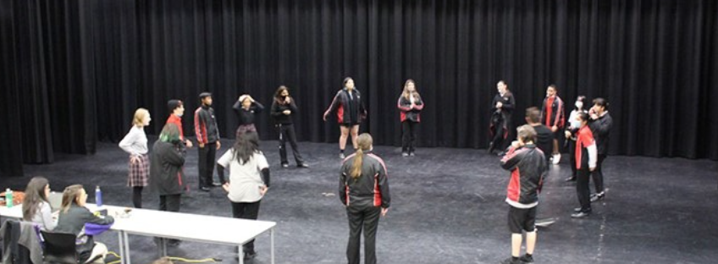

DRAMA UNITS 3 & 4

Subject Description:
VCE Drama equips students with the knowledge, skills, and confidence to communicate as individuals, as well as collaboratively, in a broad range of social, cultural, and work-related contexts. The study of drama can provide pathways to training and tertiary study in acting, theatre-making, script writing, communication, and drama criticism.

Unit 3: Devised Ensemble Performance
Students develop and present a devised ensemble performance. They examine the work of a range of drama practitioners, exploring how dramatic work is created. The focus is on developing and presenting work that goes beyond representing real life as it is lived, i.e., non-naturalistically. Students extract dramatic potential from the stimulus and devise and develop characters, story, and meaning in the ensemble performance. They also have the opportunity to go to the theatre to watch professional actors at work and to analyse what they observe.

Unit 4: Devised Solo Performance
Students explore and develop skills in the creation of a short solo performance. They demonstrate application of symbol and transformation of character, time, and place. This prepares them for the creation, development, and performance of a more extensive solo performance based on a prescribed, detailed structure. Students will then analyse and evaluate the creation, development, and presentation of their work.

Both units require students to record and document the play-making techniques used in the development of this performance work and evaluate their work.

Assessment:
- Develop and present characters in a devised ensemble performance.
- Analysis of the use of processes, techniques, and skills used to create and present a devised ensemble performance.
- Analysis and evaluation of professional as well as their own drama performances.
- Presentation of performance.

Advice to Students:
Students considering undertaking this subject should be confident, independent, and self-managed learners, willing to participate in all activities, work with others, and bring positive energy!

Teachers to see for advice regarding this subject:
Ms. Windross and Ms. Scerri



MEDIA UNITS 1 & 2

Subject Description:
VCE Media Studies is a vibrant programme that develops critical visual literacy. It equips students with a range of skills for understanding and analysing cinema as a vital, yet every day, part of modern life. Through close familiarity with a range of case studies, students will come to understand the social, cultural, aesthetic, and political dimensions of cinema in different contexts and at various times. If students want to enter any of the many media industries, this is the subject for them! People have been making, watching, and writing about movies for just over a century. In a culture that increasingly relies on visual information, an understanding of the moving image is essential to understanding society.

Unit 1: Media Forms, Representations, and Australian Stories
Students develop an understanding of the way that external reality is reflected within various media products. They also learn about the features of Australian fictional and non-fictional narratives in different media forms, developing research skills to investigate and analyse selected narratives, focusing on the media professionals’ influence on production genre and style. They experience the voices and stories of Aboriginal and Torres Strait Islander creators to gain an understanding and appreciation of how their stories contribute to our cultural identity.

Unit 2: Narrative across Media Forms
In this unit, students further develop an understanding of the concept of narrative in media products and forms in different contexts. Narratives in both traditional and newer forms include film, television, digital streamed productions, audio news, print, photography, games, and interactive digital forms. Students analyse the influence of developments in media technologies on individuals and society; design, production, and distribution of narratives in the media; and audience engagement, consumption, and reception.

Assessment:
- Medium length written responses.
- Product design folio.
- Construction of a media product.

Advice to Students:
Students must undertake this subject to study VCE Media Units 3 & 4. Students considering undertaking these units should be confident, independent, and self-managed learners.

Teachers to see for advice regarding this subject:
Mr. Marriott and Mr. Kriaris



MEDIA UNITS 3 & 4

Subject Description:
VCE Media Studies is a vibrant programme that develops critical visual literacy. It equips students with a range of skills for understanding and analysing cinema as a vital and yet everyday part of modern life. Through close familiarity with a range of case studies, students will come to understand the social, cultural, aesthetic, and political dimensions of cinema. If students want to enter any of the many media industries, this is the subject for them! People have been making, watching, and writing about movies for just over a century. In a culture that increasingly relies on visual information, an understanding of the moving image is essential to understanding society.

Unit 3: Media Narratives, Contexts, and Pre-Production
Through the study of a media narrative, students explore specific codes and narrative conventions and begin the process of research to support their understanding of how they can adopt and employ these techniques in their own works. They investigate a media form that aligns with their interests and intent, developing an understanding of the codes and narrative conventions appropriate to audience engagement, consumption, and reception within the selected media form. Students use the pre-production stage of the media production process to design the production of a media product for a specified audience.

Unit 4: Media Production: Agency and Control in and of the Media
In this unit, students focus on the production and post-production stages of the media production process. Students refine their media production in response to feedback and through personal reflection, documenting the iterations of their production as they work towards completion. They study the context in which media products are produced, distributed, and consumed as an essential framework through which audiences view and read media products. Students analyse the social, historical, institutional, cultural, economic, and political contexts that can be seen through explicit or implied views and values conveyed within media products.

Assessment:
- School Assessed Coursework comprised of medium-length written responses.
- School Assessed Task comprised of a development folio and finished media product.
- End of year examination.

Advice to Students:
Students must undertake VCE Media Units 1 & 2 to study VCE Media Units 3 & 4.

Teachers to see for advice regarding this subject:
Mr. Marriott and Mr. Kriaris

MUSIC UNITS 1 & 2

Subject Description:
Do you enjoy writing your own music and performing? This subject is recommended to anyone with a creative mind and musical flair! Students study the work of other performers and explore strategies to optimise their own approach to performance work to address technical, expressive, and stylistic challenges relevant to works they are preparing for performance.

Unit 1: Organisation of Music
This unit focuses on exploring and developing an understanding of how music is organised by performing, creating, analysing, and responding to various music works. They prepare and perform ensemble and/or solo musical works to build technical control, expression, and develop a stylistic understanding of their chosen instrument/sound source. They also arrange/compose/improvise short music exercises to demonstrate their understanding of how music is organised and of the processes they have studied.

Unit 2: Effect in Music
This unit focuses on how music can be used to create an intended effect by performing, analysing, and responding to music works and examples that create different effects. Students prepare and perform ensemble and/or solo musical works to build their technical control and expression and to develop a stylistic understanding of their chosen instrument or sound source. They arrange, compose, and improvise short music exercises to demonstrate their understanding of how music is organised and of the processes they have studied.

Assessment:
- Performances, including ensemble and group work.
- Folio and demonstration of technical exercises to prepare for performance.
- Listening, aural, theoretical, and analytical musicianship skills test.

Advice to Students:
This subject is intended for students with at least two to three years’ experience in learning an instrument. Knowledge of basic music theory is needed to understand the advanced concepts studied. Students considering undertaking these units should be confident, independent, and self-managed learners. Students must undertake this subject to study VCE Music Units 3 & 4.

Teachers to see for advice regarding this subject:
Ms. Le, Ms. Nguyen and Ms, Hutton

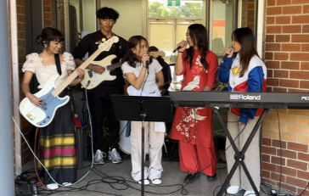

MUSIC REPERTOIRE PERFORMANCE UNITS 3 & 4
Ex

Subject Description:
This study is designed for students whose musical interests are grounded in the recreation and interpretation of notated musical works, and who wish to gain and share knowledge of musical styles and performance practices. Students may present on any instrument for which there is an established repertoire of notated works. They work towards a recital program that demonstrates highly developed technical skills and stylistic refinement as both a soloist and as an ensemble member.

Unit 3:
- Performing: students present performances of musical works including at least one ensemble work.
- Analysing for performance: students focus on the processes of analysis and research that they undertake when preparing musical works for performance.
- Responding: students develop their understanding of the ways elements of music, concepts and compositional devices can be interpreted and/or manipulated by other musicians.
Unit 4:
- Performing: students present performances of musical works including at least one ensemble work. Across Unit 4, students work towards presenting their recital program for external assessment.
- Analysing for performance: students focus on the processes of analysis and research that they undertake when preparing musical works for performance. This task should focus on approximately half of the program of works which were not covered by Unit 3

Assessment:
- Unit 3 coursework 20% - written and oral tasks on the planning of a recital program, discussion of techniques related to performance of selected works, written responses and practical demonstration of music language knowledge and skills.
- Unit 4 coursework 10% - A discussion in which materials designed to assist in the recreation of notated recital works are explained and demonstrated.
- End-of-Year Performance examination 50%
- End-of-Year Aural and Written examination 20%

Advice to Students:
This subject is intended for students with at least three to four years’ experience in learning an instrument. Knowledge of basic music theory is needed to understand the advanced concepts studied. It is highly recommended that students undertake VCE Music Units 1 & 2 prior to this subject.

Teachers to see for advice regarding this subject:
Ms. Le, Ms. Nguyen and Ms, Hutton


VISUAL COMMUNICATION DESIGN UNITS 1 & 2

Subject Description:
Do you enjoy designing? Do you have a creative mind? This subject is recommended to anyone with artistic flair and an edge for design. Students will use industry standard Software, such as Adobe Creative Cloud, to create and produce high quality visual communications across the fields of design practice: Messages, Objects, Environments, and Interactive Experiences.

Unit 1: Finding, Reframing, and Resolving Design Problems
This unit introduces students to the practices and processes used by designers to identify, reframe, and resolve human-centred problems. Students will work on a series of design tasks where they will develop an understanding of how designs can improve life and living for people, communities, and societies. Students will learn the design process and modes of divergent and convergent thinking, as well as focusing on the design fields of messages and objects. Students will learn design language and how to use media, materials, and methods as they explore brand strategy, product development, and promotion of sustainable practices.

Unit 2: Design Contexts and Connections
In this unit, students will use the design process as they work on practical tasks from the environmental design and interactive experiences fields. Students will explore the use of media, materials, and manual and digital methods, as well as the design elements and principles. Students will explore the influence of historical movements and cultural traditions as sources of inspiration. There is a focus on Indigenous design, with a particular focus on Aboriginal and Torre Strait Islander design traditions and practices. Students will learn about how issues of ownership and intellectual property impact the work of designers across contexts and specialist fields.

Assessment:
- Extended written analyses, short answer questions, a written brief, and presentations.
- Folio: including working through the VCD design process to present an environmental design solution, creating visual language for a business or brand, developing a sustainable object, and proposing an interface for an interactive digital product, environment, or service.

Advice to Students:
Students must undertake this subject to study VCE Visual Communication and Design Units 3 & 4.

Teachers to see for advice regarding this subject:
Ms. Grove


VISUAL COMMUNICATION DESIGN UNITS 3 & 4

Subject Description:
Do you enjoy designing? Do you have a creative mind? This subject is recommended to anyone with artistic flair and an edge for design. Students will be using industry standard Software, such as Adobe Creative Cloud, as they learn how to create and produce high quality visual communications from each of the fields of design practice: Messages, Objects, Environments, and Interactive Experiences.

Unit 3: Visual Communication in Design Practice
In this unit, students explore and experience the ways designers work, whilst analysing their own design. Students learn the processes used to design messages, objects, environments, and/or interactive experiences. They will understand the relationships between designers, clients, and other specialists. Students develop practical skills in visual communication practices, and they learn to analyse visual communications, providing the foundation for their own investigation of the VCD design process. Students will explore the Discover, Define, and Develop phases of the VCD design process.

Unit 4: Delivering Design Solutions
This unit explores the VCD design process, resolving design concepts and presenting solutions for two distinct communication needs. Students apply an iterative cycle to rework ideas, revisit research, and review design criteria defined in their brief. They use a range of media, materials, and manual and digital methods, in conjunction with design elements and principles, to explore and test concepts using models, mock-ups, or low-fidelity prototypes.

Assessment:
- Folio: a developmental folio including the application of the design process in the production of two final visual communications, the critiquing of a work in progress and a pitch presentation.
- Coursework: includes research, case studies, analysis of visual communications, and the production of visual communications in response to research undertaken.
- Examination: includes short answer questions to unseen visual communications and a range of practical tasks.

Advice to Students:
Students must successfully complete VCE Visual Communication and Design Units 1 & 2 prior to undertaking this subject.

Teachers to see for advice regarding this subject:
Ms. Grove

ENGLISH & ENGLISH AS AN ADDITIONAL LANGUAGE (EAL)
The study of English is central to the learning and development of all young Australians. It helps create confident communicators, imaginative thinkers, and informed citizens. It is through the study of English that individuals learn to analyse, understand, communicate, and build relationships with others and with the world around them. The study of English helps young people become ethical, thoughtful, informed, and active members of society.
What distinguishes English from other subjects is not only the skills it develops, but its central subject matter. The central concern of English is with the study and application of how language works in a range of contexts and media. English is further defined by the nature of the texts studied. English is essentially the study of language as a social and cultural form. English is also defined by the values it tries to create. English has been about the shaping of the 'self', by exploring humane values, imaginative life, and the development of aesthetic sensibility through engagement with literary texts. Today, this includes students understanding how their 'self' is located within social and cultural contexts and constructed through language and text.
PATHWAYS MAP FOR ENGLISH & EAL
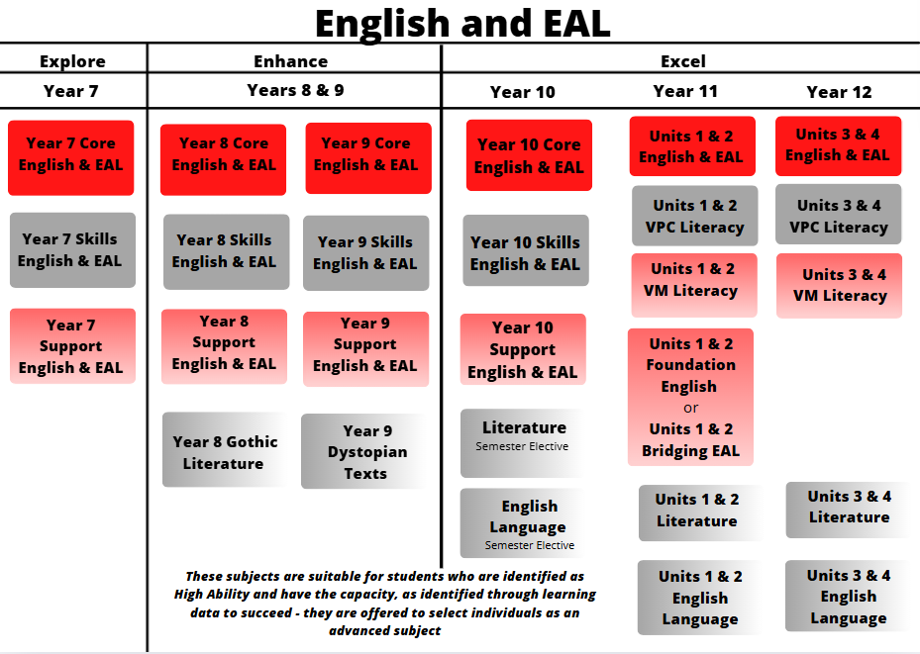
The acquisition of skills will determine the pathway students take in English. Pathways are individualised and are informed by data and learning progress.

BRIDGING ENGLISH AS AN ADDITIONAL LANGUAGE (BEAL) UNITS 1 & 2

Subject Description:
Bridging English as an Additional Language (EAL) is an intensive and explicit study of the English language in a range of socio-cultural contexts and for a range of purposes, including further education, the workplace, and social situations. The study design draws on and strengthens the language skills and knowledge students have acquired, recognising their diverse educational backgrounds and English experiences. Students use a range of registers of spoken and written Standard Australian English. Oral and aural skills are emphasised, along with explicit, close study of linguistic features, structures and meaning in Standard Australian English, and in literary and non-literary texts. Bridging English as an Additional Language covers Units 1 & 2 only.

Unit 1: English for Learning
In this unit, students build their understanding of how spoken and written Standard Australian English (SAE) is used to communicate effectively in a variety of contexts and for a range of purposes. Students develop the ability to listen, speak, read, and write for everyday and academic purposes. They explore how language features, structures and conventions can be used to express ideas and opinions, and to create their own spoken and written texts.

Unit 2: English for Life
In Unit 2, students read and produce texts created for self-expression, including those that communicate ideas, desires, goals, opinions, and experiences. They consider how authors use language to express themselves for different audiences and purposes. The students engage with and understand spoken, print, visual, and multimodal media texts, and develop understanding of how these texts reflect cultural contexts and seek to position audiences.

Assessment:
- Reading and writing a variety of texts such as opinion pieces, emails, reviews, and advertisements.
- Analyses of fiction and non-fiction texts.
- Oral presentations and speaking activities.
- Comprehension activities.

Advice to Students:
Students who have been advised to choose Bridging EAL should undertake this subject in order to support their studies in VCE EAL or VCE VM/VPC Literacy. VCE EAL Units 1 & 2 or VCE VM Literacy Units 1 & 2 must be taken along with this subject.

Teachers to see for advice regarding this subject:
Ms. Spence


FOUNDATION ENGLISH UNITS 1 & 2

Subject Description:
The Foundation English study is designed for students who need additional time and assistance to strengthen and refine their literacy skills to support their study in VCE English. Students must be able to pass VCE English to be successful in achieving their VCE certificate and gain entry into many university courses. VCE English students must achieve a minimum study score of 25. Foundation English covers Units 1 & 2 only.

For students who may find some elements of English difficult, such as studying a text, or writing an essay, VCE Foundation English can support them in building their English knowledge and skills. Taking VCE Foundation English in Year 11 will assist students in understanding how to be successful in VCE English in Year 12. VCE Foundation English also supports students in building the literacy skills needed across a variety of VCE subjects.

Unit 1: English for Practical Purposes
In Unit 1 of Foundation English, students focus on developing language and communication skills, primarily through the study of a variety of texts. They develop communication skills to listen, speak, read, and write effectively in academic, workplace, and social contexts. Several pieces of work are used to achieve each of the three outcomes. This allows for multiple opportunities to succeed and improve.

Unit 2: Thinking and Learning Through English
Unit 2 of Foundation English surrounds thinking and learning through the English language. In this unit, students develop a range of literacy skills and learning strategies. They extend the understandings and processes required to read and write effectively. Students employ learning strategies designed to enhance their achievement in, and enjoyment of, the English language. Several pieces of work are used to achieve each of the three outcomes. This allows for multiple opportunities to succeed and improve.

Assessment:
- Book review, informative writing, oral presentation, class discussion, graphic representation, and tabulated summaries.
- Analytical response, analysis of multimedia text, narrative writing.

Advice to Students:
Students who have been advised to choose VCE Foundation English should undertake this subject to support their studies in VCE English. VCE English must be taken along with this subject.

It is highly recommended that students who are enrolled in Literacy Support in Year 10 and want to select a VCE pathway, undertake VCE Foundation English in Year 11.

Teachers to see for advice regarding this subject:
Mrs. Eldridge

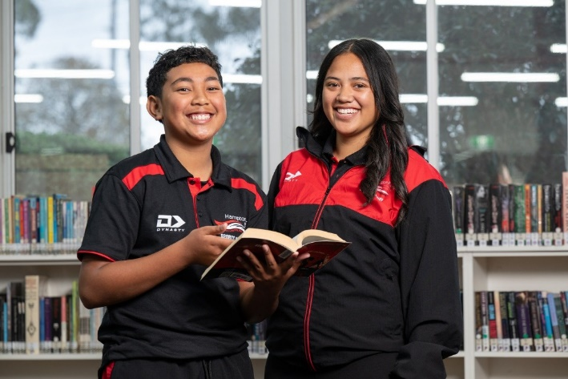
VM LITERACY UNITS 1 & 2

Subject Description:
VCE Vocational Major Literacy focuses on the development of the knowledge and skills required to be literate in Australia today. The key knowledge and key skills encompass a student’s ability to confidently and fluently interpret and create texts that have purpose and are accurate and effective.

Unit 1:
In Unit 1, students develop their understanding of the structures and features of text types, and examine how they are influenced by purpose, context, audience, and culture. Students read texts that serve a multiplicity of purposes and employ a variety of strategies to develop their understanding of the purpose and key ideas within written and spoken language. In their study of visual and film texts, students examine how purpose, language, and structure influence the audience of a text. Students develop their capacity to critically assess digital texts. They will continue to develop analytical skills needed to identify and discuss aspects of digital texts. Students read, view, and interact with different digital texts.

Unit 2:
In this unit, students consider the values and beliefs that underpin different perspectives as well as how these values create different biases and opinions. Students read, view, and listen to a range of texts and content that demonstrate diverse opinions on a range of local and global issues. They consider the language and purpose of different text types and consider how this language is used to influence an audience. Students discuss and explain how personal and vested interests affect their own responses to an issue. They consider their own perspectives on issues and develop reasoned and logical responses to these discussions. Students consider the arguments presented and critically analyse the language, evidence, and logic of the arguments of others so that they can create their own response.

Assessment:
- A written narrative.
- A digital presentation.
- Written reports, research tasks, and reflective journals.
- Case study analyses.

Advice to Students:
The VCE Vocational Major is an option for students who wish to develop the skills and capabilities needed to move into apprenticeships, traineeships, further education and training, or directly into the workforce.

Teachers to see for advice regarding this subject:
Ms. Windross and Ms. Ho
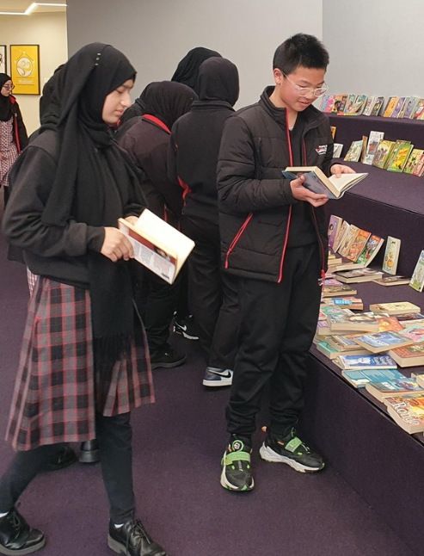

VM LITERACY UNITS 3 & 4

Subject Description:
VCE Vocational Major Literacy focuses on the development of the knowledge and skills required to be literate in Australia today. The key knowledge and key skills encompass a student’s ability to confidently and fluently interpret and create texts that have purpose and are accurate and effective.

Unit 3:
In this area of study, students become familiar with, and develop confidence in, understanding and accessing texts of an informational, organisational, or procedural nature. Students will learn to recognise, analyse, and evaluate the structures and semantic elements of informational, organisational, and procedural texts, as well as discuss and analyse their purpose and audience. As a part of this exploration of texts and content, students will participate in activities that equip them to access, understand, and discuss these text types. Students examine texts about individual rights and responsibilities within organisations, workplaces, and vocational groups. Students read and respond to a variety of technical content from a vocational, workplace, or organisational setting of their choice, demonstrating an understanding of how these texts inform and shape the organisations with which they interact.

Unit 4:
In this unit, students investigate, analyse, and create content for the advocacy of the self, a product, or a community group of the student’s choice. Students research the differences between texts used for more formal or traditional types of advocacies, influence, or promotion, as well as some of the forms that are increasingly being used in the digital domain for publicity and exposure. Students consider which elements are important for creating a ‘brand’ and how different texts, images, products, and multimedia platforms work together to produce one central message to influence an audience. They read, discuss, analyse, and create texts that influence or advocate for the self, a product, or a community group of the student’s choice. Students will use their knowledge and understanding of language, context, and audience to complete an oral presentation that showcases their learning.

Assessment:
- A written narrative.
- A digital presentation and an oral presentation.
- Written reports, research tasks, and reflective journals.
- Case study analyses.

Advice to Students:
The VCE Vocational Major is an option for students who wish to develop the skills and capabilities needed to move into apprenticeships, traineeships, further education and training, or directly into the workforce.

Teachers to see for advice regarding this subject:
Ms. Windross and Ms. Ho

VPC LITERACY UNITS 1 & 2
Subject Description:
VPC Literacy enables the development of knowledge, skills, and capabilities relevant to reading, writing, and oral communication and their practical application in the contexts of everyday life, family, employment, further learning, and community.
Unit 1:
In this unit, students develop their knowledge and skills to read and write simple or short texts. Students develop their understanding of the structures and features of these text types, and examine how these are influenced by purpose, context, and audience. They read, view, and listen to texts produced for a variety of purposes, from everyday texts written for enjoyment or information to texts written for specific workplaces or educational settings. Students develop capacity to engage with, understand, and respond to digital texts. They identify and explain the structure of a variety of digital platforms, as well as the types and purposes of different digital texts. Students read, view, and interact with different digital texts, and participate in learning activities to develop capacity to explore and discuss impact.
Unit 2:
In this unit, students engage in issues that create discussion and debate in a community of which they are part. Students consider the values that underpin different communities and how these values create different opinions and perspectives. Students read, view, and listen to a range of diverse opinions and consider the language and purpose of the content, and how the language and purpose changes depending on the audience and context. Students practise and participate in debate, either in print, orally, or via a digital platform. They consider personal perspectives of community and workplace issues and develop logical responses to these debates in a respectful and thoughtful manner, supported by evidence.
Assessment:
- A reflective journal.
- A response to structured questions.
- A digital presentation.
- A research task.

Advice to Students:
The VPC is a standards-based certificate designed to develop and extend pathways for young people who are not ready to complete the General VCE or VCE VM. This subject is suitable for students whose previous schooling experience may have been disrupted for a variety of reasons, including students with additional needs and students who have missed significant periods of learning.
Teachers to see for advice regarding this subject:
Ms. Fiddes and Ms. Windross

VPC LITERACY UNITS 3 & 4
Subject Description:
VPC Literacy enables the development of knowledge, skills, and capabilities relevant to reading, writing, and oral communication and their practical application in the contexts of everyday life, family, employment, further learning, and community.
Unit 3:
In this unit, students develop the skills and knowledge required to understand and complete a range of familiar and less familiar activities for civic participation purposes. Students engage with a range of texts and information including timetables, forms, government documentation, and contracts, in print and digital forms, and locate information, identify the audience and purpose of the text, and develop the skills necessary to complete documentation. Students develop the skills and knowledge to investigate pathway options and plan skill development to move into further training or employment. Students research and identify possible pathways and plan, document, and monitor progress towards achieving personal goals.
Unit 4:
In this unit, students develop a range of written and oral communication skills through practical application in an activity around a specific content area. Content for the unit can be drawn from any area of learner interest or aspirations. This project needs to be developed in consultation with the teacher and should focus on an area of student interest with a clearly stated vocational or personal focus. The project can be completed either individually or as a member of a group, focusing on the following areas of skill development: collaboration, problem solving, communication, self-management, planning and organising, initiative, and learning.
Assessment:
- A research task.
- A reflective journal.
- A response to structured questions.
- An oral presentation.

Advice to Students:
The VPC is a standards-based certificate designed to develop and extend pathways for young people who are not ready to complete the VCE or VCE VM. It is suitable for students whose previous schooling experience may have been disrupted for a variety of reasons, including students with additional needs and students who have missed significant periods of learning.

Teachers to see for advice regarding this subject:
Ms. Fiddes and Ms. Windross


ENGLISH & EAL UNITS 1 & 2

Subject Description:
VCE English and English as an Additional Language (EAL) focus on how English language is used to create meaning in print and digital texts of varying complexity. By developing broad skills in communication and reflection, the study of English enables students to participate in their diverse, dynamic, and multicultural world productively and positively. The study is intended to meet the needs of students with a wide range of expectations and aspirations, including those for whom English is an additional language.

Unit 1:
In Unit 1, students apply reading and viewing strategies to critically engage with a text, discussing and clarifying the ideas and values presented by authors. They analyse the ways authors construct meaning through vocabulary, text structures, language features and conventions, and the presentation of ideas. Students read and engage imaginatively and critically with texts that model effective and cohesive writing. They consider these texts through knowledge of the ways purpose, context, and audience, influence and shape writing.

Unit 2:
In Unit 2, students consolidate their capacity to critically analyse texts and deepen their understanding of the ideas and values a text can convey. They analyse how social and cultural values are presented, establishing how these values can influence the way a text is read and understood by different audiences. Students analyse the use of argument, language, and visuals in texts that debate a contemporary and significant issue. They develop their understanding of the ways in which arguments and language complement one another to position an audience. Students consider the purpose, audience, and context of each text, the arguments, and the ways language and visuals are employed for effect. They analyse the ways all these elements work together to influence an intended audience.

Assessment:
- Text analysis essays and analysing argument essays.
- Creation of own texts in response to a specific context and audience to achieve a stated purpose.
- Written reflections and an oral presentation.

Advice to Students:
Students must undertake this subject to meet the requirements of VCE. VCE English Units 1 & 2 can be studied as an alternative to VCE VM Literacy. To gain entry into many university courses, VCE English students must achieve a minimum study score of 25 and VCE EAL students must achieve a minimum study score of 30.

Teachers to see for advice regarding this subject:
Ms. Spence

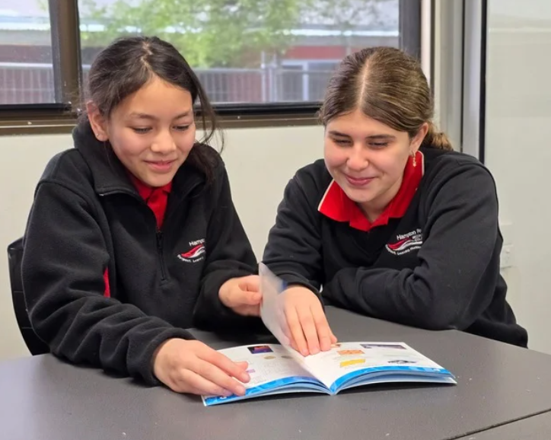
ENGLISH & EAL UNITS 3 & 4
Subject Description:
VCE English and English as an Additional Language (EAL) focus on the how English language is used to create meaning in print and digital texts of varying complexity. By developing broad skills in communication and reflection, the study of English enables students to participate in their diverse, dynamic, and multicultural world productively and positively. The study is intended to meet the needs of students with a wide range of expectations and aspirations, including those for whom English is an additional language.

Unit 3:
In Unit 3, students apply reading and viewing strategies to critically engage with a text, discussing and clarifying the ideas and values presented by authors. They analyse the ways authors construct meaning through vocabulary, text structures, language features and conventions, and the presentation of ideas. Students read and engage imaginatively and critically with texts that model effective and cohesive writing. They consider these texts through knowledge of the ways purpose, context, and audience influence and shape writing.

Unit 4:
In Unit 4, students consolidate their capacity to critically analyse texts and deepen their understanding of the ideas and values a text can convey. They analyse how social and cultural values are presented, establishing how these values can influence the way a text is read and understood by different audiences. Students analyse the use of argument, language, and visuals in texts that debate a contemporary and significant issue. They develop their understanding of the ways in which arguments and language complement one another to position an audience. Students consider the purpose, audience, and context of each text, the arguments, and the ways language and visuals are employed for effect. They analyse the ways all these elements work together to influence an intended audience.

Assessment:
- Text Analysis essays and analysing argument essays.
- Creation of own texts in response to a specific context and audience to achieve a stated purpose.
- Written reflections and an oral presentation.

Advice to Students:
Students must undertake this subject to complete the VCE. VCE English Units 1 & 2 can be studied as an alternative to VCE VM Literacy. To gain entry into many university courses, VCE English students must achieve a minimum study score of 25 and VCE EAL students must achieve a minimum study score of 30.

Teachers to see for advice regarding this subject:
Ms Spence

ENGLISH LANGUAGE UNITS 1 & 2

Subject Description:
VCE English Language gives students the power to analyse how language shapes our society, culture, values, and identity. Students will draw on the study of linguistics to develop fresh insights into their own language choices, the values and assumptions constructed when considering the language use of others, and the power of language to control, shape. and disrupt our lives. Studying English Language enables students to build and interrogate attitudes and assumptions, and to create and disrupt social cohesion.

Unit 1: Language and Communication
In this unit, students explore the nature of language and the various functions that language performs. Students are introduced to the theory that language is a system of signs and conventions, and that while the relationship between words and meanings may be arbitrary, our use of language is governed by conventions and informed by accepted systems. They come to understand that language is never a neutral and transparent means of representing the world we inhabit; rather, it is influenced by situational and cultural understandings. Students explore developmental stages of language acquisition. They are introduced to two linguistic theories that attempt to explain how children acquire their first language.

Unit 2: Language Change
This unit examines the changes that have occurred in English over time. Students investigate the factors that bring about language change, including those that come from contact with other languages, from social and technological transformation, and from within the language itself. They explore factors that contributed to the spread of English in the past, such as trade and colonisation, and factors that continue to contribute to the spread of English today. Students explore the consequences for the languages of indigenous peoples around the world, and how changes to, and loss of, language affect its users’ cultural identities and worldviews.

Assessment:
- Case studies, text analysis, short-answer questions, and essays that focus on identifying and describing the nature and functions of language and the types of language acquisition, as well as investigating and discussing language acquisition.

Advice to Students:
Students must successfully complete VCE Literature Units 1 & 2 prior to undertaking VCE Literature Units 3 & 4. This subject is taken in addition to VCE English Units 1 & 2.

Teachers to see for advice regarding this subject:
Mr. Antil

ENGLISH LANGUAGE UNITS 3 & 4

Subject Description:
In English Language, students investigate the English language in contemporary Australian society. They consider language as a means of interaction and explore how language exposes ideas, attitudes, ideologies, and prejudices. Students focus on the role of language in establishing and challenging different identities. Students explore how language can distinguish between ‘us’ and ‘them’, creating solidarity and reinforcing social distance.

Unit 3: Language Variation and Purpose
In this unit, students consider the way speakers and writers choose language to suit particular purposes. They consider the features of informal and formal language. Students investigate how informal language use can incorporate politeness strategies and how informal language choices can build rapport by encouraging inclusivity, intimacy, solidarity, and equality. They investigate how formal language choices can reinforce or challenge social distance, relationship hierarchies, and rapport. They explore how formal language can be used to clarify, manipulate, or obfuscate, particularly in the language of politics, reportage, the law, and bureaucracy.

Unit 4: Language Variation and Identity
This unit enables students to examine the range of language varieties that exist in Australian society and the role of those varieties in contributing to an increasingly contested national identity. Students examine how Standard Australian English is afforded prestige by public institutions. They consider a range of migrant ethnolects and Aboriginal Australian English’s and explore language features associated with stereotypes that can establish or challenge identities. Students examine the role of language in conveying individual and group identities and how language users construct their identities through language variation. They investigate how, as individuals, we make language choices that draw on our understanding of social expectations and community attitudes.

Assessment:
- Case studies, text analysis, short-answer questions, and essays that focus on identifying, describing, and analysing distinctive features of informal and formal language, the varieties of English in Australian society, and the identities they reflect, as well as how variation in language conveys people’s identities.

Advice to Students:
Students must successfully complete VCE Literature Units 1 & 2 prior to undertaking VCE Literature Units 3 & 4. This subject is taken in addition to VCE English Units 1 & 2.

Teachers to see for advice regarding this subject:
Mr. Anti
l

LITERATURE UNITS 1 & 2

Subject Description:
The study of VCE Literature fosters students’ enjoyment and appreciation of the artistic and aesthetic merits of stories and storytelling and enables students to participate more fully in the cultural conversations that take place around them. By reading and exploring a diverse range of established and emerging literary works, students become increasingly empowered to discuss texts. As both readers and writers, students extend their creativity and higher order thinking to express and develop their critical and creative voices.

Unit 1:
In this unit, students consider how language, structure and stylistic choices are used in different literary forms and types of text. They consider both print and non-print texts, reflecting on the contribution of form and style to meaning. Students reflect on the degree to which points of view, experiences, and contexts shape their own and others’ interpretations of text. Students closely examine the literary forms, features, and language of texts. They begin to identify and explore textual details, including language and features, to develop a close analysis response to a text.

Unit 2:
In this unit, students explore the voices, perspectives, and knowledge of Aboriginal and Torres Strait Islander authors and creators. They consider the interconnectedness of place, culture, and identity through the experiences, texts, and voices of Aboriginal and Torres Strait Islander peoples, including connections to Country, the impact of colonisation and its ongoing consequences, and issues of reconciliation and reclamation. Students examine representations of culture and identity in Aboriginal and Torres Strait Islander peoples’ texts and the ways in which these texts present voices and perspectives that explore and challenge assumptions and stereotypes arising from colonisation. Students acknowledge and reflect on a range of Australian views and values (including their own) through a text(s). Within that exploration, students consider stories about the Australian landscape and culture.

Assessment:
- A written interpretation of a text, supported by close textual analysis, using a key passage.
- An analysis of how textual form influences meaning, and a close analysis of a key passage from a text.
- A written response that compares and analyses an initial interpretation with a subsequent interpretation.
- A creative response to text.
- A close analysis of a text, supported by an examination of textual details, based on a selection of passages.

Advice to Students:
Students must successfully complete VCE Literature Units 1 & 2 prior to undertaking VCE Literature Units 3 & 4.

Teachers to see for advice regarding this subject:
Mr. Antil

LITERATURE UNITS 3 & 4

Subject Description:
The study of VCE Literature fosters students’ enjoyment and appreciation of the artistic and aesthetic merits of stories and storytelling and enables students to participate more fully in the cultural conversations that take place around them. By reading and exploring a diverse range of established and emerging literary works, students become increasingly empowered to discuss texts. As both readers and writers, students extend their creativity and higher order thinking to express and develop their critical and creative voices.

Unit 3:
In Unit 3, students focus on how the form of a text contributes to its meaning and explore the form by constructing a close analysis. They then reflect on the extent to which adapting the text to a different form, and often in a new or reimagined context, affects its meaning, comparing the original with the adaptation. Students explore the diverse ways we can read and understand a text by developing, considering, and comparing interpretations of a set text. Students first develop their own interpretations of a set text, then they explore a supplementary reading that can enrich, challenge, and/or contest their ideas and their views. Informed by the supplementary reading, students develop a second interpretation of the same text, reflecting an enhanced appreciation and understanding of the text, which they then apply to key moments from the text.

Unit 4:
In Unit 4, students focus on the imaginative techniques used for creating and recreating a literary work. They learn how authors develop representations of people and places, and they develop an understanding of language, voice, form, and structure. Students focus on a detailed scrutiny of the language, style, concerns, and construction of texts. Students attend closely to textual details to examine the ways specific passages in a text contribute to their overall understanding of the whole text.

Assessment:
- A written interpretation of a text, supported by close textual analysis, using a key passage.
- An analysis of how textual form influences meaning, and a close analysis of a key passage from a text.
- A written response that compares and analyses an initial interpretation with a subsequent interpretation.
- A creative response to text.
- A close analysis of a text, supported by an examination of textual details, based on a selection of passages.

Advice to Students:
Students must successfully complete VCE Literature Units 1 & 2 prior to undertaking VCE Literature Units 3 & 4.

Teachers to see for advice regarding this subject:
Mr. Antil
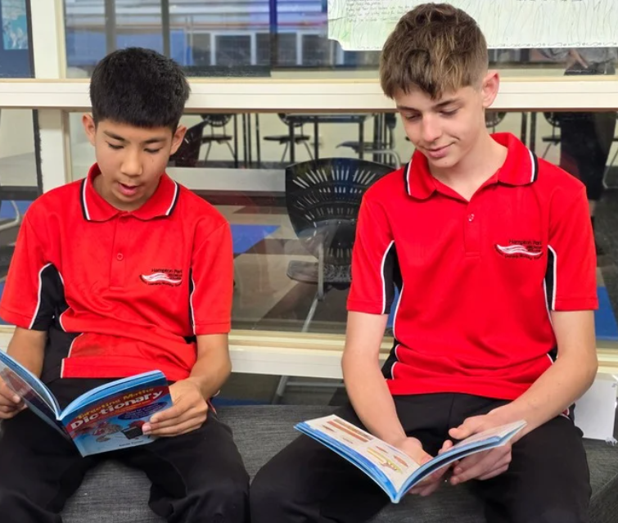

HEALTH & PHYSICAL EDUCATION

Health and Physical Education focusses on students enhancing their own and others’ health, safety, wellbeing, and physical activity and participation in varied and changing contexts. Research in fields such as sociology, physiology, nutrition, biomechanics, and psychology informs what we understand about healthy, safe, and active choices. Health and Physical Education oﬀers students an experiential curriculum that is contemporary, relevant, challenging, enjoyable, and active.
In Health and Physical Education, students develop knowledge, understanding, and skills to strengthen their sense of self and build and manage satisfying relationships. The curriculum helps them to be resilient and make decisions and take actions to promote their health, safety, and physical activity participation.
Integral to Health and Physical Education is the acquisition of movement skills, concepts, and strategies to enable students to participate in a range of physical activities conﬁdently, competently, and creatively. As a foundation for lifelong physical activity participation and enhanced performance, students develop proﬁciency in movement skills, physical activities, and movement concepts, and acquire an understanding of the science behind how the body moves.
PATHWAYS MAP FOR HEALTH & PE
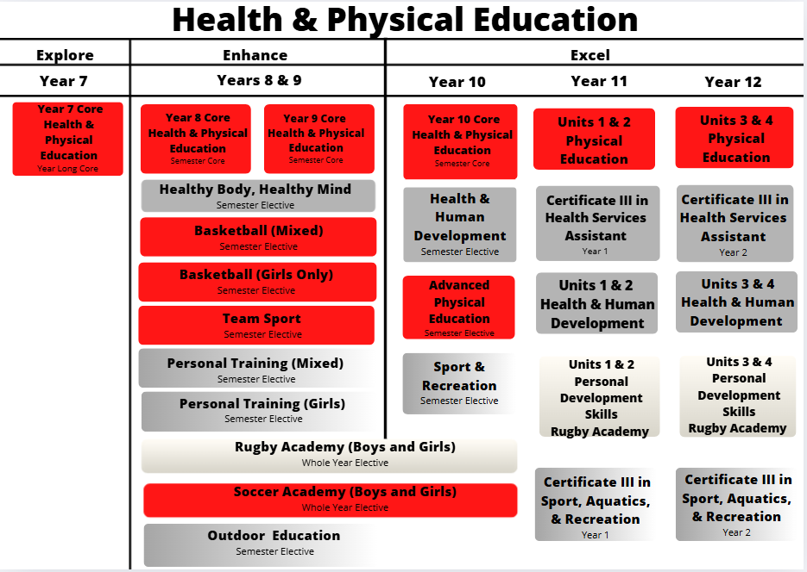

HEALTH AND HUMAN DEVELOPMENT UNITS 1 & 2

Subject Description:
VCE Health and Human Development provides students with the opportunity to examine both health and wellbeing and human development as changing over time and as being a unique experience for individuals. Students explore the numerous factors and reasons behind these changes and explain how they influence health and wellbeing. They start to look at health outside of Australia and draw comparisons between Australia and the rest of the world. Students develop the capacity to interpret health information, advertising, and other media messages, enabling them to put strategies into action to promote health and wellbeing in both personal and community contexts.

Unit 1: Understanding Health and Wellbeing
This unit looks at health and wellbeing as a concept, with varied and evolving perspectives and definitions. It takes the view that health and wellbeing are subject to a wide range of contexts and interpretations, with different meanings for different people. Students identify personal perspectives and priorities relating to health and wellbeing, and enquire into factors that influence health attitudes, beliefs, and practices.

Unit 2: Managing Health and Development
This unit investigates transitions in health, wellbeing, and development across the lifespan. Students look at changes and expectations that are a part of the progression from youth to adulthood. They enquire into the Australian healthcare system and extend their capacity to access and analyse health information. They investigate the challenges and opportunities presented by digital media and health technologies and consider issues surrounding the use of health data as well as access to quality health care.

Assessment:
- Research project.
- Structured questions.
- Data analysis.
- Case study questions.

Advice to Students:
It is recommended students have completed Year 10 Health and Human Development prior to undertaking this course, however, it is not a prerequisite. It is highly recommended that students complete Units 1 & 2 prior to undertaking Units 3 & 4 of this subject.
Teachers to see for advice regarding this subject:
Miss. Newton and Miss. Raynes

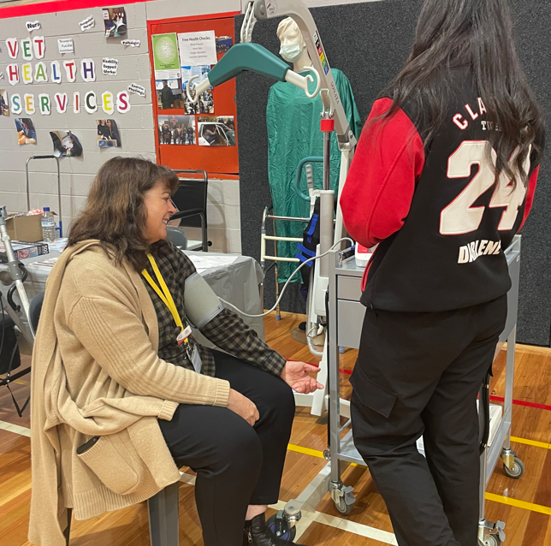

HEALTH AND HUMAN DEVELOPMENT UNITS 3 & 4

Subject Description:
VCE Health and Human Development provides students with the opportunity to examine health and wellbeing, and human development as always changing over time and being a unique experience for each individual. Students start to look outside of Australia and draw comparisons with the rest of the world regarding levels of health. The health inequalities that exist, which increase the gap between developed and developing countries, are explored, along with the various health resources of which each country has access, and how these hold a significant role in each country’s health status data: including health systems, level of poverty, trade industry, aid programmes, and food security.

Unit 3: Australia’s Health in a Globalised World
This unit looks at health, wellbeing, and illness as multidimensional, dynamic, and subject to different interpretations and contexts. Students begin to explore health and wellbeing as a global concept and to take a broader approach to inquiry. As students consider the benefits of optimal health and wellbeing and its importance as both an individual and a collective resource, their thinking extends to health as a universal right.

Unit 4: Health and Human Development in a Global Context
Students use data to investigate health status and burden of disease in different countries, exploring factors that contribute to health inequalities between and within countries, including the physical, social, and economic conditions in which people live.

Assessment:
- Research project.
- Structured questions.
- Data analysis.
- Case study questions.

Advice to Students:
It is recommended that students complete Units 1 & 2 of Health and Human Development prior to undertaking Units 3 & 4 of this subject.
Teachers to see for advice regarding this subject:
Miss. Newton and Miss. Raynes

VCE VM PERSONAL DEVELOPMENT SKILLS UNITS 1 & 2

Subject Description:
VCE Vocational Major, Personal Development Skills (PDS), takes an active approach to personal development, self- realisation, and citizenship by exploring interrelationships between individuals and communities. PDS focusses on health, wellbeing, community engagement, and social sciences, and provides a framework through which students seek to understand and optimise their potential as individuals and as members of their community.

Unit 1: Healthy Individuals
In this unit, students are introduced to the concepts of personal identity and emotional intelligence in differing contexts. Students explore concepts of health and wellbeing for individuals and groups, the factors that affect wellbeing, and the characteristics of inclusive and cohesive communities. They investigate activities and support services that aim to improve individual and group wellbeing within the community. Students explore how technology is used to facilitate health promotion programmes and understand the importance of using strategies to assess the reliability, validity and accuracy of health and well-being related information.

Unit 2: Connecting with Community
In this unit, students explore the concept of community at a local, national, and global level. They understand diverse groups within communities, characteristics that shape how communities are formed and factors that influence groups. Students analyse the roles of citizenship, empathy, and connection in individual health and wellbeing. Students investigate community participation and recognise that there are a range of ways to participate in community life. They examine issues affecting local, national, and global communities, both in the current context and in anticipation of future challenges. Students consider the concept of community engagement and recognise its benefits upon, and challenges to, addressing a range of contemporary issues.

Assessments:
- Case studies and reflective journals.
- A critical evaluation of a programme.
- Written reports and research tasks.
- A community engagement plan.

Advice to Students:
The VCE Vocational Major is an option for students who wish to develop the skills and capabilities needed to move into apprenticeships, traineeships, further education, and training, or directly into the workforce.
Teachers to see for advice regarding this subject:
Ms. Porter and Ms. Tregidga

VCE VM PERSONAL DEVELOPMENT SKILLS UNITS 3 & 4

Subject Description:
VCE Vocational Major, Personal Development Skills (PDS), takes an active approach to personal development, self- realisation, and citizenship by exploring interrelationships between individuals and communities. PDS focuses on health, wellbeing, community engagement, and social sciences, and provides a framework through which students seek to understand and optimise their potential as individuals and as members of their community.

Unit 3: Leadership and Teamwork
In this unit, students examine the characteristics of social awareness and a range of interpersonal skills to facilitate respectful interactions with others. They investigate the contexts in which people demonstrate social awareness and apply interpersonal skills. Students examine the characteristics of effective leaders and reflect on how leadership qualities and styles can be applied in a range of contexts. Students investigate the concept of leadership and the qualities of effective, ethical leaders. They look at contexts in which people become leaders, a range of leadership styles, and the ethics and expectations of leaders in a democratic society.

Unit 4: Community Project
In this unit, students complete an extended community project addressing an environmental, cultural, economic, or social issue. They identify a range of relevant issues in the community and justify the selection of a focus for the project. Students seek to understand the issue’s significance to the community, develop a project focus, and investigate previous or current responses to the area of concern. They implement a detailed plan for the selected community project. Students consider the possible health, safety, and ethical risks of a project, document evidence, and make decisions on how findings will be organised, analysed, and presented, and evaluated.

Assessment:
- Oral presentations and research reports.
- A critical reflection and evaluation report of participation in practical tasks and of interpersonal skills.
- A critical reflection on team members’ feedback.
- Planning, progress and implementation records and documentation, and a presentation evaluating the performance of self and team in executing a planned project.

Advice to Students:
The VCE Vocational Major is an option for students who wish to develop the skills and capabilities needed to move into apprenticeships, traineeships, further education and training, or directly into the workforce.
Teachers to see for advice regarding this subject:
Ms. Porter and Ms. Tregidga
VPC PERSONAL DEVELOPMENT SKILLS UNITS 1 & 2
Curriculum Design:
VPC Personal Development Skills (PDS) takes a dual approach to exploring and optimising personal development. This is done through a focus on understanding and caring for self, and then through a focus on engagement with community.
Unit 1:
In this unit, students explore personal development through self-reflection and self-care. The focus is on teamwork, communication, time management, and problem-solving. Students participate in an activity that investigates how personal development can help them achieve their goals. They investigate influences on motivation, and relationships between purposefulness and health and wellbeing. Students identify their personal strengths, abilities and potential and apply these to set personal goals. They investigate key pillars of physical, social, and emotional health and wellbeing, and how to practise self-care in a range of contexts to protect and improve their own health and wellbeing. Students explore concepts of consent, equity, and access, and how to express themselves in safe, assertive, and effective ways.

Unit 2:
In this unit, students explore the concept of community, and the types of communities to which individuals may belong. There is an emphasis on personal and emotional growth through active group participation and membership or belonging, and an introduction to the significance of community engagement. Students look at how communities are structured through investigation of community leaders and organisations. Students identify and explore options and opportunities for connecting with their local community.

Assessments:
- A digital presentation and a reflective journal.
- Analysis of a site visit and a research task.

Advice to Students:
The VPC is a standards-based certificate designed to develop and extend pathways for young people not ready to complete the VCE or VCE VM. It is suitable for students whose previous schooling experience may have been disrupted for a variety of reasons, including students with additional needs and students who have missed significant periods of learning.
Teachers to see for advice regarding this subject:
Ms. Wood and Ms. Porter

VPC PERSONAL DEVELOPMENT SKILLS UNITS 3 & 4

Curriculum Design:
VPC Personal Development Skills (PDS) takes a dual approach to exploring and optimising personal development. This is done through a focus on understanding and caring for self, and then through a focus on engagement with community.

Unit 3:
In this unit, students consider the role of interpersonal skills and the advantages of group diversity in developing effective harmonious groups. Students examine the characteristics of effective leaders and team membership. They explore key components of effective teamwork, communication, and collaboration techniques, and build skills in conflict resolution. This unit also examines various leadership styles and explores a variety of effective leadership qualities. Students gain an understanding of where and when effective leadership is required. They explore delegation in the context of developing a project or campaign plan and learn how to motivate themselves and others.

Unit 4:
In this unit, students examine service to community through the development and execution of a community project or community awareness campaign. Students engage with a variety of stakeholders to research and select an appropriate project or campaign. They apply negotiation, communication, and leadership skills to collaborate and cooperate with peers. Students develop a comprehensive project plan to enact throughout the community project or public awareness campaigns. This unit also explores community participation. Students consider numerous ways of identifying community needs, connecting with community, and serving the community. They look at how communities are structured through investigation into community leaders and organisations. Students implement a community project or awareness campaign.

Assessments:
- An oral presentation and a project plan.
- A case study and a research task.

Advice to Students:
The VPC is a standards-based certificate designed to develop and extend pathways for young people not ready to complete the VCE or VCE VM. It is suitable for students whose previous schooling experience may have been disrupted for a variety of reasons, including students with additional needs and students who have missed significant periods of learning.
Teachers to see for advice regarding this subject:
Ms. Wood and Ms. Porter

PHYSICAL EDUCATION UNITS 1 & 2
Subject Description:
VCE Physical Education explores the complex interrelationships between anatomical, biomechanical, physiological, and skill acquisition principles to understand their role in producing and refining movement, and examines behavioural, psychological, environmental, and sociocultural influences on performance and participation in physical activity. Students participate in practical activities to examine the core concepts that underpin movement and that influence performance and participation in physical activity, sport, and exercise. Through integrated physical, written, oral, and digital learning experiences, students apply theoretical concepts and reflect critically on factors that affect all levels of performance and participation in sport, exercise, and physical activity.

Unit 1: The Human Body in Motion
Students explore how the musculoskeletal and cardiorespiratory systems work together to produce movement. They investigate the relationships between the body systems and physical activity, and how these systems adapt and adjust to the demands of the activity.

Unit 2: Physical Activity, Sport, and Society
This unit develops students’ understanding of physical activity, sport, and society from a participatory perspective. Students are introduced to types of physical activity and the roles both participation in physical activity and sedentary behaviour play in their own health and wellbeing, as well as in other people’s lives across different population groups.

Assessment:
- Structured questions.
- Case Study questions.
- Data analysis.
- Written plan and reflective folio.
- Oral presentation and written report.

Advice to Students:
It is recommended that students have completed Year 10 Physical Education, however it is not a prerequisite. Students who have not completed Year 10 Physical Education can also select this subject. It is highly recommended that students complete Units 1 & 2 prior to undertaking Units 3 & 4 of this subject.
Teachers to see for advice regarding this subject:
Mr. Knowles and Mr. Van Pelt


PHYSICAL EDUCATION UNITS 3 & 4
Subject Description:
VCE Physical Education explores the complex interrelationships between anatomical, biomechanical, physiological, and skill acquisition principles to understand their role in producing and refining movement, and examines behavioural, psychological, environmental, and sociocultural influences on performance and participation in physical activity. Students participate in practical activities to examine the core concepts that underpin movement and that
influence performance and participation in physical activity.

Unit 3: Movement Skills and Energy for Physical Activity
This unit introduces students to the biomechanical and skill acquisition principles used to analyse human movement abilities and energy production from a physiological perspective. Students apply biomechanical and skill acquisition principles to improve and refine movement in physical activity, sport, and exercise. Students investigate the relative contribution and interplay of the three energy systems.

Unit 4: Training to Improve Performance
Students analyse movement skills from a physiological, psychological, and sociocultural perspective, and apply relevant training principles and methods to improve performance within physical activity at an individual, club, and elite level. Improvements in performance, in particular fitness, depend on the ability of the individual and/or coach to gain, apply, and evaluate knowledge and understanding of training. Students consider the physiological, psychological, and sociological requirements of training to design and evaluate an effective training programme.
Assessment:
- Structured and case study questions.
- Data analysis.
- Written plan and reflective folio.
- Oral presentation and written report.

Advice to Students:
It is highly recommended that students complete Units 1 & 2 of Physical Education prior to undertaking Units 3 & 4 of this subject.
Teachers to see for advice regarding this subject:
Mr. Knowles and Mr. Van Pelt

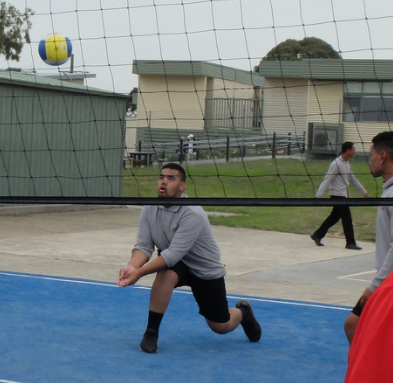

HUMANITIES
The Humanities include the study of Politics, Law, Economics, Business, Geography, History, and Philosophy.
The Humanities provide a framework for students to examine the complex processes that have shaped the modern world and investigate responses to different challenges including people’s interconnections with the environment.
In Politics, Law, Economics and Business, students explore the systems that shape society with a specific focus on legal and economic systems. Students learn about Australia’s role in global systems and are encouraged to appreciate democratic principles and to contribute as active, informed, and responsible citizens.
In History, Geography, and Philosophy, students explore the processes that have shaped, and continue to shape different societies and cultures, to appreciate the common humanity shared across time and distance, and to evaluate the ways in which humans continue to face different challenges.
PATHWAYS MAP FOR HUMANITIES
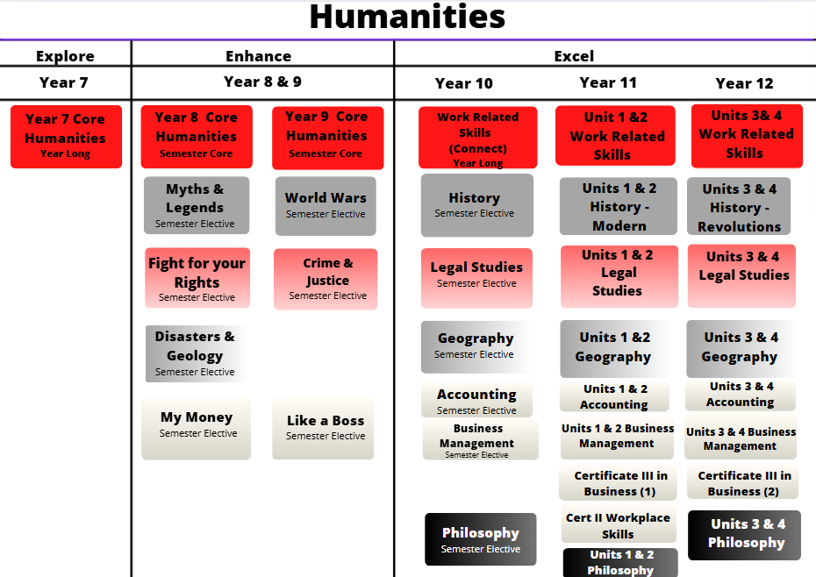

ACCOUNTING UNITS 1 & 2

Subject Description:
VCE Accounting explores the financial recording, reporting, analysis, and decision-making processes of a sole proprietor small business. Students study both theoretical and practical aspects of accounting. They collect, record, report, and analyse financial data, and report, classify, verify, and interpret accounting information, using both manual methods and information and communications technology (ICT). Students apply critical thinking skills to a range of business situations to model alternative outcomes and to provide accounting advice to business owners. In business decision-making, and financial as well as ethical considerations (incorporating social and environmental aspects) should be taken into account.

Unit 1: The Role of Accounting in Business
This unit explores the establishment of a business and the role of accounting in the determination of business success or failure. In this, it considers the importance of accounting information to stakeholders. Students analyse, interpret, and evaluate the performance of the business using financial and non-financial information. They use these evaluations to make recommendations regarding the suitability of a business as an investment. Students record financial data and prepare reports for service businesses owned by sole proprietors.

Unit 2: Accounting and Decision-Making for a Trading Business
In this unit, students develop their knowledge of the accounting process for sole proprietors operating a trading business, with a focus on inventory, accounts receivable, accounts payable and non-current assets. Students use manual processes and ICT, including spreadsheets, to prepare historical and budgeted accounting reports. Students analyse and evaluate the performance of the business relating to inventory, accounts receivable, accounts payable and non-current assets. They use relevant financial and other information to predict, budget, and compare the potential effects of alternative strategies on the performance of the business. Using these evaluations, students develop, and suggest to the owner, strategies to improve business performance.

Assessment:
- A folio of exercises and a case study (with an ICT focus).
- A feasibility investigation of a business venture (with an ICT focus).
- Structured questions and a written report.

Advice to Students:
There are no prerequisites for undertaking this subject, however, strengths in Maths and in organising information are desirable. It is highly recommended that students undertake VCE Accounting Units 1 & 2 before undertaking VCE Accounting Units 3 & 4.

Teachers to see for advice regarding this subject:
Ms. Naidoo and Ms. Noble


ACCOUNTING UNITS 3 & 4

Subject Description:
VCE Accounting explores the financial recording, reporting, analysis, and decision-making processes of a sole proprietor small business. Students study both theoretical and practical aspects of accounting. They collect, record, report, and analyse financial data, and report, classify, verify, and interpret accounting information, using both manual methods and information and communications technology (ICT). Students apply critical thinking skills to a range of business situations to model alternative outcomes and to provide accounting advice to business owners. In business decision-making, and financial as well as ethical considerations (incorporating social and environmental aspects) should be taken into account.

Unit 3 Financial Accounting for a Trading Business
This unit focuses on financial accounting for a trading business owned by a sole proprietor and highlights the role of accounting as an information system. Students use the double entry system of recording financial data and prepare reports using the accrual basis of accounting and the perpetual method of inventory recording. Students develop their understanding of the accounting processes for recording and reporting and consider the effect of decisions made on the performance of the business. They interpret reports and information presented in a variety of formats and suggest strategies to the owner to improve the performance of the business.

Unit 4 Recording, Reporting, Budgeting, and Decision-Making
In this unit, students use the double entry system of recording financial data and prepare reports using the accrual basis of accounting and the perpetual method of inventory recording. Both manual methods and ICT are used to record and report. Students extend their understanding of the recording and reporting process with the inclusion of balance day adjustments and alternative depreciation methods. They investigate both the role and importance of budgeting in decision-making for a business. They analyse and interpret accounting reports and graphical representations to evaluate the performance of a business. From this evaluation, students suggest strategies to business owners to improve business performance.

Assessment:
- A folio of exercises and a case study (with an ICT focus).
- A feasibility investigation of a business venture (with an ICT focus).
- Structured questions and a written report.

Advice to Students:
There are no prerequisites for undertaking this subject, however, strengths in Maths and organising information are desirable. It is highly recommended that students undertake VCE Accounting Units 1 & 2 before undertaking VCE Accounting Units 3 & 4.

Teachers to see for advice regarding this subject:
Ms. Naidoo and Ms. Noble

BUSINESS MANAGEMENT UNITS 1 & 2

Subject Description:
VCE Business Management examines the ways businesses manage resources to achieve objectives. This subject follows the process from the initial idea for a business concept, to planning and establishing a business, through to the day-to-day management of a business. It also considers changes that need to be made to ensure the continued success of a business. Students develop an understanding of the complexity of the challenges facing decision-makers in managing businesses and their resources.

Unit 1: Planning a Business
Businesses of all sizes are major contributors to the economic and social wellbeing of a nation. The ability of entrepreneurs to establish a business and the fostering of conditions under which new business ideas can emerge are vital for a nation’s wellbeing. Taking a business idea and planning how to make it a reality are the cornerstones of economic and social development. In this unit, students explore the factors affecting business ideas and the internal and external environments within which businesses operate, as well as the effect of these on planning a business.

Unit 2: Establishing a Business
This unit focuses on the establishment phase of a business. Establishing a business involves compliance with legal requirements as well as decisions about how best to establish a system of financial record keeping, staff the business, and establish a customer base. In this unit, students examine the legal requirements that must be met to establish a business. They investigate the essential features of effective marketing and consider the best way to meet the needs of the business in terms of staffing and financial record keeping.

Assessment:
- A case study analysis/media analysis.
- A business research report and the development of a business plan.
- An interview and a report on contact with business.
- A school-based, short-term business activity and a business simulation analysis.

Advice to Students:
Year 10 Business Management is a suggested prerequisite for undertaking this subject. Enhance subjects Like a Boss and My Money are also highly recommended. Students should have an interest in the study of business and a reasonable level of literacy. Business Management can lead to further studies in Business-related courses and is highly recommended for those who wish to pursue a career in business or open their own business.

Teachers to see for advice regarding this subject:
Ms. Dixit and Ms. Noble

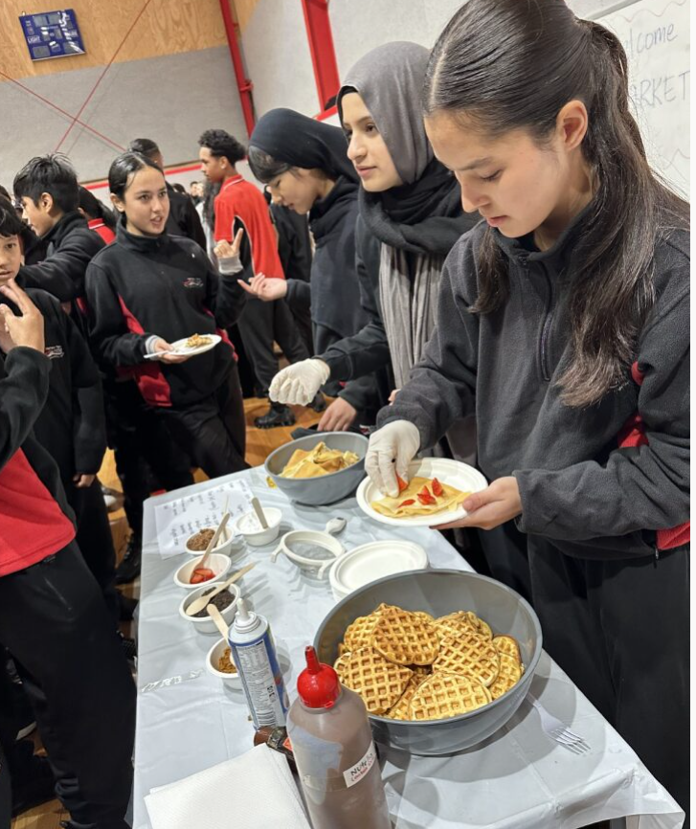

BUSINESS MANAGEMENT UNITS 3 & 4

Subject Description:
VCE Business Management examines the ways businesses manage resources to achieve objectives. This subject follows the process from the initial idea for a business concept, to planning and establishing a business, through to the day-to-day management of a business. It also considers changes that need to be made to ensure the continued success of a business. Students develop an understanding of the complexity of the challenges facing decision-makers in managing businesses and their resources.

Unit 3: Managing a Business
In this unit, students explore the key processes and considerations for managing a business efficiently and effectively to achieve business objectives. Students examine diverse types of businesses and their objectives and stakeholders. They investigate strategies to manage staff and business operations to meet objectives, and they develop an understanding of the complexities involved in managing a business. Students compare theoretical perspectives with current practice in contemporary Australian and global business case studies.

Unit 4: Transforming a Business
Businesses are under constant pressure to adapt and change to meet their objectives. In this unit, students consider the importance of reviewing key performance indicators to determine current performance and the strategic management necessary to position a business for the future. Students study a theoretical model for undertaking change and consider a variety of strategies to manage change in the most efficient and effective way. They investigate the importance of effective management and leadership in change management. Students evaluate business practice against theory.

Assessment:
- A case study analysis/ media analysis.
- A business research report related to the management of employees.
- A report that analyses the key characteristics of successful businesses.
- Structured questions.

Advice to Students:
VCE Business Management Units 1 & 2 is a prerequisite for undertaking this subject. Students should have an interest in the study of business and a reasonable level of literacy. Business Management can lead to further studies in Business-related courses and is highly recommended for those who wish to pursue a career in business or open their own business in the future.

Teachers to see for advice regarding this subject:
Ms. Dixit and Ms. Noble

GEOGRAPHY UNITS 1 & 2

Subject Description:
The study of Geography allows students to explore, analyse, and come to understand the characteristics of places that make up our world. Geographers are interested in key questions concerning places and geographic phenomena: What is there? Where is it? Why is it there? What are the effects of it being there? How is it changing over time? Students explore these questions through fieldwork, the use of geospatial technologies, and investigation of a wide range of secondary sources. These methods underpin the development of a unique framework for understanding the world, enabling students to appreciate its complexity, the diversity and interactions of its environments, economies and cultures, and the processes through which these are transformed.

Unit 1: Hazards and Disasters
This unit investigates how hazards represent the potential to cause harm to people and or the environment, whereas disasters are defined as serious disruptions of the functionality of a community. Hazards include a range of situations, including those within local areas, such as coastal erosion, to regional and global hazards, such as drought and infectious disease. Students examine hazards, considering their causes and impacts, human responses, and the interconnections between human activities and natural phenomena, including the impact of climate change.

Unit 2: Tourism: issues and challenges
In this unit, students investigate the characteristics of tourism, with particular emphasis on where it has developed, its various forms, how it has changed and continues to change, and its impacts on people, places, and environments. The study of tourism on a local, regional, and global scale, emphasises the interconnection within and between places as well as the impacts, issues, and challenges that arise from various forms of tourism.

Assessment:
- Fieldwork and fieldwork reports.
- Analysis of geographic data and structured questions.
- A research report and case studies.

Advice to Students:
Enhance Geography subjects and Year 10 Geography are highly recommended before undertaking VCE Geography. Students should have a reasonable level of literacy and numeracy skills as Geography involves the analysis and discussion of data. VCE Geography can lead to various fields of study and career pathways, including Geology, Earth Science, and Environmental Studies.

Teachers to see for advice regarding this subject:
Ms. Riley



GEOGRAPHY UNITS 3 & 4

Subject Description:
The study of Geography allows students to explore, analyse, and come to understand the characteristics of places that make up our world. Geographers are interested in key questions concerning places and geographic phenomena: What is there? Where is it? Why is it there? What are the effects of it being there? How is it changing over time? Students explore these questions through fieldwork, the use of geospatial technologies, and investigation of a wide range of secondary sources. These methods underpin the development of a unique framework for understanding the world, enabling students to appreciate its complexity, the diversity and interactions of its environments, economies and cultures, and the processes through which these are both formed and transformed.

Unit 3: Changing the Land
This unit focuses on two investigations of geographical change: change to land cover and change to land use. Land cover includes biomes such as forest, grassland, tundra, bare lands, and wetlands, as well as land covered by ice and water. Land cover is the natural state of the biophysical environment, developed over time because of the interconnection between climate, soils, landforms, flora and fauna, and, increasingly, interconnections with human activity. Natural land cover is altered by many processes such as geomorphological events, and climate change.

Unit 4: Human Population: Trends and Issues
In this unit, students investigate the geography of human populations. They explore the patterns of population change, movement, and distribution, and how governments, organisations, and individuals have responded to those changes in various parts of the world. Students study population dynamics before undertaking an investigation into two significant population trends arising in various parts of the world. They examine the dynamics of populations and their environmental, economic, social, and cultural impacts on people and places.

Assessment:
- Case studies analysing population issues.
- Fieldwork and fieldwork reports.
- Research reports and analyses of geographic data.

Advice to Students:
It is strongly recommended that students successfully complete VCE Geography Units 1 & 2 prior to undertaking this study.

Teachers to see for advice regarding this subject:
Ms. Riley

HISTORY UNITS 1 & 2 – MODERN HISTORY

Subject Description:
The study of VCE History assists students to understand themselves, others, and the contemporary world. Students develop social, political, economic, and cultural understandings of the conditions and features that have shaped the present. They explore continuity and change; the world is not as it has always been, and it will be subject to change in the future. In this sense, history is relevant to contemporary issues. It fosters an understanding of human agency and informs decision making in the present. It equips students to enhance critical thinking, take a well-versed position on how the past informs the present and future, and contributes to them becoming informed and engaged citizens.

Unit 1: Change and Conflict
In this unit, students investigate WWI as a significant turning point in modern history, including its post-war treaties’ influence in reshaping the world with new nation states, borders, movements, ideologies, and power structures. They examine how fascist governments used education, propaganda, and the military to impose totalitarian controls and exclusions on people. They will analyse how these post-war treaties and conditions shaped the rise of Nazi Germany, the nature of the USSR, the militarisation of Japan, the implementation of US isolationism, and the partitioning of the Middle East after the collapse of the Ottoman Empire.

Unit 2: The Changing World Order
In this unit, students investigate the nature of the Cold War and challenges to social, political, and economic structures and systems of power in late the 20th and early 21st centuries. They explore the failures of the United Nations and the Universal Declaration of Human Rights, along with how the competing ideologies of communism and democracy fuelled the power-struggles of the Cold War, including the nuclear-arms race, the Korean War, the Vietnam War, and further turmoil in the Middle East. Students analyse the political connections between these wars of the past and more contemporary conflicts such as the rise of al-Qaeda, and the US invasions of Afghanistan and Iraq.

Assessment:
- Evaluation of historical sources.
- Essays that explain and analyse significant historical moments.
- Inquiry research assignments.

Advice to Students:
A study of Enhance and Year 10 History is highly recommended prior to studying VCE History Units 1 & 2. Students should have a confident level of literacy as History involves the analysis and discussion of a wide variety of written information. VCE History can lead to different fields of study and career pathways, including Politics, and Sociology.

Teachers to see for advice regarding this subject:
Ms. Riley and Ms. Fiddes

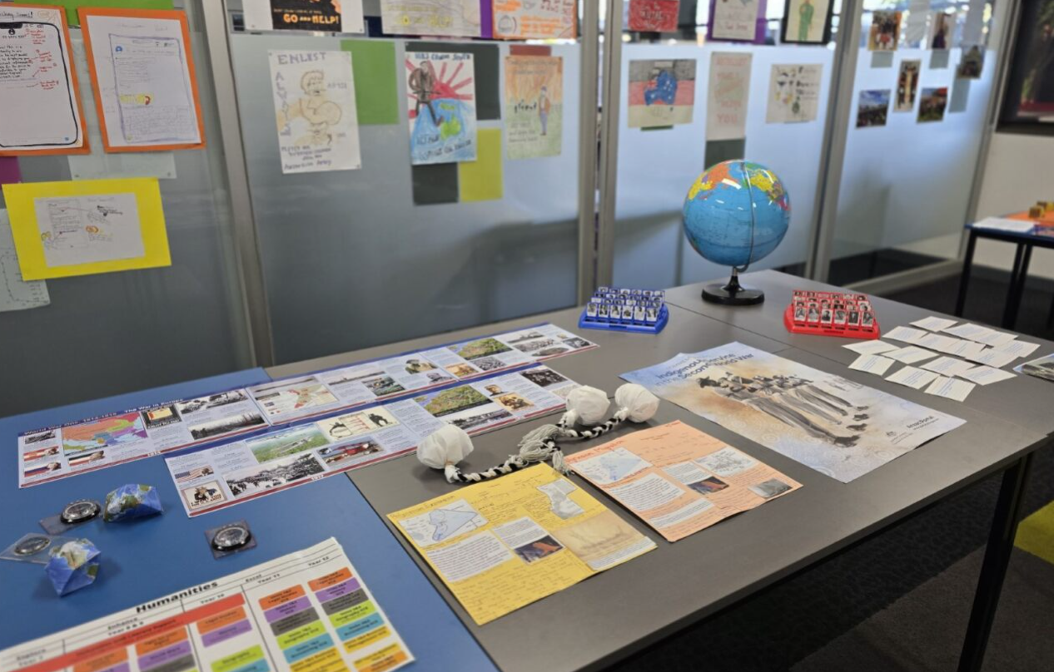

HISTORY UNITS 3 & 4 – REVOLUTIONS

Subject Description:
The study of VCE History assists students to understand themselves, others, and the contemporary world. Students develop social, political, economic, and cultural understandings of the conditions and features that have shaped the present. They explore continuity and change; the world is not as it has always been, and it will be subject to change in the future. In this sense, history is relevant to contemporary issues. It fosters an understanding of human agency and informs decision making in the present. It equips students to enhance critical thinking, take a well-versed position on how the past informs the present and future, and contributes to them becoming informed and engaged citizens.

Unit 3: Causes of Revolution
- The American Revolution (1754–4 July 1776).
- The Russian Revolution (1896– 26 October 1917).
This unit focuses on the long-term causes and short-term triggers of revolution in America and Russia. Students evaluate how revolutionary outbreaks were caused by the interplay of significant events, ideologies, individuals, and popular movements, and how these were directly or indirectly influenced by the political, social, economic, cultural, and environmental conditions of the time. Students analyse significant events and evaluate how particular conditions profoundly influenced and contributed to the outbreak of revolution.

Unit 4: Consequences of Revolution
- The American Revolution (4 July 1776–1789).
- The Russian Revolution (26 October 1917–1927).
In this unit, students evaluate the extent to which the consequences of the revolution-maintained continuity and/or brought about change to society. Students analyse the significant challenges that confronted the new regime after the initial outbreak of revolution. They also evaluate the success and outcomes of the new regime’s responses to these challenges, and the extent to which the revolution resulted in dramatic and wide-reaching political, social, cultural, and economic change, progress, or decline.

Assessment:
- Evaluation of historical sources.
- An inquiry research assignment.
- Extended responses and essays

Advice to Students:
A study of Enhance subjects in History is highly recommended before undertaking VCE History. Students should have a confident level of literacy as History involves the analysis and discussion of a wide variety of written information.

Teachers to see for advice regarding this subject:
Ms. Riley

LEGAL STUDIES UNITS 1 & 2

Subject Description:
VCE Legal Studies examines the institutions and principles that are essential to the Australian legal system. Students develop an understanding of the rule of law, lawmakers, legal institutions, the relationship between the people and the Australian Constitution, the protection of rights in Australia, and the Victorian justice system. Through applying knowledge of legal concepts and principles, students develop an ability to use legal reasoning to argue a case for or against a party in a civil or criminal matter. They analyse both the extent to which our legal institutions are effective, and the extent to which the Victorian justice system achieves the principles of justice.

Unit 1: The Presumption of Innocence
In this unit, students develop an understanding of legal foundations, such as the distinct types and sources of law, the characteristics of an effective law, and an overview of parliament and the courts. Students are introduced to, and apply, the principles of justice. They investigate fundamental concepts of criminal law and apply these to different scenarios to determine whether an accused may be found guilty of a crime. In doing this, students develop an appreciation of the way legal principles and information are used in making reasoned judgments and conclusions about the culpability of an accused.

Unit 2: Wrongs and Rights
In this unit, students investigate crucial concepts of civil law and apply these to different scenarios to determine whether a party is liable in a civil dispute. Students explore different areas of civil law, and the methods and institutions that may be used to resolve a civil dispute and provide remedies. Students also develop an understanding of how human rights are protected in Australia and possible reforms to the protection of rights, and they investigate a contemporary human rights issue in Australia, with a specific focus on one case study.

Assessment:
- Structured questions and a folio of exercises.
- Written research reports.
- Essays and media analyses.

Advice to Students:
Year 10 Legal Studies is a suggested prerequisite for undertaking this subject and the Enhance subject, Crime and Justice, is also highly recommended. Students should have an interest in studying the law and a reasonable level of literacy due to the complexity of language required. Legal Studies can lead to further studies in law and justice related courses and is highly recommended for those who wish to pursue a career in law or the justice system.

Teachers to see for advice regarding this subject:
Ms. Ho and Ms. Noble



LEGAL STUDIES UNITS 3 & 4

Subject Description:
VCE Legal Studies examines the institutions and principles that are essential to the Australian legal system. Students develop an understanding of the rule of law, lawmakers, legal institutions, the relationship between the people and the Australian Constitution, the protection of rights in Australia, and the Victorian justice system They analyse both the extent to which our legal institutions are effective, and whether the Victorian justice system achieves the principles of justice.

Unit 3: Rights and Justice
In this unit, students examine the methods and institutions in the criminal and civil justice system and consider their appropriateness in determining criminal cases and resolving civil disputes. Students consider the Magistrates’ Court, County Court, and Supreme Court within the Victorian court hierarchy. Students explore topics such as the rights available to an accused and to victims in the criminal justice system, the roles of the judge, jury, legal practitioners and the parties, and the ability of sanctions and remedies to achieve their purposes. Students investigate the extent to which the principles of justice are upheld in the justice system.

Unit 4: The People, the Law and Reform
In this unit, students explore how the Australian Constitution establishes the law-making powers of the Commonwealth and state parliaments, and how it protects the Australian people through structures that act as a check on parliament in law-making. Students develop an understanding of the significance of the High Court in protecting and interpreting the Australian Constitution. They investigate parliament and the courts, and the relationship between the two in law-making, and consider the roles of the individual, the media, and law reform bodies in influencing changes to the law, and past and future constitutional reform.

Assessment:
- Structured questions and a folio of exercises.
- Written research reports.
- Essays and case studies.

Advice to Students:
VCE Legal Studies Units 1 & 2 is a prerequisite for undertaking this subject. Students should have an interest in studying the law and a reasonable level of literacy due to the complexity of language required. Legal Studies can lead to further studies in law and justice related courses and is highly recommended for those who wish to pursue a career in law or the justice system.

Teachers to see for advice regarding this subject: M
Ms. Ho and Ms. Noble

PHILOSOPHY UNITS 1 & 2

Subject Description:
Philosophy is a captivating discipline that invites students to critically examine fundamental questions about existence, knowledge, ethics, and the nature of reality. Through philosophical inquiry, students develop their critical thinking, analytical reasoning, and argumentation skills, enabling them to engage with complex concepts and grapple with profound philosophical dilemmas.

Unit 1: Philosophy, existence and knowledge
In this unit, students embark on a fascinating journey into the world of philosophy, exploring various branches such as metaphysics, epistemology, and ethics. They delve into foundational philosophical questions, including the nature of reality, the limits of human knowledge, and the principles that guide ethical decision-making. Through engaging discussions and thought-provoking readings, students develop their ability to analyse philosophical arguments, identify logical fallacies, and construct well-reasoned arguments of their own. As students learn to think philosophically, appropriate examples of philosophical viewpoints and arguments, both contemporary and historical, are used to support, stimulate and enhance their thinking about central concepts and problems. At least one of these examples will be from a primary philosophical text. As students investigate central concepts and problems, they also consider the relationship between philosophical problems and relevant contemporary issues.

Unit 2: Questions of Value
In Unit 2, students explore questions in relation to different categories of value judgement within the realms of morality, political and social philosophy and aesthetics. Students also explore ways in which viewpoints and arguments in value theory can inform and be informed by contemporary debates. They study at least one primary philosophical text, using the complete text or an extract, and develop a range of skills including formulating philosophical questions and developing philosophical perspectives.

Assessment:
- Essays, written analyses, research tasks.
- Short-answer responses and written reflections.
- Oral and multimedia presentations, oral and written dialogues.

Advice to Students:
Year 10 Philosophy is a suggested prerequisite for undertaking this subject, and the Enhance subject Fight for your Rights, is highly recommended before taking this subject. Students should have an interest in studying big ideas around knowledge, reality, and existence and have a reasonable level of literacy due to the complexity of language required. Philosophy can lead to further studies in journalism and writing, business and consulting, and law, justice, and politics related courses.

Teachers to see for advice regarding this subject:
Ms. Phelan



PHILOSOPHY UNITS 3 & 4

Subject Description:
Philosophy is a captivating discipline that invites students to critically examine fundamental questions about existence, knowledge, ethics, and the nature of reality. Through philosophical inquiry, students develop their critical thinking, analytical reasoning, and argumentation skills, enabling them to engage with complex concepts and grapple with profound philosophical dilemmas.

Unit 3: The Good Life
This unit considers the crucial questions of what it is for a human to live well. It explores questions of relevance to our own good lives – what is happiness? What role should pleasure, and self-disciplines, friendship and love play in the good life? – as well as questions regarding the good life as it may be understood within the context of our relationships with others beyond our immediate communities. Students consider the implications of adopting perspectives, viewpoints and arguments for questions of relevance to contemporary living, such as our relationship with those in our immediate communities, non-human animals and the broader natural world.
Students engage with the set texts to develop perspectives on questions relating to the good life, including questions of relevance to contemporary living. Through critical reflection on ideas, perspectives, viewpoints and arguments, students develop and defend their own philosophical positions.

Unit 4: On Believing
This unit focuses on interpersonal aspects of belief and belief formation, considering what it means to believe well by examining the nature of belief and the grounds for accepting or rejecting beliefs. Students explore what our obligations are in relation to belief; when we should adjust or change our beliefs; and to what extent we should take responsibility for fostering the good beliefs of others and the conditions that make then possible. Through so doing, students are invited to consider the interrelationship between believing well and living well.

Assessment:
- Essays, written analyses, research tasks.
- Short-answer responses, written reflections.
- Oral and multimedia presentations, oral and written dialogues.

Advice to Students:
Units 1 & 2 Philosophy is a prerequisite for undertaking this subject. Students should have an interest in studying the big ideas around knowledge, reality, and existence and have a reasonable level of literacy due to the complexity of language required. Philosophy can lead to further studies in journalism and writing, business and consulting, law, and justice related courses.

Teachers to see for advice regarding this subject:
Ms. Phelan

POLITICS UNITS 1 & 2

Subject Description:
VCE Politics is the study of contemporary power, conflict, and cooperation in a world that is characterised by unpredictability and constant change. In this study, students investigate contemporary issues of conflict, political stability, and change across the world. They consider how national and global political actors respond to issues and crises such as national political reform, climate change, violent conflicts, human rights, sustainability and development, inequality, and global economic instability. Students analyse the sources and forms of power available to these political actors and the consequences of their use. Throughout this study, students examine Australia’s place in the region and globally.

Unit 1: Politics, Power, and Political Actors
In Unit 1, students consider the concept of power through examining why and how political power is used, with special attention to the way national and global political actors exercise power and the consequences of that use. Students examine how power is used by political actors to achieve their interests. They investigate the power of global actors that use power across national and regional boundaries to achieve their interests.

Unit 2: Democracy: Stability and Change
In this unit, students investigate the principles of democracy and assess the degree to which these principles are expressed, experienced, and challenged. They consider democratic principles in the Australian context and complete an in-depth study of a political issue or crisis that inherently challenges basic democratic ideas or practice. Students investigate the degree to which global political actors and trends can challenge, inhibit, or undermine democracy, and evaluate the political significance of these challenges.

Assessment:
- A political inquiry.
- Analysis and evaluation of sources.
- A political debate
- Short answer questions, extended responses, and essays.

Advice to Students:
Students are recommended to have studied Fight for Your Rights! and Australian Political systems. They are highly recommended to have studied Year 10 Philosophy and Year 10 World Wars before undertaking this subject.

Teachers to see for advice regarding this subject:
Ms. Riley



POLITICS UNITS 3 & 4

Subject Description:
VCE Politics is the study of contemporary power, conflict, and cooperation in a world that is characterised by unpredictability and constant change. In this study, students investigate contemporary issues of conflict, political stability, and change across the world. They consider how national and global political actors respond to issues and crises such as national political reform, climate change, violent conflicts, human rights, sustainability and development, inequality, and global economic instability. Students analyse the sources and forms of power available to these political actors and the consequences of their use. Throughout this study, students examine Australia’s place in the region and globally.

Unit 3: Global Cooperation and Conflict
In this unit, students investigate a crisis that poses challenges to the global community. Students investigate an issue of global scale, such as climate change, global economic instability, or ‘weapons of mass destruction’. Students examine the causes and consequences of a humanitarian crisis that has crossed state boarders and requires an emergency response. This crisis is chosen from the areas of human rights, armed conflict, or the mass movement of people. They consider the causes of this crisis and investigate its consequences on a global level.

Unit 4: Power in the Indo-Pacific
In this unit, students investigate the strategic competition for power and influence in the Indo-Pacific region. They consider the interests of global actors within the region, including the challenges to regional stability. Students develop their understanding of power and national interests through an examination of one state’s interests and actions. Students examine Australia’s strategic interests and actions in the region and consider their consequences.

Assessment:
- A political inquiry.
- Analysis and evaluation of sources.
- Extended responses and essays.
- Short answer questions.

Advice to Students:
Units 1 & 2 Politics is a prerequisite for undertaking this subject Students are recommended to have studied Fight for Your Rights! and Australian Political systems. They are highly recommended to have studied Year 10 Philosophy and Year 10 World Wars before undertaking this subject.

Teachers to see for advice regarding this subject:
Ms. Riley

VCE VM WORK RELATED SKILLS UNITS 1 & 2

Subject Description:
VCE Vocational Major, Work Related Skills (WRS), examines a range of knowledge, skills, and capabilities relevant to achieving individual career and educational goals. Students develop a broad understanding of workplace environments and the future of work and education. Students apply this knowledge to engage in theoretical and practical planning and decision-making linked to a successful transition to their desired pathway. Students build strategies for conducting research as well as for presenting their research findings, seeking feedback, and refining their goals.

Unit 1: Careers and Learning for the Future
In this unit, students evaluate information relating to employment. They consider the reliability and credibility of information sources and the scope of labour market information available, including skills shortages and industry growth areas, emerging industries, and current and future trends. Students apply strategies to improve planning and decision-making related to gaining employment. They acquire research skills, and they collate evidence and artefacts relating to their future employment prospects. In this area of study, students consolidate their knowledge and understanding of potential future careers, and they establish an ability to articulate their personal aspirations, skills, and capabilities.

Unit 2: Workplace Skills and Capabilities
In this unit, students consider the changing nature of work and the impact this has on future career pathways. They distinguish between transferable skills that are valued across industries, and the specialist and technical skills required for specific industries. They recognise how personal capabilities contribute to future success, and they demonstrate their own skills and capabilities through artefacts and evidence. Students investigate the role of ongoing education, training, and development in the acquisition of essential and specialist skills. They explore how these skills can be applied across different careers and industries.

Assessments:
- A record of data analysis.
- A research assignment.
- A career and education research report and presentation.
- A career action plan.
- Mock interviews.
- Cover Letter and resumé.

Advice to Students:
The VCE Vocational Major is an option for students who wish to develop the skills and capabilities needed to move into apprenticeships, traineeships, further education and training, or directly into the workforce.

Teachers to see for advice regarding this subject:
Ms. Tregidga and Ms. Wood

VCE VM WORK RELATED SKILLS UNITS 3 & 4

Subject Description:
VCE Vocational Major, Work Related Skills (WRS), examines a range of knowledge, skills, and capabilities relevant to achieving individual career and educational goals. Students develop a broad understanding of workplace environments and the future of work and education. Students apply this knowledge to engage in theoretical and practical planning and decision-making linked to a successful transition to their desired pathway. Students build strategies for conducting research as well as for presenting their research findings, seeking feedback, and refining their goals.

Unit 3: Industrial Relations, Workplace Environment, and Practice
In this unit, students are introduced to the features and characteristics of a healthy, collaborative, and harmonious workplace. They examine the concept of workplace culture and consider the characteristics of work–life balance. Students analyse the interconnection between employee and employer expectations and understand the importance of diversity and inclusion in the workplace. Students explore workplace relations, including the National Employment Standards, and methods of determining pay and conditions. They consider the characteristics and legal consequences of workplace bullying, workplace discrimination, and workplace harassment, and gain an overview of the common legal issues experienced in the workplace. Students examine processes to address and resolve workplace disputes. They consider their role, and the role of teams, in the workplace.

Unit 4: Portfolio Preparation and Presentation
In this unit, students explore the purpose of a portfolio and consider their intended audiences and uses across different contexts. They discuss and compare the features and uses of physical and digital portfolios and examine the characteristics of a high-quality portfolio. Students understand how to prepare a portfolio proposal and how to plan the development of a portfolio. Students apply this knowledge through engagement with the process of developing and formally presenting their completed portfolio in a panel style interview. Students use a range of verbal, written, and practical strategies to communicate their skills and knowledge, including visual appeal, and varied and appropriate content.

Assessments:
- Case studies, presentations, analytical and evaluative reports.
- Research assignment.
- Presentation of a portfolio related to a target industry.
- Evaluation of presented portfolio.

Advice to Students:
The VCE Vocational Major is an option for students who wish to develop the skills and capabilities needed to move into apprenticeships, traineeships, further education and training, or directly into the workforce.

Teachers to see for advice regarding this subject:
Ms. Tregidga and Ms. Wood

VPC WORK RELATED SKILLS UNITS 1 & 2
Subject Description:
VPC Work Related Skills (WRS) enables the development of knowledge, skills, and personal attributes relevant to further education and employment. The study also provides practical, authentic opportunities for students to develop employability skills.
Unit 1:
This unit examines the skills, capabilities, and personal attributes required within the workplace. Students develop an understanding of how employability skills and capabilities can be applied in a variety of settings. Students examine employment opportunities that exist within the workplace and how qualifications and further study can increase the opportunities that may be available. They identify and describe employee and employer rights and responsibilities in the workplace relating to pay and conditions within a selected setting. Students interview an employee about training and employment experiences and present findings supported by appropriate technology. Students examine the process of identifying an employment opportunity and writing a resume and cover letter that includes information relevant to the opportunity.

Unit 2:
In Unit 2, students consider the distinction between essential employability skills, specialist and technical work skills, and personal capabilities. They collect evidence and artefacts relating to their personal skills and capabilities and promote them through resumes, cover letters, and interview preparation. Students identify and describe employee and employer rights and responsibilities in the workplace relating to pay and conditions within a selected setting. They develop their communication and technology skills through reporting on small-scale work-related activities and learn about the structure and conventions of writing a report for a small-scale work-related activity. Students reflect on how they can improve future work-related outcomes.

Assessments:
- Creation of a cover letter and resumé.
- Participation in a mock interview.
- Reports, case studies, and a project plan.
- Planned responses to interview questions.

Advice to Students:
The VPC is a standards-based certificate designed to develop and extend pathways for young people not ready to complete the VCE or VCE VM. It is suitable for students whose previous schooling experience may have been disrupted for a variety of reasons, including students with additional needs and students who have missed significant periods of learning.

Teachers to see for advice regarding this subject:
Ms. Tregidga and Ms. Wood

VPC WORK RELATED SKILLS UNITS 3 & 4
Subject Description:
VPC Work Related Skills (WRS) enables the development of knowledge, skills, and personal attributes relevant to further education and employment. The study also provides practical, authentic opportunities for students to develop employability skills.

Unit 3:
This unit develops students’ communication and technology skills through reporting on a small-scale work-related activity. Students learn about the structure and conventions of writing a report and apply this format to describe the planning, implementation, and evaluation of the small-scale work-related activity. Students distinguish between a safe and an unsafe workplace and explore how they can address unlawful practices. They identify unlawful workplace practices including bullying, harassment, and discrimination, and internal and external processes to report unsafe practices. Students examine employee responsibilities in the workplace and present findings. They explore physical health and safety in the workplace. They describe strategies to reduce harm in a workplace or environment, including processes to assess risk, analyse safety, report hazards and harms, and make recommendations to improve safety in the workplace.

Unit 4:
This unit provides students with an overview of potential employment and educational pathway options, to support the development and refinement of a future pathway plan. Students explore strategies to apply when collecting and assessing information about employment opportunities. Students apply knowledge and skills by preparing a job application in response to a job advertisement, including a resume and cover letter. Students prepare for future job interviews. They engage with sources to identify possible interview questions, plan suitable responses, and prepare relevant questions to ask a potential employer. Students participate in a mock interview and apply strategies to reflect on and evaluate performance to improve future employment prospects.

Assessments:
- An oral presentation.
- A research task.
- A risk management plan.
- A mock interview and a career action plan.

Advice to Students:
The VPC is a standards-based certificate designed to develop and extend pathways for young people not ready to complete the VCE or VCE VM. It is suitable for students whose previous schooling experience may have been disrupted for a variety of reasons, including students with additional needs and students who have missed significant periods of learning.

Teachers to see for advice regarding this subject:
Ms. Tregidga and Ms. Wood

LANGUAGES

Learning languages broadens your horizons about the personal, social, cultural, and employment opportunities that are available in an increasingly interconnected and interdependent world. The interdependence of countries and communities requires people to negotiate experiences and meanings across languages and cultures. A bilingual or plurilingual capability is the norm in most parts of the world.
For students who already speak one or more languages, there are opportunities in the Languages Domain for them to engage in subjects that make the most of those skills. Learning another language helps develop essential areas of the brain. Research shows that it also improves memory, concentration, creativity, and critical thinking skills.
Learning another language means more than just memorising unfamiliar words. Languages all use different systems, so when we learn a new language, we compare it with English. This deepens understanding of English and significantly improves English language skills. It also grants the skill to learn other new languages more easily.
To know more about the benefits of learning a new language, watch this YouTube video:
https://www.youtube.com/watch?v=dtBxBHBN8nk – Why learn a language?

LANGUAGES PATHWAYS MAP
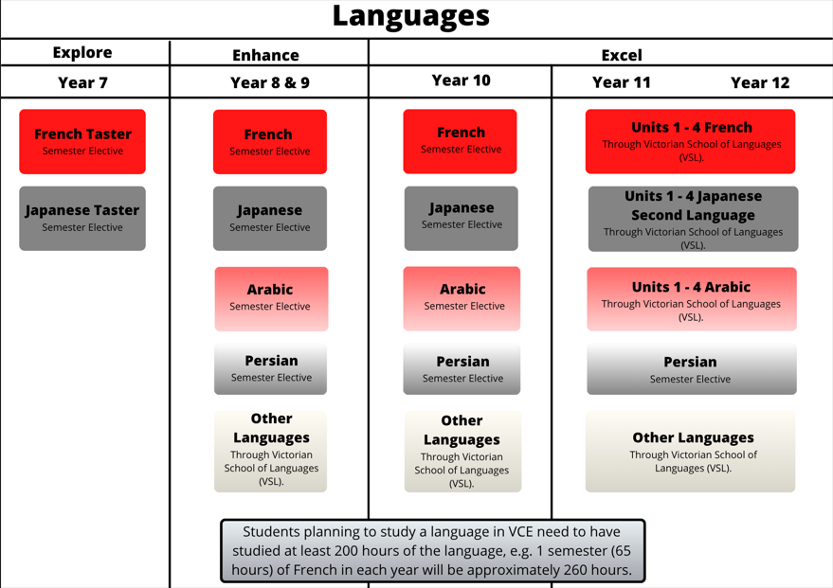
The subjects we can offer vary based on staff expertise and availability. Student choice determines the Languages that run.

VCE LANGUAGES
VCE Languages will not be offered on-site at Hampton Park Secondary College for 2025. However, we can make provisions for students interested in undertaking languages via Distance Education with the VSL.

If you are interested in studying a language at VCE, please speak with Ms. Attard.

You can also contact the Victorian School of Languages (VSL). The closest VSL centres are Hampton Park Secondary College, Dandenong High School, and Berwick College for face-to-face classes. The VSL also offers distance education classes. You can find out more information at the VSL website: https://www.vsl.vic.edu.au/.

Advice to Students:
Learning a language is an ongoing process. If you are considering undertaking VCE Languages, you should aim to study your Language for a minimum of 200 hours before moving into VCE Units 1 & 2. VCE Languages is not for beginners to a language. Background speakers are encouraged to pick up a language in VCE. Please be aware, you will be required to read passages and write short essays in your target language.

VCE-Baccalaureate: Students who complete Units 3 & 4 in any Language, complete Mathematical Methods, or Specialist Mathematics, and who receive a study score of 33 in EAL or 30 in English or English Language or Literature will receive the VCE-Baccalaureate

Teachers to see for advice regarding this subject:
Ms. Attard



MATHEMATICS

Mathematics provides students with access to important mathematical ideas, knowledge, and skills that they will draw on in their personal and work lives. Mathematical ideas are constantly developing as digital technologies provide new tools for mathematical exploration and invention.
While the usefulness of mathematics for modelling and problem-solving is well known, mathematics also has a fundamental role in both enabling and sustaining cultural, social, economic, and technological advances and empowering individuals to become critical citizens.
Number and Algebra, Measurement and Space, Statistics and Probability are common aspects of most people’s mathematical experience in everyday personal, study, and work situations. Equally important are the essential roles that algebra, functions and relations logic, mathematical structure, and working mathematically play in people’s understanding of the natural and human worlds, and the interaction between them.
The mathematics curriculum focuses on developing increasingly sophisticated and reﬁned mathematical understanding, ﬂuency, reasoning, modelling, and problem-solving.

MATHEMATICS PATHWAYS MAP
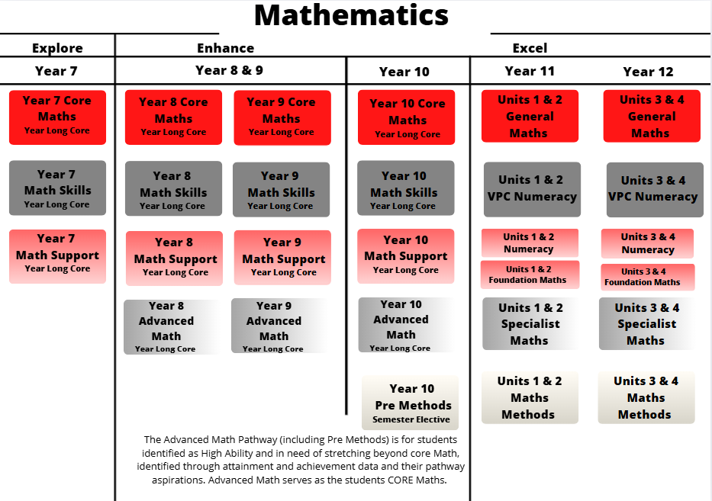

For a more detailed Pathways Map showing how students can progress through the years, please see the Appendix items.

VCE VM NUMERACY UNITS 1 - 4

Subject description:

VCE Vocational Major (VM) Numeracy develops the mathematical knowledge and skills students need for work, personal life, and active participation in the community. Across Units 1–4, students apply maths to practical, real-world contexts such as budgeting, design, measurement, data, and planning projects.

Units 1-4 of the course focuses on problem-solving, interpreting and communicating mathematical information, and making informed decisions using evidence. Students work independently and collaboratively on authentic tasks that connect maths to their vocational and future pathways. Students utilise the problem-solving cycle and the mathematical toolkit to investigate eight areas of numeracy across six numeracy contexts: Personal, civic, financial, health, vocational and recreational.

Unit 3
- Area of Study 1: Number.
- Area of Study 2: Shape.
- Area of Study 3: Quantity and measures.
- Area of Study 4: Relationships.
Unit 4
- Area of Study 5: Dimension and direction.
- Area of Study 6: Data.
- Area of Study 7: Uncertainty.
- Area of Study 8: Systematics.

Assessment:
Students can show their understanding through their coursework and participation in learning activities. Students complete a financial portfolio based on their future careers, create ‘mini cities’ using scaling and measurement, design board games utilising probability principles, plan a ‘prison escape’ using dimension and direction and collect and analyse data for an issue of their choice.

Pathways:
After completing VCE VM Numeracy, students are equipped with the practical maths skills needed for employment, apprenticeships, traineeships, and further vocational education. The course builds confidence in applying maths to real-world situations, preparing students for TAFE studies, trade qualifications, and workplace training programs. It also supports pathways into community, business, and service industries where problem-solving and numeracy are essential.
Teachers to see for advice regarding this subject:
Ms. Powell & Ms. Marshall

VPC NUMERACY UNITS 1-4

Subject description:

VPC Numeracy is a specialised program that helps students develop practical maths skills for everyday life, work, and community participation. This subject focuses on using number, measurement, and data to solve real-world problems and make informed decisions with confidence. Students will be identified for this program based on their needs.
Units 1-4 focus on supporting and enabling students to develop their numeracy skills and practices to make sense of their daily personal, public, and future vocational lives, and in their local community. Each module describes the range of contexts that are the starting point for developing the students’ numeracy and underpinning their mathematical skills. This range covers four numeracies where foundational mathematical skills are situated and embedded: personal, financial, health & recreational and civic. Students will utilise the problem-solving cycle and the mathematical toolkit to engage in the eight learning areas of numeracy.

Module 1 - Personal numeracy: Location and systematics
Module 2 - Financial numeracy: Number and change
Module 3 - Health and recreational numeracy: Shape, quantity and measures
Module 4 - Civic numeracy: Data and likelihood

Assessment:
VPC students can show their understanding through their coursework and participation in learning activities. Some examples of how VPC students can show their learning include community projects, hands-on application, the creation of work portfolios, case study responses and written responses.

Pathways:
The VPC is a standards-based certificate designed to develop and extend pathways for young people who are not ready to complete the VCE or VCE VM. It is suitable for students whose previous schooling experience may have been disrupted for a variety of reasons, including students with additional needs and students who have missed significant periods of learning. Students can participate in further study or enter the workforce with a VPC certificate.

Teachers to see for advice regarding this subject:
Ms. Powell
VCE FOUNDATION MATHS UNITS 1 - 4
Subject description:
VCE Foundation Mathematics focuses on developing essential mathematical knowledge and skills for everyday life, work, and community participation. The course is designed for students who benefit from practical, applied learning and aims to build confidence in using maths to solve real-world problems.
Across Units 1–4, students explore number, measurement, shape, data, and financial mathematics through hands-on and relatable contexts. Foundation Mathematics supports pathways into employment, apprenticeships, traineeships, and further vocational study by strengthening numeracy for practical and personal success.
Units 1 & 2:
Foundation Mathematics Units 1 and 2 focus on developing essential numeracy skills for everyday life, work, and community participation. Students explore number, measurement, shape, and data through practical, hands-on activities. The course builds confidence in applying maths to real-world contexts such as budgeting, planning, and interpreting information, preparing students for further vocational study or employment.

Units 3 & 4:
Foundation Mathematics Units 3 and 4 extend students’ ability to use mathematics in practical and applied ways. Students analyse everyday situations involving financial literacy, design, data, and measurement, and apply problem-solving strategies to make informed decisions. The course emphasises communication, reasoning, and the use of technology to solve meaningful problems, supporting pathways into TAFE, apprenticeships, and a range of workplaces.

Assessment:
  - Modelling tasks, problem-solving tasks, and mathematical investigations.
  - Portfolios, assignments, and tests.
  - Solutions to sets of worked questions.
  - Summary notes or review notes.

Pathways:
Completing VCE Foundation Mathematics prepares students for a wide range of practical pathways after school. The subject builds confidence using math’s in real-life situations, supporting transitions into employment, apprenticeships, traineeships, and TAFE or vocational courses. Students develop problem-solving, budgeting, and measurement skills that are valuable in industries such as construction, hospitality, retail, and community services.

Teachers to see for advice regarding this subject:
Ms. Fernando & Ms. Zerman

GENERAL MATHEMATICS UNITS 1 - 4
Subject description:
VCE General Mathematics develops students’ understanding and application of mathematics in everyday, work and study contexts. The course focuses on problem-solving, logical reasoning, and interpreting and communicating mathematical ideas effectively.
In Units 1-4, students explore topics such as algebra, data analysis, measurement, geometry, networks, and financial modelling. Through real-world investigations and the use of technology, students learn to analyse situations, make informed decisions, and justify their reasoning. General Mathematics prepares students for further study and supports pathways into tertiary courses, TAFE, and careers that require strong analytical and problem-solving skills.
Units 1 & 2:
General Mathematics Units 1 and 2 focus on developing mathematical knowledge and skills for solving practical and theoretical problems. Students explore topics such as algebra and structure, data analysis, measurement, geometry, and financial mathematics. Emphasis is placed on using technology, modelling real-life situations, and communicating mathematical reasoning clearly. These units build confidence and prepare students for further study in VCE General Mathematics Units 3 and 4.
Units 3 & 4:
General Mathematics Units 3 and 4 extend students’ understanding of mathematics in everyday and analytical contexts. Students study areas including data analysis, recursion and financial modelling, matrices, networks, and geometry and measurement. The course develops skills in reasoning, interpreting data, and solving complex problems using technology and real-world applications. These units support pathways into tertiary study, TAFE, and careers that value critical thinking and quantitative skills.
Assessment:
  - Application tasks.
  - Modelling tasks, problem-solving tasks, mathematical investigations, and assignments.
  - Tests.
  - Solutions to sets of worked questions.
  - Summary notes or review notes.

Pathways:
Completing VCE General Mathematics opens pathways to a wide range of study and career options, with scores in this subject being a prerequisite for many university courses. The subject provides a strong foundation for tertiary study in fields such as business, health, education, social sciences, and technology, as well as for TAFE and vocational courses. The problem-solving, analytical, and data interpretation skills developed in General Mathematics are valuable in careers including finance, marketing, nursing, trades, and management.
Teachers to see for advice regarding this subject:
Ms. Fernando & Mr. Illangakoon

MATHEMATICAL METHODS UNITS 1 - 4

Subject description:

VCE Mathematical Methods focuses on the study of functions, algebra, calculus, probability, and statistics. Across Units 1–4, students develop strong analytical and problem-solving skills by modelling and solving practical and theoretical problems.

The course emphasises reasoning, application of mathematical techniques, and the use of technology to explore and represent relationships between variables. Mathematical Methods provides a foundation for tertiary studies in science, engineering, economics, medicine, and technology, and supports pathways that require advanced mathematical understanding.

Students are unable to accelerate into VCE maths methods due to the complexity of the subject. Students recommended for this pathway will be those identified as high ability and need to have completed the advanced maths program, including the pre-methods elective.

Units 1 and 2:
Mathematical Methods Units 1 and 2 focus on developing students’ understanding of algebra, functions, calculus, and probability. Students learn to analyse relationships, model real-world situations, and solve problems using both analytical and technological methods. These units build the foundational skills needed for advanced study in mathematics and related fields.

Units 3 and 4:
Mathematical Methods Units 3 and 4 extend students’ knowledge of calculus, functions, algebra, and statistics, with a focus on complex problem-solving and mathematical reasoning. Students apply these skills to model and interpret real-world phenomena, using technology and analytical techniques. These units prepare students for tertiary studies in science, engineering, economics, technology, and medicine, and develop the advanced mathematical understanding required for these pathways.

Assessment:
  - Assignments which consist of modelling and problem-solving tasks and mathematical investigations.
  - Tests and summary or review notes.
  - Ongoing coursework which will be assessed through book checks.

Pathways:
Completing VCE Mathematical Methods prepares students for a wide range of tertiary study and career pathways that require strong analytical and problem-solving skills. Mathematical Methods is a prerequisite subject for a variety of courses. It provides essential knowledge for courses in science, engineering, mathematics, economics, technology, and medicine. The skills developed in Methods, including modelling, reasoning, and interpreting complex data, are also highly valued in careers such as finance, research, data analysis, and IT.
Teachers to see for advice regarding this subject:
Ms. Nguyen and Ms. Podsytnik

SPECIALIST MATHEMATICS UNITS 1 & 2
Subject description:

VCE Specialist Mathematics is designed for students seeking to extend their mathematical skills beyond the standard curriculum. The course focuses on advanced topics including complex numbers, vectors, calculus, algebra, functions, and matrices.

Students develop high-level problem-solving, logical reasoning, and analytical skills through challenging and abstract mathematical concepts. Specialist Mathematics provides essential preparation for tertiary studies in engineering, mathematics, physics, computer science, and other mathematically intensive fields, and complements VCE Mathematical Methods for students pursuing careers in science, technology, and engineering.

Students are unable to accelerate into VCE specialist maths due to the complexity of the subject. Students recommended for this pathway will be those identified as high ability and need to have completed the advanced maths program, including the pre-methods elective.

Units 1 and 2:
Specialist Mathematics Units 1 and 2 focusses on developing advanced mathematical skills, including algebra, functions, calculus, vectors, and introductory matrices. Students explore challenging problems that require logical reasoning and analytical thinking, building a strong foundation for higher-level mathematical study. These units complement VCE Mathematical Methods and prepare students for Units 3 and 4.

Units 3 and 4:
Specialist Mathematics Units 3 and 4 extend students’ understanding of advanced mathematical concepts such as complex numbers, vectors, calculus, functions, and matrices. The course emphasises rigorous problem-solving, modelling, and abstract reasoning. These units provide essential preparation for tertiary studies in mathematics, physics, engineering, and other mathematically intensive fields.

Assessment:
  - Assignments which include Mathematical investigations and a selection of modelling or problem-solving tasks.
  - Solutions to sets of worked questions, tests, and summary notes or review notes.

Pathways:
Completing VCE Specialist Mathematics prepares students for tertiary study and careers that require advanced mathematical knowledge. It provides essential preparation for courses in engineering, mathematics, physics, computer science, and technology. The problem-solving, analytical, and abstract reasoning skills developed in Specialist Mathematics are highly valued in careers such as research, data analysis, engineering, finance, and any field involving complex mathematical modelling.
Teachers to see for advice regarding this subject:
Ms. Podsytnik
SCIENCE

Science allows students to answer interesting and important questions about the biological, physical, and technological world through observation and experience. Science is a dynamic, collaborative, and creative endeavour arising from our world by exploring the unknown, investigating universal mysteries, making predictions, and solving problems.

The Science curriculum provides opportunities for students to develop an understanding of important scientific concepts and processes, the practices used to develop scientific knowledge, the contribution of science to our culture and society, and its applications in our lives. The curriculum supports students to develop scientific knowledge, understanding, and skills to make informed decisions about local, national, and global issues.

Through the study of science, students experience the joy of scientific discovery and nurture their curiosity about the world around them. Students can engage in the five major disciplines of science: Biology, Psychology, Physics, Chemistry and Environmental Science. In doing this, they develop critical thinking skills and challenge themselves to identify questions, apply new knowledge, explain science phenomena, and draw evidence- based conclusions using scientific methods. Students also develop scientific literacy, including the capacity to investigate the world around them and the way it changes as a result of human activity.
SCIENCE PATHWAYS MAP

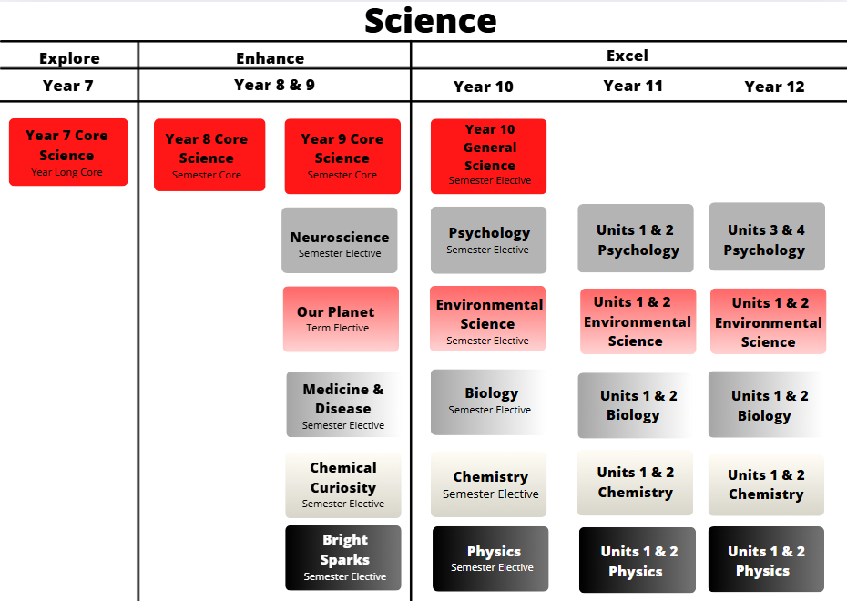

For a more detailed Pathways Map showing how students can progress through the years, please see the Appendix items.

BIOLOGY UNITS 1 - 4

Subject description:
VCE Biology explores the diversity of life, the structure and function of living organisms, and the processes that sustain life. Across Units 1–4, students investigate cells, genetics, evolution, ecosystems, and human physiology, developing scientific understanding through inquiry and practical investigations.
The course emphasises applying biological knowledge to real-world contexts, interpreting data, and evaluating scientific information. Students gain skills in research, critical thinking, and problem-solving, preparing them for tertiary study and careers in health, biotechnology, environmental science, and related fields.

Units 1 and 2:
Units 1 and 2 focus on the fundamental concepts of biology. Students explore cell structure and function, the role of enzymes and biological molecules, reproduction and inheritance, and the diversity of life. Practical investigations and experiments help students develop scientific skills, including observation, data collection, and analysis. These units provide a foundation for understanding more complex biological systems in Units 3 and 4.

Units 3 and 4:
Units 3 and 4 focus on how biological systems operate and interact. Students study genetics and evolution, homeostasis in humans, ecosystems, and the interactions between organisms and their environments. Practical investigations and research projects enable students to analyse data, evaluate evidence, and apply biological concepts to real-world issues. These units prepare students for tertiary study and careers in health, biotechnology, environmental science, and other biology-related fields.

Assessment:
- Ongoing coursework, including engagement in practical work.
- Topic tests.
- Scientific posters.
- Case studies and data analyses.
- Annotated logbook of practical activities.

Pathways:
Completing VCE Biology provides a strong foundation for tertiary study and careers in health, medicine, biotechnology, environmental science, and life sciences. The subject develops skills in research, critical thinking, data analysis, and problem-solving, which are valuable in scientific and health-related fields. Biology also supports pathways into courses such as nursing, veterinary science, pharmacology, ecology, and laboratory-based careers.
Teachers to see for advice regarding this subject:
Ms. Marshall & Ms. Peters

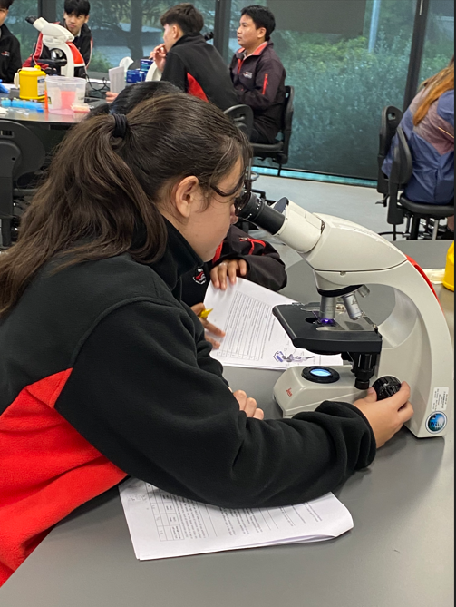

CHEMISTRY UNITS 1 – 4

Subject description:
VCE Chemistry explores the composition, structure, properties, and reactions of matter. Across Units 1–4, students investigate chemical systems, including atomic and molecular structure, bonding, chemical reactions, energy changes, equilibrium, and organic and inorganic chemistry.

The course emphasises scientific inquiry, practical investigations, and the application of chemical knowledge to real-world contexts. Students develop skills in research, data analysis, problem-solving, and scientific communication, preparing them for tertiary study and careers in science, engineering, health, and related fields.

Students are unable to accelerate in VCE Chemistry due to the complexity of the subject. Consolidation of skills and knowledge is key to success.

Units 1 and 2:
Units 1 and 2 focus on fundamental chemistry concepts. Students explore atomic structure, chemical bonding, reactions, the periodic table, and the properties of substances. Practical investigations develop skills in observation, data collection, analysis, and safe laboratory practice, providing a foundation for more complex chemical systems in Units 3 and 4.

Units 3 and 4:
Units 3 and 4 focus on how chemical systems interact and change. Students study reaction rates, equilibrium, energy changes, redox reactions, and organic and inorganic chemistry. Through practical experiments and inquiry-based learning, students analyse data, evaluate evidence, and apply chemical principles to real-world problems. These units prepare students for tertiary study and careers in science, engineering, medicine, and technology.

Assessment:
- Ongoing coursework, including engagement in practical work.
- Topic tests.
- Scientific posters.
- Case studies and data analyses.
- Annotated logbook of practical activities.

Pathways:
Completing VCE Chemistry provides a strong foundation for tertiary study and careers in science, medicine, engineering, environmental science, and technology. This subject acts as a prerequisite for some university degrees. The subject develops skills in practical laboratory work, data analysis, problem-solving, and scientific reasoning, which are highly valued in fields such as pharmacology, chemical engineering, biotechnology, and research. Chemistry also supports pathways into allied health, veterinary science, and laboratory-based careers.

Teachers to see for advice regarding this subject:
Ms. Naidoo and Ms. Glenn

ENVIRONMENTAL SCIENCE UNITS 1 – 4

Subject description:
VCE Environmental Science explores the interactions between humans and the natural environment, focusing on sustainability, ecosystems, and the impact of human activity. Across Units 1–4, students investigate environmental processes, human influences, and strategies for managing natural resources and protecting biodiversity.
The course emphasises scientific inquiry, data analysis, and real-world applications, enabling students to evaluate environmental issues, propose solutions and communicate findings effectively. Students develop skills in critical thinking, problem-solving, and research, preparing them for tertiary study and careers in environmental management, conservation, sustainability, and related fields.

Units 1 and 2:
Units 1 and 2 focus on the fundamentals of environmental science. Students explore ecosystems, natural resources, and the ways human activity affects the environment. Practical investigations develop skills in observation, data collection, and analysis, helping students understand the relationships between humans and the natural world.

Units 3 and 4:
Units 3 and 4 focus on complex environmental systems and management strategies. Students investigate sustainability, environmental change, conservation, and methods for addressing environmental challenges. Through practical and research-based learning, students analyse data, evaluate evidence, and apply solutions to real-world environmental issues, preparing them for tertiary study and careers in environmental science, conservation, and sustainability.

Assessment:
- Ongoing coursework, including engagement in practical work.
- Topic tests.
- Scientific posters.
- Case studies and data analyses.
- Fieldwork.

Pathways:
Completing VCE Environmental Science prepares students for tertiary study and careers in environmental management, conservation, sustainability, and related fields. The subject develops skills in scientific investigation, data analysis, critical thinking, and problem-solving, which are valuable in careers such as environmental consultancy, natural resource management, ecology, and policy development. It also provides a strong foundation for further study in science, agriculture, geography, and environmental engineering.

Teachers to see for advice regarding this subject:
Ms. Naidoo and Ms. Marshall

PHYSICS UNITS 1 - 4

Subject descriptions:
VCE Physics explores the fundamental principles that govern the physical world. Across Units 1–4, students investigate motion, forces, energy, waves, electricity, fields, and the behaviour of matter at both macroscopic and atomic scales.
The course emphasises scientific inquiry, experimentation, and modelling to develop analytical and problem-solving skills. Students learn to interpret data, evaluate evidence, and apply physics concepts to real-world contexts, preparing them for tertiary study and careers in engineering, technology, medical sciences, and other STEM-related fields.

Students are unable to accelerate in VCE Physics due to the complexity of the subject. Consolidation of knowledge and skills is key to success.

Units 1 and 2:
Units 1 and 2 focus on the fundamental concepts of physics. Students explore motion, forces, energy, waves, and electricity through practical investigations and theoretical study. These units develop skills in observation, data collection, analysis, and scientific reasoning, providing a foundation for more complex topics in Units 3 and 4.

Units 3 and 4:
Units 3 and 4 focus on advanced physics concepts and applications. Students study energy transformations, fields, atomic and nuclear physics, and the interactions of matter. Practical and inquiry-based learning develops skills in problem-solving, modelling, and data interpretation, preparing students for tertiary study and careers in engineering, technology, medical sciences, and other STEM-related fields.

Assessment:
- Ongoing coursework, including engagement in practical work.
- Topic tests.
- Scientific posters.
- Case studies and data analyses.
- Annotated logbook of practical activities.

Pathways:
Completing VCE Physics prepares students for tertiary study and careers in science, engineering, technology, medical sciences, and other STEM-related fields. This subject acts as a prerequisite for some university degrees. The subject develops skills in problem-solving, data analysis, modelling, and critical thinking, which are highly valued in research, engineering, electronics, environmental science, and health-related professions. Physics also provides a strong foundation for further study in mathematics, engineering, and physical sciences.

Teachers to see for advice regarding this subject:
Ms. Podsytnik & Ms. Glenn

PSYCHOLOGY UNITS 1 - 4

Subject description:
VCE Psychology explores human behaviour and mental processes, examining how biological, psychological, and social factors influence the way people think, feel, and act. Across Units 1–4, students investigate brain function, learning, memory, development, mental health, and social interactions.
The course emphasises scientific inquiry, research methods, and critical thinking. Students develop skills in analysing data, evaluating evidence, and applying psychological concepts to real-world contexts, preparing them for tertiary study and careers in psychology, health, social services, education, and related fields.

Units 1 and 2:
Units 1 and 2 focus on the foundations of psychology and human behaviour. Students explore how the brain functions, how people learn and remember, and how development and personal factors influence behaviour. Practical activities and research investigations help students develop skills in observation, data collection, analysis, and critical thinking, providing a foundation for more complex topics in Units 3 and 4.

Units 3 and 4:
Units 3 and 4 focus on advanced psychological concepts and applications. Students study mental health, social interactions, and the biological, psychological, and social influences on behaviour. Through experiments, research, and case studies, students develop skills in analysing evidence, evaluating psychological theories, and applying knowledge to real-world contexts, preparing them for tertiary study and careers in psychology, health, education, and human services.

Assessment:
- Ongoing coursework, including engagement in practical work.
- Topic tests.
- Scientific posters.
- Case studies and data analyses.
- Annotated logbook of practical activities.

Pathways:
Completing VCE Psychology prepares students for tertiary study and careers in psychology, health, education, social work, counselling, and human services. The subject develops skills in research, critical thinking, data analysis, and understanding of human behaviour, which are valuable in a wide range of professions. Psychology also provides a foundation for further study in neuroscience, mental health, education, and social sciences.

Teachers to see for advice regarding this subject:
Ms. Dawson & Ms. Kios

STEM

STEM is an acronym for Science, Technology, Engineering, and Mathematics. STEM enables students to apply knowledge from these subject areas to solve problems creatively using the scientiﬁc method, design process, and various mathematical skills. STEM encourages teamwork and high-level communication, which are both necessary skills in industry as workplaces become more collaborative and digitised. Working on STEM projects and learning tasks helps build resilience as not all endeavours will succeed the ﬁrst time. Processes must be modiﬁed and reﬁned to achieve success. Put simply, STEM helps to develop students into creative problem-solvers and lifelong learners. There is a key focus on Digital Technology and Design Technology in all STEM subjects.
Digital Technology is a major part of our lives and thus, our education. Our STEM subjects allow students to acquire a deep knowledge and understanding of digital systems, data and information, and the processes associated with creating digital solutions so that they can take up an active role in meeting current and future needs of society.
Design Technology uses design thinking, where students plan and manage projects from conception to realisation. They design processes to investigate ideas, generate and reﬁne ideas, plan and manage, and produce and evaluate designed solutions.
STEM PATHWAYS MAP

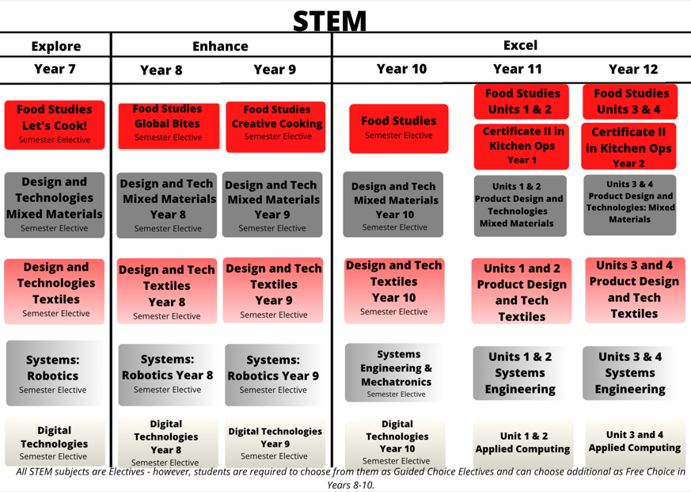

APPLIED COMPUTING UNITS 1 & 2

Subject Description:
VCE Applied Computing focuses on the application of a problem-solving methodology and strategies and techniques for managing information systems in a range of contexts to create digital solutions that meet specific needs. VCE Applied Computing is underpinned by four key concepts: approaches to problem-solving, data and information, digital systems, and interactions and impact.

Unit 1: Applied Computing
In this unit, students focus on how data can be used within software tools such as databases and spreadsheets to create data visualisations, as well as the use of programming languages to develop working software solutions. Students respond to an analysis of requirements and designs to identify and collect data to present their findings as data visualisations. They present work that includes databases, spreadsheets, and data visualisation solutions. Students select and use a programming language to create a working software solution.

Unit 2: Applied Computing
In this unit, students focus on developing innovative solutions to needs or opportunities that they have identified, and on proposing strategies for reducing security risks to data and information in a networked environment. Students work collaboratively and select a topic for further study to create an innovative solution in an area of interest. Students investigate networks and the threats, vulnerabilities, and risks to data and information. They propose strategies to protect the data accessed using a network.

Assessment:
- A folio of exercises and software solutions.
- A presentation that communicates findings, software solutions, and innovative solutions.
- Written reports and an annotated visual report.
- The design of a wireless network and working model of a wireless network.

Advice to Students:
Students who undertake this subject must have knowledge of Microsoft Word, Microsoft Excel, databases, web design, and computer programming. Students are highly recommended to undertake Year Digital Technology prior to undertaking this subject. Students must undertake this subject to study Units 3 & 4 Data Analytics OR Units 3 & 4 Software Development.
Teachers to see for advice regarding this subject:
Mr. D’Auria

DATA ANALYTICS UNITS 3 & 4

Subject Description:
VCE Computing focuses on the application of a problem-solving methodology and strategies and techniques for managing information systems in a range of contexts to create digital solutions that meet specific needs. It is underpinned by four concepts: approaches to problem-solving, data and information, digital systems, and interactions and impact. A critical component of the study is the opportunity for students to develop social capital, that is, the shared understanding in social networks that enable cooperation and a cooperative approach to problem- solving.

Unit 3: Data Analytics
In this unit, students apply the problem-solving methodology to identify and extract data using software tools such as databases, spreadsheets, and data visualisation software to create data visualisations or infographics. Students develop an understanding of the analysis, design, and development stages of the problem-solving methodology. Students develop data visualisations and use appropriate software tools to present findings. Students prepare a project plan, collect and analyse data, and design infographics or dynamic data visualisations.

Unit 4: Data Analytics
In this unit, students focus on determining the findings of a research question by developing infographics or dynamic data visualisations based on large complex data sets and on the security strategies used by an organisation to protect data and information from threats. Students investigate security practices of an organisation. They examine the threats to data and information, evaluate security strategies, and recommend improved strategies for protecting data and information.

Assessment:
- Creation of software solutions.
- A written report and structured questions.
- A project plan and evaluation and assessment of a project plan.
- Infographics and dynamic data visualisations that present research findings.

Advice to Students:
Students must successfully complete Applied Computing Units 1 & 2 to study Units 3 & 4 Data Analytics OR to study Units 3 & 4 Software Development.

Teachers to see for advice regarding this subject:
Mr. D’Auria



SOFTWARE DEVELOPMENT UNITS 3 & 4

Subject Description:
VCE Computing focuses on the application of a problem-solving methodology and strategies and techniques for managing information systems in a range of contexts to create digital solutions that meet specific needs. It is underpinned by four concepts: approaches to problem-solving, data and information, digital systems, and interactions and impact. A critical component of the study is the opportunity for students to develop social capital, that is, the shared understanding in social networks that enable cooperation and a cooperative approach to problem- solving.

Unit 3: Software Development
In this unit, students apply problem-solving methodology to develop working software modules using a programming language. Students develop an understanding of the analysis, design, and development stages of the problem-solving methodology. They respond to solution requirements and designs and develop a set of working modules through a programming language. Students examine a simple software requirement specification and a range of software design tools to apply specific processing features of a programming language to create working modules. Students analyse a need and design a software solution.

Unit 4: Software Development
In this unit, students focus on how information needs are met through the creation of software solutions. They consider the risks to software and data during the software development process and throughout the use of the software solution by an organisation. Students apply the problem-solving stages of development and evaluation to develop their preferred design into a software solution and then evaluate the solution, chosen development model, and project plan. Students examine the security practices of an organisation and the risks to software and data during the development and use of the software solutions.

Assessment:
- Creation of working software modules.
- A written report and structured questions.

Advice to Students:
Students must successfully complete Applied Computing Units 1 & 2 to study Units 3 & 4 Data Analytics OR
Units 3 & 4 Software Development.
Teachers to see for advice regarding this subject:
Mr. D’Auria

FOOD STUDIES UNITS 1 & 2
Subject Description:
Food Studies is all about building students’ capacities for skills and knowledge in the kitchen and in the real world. Here, students explore food as well as find pathways to health and wellbeing through the application of practical food skills. Students explore food from a wide range of perspectives and study past and present patterns of eating, Australian and global food production systems, and physical and social roles of food in society.

Unit 1: Food Origins
This unit focusses on food from historical and cultural perspectives. Students explore the origins and roles of food through time and across the world. Students explore traditional hunting and gathering of food through to today’s urban living and global trade of food. They investigate Australian Indigenous food as it existed prior to European settlement and how patterns have changed since, particularly through the influence of food production, processing and manufacturing industries, and immigration.

Unit 2: Food Makers
In this unit, students investigate food systems in contemporary Australia. Students focus on food production industries and food production in small-scale domestic settings as both a comparison and complement to commercial production. Students use practical skills and knowledge to produce foods and consider a range of evaluation measures to compare their foods to commercial products.

Assessment:
- Practical assessment tasks with records that reflect on these activities.
- Written assessment tasks: short written report, research inquiry,
- Design and produce a practical food solution.
- An oral presentation.

Advice to Students:
There are no prerequisites for undertaking this subject. But it is highly recommended that students have undertaken a selection of Food Studies subjects during Enhance as well as Year 10 Food Studies.

Teachers to see for advice regarding this subject:
Ms. Bush and Ms. Ellis



FOOD STUDIES UNITS 3 & 4

Subject Description:
Food Studies is all about building students’ capacities for skills and knowledge in the kitchen and in the real world. Here, students explore food as well as find pathways to health and wellbeing through the application of practical food skills. Students explore food from a wide range of perspectives and study past and present patterns of eating, Australian and global food production systems, and physical and social roles of food in society.

Unit 3: Food in Daily Life
This unit investigates the many roles and everyday influences of food. Students explore the physiology of eating and appreciating food and the microbiology of digestion. Students also investigate the functional properties of food and the changes that occur during cooking. They explore food choices, how communities, families, and individuals change their eating patterns over time, and how our food values and behaviours develop within social environments.

Unit 4: Food Issues, Challenges, and Futures
Students examine debates about global and Australian food systems. They explore issues about the environment, ecology, ethics, farming practices, the development and application of technologies, the challenges of food security, food safety, food waste, and the management of water and land. Students investigate food knowledge, skills, and habits as means that empower consumers to make healthy food choices. They demonstrate their food production repertoire by reflecting on the Australian Dietary Guidelines and the Australian Guide to Healthy Eating.

Assessment:
- Practical assessment tasks with records, that reflect on these activities.
- Written assessment tasks: short written report, research inquiry.
- A research inquiry report into a food solution, including an analysis and findings.
- An oral presentation.

Advice to Students:
Students must have successfully completed Units 1 & 2 Food Studies prior to undertaking this subject.

Teachers to see for advice regarding this subject:
Ms. Bush and Ms. Ellis
PRODUCT DESIGN AND TECHNOLOGY: MIXED MATERIALS OR TEXTILES UNITS 1 & 2
Subject Description:
In Product Design and Technology, students are designer-makers who plan solutions that are innovative and ethical. As designer-makers, they learn about the design industry, teamwork and the collaborative nature of teams, entrepreneurial activities, innovative technologies, and enterprise. Students participate in problem-based design approaches that trial, test, evaluate, critique, and iterate product solutions. Students learn that innovative and ethical solutions come from constructive failure and intentional evaluation.

Unit 1: Design Practices
This unit focuses on the work of designers across relevant specialisations in product design. Students explore how designers collaborate and work in teams, they consider the processes that designers use to conduct research, and the techniques designers employ to generate ideas and design products When creating their own designs, students use appropriate drawing systems to develop graphical product concepts. They experiment with materials, tools, and processes to prototype and propose physical product concepts.

Unit 2: Positive Impacts for End Users
Designers should look outward, both locally and globally to research the diverse needs of end users. They should explore how inclusive product design solutions can support belonging, access, usability, and equity. In this unit, students specifically examine social and/or physical influences on design. They formulate a profile of an end user, research and explore the specific needs or opportunities of the end user and make an inclusive product that has a positive impact on belonging, access, usability, and/or equity.

Assessment:
- Multimodal records of evidence of research, development, conceptualisation of products, and reflection.
- Practical work: demonstrations of graphical and physical product concepts, including prototyping and making final proofs of concept, along with finished products.
- Research inquiry of a designer and end user that explores the influence of culture in product design.

Advice to Students:
This subject is recommended for students who have a passion for experimenting and manipulating objects to make them functional and aesthetically appealing. It is highly recommended that students who wish to undertake this subject have studied Year 10 Product Design and Technology.

Teachers to see for advice regarding this subject:
Mr. Beveridge and Ms. Long
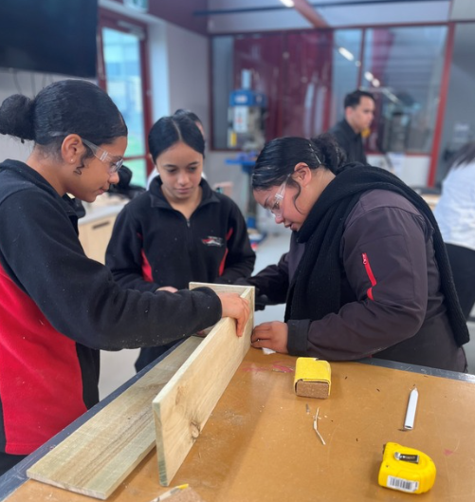

PRODUCT DESIGN AND TECHNOLOGY: MIXED MATERIALS OR TEXTILES UNITS 3 & 4

Subject Description:
In Product Design and Technology, students are designer-makers who plan solutions that are innovative and ethical. As designer-makers, they learn about the design industry, teamwork and the collaborative nature of teams, entrepreneurial activities, innovative technologies, and enterprise. Students participate in problem-based design approaches that trial, test, evaluate, critique, and iterate product solutions.

Unit 3: Ethical Product Design and Development
In this unit, students research a real personal, local, or global need or opportunity with explicit links to ethical considerations. They conduct research to generate product concepts along with a final proof of concept for a product solution that addresses the needs or opportunities of the end user. Product designers respond to current and future social, economic, environmental, or other ethical considerations. This unit focuses on the analysis of available materials in relation to sustainable practices, tensions between manufacturing and production, modern industrial and commercial practices, and the lifecycles of products from sustainability or worldview perspectives.

Unit 4: Production and Evaluation of Ethical Designs
In this unit, students continue to work as designers throughout the production process. They observe safe work practices in their chosen design specialisations by refining their production skills using a range of materials, tools, and processes. Students collect, analyse, interpret, and present data, use ethical research methods, and engage with end users to gain feedback and then apply their research and findings to the production of their designed solution.

Assessment:
- Practical work: demonstrations of graphical and physical product concepts, including prototyping and making final proofs of concept, along with finished products, as well as a demonstration of a multimodal record of evidence.
- Research inquiry into ethical product design and innovation within industrial settings.
- Case studies, data analysis, and product analysis

Advice to Students:
This subject is recommended for students who have a passion for experimenting and manipulating objects to make them functional and aesthetically appealing. Students must have successfully completed Design Technology Units 1 & 2 prior to undertaking Units 3 & 4.

Teachers to see for advice regarding this subject:
Mr. Beveridge and Ms. Long
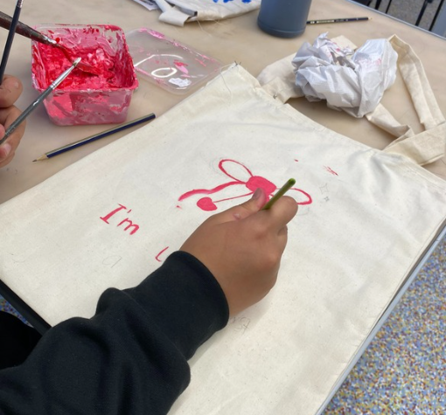

SYSTEMS ENGINEERING UNITS 1 & 2

Subject Description:
VCE Systems Engineering involves the design, production, operation, evaluation, and iteration of integrated systems. Integral to VCE Systems Engineering is the identification and quantification of systems goals, the generation of system designs, trial and error, justified design trade-offs, and selection and implementation of the most appropriate design. Students test and evaluate how well the completed system meets the intended goals and reflect upon the systems engineering process to create a satisfactory design outcome.

Unit 1: Mechanical Systems
This unit focuses on engineering fundamentals as the basis of understanding concepts, principles, and components that operate in mechanical systems. The term ‘mechanical systems’ includes systems that utilise all forms of mechanical components and their linkages. The creation process draws heavily upon design and innovation processes. Students create an operational system using the systems engineering process. Students research and quantify how systems use or convert the energy supplied to them. They are introduced to mechanical engineering principles, including mechanical subsystems and devices, their motions, elementary applied physics, and related mathematical calculations that can be applied to define and explain the physical characteristics of mechanical engineering principles.

Unit 2: Electrotechnological Systems
In this unit, students study fundamental electrotechnological (electrical/electronic circuitry, including microelectronic circuitry) engineering principles. Using the systems engineering process, students create operational electrotechnological systems. They study fundamental electrotechnological principles, including applied electrical theory, standard representation of electronic components and devices, elementary applied physics in electrical circuits, and mathematical processes that can be applied to define and explain the electrical characteristics of circuits.

Assessment:
- Production work to create a mechanical system.
- Documentation of the systems engineering process in a written report as well as a brochure or poster.

Advice to Students:
It is highly recommended that students who wish to undertake this subject have studied Design Technology or STEM subjects during Enhance and Year 10 and have successfully completed Year 10 Engineering and Mechatronics.

SYSTEMS ENGINEERING UNITS 3 & 4

Subject Description:
VCE Systems Engineering involves the design, production, operation, evaluation, and iteration of integrated systems. Integral to VCE Systems Engineering is the identification and quantification of systems goals, the generation of system designs, trial, and error, justified design trade-offs, and selection and implementation of the most appropriate design. Students test and evaluate how well the completed system meets the intended goals and reflect upon the systems engineering process to create a satisfactory design outcome.

Unit 3: Integrated and Controlled Systems
In this unit, students design and plan an operational, mechanical, and electrotechnological integrated and controlled system. They learn about the technologies used to harness energy sources to provide power for engineered systems. Students commence work on the creation of an integrated and controlled system using the systems engineering process. This production work has a strong emphasis on innovation, designing, producing, testing, and evaluating, as well as project management. Students develop their understanding of technological systems developed to capture and store renewable energy.

Unit 4: Systems Control
In this unit, students complete the creation of the mechanical and electrotechnological integrated and controlled system they researched, designed, planned, and commenced production of in Unit 3. Students investigate new and emerging technologies, consider reasons for their development, and analyse their impacts. They effectively document the use of project and risk management methods throughout. They use a range of materials, tools, equipment, and components. Students test, diagnose, and analyse the performance of the system. They evaluate their process and the system. Students expand their knowledge of emerging developments and innovations through their investigation and analysis of a range of engineered systems.

Assessment:
- A written report in the form of a case study.
- A written report in the form of a media analysis.
- A multimedia presentation.

Advice to Students:
Students who wish to undertake this subject must have successfully completed VCE Systems Engineering Units 1 & 2.

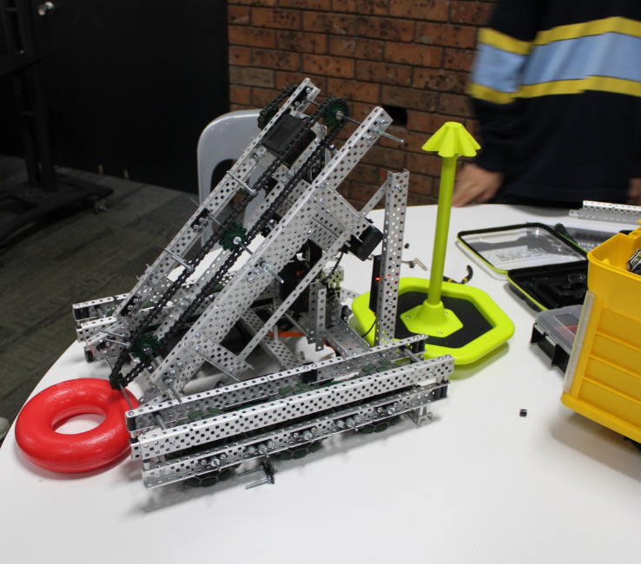

VET SUBJECTS

Internal VET Subjects:
At Hampton Park Secondary College we offer a range of VET studies in school. Please refer to the relevant information below, speak to our VET Coordinator, or view more detailed information at Pages - VCE VET programs (vcaa.vic.edu.au).

External VET Subjects:
There are many VET subjects available as ‘External VET Subjects’. This means that students need to travel to the location where the VET subject is offered (such as another Secondary College or a TAFE institute) off site. Most external VET courses are offered through Chisholm TAFE, the South East Local Learning and Employment Network (SELLEN), and other secondary colleges. VET courses usually cost between $200 - $500, and students are required to pay a 50% deposit prior to enrolment. Enrolment is also dependent on availability. For more information about the variety and requirements of VET courses, see our Careers Education Team and visit Pages - VCE VET programs (vcaa.vic.edu.au).
For more information on VET, see the links below:
Pages - Get VET (vcaa.vic.edu.au)
What is VET? - Victorian Curriculum and Assessment Authority
VCE VET programs - Victorian Curriculum and Assessment Authority
How VET works - Victorian Curriculum and Assessment Authority
Shape Your VCE - Victorian Curriculum and Assessment Authority

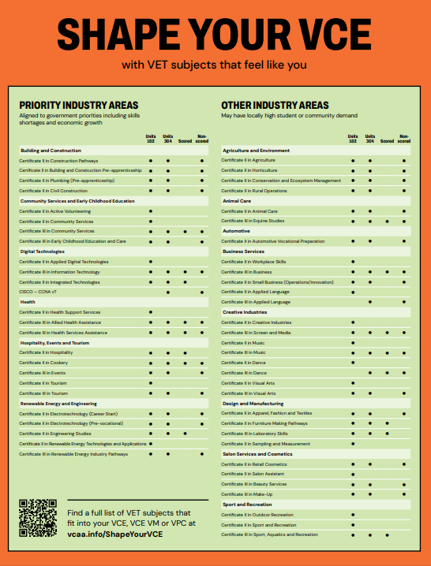
For an enlarged copy of this document, see here - VET-Program-Chart.pdf

CERTIFICATE III IN BUSINESS
Subject Description:
This VCE VET Business programme, delivered across two years, is drawn from a national training package offering a qualification that is recognised throughout Australia. This qualification provides students with a broad range of knowledge and skills in information and communications technology, administration, communication, creativity and innovation, design, finance, management, leadership, regulation, stakeholder relations, and workforce development. This is an entry-level Certificate for students wanting to pursue a career or further training in business studies. The VCE VET Business programme aims to provide students with knowledge, skills and competencies that will enhance their training and employment prospects in a broad range of business and industry settings.
* This course is completed in two years. Scored assessment is available in the second year of the programme.

VCE Credits:
- Two VCE VET units at a Units 2 & 3 level.
- Two VCE VET units at a Units 3 & 4 sequence (scored or non-scored).
*Please note, VCE VET Business can be studied in both a VCE and VCE VM pathway.

Compulsory Units (Units 1 & 2):
- Support personal wellbeing in the workplace ● Participate in sustainable work practices ● Use inclusive work practices ● Assist with maintaining workplace safety ● Apply critical thinking skills in a team environment.

Compulsory Units (Units 3 & 4):
- Engage in workplace communications ● Design and produce business documents ● Organise personal work priorities ● Deliver and monitor a service to customers ● Organise workplace information.

Possible Elective Units:
- Securely manage personally identifiable information and workplace information ● Research and develop business plans ● Maintain business to business relationships ● Process payroll ●Use business software applications ● Maintain patient records.

Assessment:
- Students must complete the ten compulsory units for Units 1 & 2 and Units 3 & 4 (180 & 215 nominal hours).
- Students must satisfactorily complete a minimum of three electives (minimum of 180 nominal hours).
- Students wishing to receive an ATAR contribution must undertake scored assessment, consisting of three coursework tasks and an end of year exam.

Possible Pathways:
 | Year 7 | Year 8 | Year 9 | Year 10 | Year 11 | Year 12
Option One | Core Hums | Like a Boss: Running Your Own Business | My Money | Year 10 Accounting OR Year 10 Business Management | VET Cert II Workplace Skills | VET Cert III Business  (Part completion)
Acceleration Option | Core Hums | Like a Boss: Running Your Own Business | Year 10 Accounting OR Year 10 Business Management | VET Cert III Business | VET Cert III Business
Acceleration Option | Core Hums | Like a Boss: Running Your Own Business | Year 10 Accounting OR Year 10 Business Management | VET Cert II Workplace Skills | VET Cert III Business | VET Cert III Business
*Please note, these are sample options only. Please consider all appropriate Humanities subjects.

Teachers to see for advice regarding this subject: Mr. Andrews

CERTIFICATE II IN COOKERY
Subject Description:
This Australia wide recognised qualification reflects the role of individuals working in kitchens who use a defined range of food preparation and cookery skills to prepare food and menu items. They are involved in mainly routine and repetitive tasks and work under direct supervision. This qualification is a pathway to work in kitchen operations in organisations such as restaurants, hotels, catering operations, clubs, pubs, cafes, and coffee shops, as well as institutions such as aged care, hospitals, prisons, and schools. Scored assessment is available in the second year of this programme.
*This course is completed in two years. Scored assessment is available in the second year of the programme.

VCE Credits:
- Two VCE VET units at a Units 2 & 3 level.
- Two VCE VET units at a Units 3 & 4 sequence (scored or non-scored).
*Please note, VCE VET Cooking can be studied in both a VCE and VCE VM pathway.

Compulsory Units (Units 1 – 4):
- Use food preparation equipment ● Prepare dishes using basic methods of cookery ● Work effectively in a commercial kitchen ● Clean kitchen premises and equipment ● Use hygienic practices for food safety ● Receive, store, and maintain stock ● Participate in safe work practices.

Possible Elective Units: (Units 1 – 4):
- Prepare and present simple dishes ● Prepare vegetable, fruit, eggs, and farinaceous dishes ● Prepare appetisers and salads ● Prepare stocks, sauces, and soups ● Participate in safe food handling practices ● Prepare and present sandwiches ● Produce Cakes ● Provide first aid.

Assessment:
- Students must successfully complete the six compulsory units for Units 1 to 4 (190 nominal hours).
- Students must complete a minimum of six elective units for Units 1 to 4 (approximately 185 hours).
- Students wishing to receive an ATAR contribution must undertake scored assessment, consisting of three coursework tasks and an end of year exam.

Possible Pathways:
 | Year 7 | Year 8 | Year 9 | Year 10 | Year 11 | Year 12
Option One | Let’s Cook | Creative  Cooking | Global Bites | Year 10 Food Studies | VET Cert II Cookery | VET Cert II Cookery
Acceleration Option | Let’s Cook | Global Bites | Year 10 Food Studies | Vet Cert II Cookery | VET Cert II Cookery (Scored) | VCE Food Studies Units 3 & 4
*Please note, these are sample options only. Please consider all appropriate STEAM and Design & Digital Technologies subjects.

Teachers to see for advice regarding this subject: Ms.
CERTIFICATE III IN HEALTH SERVICES ASSISTANCE
Subject Description:
The VCE VET Health programme provides students with the knowledge and skills to enhance their employment prospects in the Health Industry. The industry is large and diverse, covering many occupations, ranging from highly qualified professionals to support staff and volunteers. The Health Training Package is designed to reflect the full range of health providers, modes of delivery, and client services. With further education and training, students can work in careers such as physiotherapy, nursing, exercise physiology, dental assisting, aged care, disability support, and occupational therapy.
*This course is completed in two years. Scored assessment is available in the second year of the programme.

VCE Credits:
- Two VCE VET units at a Units 2 & 3 level.
- Two VCE VET units at a Units 3 & 4 sequence (scored or non-scored).
*Please note, VCE VET Cooking can be studied in both a VCE and VCE VM pathway.

Compulsory Units (Units 1 & 2):
- Communicate and work in health or community services ● Comply with infection prevention and control policies and procedures OR Apply basic principles and practices of infection prevention and control ● Participate in workplace health and safety.

Compulsory Units (Units 3 & 4):
- Organise personal work priorities and development ● Assist with movement ● Maintain high standard of service ● Response effectively to behaviours of concern.

Possible Elective Units: (Units 1 – 4):
- Recognise healthy body systems ● Interpret and apply medical terminology ● Take clinical measurements ● Prepare and process medical accounts ● Maintain patient records ● Work with people with mental health issues ● Clean and disinfect reusable medical devices ● Assist with preparation of clients for operative procedures ● Provide support for people living with dementia ● Facilitate the empowerment of old people.

Assessment:
- Students must successfully complete the three compulsory units for Units 1 & 2 (75 - 85 nominal hours).
- Students must successfully complete the four compulsory units for Units 3 & 4 (105 nominal hours).
- Students must complete a minimum of six elective units for Units 1 to 4 (approximately 180 hours).
- Students wishing to receive an ATAR contribution must undertake a scored assessment, consisting of three coursework tasks and an end of year exam.

Possible Pathways:
 | Year 7 | Year 8 | Year 9 | Year 10 | Year 11 | Year 12
Op�on One | Year 7 Science | Medicine & Disease | Neuroscience | Year 10 Biology | VET Cert III Health Services Assistance | VET Cert III Health Services Assistance
Acceleration Op�on | Year 7 Science | Healthy Body, Healthy Mind | Year 10  Health & Human Development | VET Cert III Health Services Assistance | VET Cert III Health Services Assistance (Scored) | VCE Health & Human Development Units 3 & 4
*Please note, these are sample options only. Please consider all appropriate Science and Health & Physical Education subjects.
Teachers to see for advice regarding this subject: Ms. Tregidga and Ms. Raine
CERTIFICATE III IN SPORT, AQUATICS, AND RECREATION
Subject Description:
This qualification reflects the role of individuals with well-developed skills and knowledge required to deliver recreational services. Using discretion and judgement, they work with some independence and under limited supervision using clearly defined plans, policies, and procedures to guide work activities. They work in locations such as fitness centres, sporting grounds or complexes, leisure and aquatic centres, and community recreation centres.
*This course is completed in two years. Scored assessment is available in the second year of the programme.

VCE Credits:
- Two VCE VET units at Units 2 & 3 level.
- Two VCE VET units: a Units 3 & 4 sequence (scored or non-scored).
*Please note, VCE VET Sport, Aquatics, and Recreation can be studied in both a VCE and VCE VM pathway.

Compulsory Units (Units 1 – 4):
- Participate in WHS hazard identification, risk assessment, and risk control processes ●Participate in workplace health and safety ● Provide quality service ● Respond to emergency situations ● Maintain activity equipment ● Maintain sport, fitness, and recreation industry knowledge.

Possible Elective Units: (Units 1 – 4):
- Use business software applications ● Provide first aid ● Maintain business resources ● Supervise patron safety in aquatic locations ● Perform complex water rescues ● Deliver recreation sessions ● Facilitate inclusion for people with disability ● Provide cardiopulmonary resuscitation ● Teach water safety and survival skills ● Conduct visual inspections of park facilities ● Provide general grounds care ● Perform open water rescues ● Minimise environmental impact ● Conduct sport coaching sessions with foundation level participants.

Assessment:
- Students must successfully complete the six compulsory units.
- Students must successfully complete a minimum of nine elective units.
- Students wishing to receive an ATAR contribution must undertake scored assessment, consisting of three coursework tasks and an end of year exam.

Possible Pathways:
 | Year 7 | Year 8 | Year 9 | Year 10 | Year 11 | Year 12
Op�on One | Year 7  Core Health & Physical Education | Team Sports | Healthy Body, Healthy Mind AND  Year 10  Sport & Recreation | Year 10 Sport & Recreation | VET Cert III Sport, Aquatics,  & Recreation | VET Cert III Sport, Aquatics,  & Recreation
Acceleration | Year 7 | Outdoor | Year 10 | VET Cert III | VET Cert III | Cert II
Option | Core Health | Education | Environmental Science | Sport, | Sport, | Workplace
 | & Physical |  |  | Aquatics, | Aquatics, | Skills
 | Education |  |  | & Recreation | & Recreation
 | AND
 | Planet Earth
*Please note, these are sample options only. Please consider all appropriate Science and Health & Physical Education subjects.

Teachers to see for advice regarding this subject: Mr Jessop and Mr Haare

OTHER INTERNAL VETS WE OFFER AT HPSC

Certificate III in Lab Skills
This program prepares individuals for job roles such as laboratory technicians and instrument operators. As laboratory technicians, students engage in basic laboratory work within a specific scientific discipline. First year units of competency may include plan and conduct laboratory / field work, record and present data and contribute to the achievement of quality objectives.

Units 3 and 4 (year 2), offers a scored assessment option for VCE students. Units may include – receive and prepare samples for testing, prepare culture media, and collect routine site samples.

Certificate III in Engineering Studies
This program introduces students to a range of engineering pathways through practical participation. Engineering areas studied may cover fabrication, technical, mechanical and electrical engineering. Units of competency may include perform basic machining processes, apply basic fabrication techniques and use hand tools.

Units 3 and 4 (year 2), offers a scored assessment option for VCE students. Units may include undertake a basic engineering project, perform intermediate engineering computations and produce basic engineering components and products using fabrication and machining operations.

Please Note: The information contained in this booklet is a guide only. Subject oﬀerings may change at any time depending on staﬃng and resourcing requirements and availability. Furthermore, subjects may not run due to timetable or staﬃng issues. The most up-to-date information regarding subjects, qualiﬁcations, or accredited courses is kept on the school’s website.

GLOSSARY

ATAR (AUSTRALIAN TERTIARY ADMISSIONS RANK) | The overall ranking on a scale of 0 – 99.95 that students receive based on their study scores. The ATAR is used by some universities and TAFE institutes to select students for courses.
AUTHENTICATION | Process of ensuring that the work submitted by students for assessment is their own.
DES (DERIVED EXAM SCORE) | Students can apply to the VCAA for a Derived Examination Score if their preparation for, and examination performance, is significantly affected by adverse circumstances within two weeks or so of an examination.
EAL (ENGLISH AS AN ADDITIONAL LANGUAGE) | Students who have comparative unfamiliarity with the English language due to non-English speaking background or hearing impairment may apply for EAL status.
EXAMINATIONS | Units 1 &2 include a semester/unit examination which does not contribute towards a student’s final study scores.  Units 3 & 4 sequences have at least one examination which directly contributes to a student’s final study scores.
FIELD OF STUDY | Subject. Most VCE studies are made up of 4 units.
GAT – General Achievement Test | General Achievement Test – is a test of general knowledge and skills in written communication, mathematics, science, technology, humanities, the arts, and social sciences.
LEARNING OUTCOME (VCE)/MODULE (VPC) | These define what the students will know and be able to do as a result of satisfactorily completing a study. Each outcome has a definition, the key knowledge to be learnt and the key skills to be acquired.
PREREQUISITES | These are units which must be passed and must be included in a student’s programme.
PROGRAMME OF STUDY | A sequence of studies taken over two years normally made up of 22/24 units.
RECOMMENDED | These are units which are desirable, and their knowledge may be assumed, but they do not affect selection into tertiary courses.
REDEMPTION | School based process to give students an opportunity to convert an N for a particular piece of school-assessed coursework, school-assessed task, or school-based assessment, to an S.
SACs (SCHOOL-ASSESSED COURSEWORK) | Tasks set and marked within VCAA guidelines by teachers to assess students’ achievement of Units 3 & 4 outcomes. Most tasks are done in class time. The scores relating to these assessments are reported to the VCAA.
SATs (SCHOOL-ASSESSED TASKS) | Units 3 & 4 school-based assessment which is part of graded assessment in scored VCE VET subjects, Art, Design and Technology, Food & Technology, Art Making and Exhibiting and Visual Communication & Design. Tasks are set by the VCAA and assessed by teachers in accordance with published criteria. Task grades are subject to review by a panel appointed by the VCAA. Failure to meet the school’s deadlines will adversely affect a student’s final mark and/or mean failing a unit.

SATISFACTORY COMPLETION | In simple terms, this means a student has passed a unit and therefore gained an ‘S’ for the unit. If a student does not satisfactorily complete a unit, they get an ‘N’. Satisfactory and unsatisfactory completion of Units 1 – 4 is reported to the VCAA and included on students’ VCE Statement of Results.

Satisfactory completion depends on students achieving the Learning Outcomes of a particular unit.
Failure to meet the College’s deadlines for an assessment task, or attendance requirements, may mean failing a unit and/or adversely affect a student’s final study score.
SEMESTER | One half of the academic year. Most units last for one semester.
SEQUENCE | The order in which students do units, for example, a Units 3 & 4 sequence
SPECIAL PROVISION | Special Provision can be made to allow students studying a VCE unit who are experiencing significant hardship the maximum opportunity to demonstrate both what they know and what they can do.  A student is eligible for Special Provision if their performance is adversely affected to a significant degree, by illness, by any factors relating to personal environment or other serious cause or disadvantaged by a disability or impairment.  Applications for special examination arrangements must be well documents.
STATEMENT OF RESULTS | A set of documents which formally state the results a student achieved in the VCE, and whether they have graduated.
STATISTICAL MODERATION | VCAA process that involves adjusting each school’s coursework scores to ensure that schools’ assessments are comparable throughout the state.
STUDIES | The subjects available in the VCE.
STUDY DESIGN | The description of the content of a study, and how students’ work is to be assessed. The VCAA publishes a Study Design for each VCE study. Schools and other VCE providers must adhere to the Study Designs.
STUDY SCORE | A score from 0 – 50 which shows how a student performed in a Units 3 & 4 study, relative to all other students doing that same study. It is based on school assessments and examination results for each study.
UNIT | A unit normally lasts for one semester or half a year.
UNITS 1 & 2 | Units 1 & 2 are equivalent to Year 11 level.
UNITS 3 & 4 | Units 3 & 4 are equivalent to Year 12 level. Students may be able to select Units 1 or 2 in their second year of VCE and students may be able to select Units 3 & 4 in their first year of VCE.
VCAA | Victorian Curriculum and Assessment Authority, the body which administers the VCE/VCE VM/VPC.
VCE | Victorian Certificate of Education.
VETiS | Vocational Education and Training (VET) delivered to school students
VTAC | Victorian Tertiary Admissions Centre.

APPENDIX #1
SCIENCE PATHWAYS
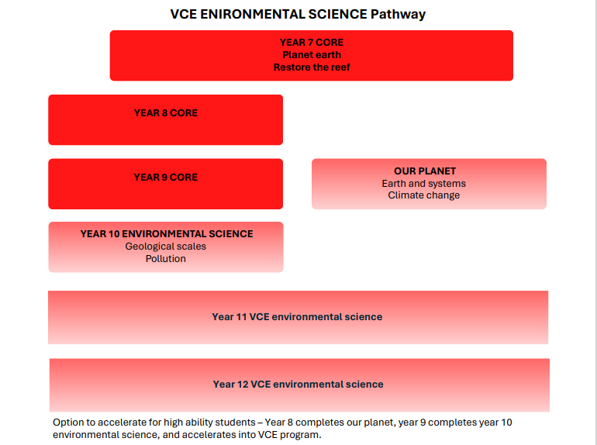
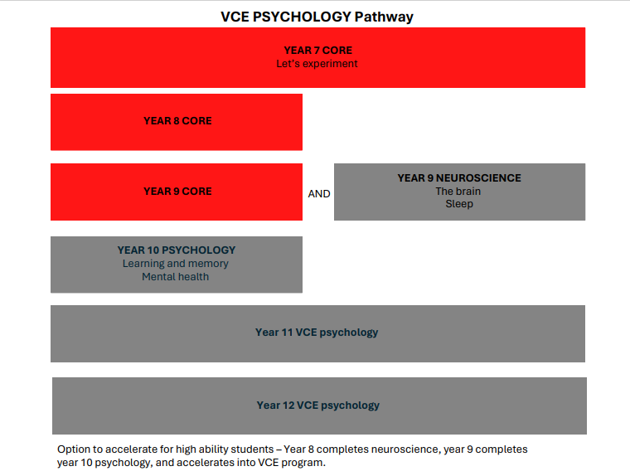

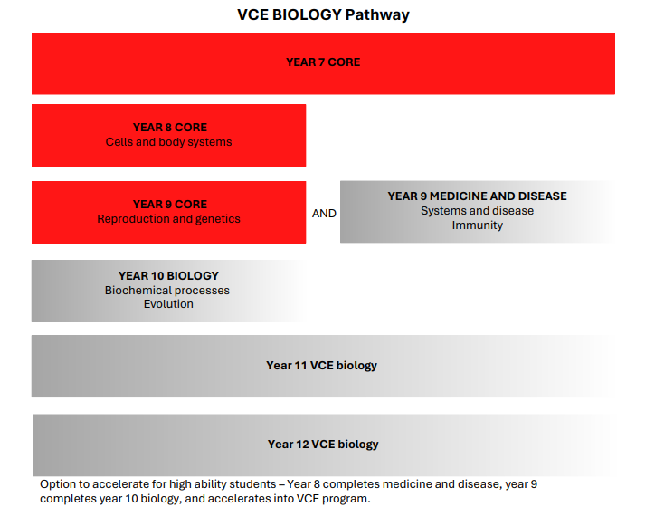

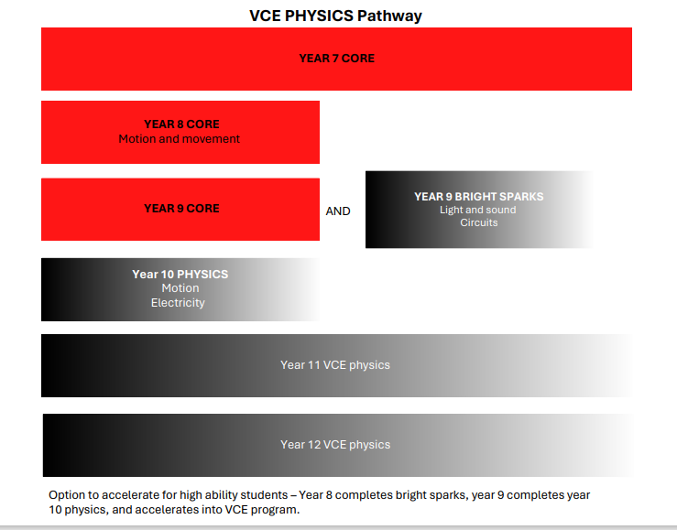
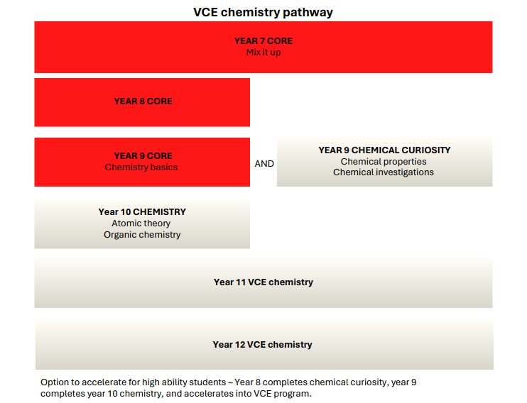

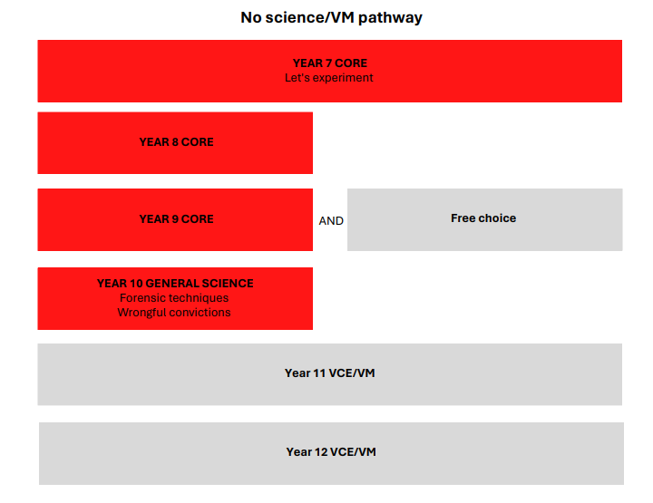

MATHEMATICS PATHWAYS


