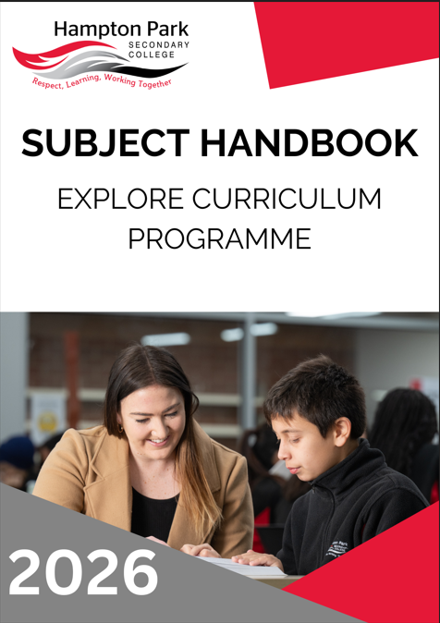

Hampton Park Secondary College
58-96 Fordholm Road
(P.O. Box 480)
Hampton Park Vic 3976 Ph: 03 8795 9400
Fax: 03 8795 9455
Email: hampton.park.sc@education.vic.gov.au
Website: http://www.hpsc.vic.edu.au
Compass: http://hpsc-vic.compass.education

PROPERTY OF AND COPYRIGHTED TO HAMPTON PARK SECONDARY COLLEGE.
NOT TO BE DISTRIBUTED OR SHARED WITHOUT PERMISSION.
VERSION 5
LAST UPDATED November 2025

PRINCIPAL’S INTRODUCTION
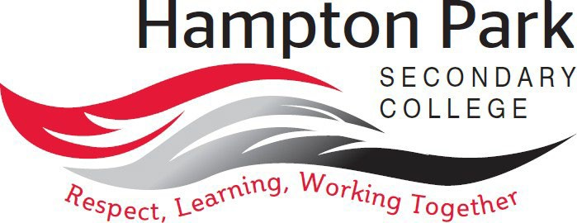

“At Hampton Park Secondary College, we are rich in diversity, and through empowering and engaging students, we remain wholehearted in our pursuit of excellence.”

Our values are Respect, Learning and Working Together
We Respect ourselves, each other, and our school environment and understand that our attitudes and behaviours have an impact on the people around us.
Our key focus is on Learning, improving each day. We acknowledge and celebrate both learning growth and excellence.
By Working Together, we learn from each other and build the skills to achieve our best.
Hampton Park Secondary College is committed to providing an education that is student-centered and where students are empowered with their learning. Our learning program enables students to have more voice, choice, and agency in their learning. In line with this approach is our recognition that all students are unique, and that each student brings their own distinct and individual passions, interests, skills, and knowledge into our learning ecosystem.
We recognise that our young people are entering into a world that is changing at a faster rate than ever before, posing new environmental, political, societal, economic, and technological challenges and complexities that were never imaginable. We believe that by empowering students, we create a learning environment where learning is with students, rather than to students. Our approach to learning supports students regardless of their level of learning and understanding, ensuring that no student is left behind and all can reach their full potential. Through professional learning, individual reflections, learning walks and coaching, teaching staff aim to create optimal conditions for learning.
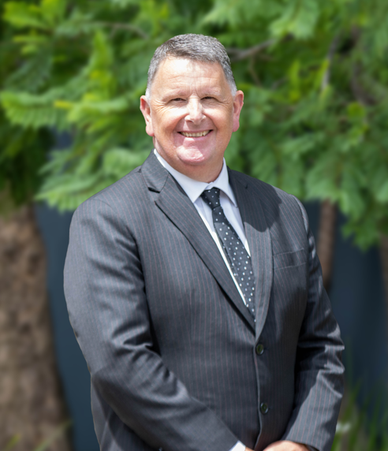
Wayne Haworth
Principal
COLLEGE VALUES

Respect, Learning, and Working Together
Our vision of learning excellence is underpinned by the Hampton Park Secondary College values of Respect, Learning, and Working Together. Informing our daily interactions and decisions, these values are embedded into our whole school practices and are supported by our Berry Street and Positive Behaviours for Learning approach. We strive to build students who are life-long learners, with high levels of empathy and who are always critical and creative problem solvers.
Our values of Respect, Learning, and Working Together guide our educational programmes within the community in the following ways:
- I respect myself and other people.
- I actively listen to others with an open mind.
- I respect other people’s different perspectives.
- I am inclusive.
- I respect school property and the property of others.
- I wear my school uniform with pride.
- I set personal goals and have high expectations of myself and others to continually improve.
- I have a positive attitude and enthusiasm for learning.
- I strive to achieve my personal best.
- I take pride in the achievements of myself and others.
- I am willing to share ideas, resources, and skills.
- I am helpful and approachable.
- I contribute positively to class, group activities, and the school community.
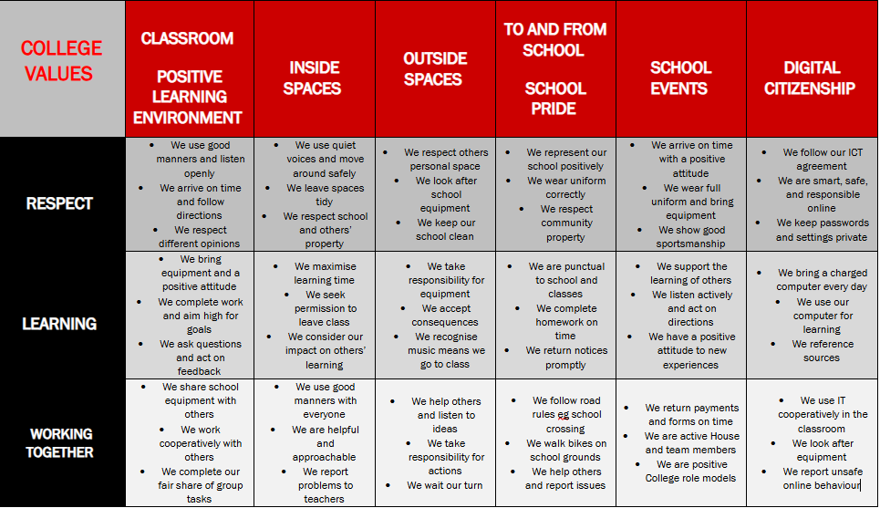
LEARNING AT HAMPTON PARK SECONDARY COLLEGE
College Vison for Teaching and Learning: At Hampton Park Secondary College every student achieves personalised success through the delivery of consistent high quality teaching practice.
Our Teaching and Learning Framework captures our whole school areas of focus, aligned with the priorities of the Department, the VTLM 2.0 and the Victorian Curriculum 2.0. Our framework is used by all teachers as a reflective tool and supports teacher clarity and consistency of practice.
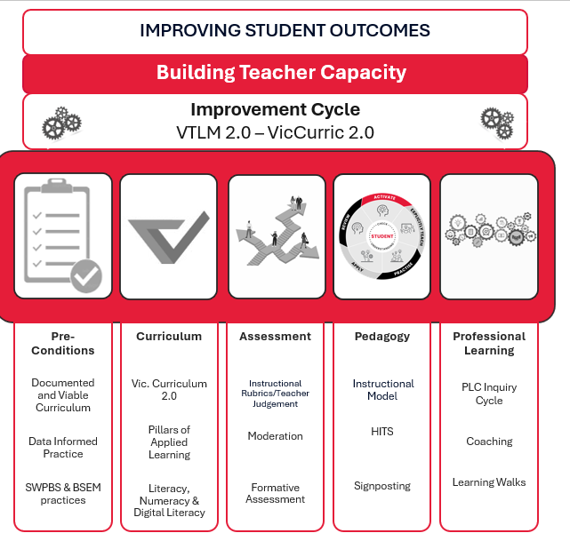
Our Instructional Model brings to life our pedagogical approach and has five phases of learning – Activate, Explicitly Teach, Practice, Apply and Review.
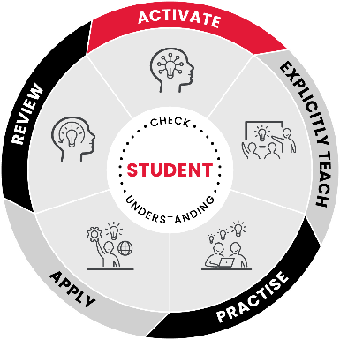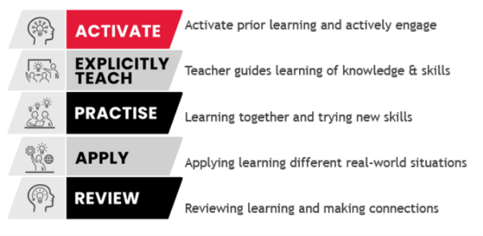
Curriculum Design and Implementation
Hampton Park Secondary College structures its curriculum into three stages or ‘programmes’:
- Explore (Year 7)
- Enhance (Year 8 and 9), and
- Excel (Year 10, 11 and 12)
In Years 7-10, students undertake a combination of core subjects, guided choice (required to choose subjects from specified domain areas) and free choice subjects (except in Year 7, where our focus is on building a strong transition into the College and the skills required for development across the curriculum areas).

YEAR 7 EXPLORE - COURSE MAP
The Course Map below shows how the eight Key Learning Areas of the Victorian Curriculum are addressed and delivered at HPSC.
Year 7 – Explore
 | Semester One | Semester Two | Period Count P/W
Subject / Line 1 - CORE | English/EAL - Year long |  | 4
Subject / Line 2- CORE | Maths - Year long |  | 4
Subject / Line 3- CORE | Humanities- Year long |  | 4
Subject / Line 4 - CORE | Science- Year long |  | 4
Subject / Line 5 - CORE | Health/PE- Year long |  | 4
Subject / Line 6A - GUIDED CHOICE | STEM/Arts- Elective | STEM/Arts- Elective | 2
Subject / Line 6B – GUIDED CHOICE | STEM/Arts- Elective | STEM/Arts- Elective | 2
Connect | Connect- Year long |  | 1
 |  |  | Total = 25 periods of learning each week
Electives - Note: interchangeable across Semesters
In Year 7, students have choice over the Design and Technology, Digital Technology and Arts (Visual and Performing) electives on offer. To ensure students are exposed to all displines, students must choose across the year:
- 1 elective from the Visual Arts
- 1 elective from the Performing Arts
- 1 elective from Design and Technology
- 1 elective from Digital Technology
This ensures, all four required areas are covered.
Whilst students can cover these areas in Years 7 and 8 (across the two-year band), ensuring students cover all 4 disciplines in Year 7, when they have limited understanding about Secondary learning, ensures students have more choice in Year 8 – as we value student choice - and their choices are informed.
The Victorian Registration and Qualiﬁcations Authority (VRQA) has granted HPSC an exemption for languages. French and Japanese however can be studied as a semester long elective if a student chooses.
Minutes of Instruction:
Period length is 60mins. This equates to:
- 1500mins per week of instruction time at Year 7-10

CONNECT
Hampton Park Secondary College runs a Connect Program for students in Years 7-10, to provide opportunities for increased connectedness and a deeper understanding of self. The Connect Program runs for one period a week.
In Years 7 -9, in Connect, students focus is on:
- Self-reflection and goal setting, supported through the development of Student Learning Portfolios and their presentation through Student Led Conferences
- Careers and Pathways Education
- Social and Emotional Learning, facilitated through the implementation of Berry Street Strategies and our approach to School Wide Positive Behaviours, as well as Respectful Relationships
In Year 10, students focus primarily on developing their understanding of Careers and Pathways Education through the study of one WRS unit (Work Related Skills), from the VCE Vocational Major. This unit also supports students to access and engage with meaningful Work Experience. Social and Emotional Learning and self-reflection and goal setting skills are explicitly taught through relevant subjects where the capabilities are reported on and assessed against, this includes Respectful Relationships.
Student Led Conferences empower students to lead a reflective conversation about their learning journey.
Year 7-9 students present Student Learning Portfolios to their families. Students share their learning goals with subject teachers and families in the first of the Student Led Conference in Semester 1. In the Term 3 Conference, students present their Learning Portfolio to a Connect or significant teacher and their families. They share their reflections of learning across subjects for the year drawing on examples in their portfolios, addressing goals set and their next steps.
Year 10-12 students engage in a conversation with their families and teachers at both conferences to share their learning progress, strengths and areas for growth. Teachers and families follow the students lead, asking questions to promote learning growth and reflection.
Conferences are held twice per year, mid Semester 1 and the end of Term 3 and can be undertaken virtually if required.

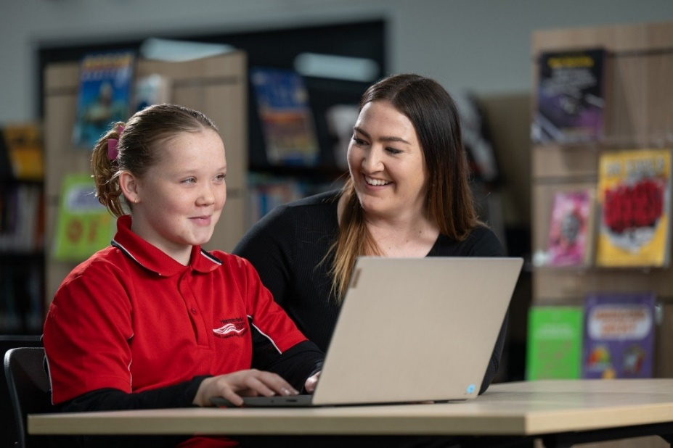

EXPLORE SUBJECTS
The studies below are for all Explore students at Hampton Park Secondary College. Please refer to the relevant information about each study in the Handbook and speak to the nominated staff listed if you have questions.
VISUAL AND PERFORMING ARTS

Year 7 Art (Art Making and Exhibiting)

Year 7 Media

Year 7 Visual Communication and Design

Year 7 Drama and Theatre Studies

Year 7 Try an Instrument (Music)

ENGLISH

Year 7 Core English and EAL

Year 7 English Skills and EAL

Year 7 English Support and EAL

HEALTH AND PHYSICAL EDUCATION

Year 7 Core Health and Physical Education

LANGUAGES

Japanese

French

MATHEMATICS

Year 7 Core Mathematics

Year 7 Skills Mathematics

Year 7 Support Mathematics

Year 7 Advanced Mathematics

SCIENCE

Year 7 Core Science
STEM

Year 7 Product Design and Technologies: Mixed Materials OR Textiles

Year 7 Robotics (Systems Engineering)

Year 7 Let’s Cook (Food Studies)

Year 7 Digital Technology

VISUAL AND PERFORMING ARTS
The Arts include Dance, Drama, Media, Music, Visual Arts, and Visual Communication and Design.
The Arts enable students to develop their creative and expressive capacities by learning about the different practices, disciplines, and traditions that have shaped the expression of culture - locally, nationally, and globally. Students are both artists and audience members in the Arts. They make, respond and learn to appreciate the specific ways this process occurs in different disciplines.
The Arts present ideas that are dynamic and rich in tradition. Through engaging in The Arts, students are entertained, challenged, and provoked to respond to questions and assumptions about individual and community identity, considering different histories and cultures. The Arts contribute to the development of confident and creative individuals and enrich Australian society. Students express, represent, and communicate ideas in contemporary, traditional, and emerging art forms. In Dance, Drama, and Music students explore the performing arts, whilst in Media, Visual Arts, and Visual Communication and Design students explore the world of visual representation and expression – the visual arts.
The significant contributions of Aboriginal and Torres Strait Islander peoples to Australia’s arts heritage and contemporary arts practices are explored across The Arts, and students are encouraged to respect and value these unique and evolving traditions.
PATHWAYS MAP FOR VISUAL AND PERFORMING ARTS
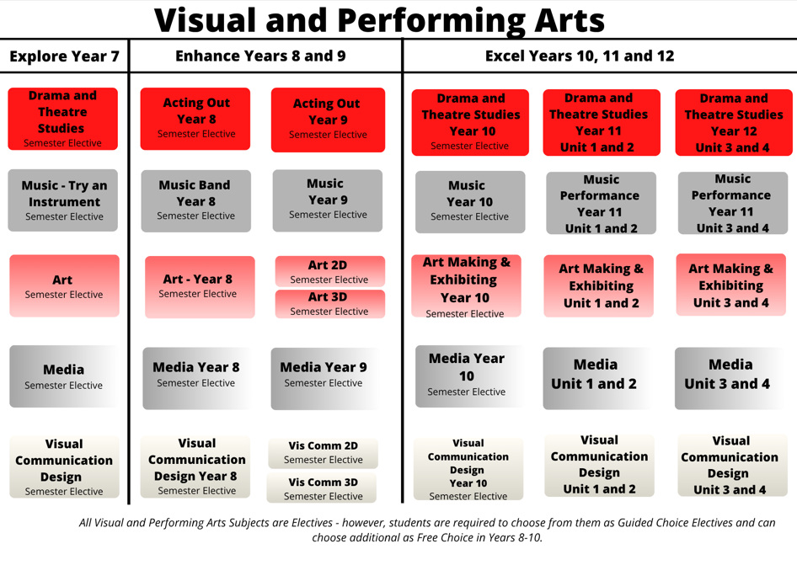

YEAR 7 ART (ART MAKING AND EXHIBITING)

Subject Description:
This subject provides a foundation for creating two-dimensional and three-dimensional artworks. Students learn the skills and techniques needed to create artworks with clay, watercolour paint, acrylic paint, pencils, markers, and mixed media. Students develop and create artworks with the intention of expressing and communicating ideas and passions. There is a focus on drawing from life, to capture perspective and proportions, in a variety of styles and art materials. Students look at a range of artists and discover how they express their ideas visually in diverse cultural and historical contexts.

Assessment:
- A folio of artworks.
- Work presentation to an audience.
- Peer and self-review and analysis.
- Investigation of artists, culture, and history.

Advice to Students:
There are no prerequisites for undertaking this subject. Students undertaking this unit are supported to become confident, independent, and self-managed learners, passionate about the creative process of artmaking. Students have a range of Art subjects they can continue with in the following years, including Drawing & Painting, Sculpting with Multi Materials, Street Art, and, eventually, VCE Art Making and Exhibiting.
Teachers to see for advice regarding this subject:
Ms. Fee, Mr. Horsfall, and Ms. Long
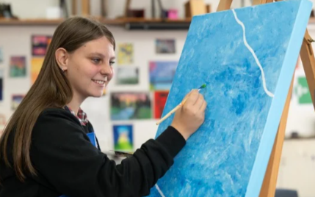

YEAR 7 MEDIA

Subject Description:

In this subject, students analyse advertising and marketing strategies to create their own film and media. They view a series of short advertisements where they analyse how they are made and learn about specific film-making and product marketing techniques. They learn the building blocks of film production, with a particular focus on camera skills and editing. Students use their knowledge to create their own short advertisements. These narratives focus on different film elements and different editing techniques. After this they will do similar tasks on movie posters to create and present their own. These videos and posters will be presented to the class, evaluated, and reflected upon.

Assessment:

Producing short films and movie posters.

Presenting short films and digital media techniques.

Written analysis of processes, genres, short films, and advertisements.

Advice to Students:

This subject is perfect for students who love watching movies and short films. It is also great for students who want to learn how to make things explode via special effects. This provides a foundation for any students wanting to do anything with film, providing them with the essential skills in this area.

Students have a range of Media subjects they can continue with in following years, including 8-10 Media classes, and VCE Media.

Teachers to see for advice regarding this subject:

Mr. Kriaris, Mr. Marriott, and Mrs. Grove.
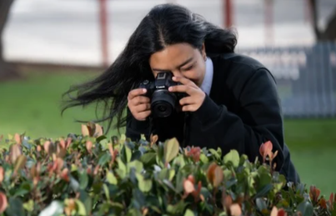

YEAR 7 VISUAL COMMUNICATION AND DESIGN
Subject Description:
In this subject, students learn how to follow the design process both digitally and manually to make logos for specific clients. In addition to manual drawing methods, students learn how to use computers to draw digitally. They access industry standard software such as Adobe Photoshop, Illustrator, and InDesign. Students explore how logos are designed and how logos influence people in recognising companies and products. Students learn the elements of design, embedding these skills in their design choices throughout the term.
Assessment:
- Practical assessment presented in a folio.
- Final presentations using manual drawing methods and Photoshop/Illustrator.
- Written analysis of design making processes (digital and manual drawing) and analysis of famous designs.
Advice to Students:
This subject is perfect for students who love design and want to create and make graphics using computers. Students learn Adobe Illustrator and Photoshop skills that provide them with a foundation for other design subjects as they progress through school. This subject is recommended to any student who is creative, and who also enjoys drawing, designing, or working on a computer.
There are many directions that can be taken after this subject, including any artistic and creative area, or any of the Visual Communication Design subject.
Teachers to see for advice regarding this subject:
Ms. Grove
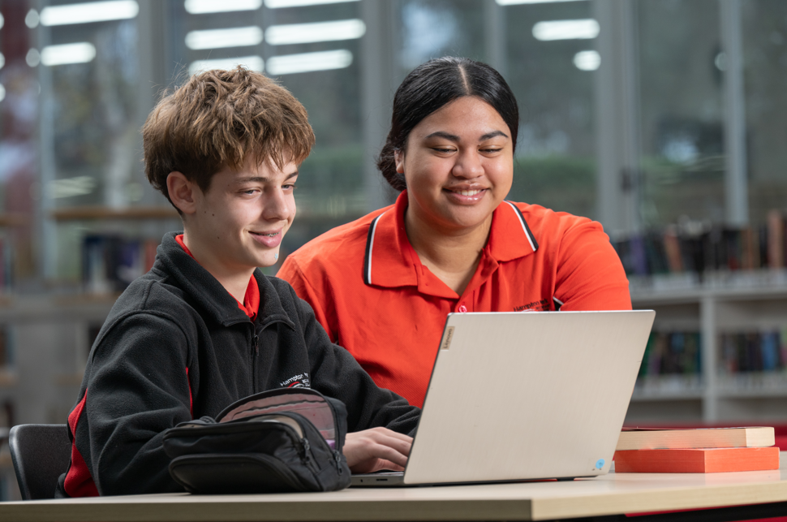

YEAR 7 DRAMA AND THEATRE STUDIES

Subject Description:
Students explore the creation of characters and stories using different ideas, themes, and issues to make and perform plays. They develop their acting skills, using voice, facial expression, and movement to further expand their range of believable characters. They investigate drama from various times, cultures, and places.

Assessment:
- Practical drama activities and exercises.
- Peer feedback and self-reflection.
- Research assignment.

Advice to Students:
There are no prerequisites for undertaking Drama, however students must be willing to participate in all activities, work with others, and bring positive energy.
Students have a range of Drama subjects they can continue with in following years, including Year 8-10 Drama, Theatre Studies, and VCE Drama.
Teachers to see for advice regarding this subject:
Ms. Windross, Ms. Scerri, and Ms. Wood
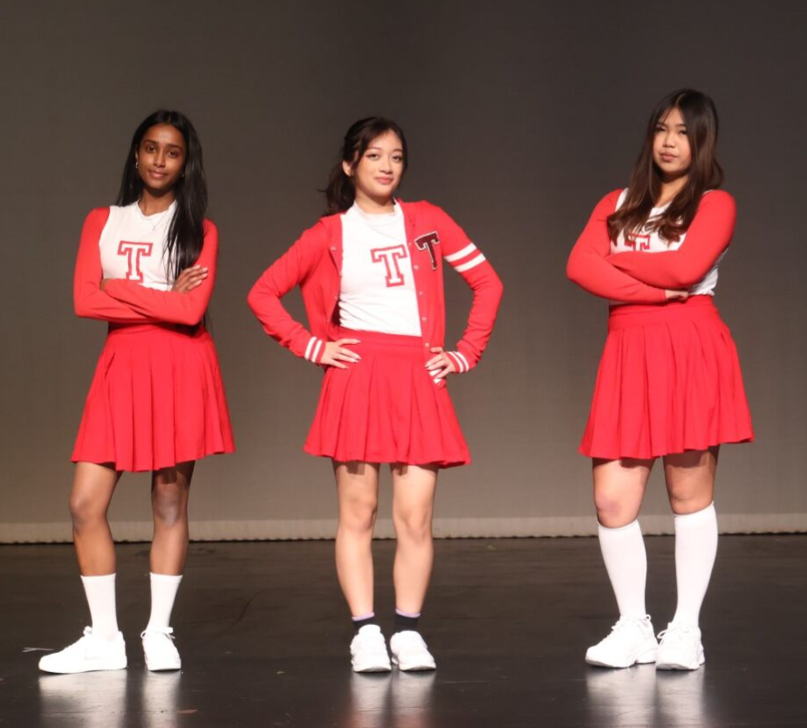

YEAR 7 TRY AN INSTRUMENT (MUSIC)

Subject Description:
In this subject, students learn to play an instrument and how to play in a band. Students develop creativity as they work towards performing with their class. Learning to play an instrument helps build confidence and life skills like persistence, leadership, and teamwork. Music is a creative means of self-expression in which students are given the opportunity to make music with others.
Students listen to songs across various music genres to gain ideas for creating their own music. Listening skills are used to make decisions about how to incorporate elements such as rhythm, dynamics, form, and structure into their performances.
Skills taught in this subject:
Students learn how to read music and play an instrument. They learn how to rehearse and perform as a group, by playing in a band. Students develop knowledge of music by listening and learning from other musicians and they develop creativity within their performances by using the elements of music.

Assessment:
- Practical assessment of rehearsal and band performances.
- Written analysis of own music making processes and of genres of music and musical artists.
- Written reflection on performances.

Advice to Students:
There are no prerequisites for undertaking this subject. Students who consider music are advised to undertake instrumental lessons for further support. This subject is recommended for students who have a passion for Music, are interested in learning one or more instruments, and are interested in learning how to play as a band.
It is highly recommended that students undertake this subject to study Enhance and Excel music subjects in the future.
Teachers to see for advice regarding this subject:
Ms. Le, Ms. Nguyen, and Ms. Hutton
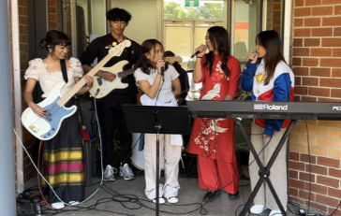

ENGLISH & ENGLISH AS AN ADDITIONAL LANGUAGE (EAL)
The study of English is central to the learning and development of all young Australians. It helps create confident communicators, imaginative thinkers, and informed citizens. It is through the study of English that individuals learn to analyse, understand, communicate, and build relationships with others and with the world around them. The study of English helps young people become ethical, thoughtful, informed, and active members of society.
What distinguishes English from other subjects is not only the skills it develops, but its central subject matter. The central concern of English is with the study and application of how language works in a range of contexts and media. English is further defined by the nature of the texts studied. English is essentially the study of language as a social and cultural form. English is also defined by the values it tries to create. English has been about the shaping of the 'self', by exploring humane values, imaginative life, and the development of aesthetic sensibility through engagement with literary texts. Today, this includes students understanding how their 'self' is located within social and cultural contexts and constructed through language and text.
PATHWAYS MAP FOR ENGLISH & EAL
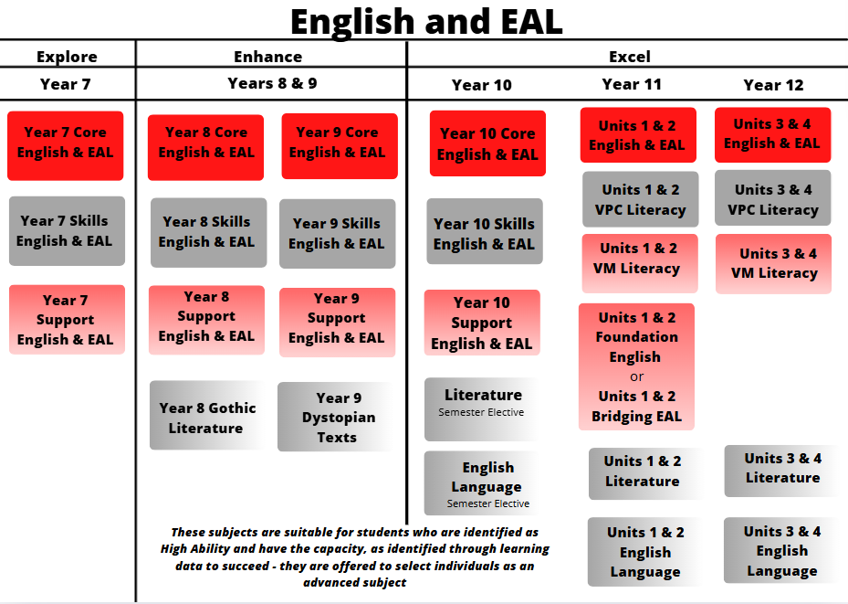
The acquisition of skills will determine the pathway students take in English. Pathways are individualised and are informed by data and learning progress.
YEAR 7 ENGLISH & EAL

Subject Description:
The big idea for English and EAL is communication. Students learn in four key areas: Speaking, listening, reading, viewing and writing. Students learn to write in three key genres: Narrative, persuasive, and analytical.
In Year 7 English and EAL, students develop an understanding of the structure of persuasive writing, studying persuasive techniques so that they can learn how to write an effective persuasive piece to present their opinion. They also produce an engaging narrative piece in the genre of mystery. In semester two, the focus is on an in-depth study of the selected text and constructing an analytical response. EAL students develop oral skills by studying the importance of pace, pitch, volume, and intonation in rendering a speech effectively.
Assessment:
- Text analysis essays and persuasive essays.
- Creation of own texts.
- Written reflections and an oral presentation.

Advice to Students:
Students must undertake this subject, if they are not undertaking English Skills or Support. Students are assigned to either English Skills/EAL, English Support/EAL or CORE English/EAL based on their ability and skill attainment.

Teachers to see for advice regarding this subject:
Ms. Noble and Ms. Mendoza
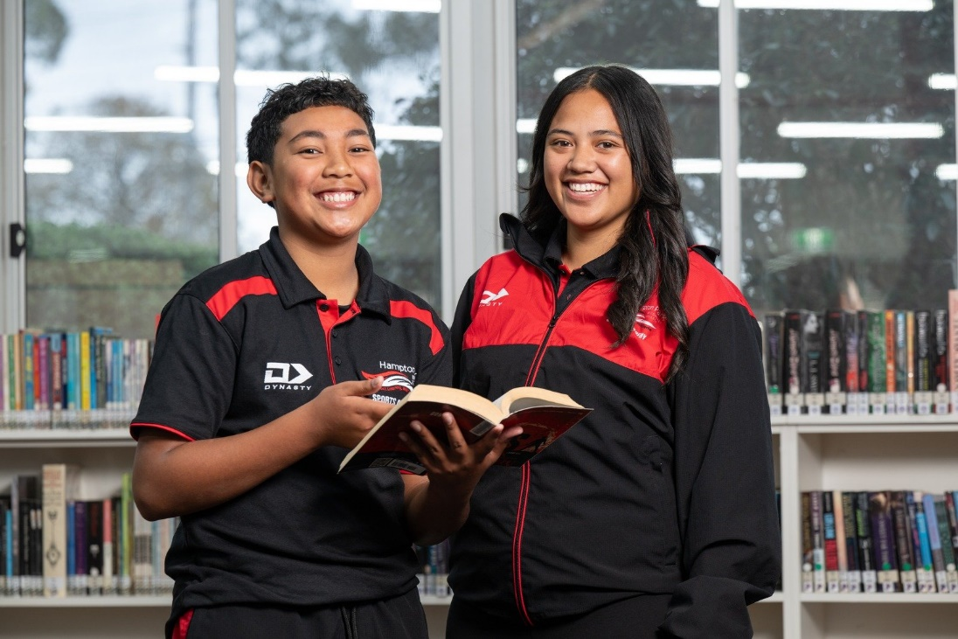

YEAR 7 ENGLISH SKILLS & EAL
Subject Description:
English Skills focuses on building strong foundations in reading, writing, speaking, and listening. The big idea for this subject is communication through literacy. Students participate in explicit, systematic phonics instruction to strengthen their decoding and spelling skills. Reading comprehension and fluency are developed through targeted practice and exploration of engaging texts.
Students study key areas of the English and EAL curriculum, text analysis (novel and film), persuasive writing and speaking, and narrative writing through the genre of horror.
Assessment:
- Oral Reading Fluency assessment
- Comprehensive phonics assessment
- Written responses to varied text types
- Persuasive and narrative writing pieces
- Oral presentations and reflections

Advice to Students:
English Skills is designed to help students strengthen their literacy skills and confidence in preparation for success in English and EAL and across all subjects. It provides additional time and targeted teaching to ensure students can participate fully in the English and EAL curriculum and progress toward VCE English, EAL, or VCE VM/VPC Literacy pathways.
Teachers to see for advice regarding this subject:
Mrs. Spence
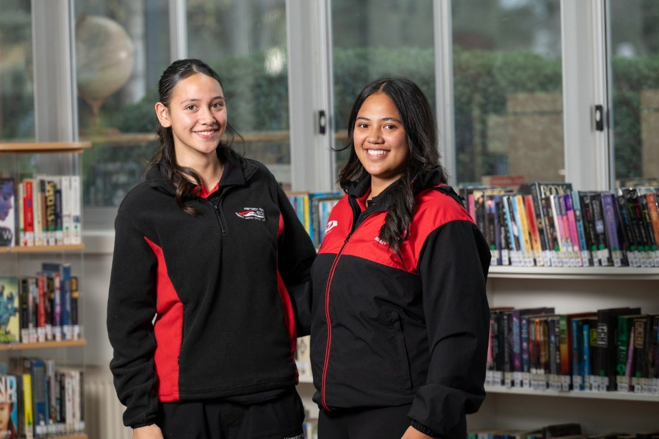
YEAR 7 ENGLISH SUPPORT & EAL
Subject Description:
English Support builds on foundational literacy skills to develop students’ confidence and independence in reading, writing, speaking, and listening. The big idea for this subject is growth in communication and comprehension. Students move beyond basic decoding to focus on vocabulary development, sentence structure, paragraphing, and cohesive writing. Reading comprehension and fluency are extended through the study of increasingly complex texts.
Students study the key areas of the English and EAL curriculum, including text analysis (novel and film), persuasive writing and oral presentation, and narrative writing. The focus is on applying and extending literacy skills to understand ideas, purpose, and audience.
Assessment:
- Reading comprehension and fluency assessment
- Written responses to studied texts
- Persuasive and narrative writing pieces
- Oral presentations and reflections

Advice to Students:
English Support is designed for students who are developing more advanced literacy skills but may still require additional guidance before moving into core English and EAL. This subject helps bridge the gap to ensure success across the curriculum and provides the skills needed to progress confidently toward VCE English, EAL, or VCE VM/VPC Literacy.
Teachers to see for advice regarding this subject:
Mrs. Spence
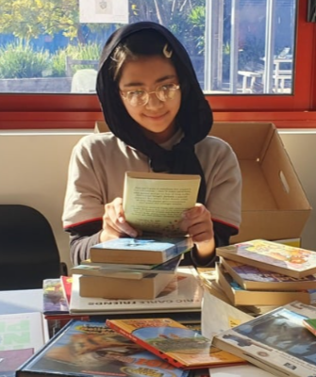

HEALTH & PHYSICAL EDUCATION
Health and Physical Education focusses on students enhancing their own and others’ health, safety, wellbeing, and physical activity and participation in varied and changing contexts. Research in fields such as sociology, physiology, nutrition, biomechanics, and psychology informs what we understand about healthy, safe, and active choices. Health and Physical Education oﬀers students an experiential curriculum that is contemporary, relevant, challenging, enjoyable, and active.
In Health and Physical Education, students develop knowledge, understanding, and skills to strengthen their sense of self and build and manage satisfying relationships. The curriculum helps them to be resilient and make decisions and take actions to promote their health, safety, and physical activity participation.
Integral to Health and Physical Education is the acquisition of movement skills, concepts, and strategies to enable students to participate in a range of physical activities conﬁdently, competently, and creatively. As a foundation for lifelong physical activity participation and enhanced performance, students develop proﬁciency in movement skills, physical activities, and movement concepts, and acquire an understanding of the science behind how the body moves.
PATHWAYS MAP FOR HEALTH & PE
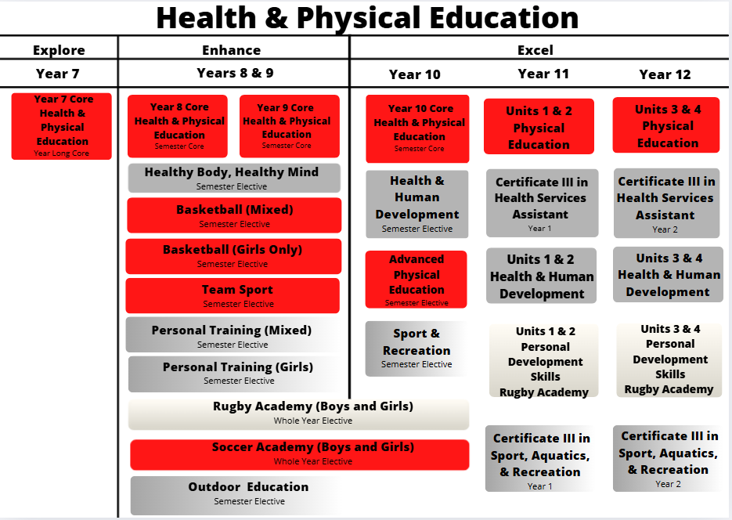

YEAR 7 CORE HEALTH & PHYSICAL EDUCATION

Subject Description:
Health and Physical Education focusses on students enhancing their own and others’ health, safety, wellbeing, and physical activity participation in varied and changing contexts. This unit involves practical sessions in the gym and health theory lessons in the classroom. The Physical Education sessions focus on the acquisition of movement skills, concepts, and strategies to enable students to participate in a range of physical activities confidently, competently, and creatively. Students are also given the opportunity to participate in a Swimming Safety Program for one Term. Throughout the Health sessions, students explore the physical, social, and emotional changes that occur as they grow older. Additionally, they examine the barriers to seeking support and how to overcome them. The curriculum helps students become resilient, make informed decisions, and take actions to promote their health, safety, and physical activity participation.

Assessment:
- Skill and strategy application to various sports.
- Case-study questions.
- Youth-issues project.

Advice to Students:
All Health and Physical Education subjects lead to a VCE Physical Education Pathway, VCE Health and Human Development Pathway, and VET/VCE VM/VPC Pathway/Certificate III Sport, Aquatics, and Recreation.
Students MUST Purchase the College Physical Education uniform to participate in practical sessions.
Teachers to see for advice regarding this subject:
Ms. Porter and Miss. Newton
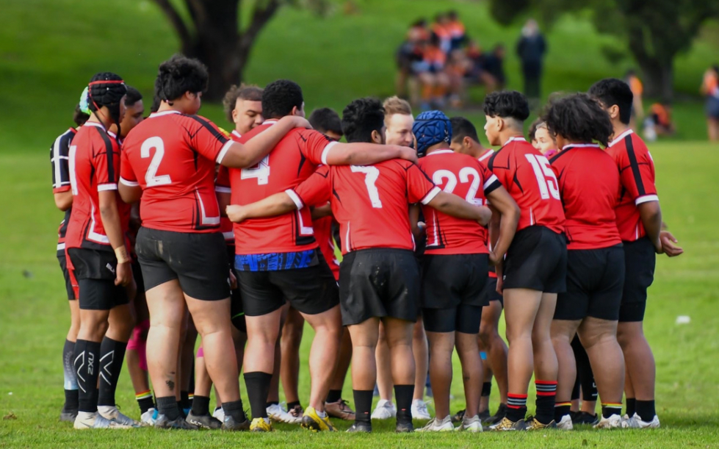

HUMANITIES
The Humanities include the study of Politics, Law, Economics, Business, Geography, History, and Philosophy.
The Humanities provide a framework for students to examine the complex processes that have shaped the modern world and investigate responses to different challenges including people’s interconnections with the environment.
In Politics, Law, Economics and Business, students explore the systems that shape society with a specific focus on legal and economic systems. Students learn about Australia’s role in global systems and are encouraged to appreciate democratic principles and to contribute as active, informed, and responsible citizens.
In History, Geography, and Philosophy, students explore the processes that have shaped, and continue to shape, different societies and cultures, to appreciate the common humanity shared across time and distance, and to evaluate the ways in which humans continue to face different challenges.
PATHWAYS MAP FOR HUMANITIES
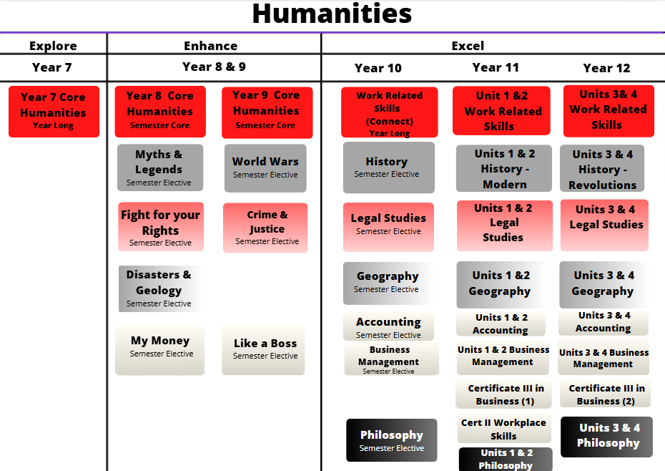

YEAR 7 CORE HUMANITIES
Subject Description:
Students explore the four major disciplines of Humanities: History, Civics and Citizenship, Economics and Business, and Geography through the theme of survival.

In History, students explore how ancient civilisations developed over time, and they develop their skills in interpreting and analysing historical sources. In Civics and Citizenship, students explore how societies maintain social cohesion through the development of shared values and ideals. In Economics and Business, students explore how the scarce resource of human labour and energy is divided in society to meet the needs and wants of the community. In Geography, students explore how societies meet the challenges of water scarcity.

Assessment:
- Curation of a museum display and written responses to case studies.
- Research assignments and source analysis tasks.
- Data analysis tasks and mapping activities.

Advice to Students:
Core Humanities leads to a variety of different pathways in the Humanities including further studies in History, Politics, Legal Studies, Economics, Business, Accounting, Geography, and Philosophy.

Teachers to see for advice regarding this subject:
Ms. Noble, Ms. Riley and Ms. Fiddes
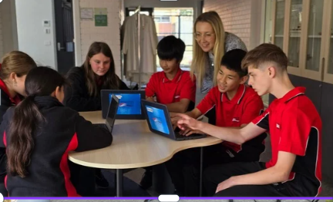

LANGUAGES
Learning languages broadens your horizons about the personal, social, cultural, and employment opportunities that are available in an increasingly interconnected and interdependent world. The interdependence of countries and communities requires people to negotiate experiences and meanings across languages and cultures. A bilingual or plurilingual capability is the norm in most parts of the world.
For students who already speak one or more languages, there are opportunities in the Languages Domain for them to engage in subjects that make the most of those skills. Learning another language helps develop essential areas of the brain. Research shows that it also improves memory, concentration, creativity, and critical thinking skills.
Learning another language means more than just memorising unfamiliar words. Languages all use different systems, so when we learn a new language, we compare it with English. This deepens understanding of English and significantly improves English language skills. It also grants the skill to learn other new languages more easily.
To know more about the benefits of learning a new language, watch this YouTube video:
https://www.youtube.com/watch?v=dtBxBHBN8nk – Why learn a language?
LANGUAGES PATHWAYS MAP
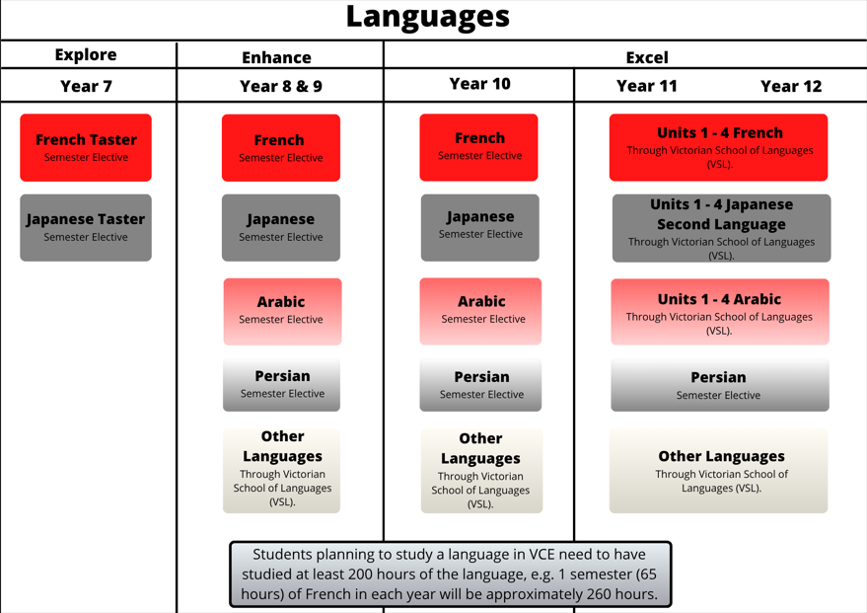
The subjects we can offer vary based on staff expertise and availability. Student choice determines the Languages that run.

YEAR 7 FRENCH
Subject Description:
French is a young, vibrant, international language. Among its 275 million speakers, more than 96 million live in Africa, and it also represents the second most widely spoken native language and foreign language in Europe. By the year 2050, it is estimated that French will be the language most spoken in the world - the latest projection is that French will be spoken by 750 million people by 2050. France itself is known as a home of great food, wine, the arts, science, and fashion. A knowledge of French can provide you with enhanced vocational opportunities in many fields, including banking, international finance, commerce, diplomacy, translating and interpreting. In Melbourne there are now 120 French companies which have set up offices, subsidiaries, or headquarters here in fields such as infrastructure and transport.
In Year 7, students will learn how to introduce themselves, as well as some basic vocabulary such as numbers. They will also learn about the culture of France and French-speaking countries. This will allow them to make an informed subject choice in the middle years.
Assessment:
- Oral presentation.
- Reading and listening comprehension task.
Advice to Students:
Learning a language is an ongoing process. If students are considering undertaking VCE French, they should aim to study French for a minimum of 200 hours (3 semesters) before moving into VCE Units 1 & 2. In Enhance and Year 10, students may choose to study French each semester. Each semester is approximately 65 hours duration. For students to prepare to perform at the highest level in French at VCE, they should consider taking French in consecutive units across each year of secondary school.
Teachers to see for advice regarding this subject:
Ms Eid and Ms Attard
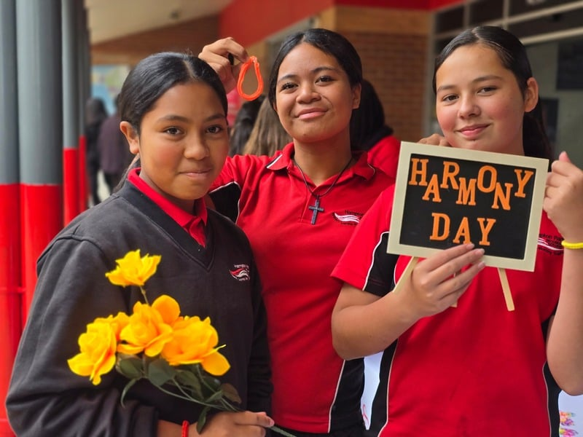

YEAR 7 JAPANESE
Subject Description:
Japanese is the official language of Japan, Australia’s northern neighbour in the Asia region. Japanese is also widely used by communities of speakers in Hawaii, Peru, and Brazil, and learnt as an additional language by large numbers of students in South Korea, China, Indonesia, and Australia. Japan holds the world’s third largest economy, moreover, it is Australia’s third largest trading partner. Australia and Japan are currently actively developing a deeper relationship in different spheres and have been close strategic and economic partners for more than 50 years. Japan has a multifaceted culture; on the one hand, it is steeped in the deepest of traditions dating back thousands of years, on the other hand, it is a society in a constant state of rapid flux, with continually shifting fads and fashions and technological development that continuously pushes back the boundaries of the possible.
In this subject, students will learn Japanese greetings, how to introduce themselves, as well as other basic vocabulary. Students learn about the differences between the three Japanese scripts, Hiragana, Katakana, and Kanji. They will learn about the culture of Japan and Japanese-speaking communities.
Assessment:
- Oral presentation.
- Listening comprehension task.
- Research Task
Advice to Students:
Learning a language is an ongoing process. If students are considering undertaking VCE Japanese as a Second Language, they should aim to study Japanese for a minimum of 200 hours (three semesters) before moving into VCE Units 1 & 2.
In Enhance and year 10, students may choose to study Japanese each semester. Each semester is approximately 65 hours duration. For students to prepare to perform at the highest level in Japanese at VCE, they should consider taking Japanese in Enhance and year 10 in consecutive units. It is highly recommended that students undertake Japanese to enhance the study of linguistics, literature, law, politics, travel, or international relations in the future.
Teachers to see for advice regarding this subject:
Ms Attard
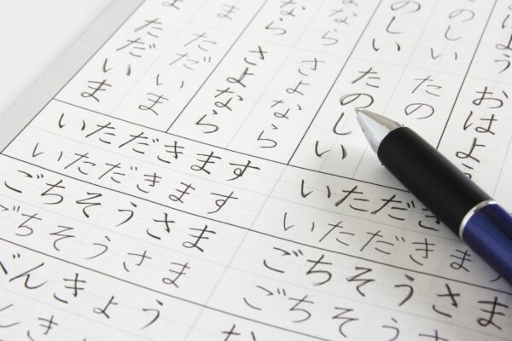

MATHEMATICS
Mathematics provides students with access to important mathematical ideas, knowledge, and skills that they will draw on in their personal and work lives. Mathematical ideas are constantly developing as digital technologies provide new tools for mathematical exploration and invention.
While the usefulness of mathematics for modelling and problem-solving is well known, mathematics also has a fundamental role in both enabling and sustaining cultural, social, economic, and technological advances and empowering individuals to become critical citizens.
Number and Algebra, Measurement and Space, Statistics and Probability are common aspects of most people’s mathematical experience in everyday personal, study, and work situations. Equally important are the essential roles that algebra, functions and relations logic, mathematical structure, and working mathematically play in people’s understanding of the natural and human worlds, and the interaction between them.
The mathematics curriculum focuses on developing increasingly sophisticated and reﬁned mathematical understanding, ﬂuency, reasoning, modelling, and problem-solving.
MATHEMATICS PATHWAYS MAP
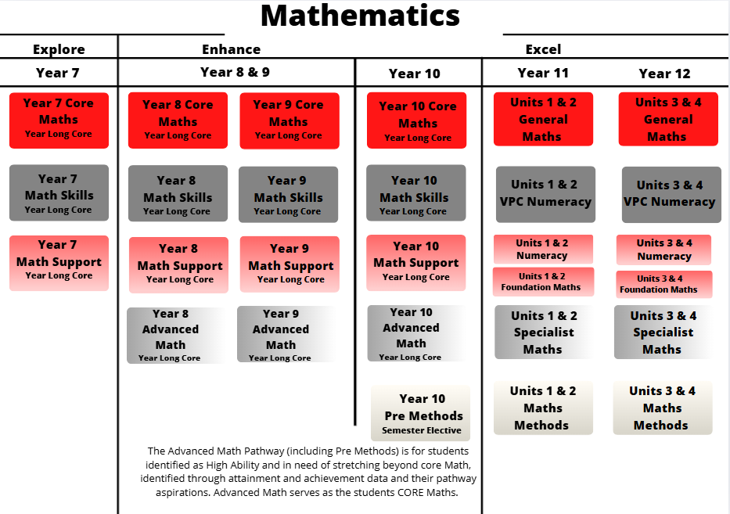

YEAR 7 MATHS
Subject description:
The Year 7 Mathematics curriculum focuses on developing increasingly sophisticated and refined mathematical understanding, fluency, reasoning, modelling and problem-solving. These capabilities enable students to respond to familiar and unfamiliar situations by employing mathematics to make informed decisions and solve problems efficiently. The proficiencies are fundamental to learning mathematics and working mathematically and are applied across all six strands: Number and Algebra, Measurement and Space, and Statistics and Probability.
Students participate in one of four different Mathematics subjects in Year 7. Students study a Maths program that will suitably challenge them, supporting them to build upon their mathematics skills at their current learning level. Students may move between Maths programs, based on their progress and learning needs.
Year 7 Maths Skills
This subject focuses on building fundamental mathematics skills and provides extensive support to learners. Students will learn how to work with numbers and money, recognize patterns, use measurement tools, navigate space, and collect data.
Year 7 Maths Support
This subject further builds upon fundamental mathematics skills and challenges students to apply their learning with scaffolds and support. Students will learn how to use the operations, differentiate between fractions decimals and percentage, convert between measures, classify shapes, organise data, and calculate chance.
Year 7 Core Maths
This subject supports students to engage with the six strands of mathematics and apply their learning to a range of contexts. Students will learn how to operate with fractions, decimals and percentages, represent problems algebraically, calculate areas, transform objects, conduct statistical investigations, and make predictions about events.
Year 7 Advanced Maths
This subject extends high ability students beyond the year 7 curriculum and focuses on problem-solving and extension tasks. Students will learn how to work with real number systems, extend their knowledge of algebra, perform calculations with shapes, conduct statistical analysis, and calculate probabilities.
Teachers to see for advice regarding this subject:
Ms. Marshall and Ms. Fernando

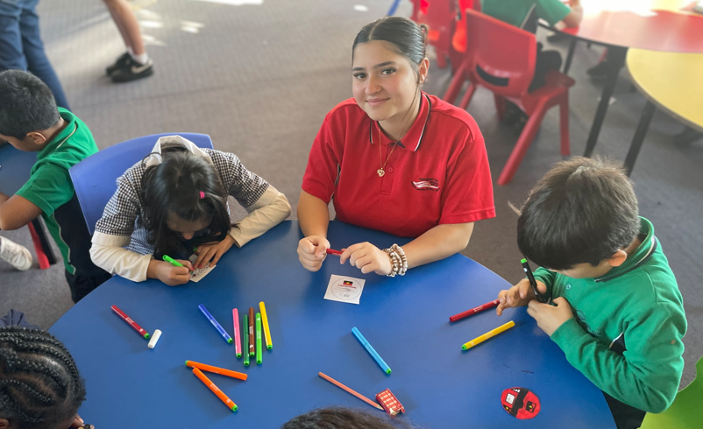
SCIENCE
Science allows students to answer interesting and important questions about the biological, physical, and technological world through observation and experience. Science is a dynamic, collaborative, and creative endeavour arising from our world by exploring the unknown, investigating universal mysteries, making predictions, and solving problems.

The Science curriculum provides opportunities for students to develop an understanding of important scientific concepts and processes, the practices used to develop scientific knowledge, the contribution of science to our culture and society, and its applications in our lives. The curriculum supports students to develop scientific knowledge, understanding, and skills to make informed decisions about local, national, and global issues.

Through the study of science, students experience the joy of scientific discovery and nurture their curiosity about the world around them. Students can engage in the five major disciplines of science: Biology, Psychology, Physics, Chemistry and Environmental Science. In doing this, they develop critical thinking skills and challenge themselves to identify questions, apply new knowledge, explain science phenomena, and draw evidence- based conclusions using scientific methods. Students also develop scientific literacy, including the capacity to investigate the world around them and the way it changes as a result of human activity.
SCIENCE PATHWAYS MAP
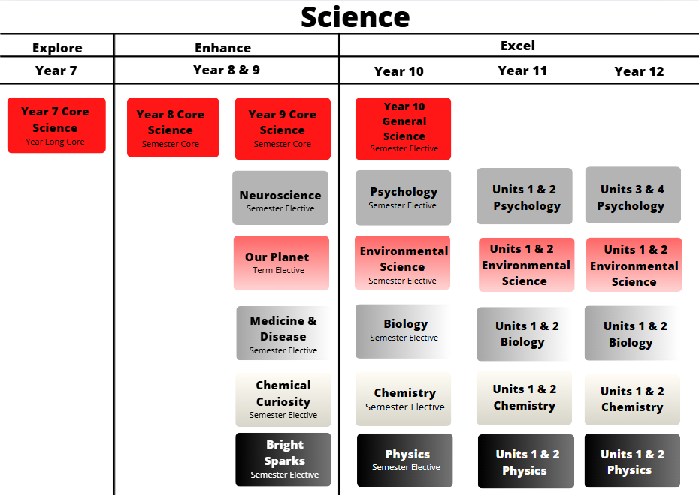

YEAR 7 CORE SCIENCE
Subject Description:
Core Science introduces students to three core fields of science – Chemistry, Biology and Earth science. Students also engage in a unit dedicated to science inquiry, assisting with the development of critical and creative thinking, as well as consideration of ethics in science. As students explore these sciences, they develop important science safety skills as they learn to navigate the science classroom and identify and use scientific equipment. Students complete a variety of practical experiments as they begin to build upon inquiry and investigative strategies that are essential to science. Core Science develops and builds upon these essential skills that students apply not only to science subjects, but to a range of subjects across the curriculum and to their everyday lives.

Assessment:
- Formative assessment strategies such as review quizzes and exit slips.
- Completion of a variety of practical experiments through scientific inquiry projects.
- Scientific reports and communication.
- Case studies.

Advice to Students:
Core Science leads to and contributes to several pathways in the areas of Science, Technologies, Health, and Mathematics. Please note: Acceleration into VCE Chemistry and Physics pathways is not recommended.

Teachers to see for advice regarding this subject:
Ms Marshall and Ms Peters
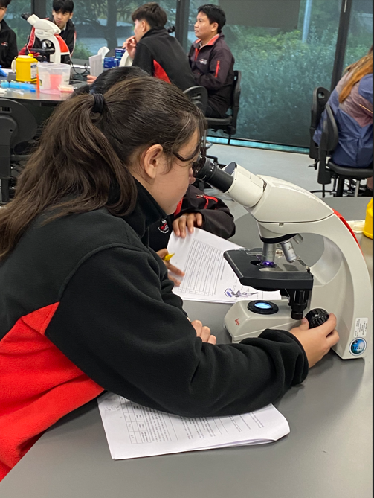

STEM
STEM is an acronym for Science, Technology, Engineering, and Mathematics. STEM enables students to apply knowledge from these subject areas to solve problems creatively using the scientiﬁc method, design process, and various mathematical skills. STEM encourages teamwork and high-level communication, which are both necessary skills in industry as workplaces become more collaborative and digitised. Working on STEM projects and learning tasks helps build resilience as not all endeavours will succeed the ﬁrst time. Processes must be modiﬁed and reﬁned to achieve success. Put simply, STEM helps to develop students into creative problem-solvers and lifelong learners. There is a key focus on Digital Technology and Design Technology in all STEM subjects.
Digital Technology is a major part of our lives and thus, our education. Our STEM subjects allow students to acquire a deep knowledge and understanding of digital systems, data and information, and the processes associated with creating digital solutions so that they can take up an active role in meeting current and future needs of society.
Design Technology uses design thinking, where students plan and manage projects from conception to realisation. They design processes to investigate ideas, generate and reﬁne ideas, plan and manage, and produce and evaluate designed solutions.
STEM PATHWAYS MAP
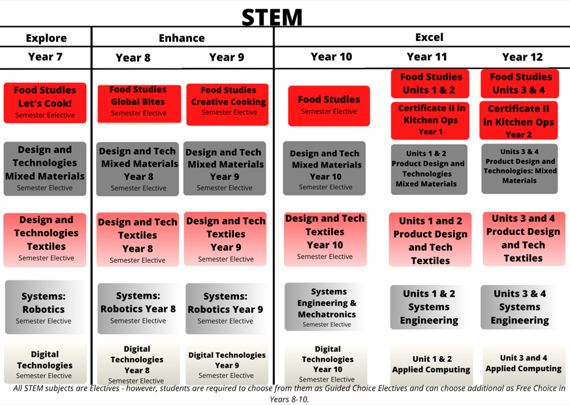

YEAR 7 PRODUCT DESIGN &TECHNOLGY: MIXED MATERIALS OR TEXTILES

Subject Description:
Product Design and Technology is a STEM-based, cross-disciplinary, project learning, subject. It empowers students and allows them to develop their 21st century skills including design thinking, creativity, collaboration, communication, and critical thinking. They engage with new and emerging technologies while also considering and developing more traditional design technology skills and their application.
This subject provides students with the opportunity to work on solving a real-world problem that they are interested in or passionate about. Students work in teams and use the design process; first empathising with and unpacking the problem to be solved, then designing and developing a sustainable solution to the problem, before finally sharing this solution with the community.

Assessment:
- Multimodal records of evidence of research, development, and conceptualisation of products and of reflection.
- Practical work: demonstrations of graphical and physical product concepts including prototyping and making final proofs of concept along with finished products.

Advice to Students:
There are no prerequisites for undertaking this subject. It is recommended for students who have a passion for creating designed solutions and an interest in new and emerging technologies. Students will select either Mixed Materials (Wood, Metals, Plastics) or Textiles.
Teachers to see for advice regarding this subject:
Mr. Spence, Ms. Long, and Mr. Beveridge.
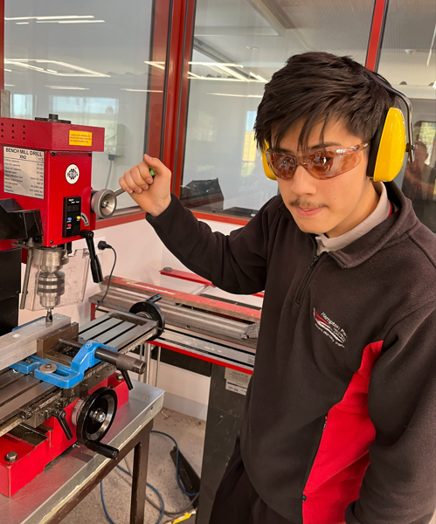

YEAR 7 ROBOTICS (SYSTEMS ENGINEERING)

Subject Description:
In this subject, students learn how to design, build and code VEX IQ robots to solve problems and compete in a variety of challenges. VEX IQ is an easy-to-use robotics system designed to provide all students with access to state-of-the-art robotics, regardless of their skill level. By its nature, the study of robotics provides students with exposure to four areas of STEM (Science, Technology, Engineering, and Mathematics). This subject is for budding engineers, as well as anyone who wishes to develop their teamwork, problem-solving, and leadership skills. The skills acquired provide students with the fundamentals required to select Robotics VEX V5 EDR in the future. VEX robotics is an internationally recognised robotics platform that provides students with opportunities to compete in robotics tournaments across Australia and the world.

Assessment:
- Engineering logbook, documenting the application of the design process to solve an identified need or problem, and evaluating the effectiveness of the solution.
- Robots will be assessed in a range of practical field challenges.
- Written assessments within the logbook include the creation of evaluation criteria, justification of design changes, and reflections.

Advice to Students:
There are no prerequisites for undertaking this subject. Students considering undertaking Robotics should be confident, independent, and self-managed learners. It is recommended for students who have passion for machines, creating designed solutions, coding, and practical mathematics. It is highly recommended that students undertake this subject to study any STEM, physical science, or Digital & Design Technologies subjects in the future.
Teachers to see for advice regarding this subject:
Mr. Beveridge, Mr. Pelicanos, and Mr. D’Auria

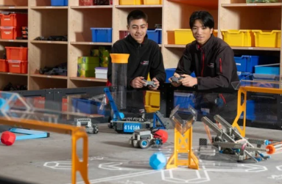

YEAR 7 LET’S COOK! (FOOD STUDIES)

Subject Description:
Let’s Cook! allows students to explore the basics of cooking, including the importance of following safety and hygiene procedures, the use of tools and equipment, and the demonstration of a range of cooking techniques. This subject enables students to build their confidence in the kitchen and allows them to demonstrate their creativity through the production of a variety of food items. Students cook every week, building on the skills learnt and establishing confidence in the kitchen. Students learn about healthy eating and choose their ingredients for certain recipes, to cater for their own likes and dislikes.

Assessment:
- Practical assessment tasks with records of reflection on these activities.
- Research investigation.

Advice to Students:
This subject is for students who enjoy challenging themselves, love food and trying new ingredients, and who are, or would like to be creative, and learn how to make different food for themselves and their families.
Teachers to see for advice regarding this subject:
Ms. Zhao, Ms. Mahwinney and Ms. Bush
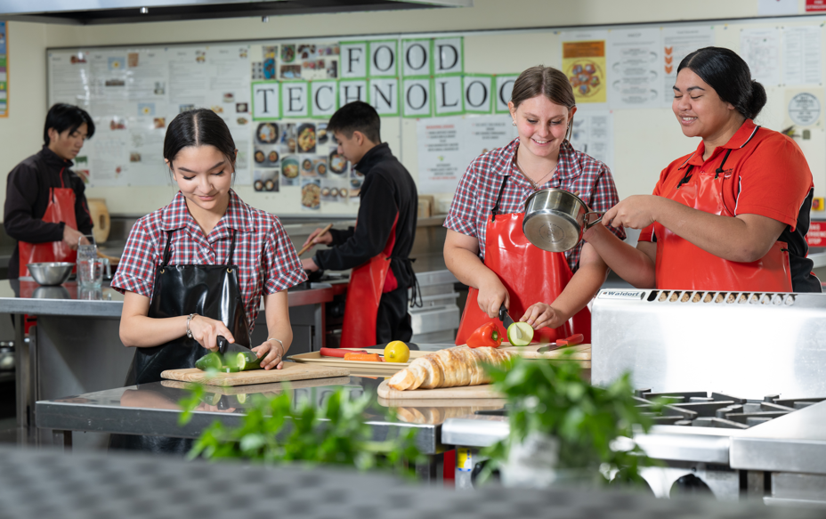

YEAR 7 DIGITAL TECHNOLOGY
Subject Description:
Join us to become a tech-savvy leader in a rapidly evolving digital world! Digital Technologies explores the future of technology with skills in AI, digital security, software, and hardware. In Digital Technology students become experts in cutting-edge tec, coding, and diving into the exciting world of artificial intelligence.

Assessment:
- Practical tasks such as organising files, using proper file naming convention creating and formatting documents
- Data interpretation and evaluation.
- Utilisation and assessment of AI functions.

Advice to Students:
There are no prerequisites for undertaking this subject. It is recommended that students undertake this subject to study any Digital Technology subject in consecutive year levels.

Teachers to see for advice regarding this subject:
Mr. D’Auria, Ms. Liu, Ms. Stewart-North, or Ms. Ellis.
