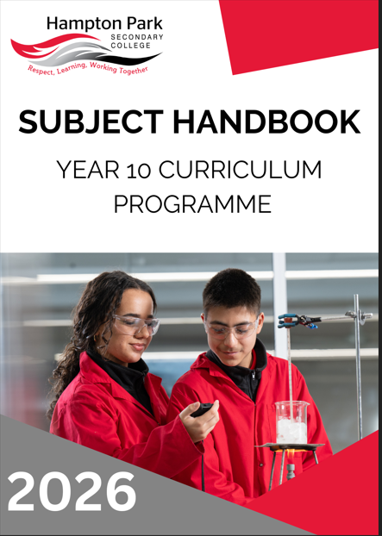

Hampton Park Secondary College
58-96 Fordholm Road
(P.O. Box 480)
Hampton Park Vic 3976 Ph: 03 8795 9400
Fax: 03 8795 9455

Email: hampton.park.sc@education.vic.gov.au
Website: http://www.hpsc.vic.edu.au
Compass: http://hpsc-vic.compass.education

PROPERTY OF AND COPYRIGHTED TO HAMPTON PARK SECONDARY COLLEGE.
NOT TO BE DISTRIBUTED OR SHARED WITHOUT PERMISSION.

VERSION 5
LAST UPDATED November 2025

PRINCIPAL’S INTRODUCTION
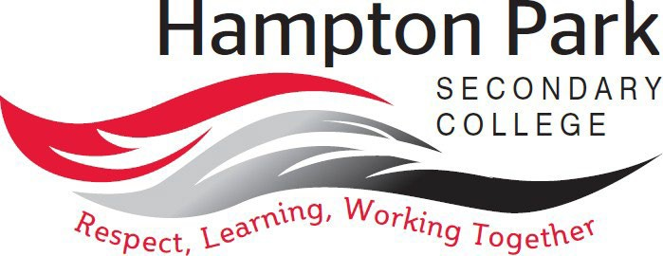

“At Hampton Park Secondary College, we are rich in diversity, and through empowering and engaging students, we remain wholehearted in our pursuit of excellence.”

Our values are Respect, Learning and Working Together
We Respect ourselves, each other, and our school environment and understand that our attitudes and behaviours have an impact on the people around us.
Our key focus is on Learning, improving each day. We acknowledge and celebrate both learning growth and excellence.
By Working Together, we learn from each other and build the skills to achieve our best.
Hampton Park Secondary College is committed to providing an education that is student-centered and where students are empowered with their learning. Our learning program enables students to have more voice, choice, and agency in their learning. In line with this approach is our recognition that all students are unique, and that each student brings their own distinct and individual passions, interests, skills, and knowledge into our learning ecosystem.
We recognise that our young people are entering into a world that is changing at a faster rate than ever before, posing new environmental, political, societal, economic, and technological challenges and complexities that were never imaginable. We believe that by empowering students, we create a learning environment where learning is with students, rather than to students. Our approach to learning supports students regardless of their level of learning and understanding, ensuring that no student is left behind and all can reach their full potential. Through professional learning, individual reflections, learning walks and coaching, teaching staff aim to create optimal conditions for learning.

Wayne Haworth
Principal

COLLEGE VALUES

Respect, Learning, and Working Together
Our vision of learning excellence is underpinned by the Hampton Park Secondary College values of Respect, Learning, and Working Together. Informing our daily interactions and decisions, these values are embedded into our whole school practices and are supported by our Berry Street and Positive Behaviours for Learning approach. We strive to build students who are life-long learners, with high levels of empathy and who are always critical and creative problem solvers.
Our values of Respect, Learning, and Working Together guide our educational programmes within the community in the following ways:
- I respect myself and other people.
- I actively listen to others with an open mind.
- I respect other people’s different perspectives.
- I am inclusive.
- I respect school property and the property of others.
- I wear my school uniform with pride.
- I set personal goals and have high expectations of myself and others to continually improve.
- I have a positive attitude and enthusiasm for learning.
- I strive to achieve my personal best.
- I take pride in the achievements of myself and others.
- I am willing to share ideas, resources, and skills.
- I am helpful and approachable.
- I contribute positively to class, group activities, and the school community.
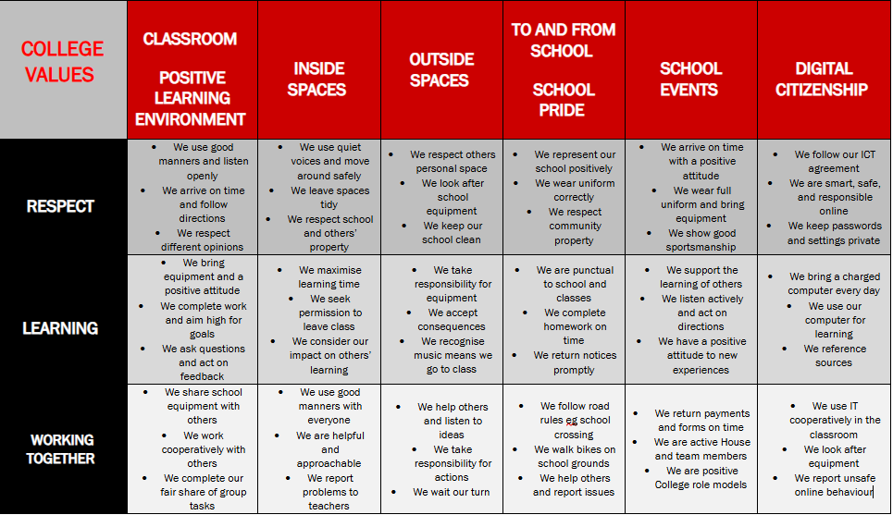
LEARNING AT HAMPTON PARK SECONDARY COLLEGE

College Vison for Teaching and Learning: At Hampton Park Secondary College every student achieves personalised success through the delivery of consistent high quality teaching practice.

Our Teaching and Learning Framework captures our whole school areas of focus, aligned with the priorities of the Department, the VTLM 2.0 and the Victorian Curriculum 2.0. Our framework is used by all teachers as a reflective tool and supports teacher clarity and consistency of practice.

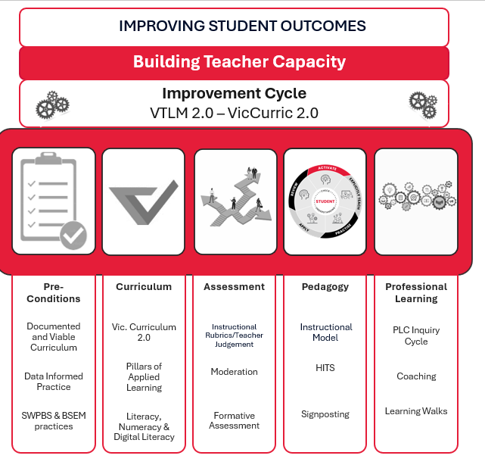
Our Instructional Model brings to life our pedagogical approach and has five phases of learning – Activate, Explicitly Teach, Practice, Apply and Review.
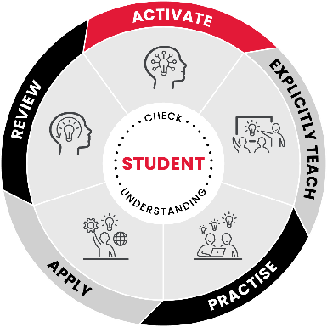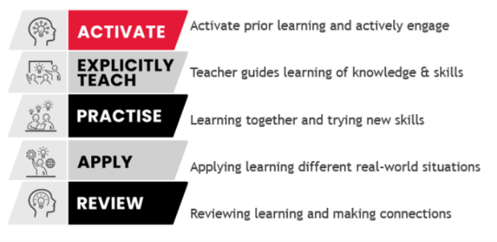

Curriculum Design and Implementation

Hampton Park Secondary College structures its curriculum into three stages or ‘programmes’:
- Explore (Year 7)
- Enhance (Year 8 and 9), and
- Excel (Year 10, 11 and 12)
In Years 7-10, students undertake a combination of core subjects, guided choice (required to choose subjects from specified domain areas) and free choice subjects (except in Year 7, where our focus is on building a strong transition into the College and the skills required for development across the curriculum areas).

YEAR 10 EXCEL - COURSE MAP
The Course Map below shows how the eight Key Learning Areas of the Victorian Curriculum are addressed and delivered at HPSC.
Year 10 - Excel
 | Semester One |  | Semester Two |  | Period Count P/W
Subject / Line 1 | English/EAL - Year Long CORE |  |  |  | 4
Subject / Line 2 | Maths – Year Long  CORE |  |  |  | 4
Subject / Line 3 | Health/PE  Semester CORE |  | Health/PE Elective  GUIDED CHOICE |  | 4
Subject / Line 4 | Science Elective  GUIDED CHOICE |  | Humanities Elective  GUIDED CHOICE |  | 4
Subject / Line 5 | STEM/Arts Elective  GUIDED CHOICE |  | Free Choice Elective |  | 4
Subject / Line 6 | Free Choice Elective |  | Free Choice Elective |  | 4
Connect | Connect- Year long |  |  |  | 1
 |  |  |  |  | Total = 25
Electives- Note: interchangeable across Semesters

In Year 10 (Excel), students are provided with more choice, as they consider learning in Years 11 and 12. Students solidify the skills required for success in senior subjects linked to their chosen pathway/destination. Students must still study CORE subjects to ensure the required breadth across the Curriculum.
To ensure students learn across all disciplines, whilst ensuring choice, students then choose Guided Choice Electives from the areas of:

- Design and Technology, or Digital Technology
- Performing Arts or Visual Arts
- Science
- Humanities
- Health and PE
Across Year 9 and 10 students must have studied 1 Digital Technology, 1 Design Technology, and either 1 Performing Arts or Visual Arts subject.

Students then have Free Choice subjects to choose from.
- If students were to choose a Language, this is where they would study it
- Any student who has been recommended to study an Advanced Math or Advanced English Pathway, would do their advanced subject in this block
- Free Choice can also come from English/Arts/STEM/Humanities/Science/or Health and PE

CONNECT
Hampton Park Secondary College runs a Connect Program for students in Years 7-10, to provide opportunities for increased connectedness and a deeper understanding of self. The Connect Program runs for one period a week.

In Years 7 -9, in Connect, students focus is on:
- Self-reflection and goal setting, supported through the development of Student Learning Portfolios and their presentation through Student Led Conferences
- Careers and Pathways Education
- Social and Emotional Learning, facilitated through the implementation of Berry Street Strategies and our approach to School Wide Positive Behaviours, as well as Respectful Relationships

In Year 10, students focus primarily on developing their understanding of Careers and Pathways Education through the study of one WRS unit (Work Related Skills), from the VCE Vocational Major. This unit also supports students to access and engage with meaningful Work Experience. Social and Emotional Learning and self-reflection and goal setting skills are explicitly taught through relevant subjects where the capabilities are reported on and assessed against, this includes Respectful Relationships.

Student Led Conferences empower students to lead a reflective conversation about their learning journey.

Year 7-9 students present Student Learning Portfolios to their families. Students share their learning goals with subject teachers and families in the first of the Student Led Conference in Semester 1. In the Term 3 Conference, students present their Learning Portfolio to a Connect or significant teacher and their families. They share their reflections of learning across subjects for the year drawing on examples in their portfolios, addressing goals set and their next steps.

Year 10-12 students engage in a conversation with their families and teachers at both conferences to share their learning progress, strengths and areas for growth. Teachers and families follow the students lead, asking questions to promote learning growth and reflection.
Conferences are held twice per year, mid Semester 1 and the end of Term 3 and can be undertaken virtually if required.

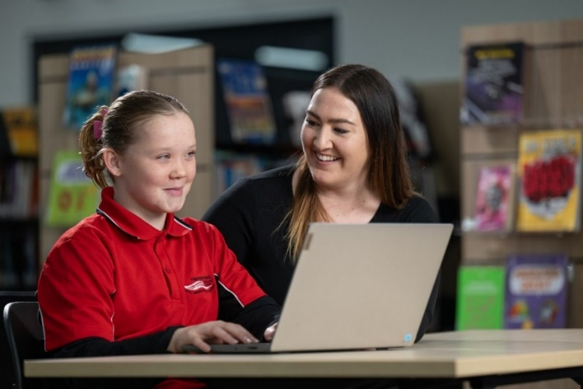

YEAR 10 SUBJECTS (EXCEL)
The following is a list of Year 10 studies offered at Hampton Park Secondary College. Please refer to the relevant information about each study in the handbook and speak to the nominated staff listed in the subject description. Students should refer to the Excel Handbook if applying for an accelerated study.
ARTS (VISUAL & PERFORMING)
Art Making and Exhibiting – Year 10
Drama and Theatre Studies – Year 10
Media – Year 10
Music – Year 10
Art Making and Exhibiting – Year 10
Visual Communication Design – Year 10
ENGLISH
Year 10 English & EAL
Year 10 English Skills
Year 10 English Support
Year 10 Literature – Banned Books
HEALTH & PHYSICAL EDUCATION
Core Health and Physical Education – Year 10
Health and Human Development – Year 10
Advanced Physical Education – Year 10
Rugby Academy – Years 8, 9 and 10 (Physical Education)
Soccer Academy – Years 8, 9 and 10 (Physical Education)
Sport and Recreation – Year 10
HUMANITIES
Accounting – Year 10
Business Management – Year 10
Geography – Year 10
History – Year 10
Legal Studies – Year 10
Philosophy – Year 10

LANGUAGES
Arabic – Year 10
French – Year 10
Japanese – Year 10
Persian – Year 10
MATHEMATICS
Year 10 Mathematics – Core, Skills, Support and Advanced
Year 10 Pre Methods
SCIENCE
Biology – Year 10
Chemistry – Year 10
Environmental Science – Year 10
Physics – Year 10
Psychology – Year 10
General Science – Year 10
STEM (DIGITAL & DESIGN TECHNOLOGIES)
Applied Computing – Year 10
Systems Engineering – Year 10
Food Studies – Year 10
Design and Technology - Mixed Materials OR Textiles – Year 10
Digital Technologies – Year 10

VISUAL AND PERFORMING ARTS

The Arts include Dance, Drama, Media, Music, Visual Arts, and Visual Communication and Design.

The Arts enable students to develop their creative and expressive capacities by learning about the different practices, disciplines, and traditions that have shaped the expression of culture - locally, nationally, and globally. Students are both artists and audience members in the Arts. They make, respond and learn to appreciate the specific ways this process occurs in different disciplines.

The Arts present ideas that are dynamic and rich in tradition. Through engaging in The Arts, students are entertained, challenged, and provoked to respond to questions and assumptions about individual and community identity, considering different histories and cultures. The Arts contribute to the development of confident and creative individuals and enrich Australian society. Students express, represent, and communicate ideas in contemporary, traditional, and emerging art forms. In Dance, Drama, and Music students explore the performing arts, whilst in Media, Visual Arts, and Visual Communication and Design students explore the world of visual representation and expression – the visual arts.

The significant contributions of Aboriginal and Torres Strait Islander peoples to Australia’s arts heritage and contemporary arts practices are explored across The Arts, and students are encouraged to respect and value these unique and evolving traditions.

PATHWAYS MAP FOR VISUAL AND PERFORMING ARTS
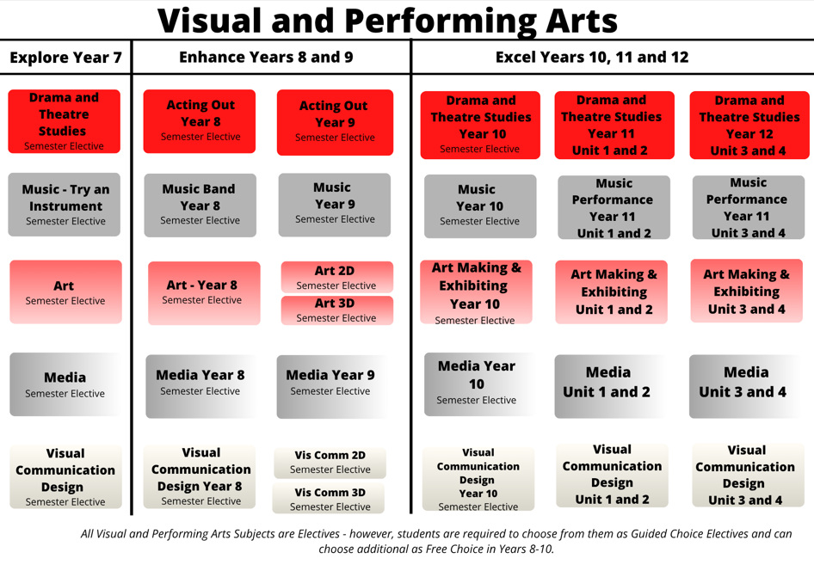

ART MAKING AND EXHIBITING - YEAR 10

Subject Description:
Year 10 Art Making and Exhibiting is for students who are passionate about making artwork and are interested in the way the art world operates. In this subject, students experience what it is like to be an artist in the studio, an exhibiting artist, and an artist in other contexts. By examining the roles and practices of artists in society, students develop an understanding of the way artists work across a range of cultures and periods of time. Students gain insight into artistic perception, the role of beliefs and intention in artistic process, and the artist’s relationship with the viewer. This elective focusses on a range of artforms that may include drawing, painting, printmaking, mixed media, digital art, and three-dimensional artforms.

Assessment:
- A folio of developmental and finished artworks.
- Presentation of own artworks.
- Written and aural tasks about the studio practice of renowned artists from various times and places.
- Peer review and self-assessment.
- Assessment processes will involve rubrics adapted from the Art Making and Exhibiting study design.
- Students will sit an examination for this subject.

Advice to Students:
There are no pre-requisites for this subject, however students should be confident, independent, and self-managed learners who are passionate about the creative process of artmaking. Students should be aware that this subject is designed to develop the necessary skills required to undertake VCE Art Making and Exhibiting. It is highly recommended that students take Year 10 Art Making and Exhibiting if they wish to take VCE Art Making and Exhibiting in the following year.
Teachers to see for advice regarding this subject:
Ms. Fee and Mr. Horsfall

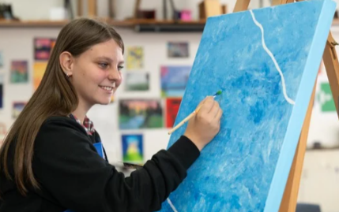

DRAMA AND THEATRE STUDIES – YEAR 10

Subject Description:
Have you ever wanted to design the next superhero costume? Have you ever wanted thunder to crash with your every word? How do you build a swamp? Students will go on a journey that will prepare them for all that VCE Drama and Theatre Studies has to offer. They will explore a range of styles, scenes, and characters, use lighting and sound to enhance performance, prepare to entertain audiences, and take a trip to the theatre. Students will be encouraged to participate in school and/or house productions to further their experience.
This will include experiencing such elements as:
- Lighting and sound design.
- Costume and sake-up design.
- Prop and set building.
- Acting and directing.
- Artwork and advertisement.
- Stage management.
The group will work as a production team, take on a script and design a show from the ground up, creating a product for a performance evening!

Assessment:
- Research assignments.
- Reflection based assessment tasks.
- Practical drama activities, exercises, and presentations.
- Creating and developing a devised ensemble performance.
- Presenting a devised performance.
- Analysis and evaluation of own and others’ work.
- Students will sit an examination for this subject.

Advice to Students:
There are no prerequisites for undertaking any Drama subject, however, you must be willing to participate in all activities, work with others, and bring positive energy!
This subject continues to build important skills in drama; however, it is not directly linked to VCE Drama studies.
Teachers to see for advice regarding this subject:
Ms. Windross or Ms. Scerri
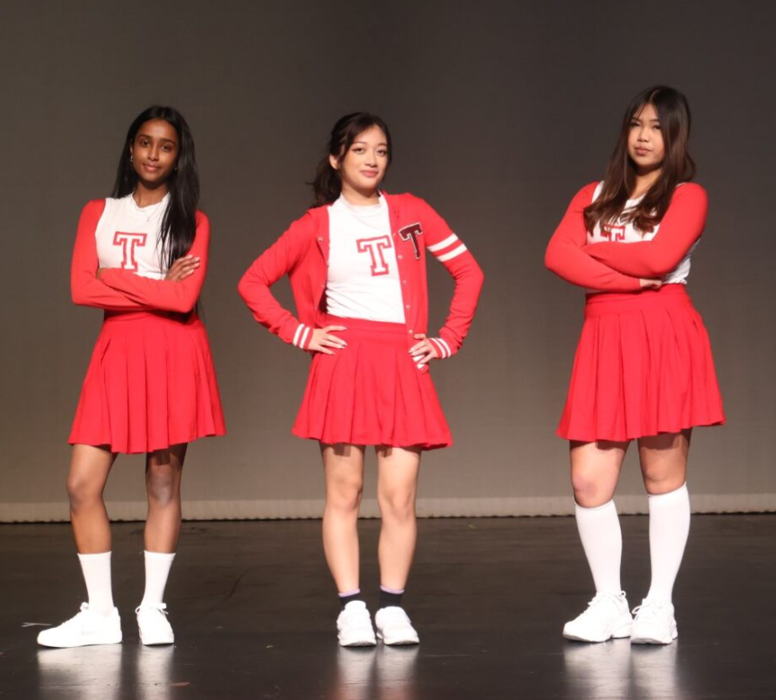

MEDIA - YEAR 10

Subject Description:
This subject introduces students to the practical and theoretical skills that they will use in VCE Media. In this subject, students study the basics of film analysis, cinematic formal elements, genre, and narrative structure. They develop the skills to recognise, analyse, describe, and enjoy film as an art and entertainment form. Students learn to understand how films are constructed to make meaning and engage audiences. They are introduced to the basic ‘building blocks’ and formal elements (narrative, mise-en-scène, cinematography, sound, and editing) that make up a film, as well as some fundamental principles of analysis, genre, style, performance, and storytelling.
Students learn the knowledge and skills that will help them to undertake VCE Media. Students analyse and evaluate how technical and symbolic elements are manipulated in media artworks to challenge representations framed by social beliefs and values in different community and institutional contexts. Students develop and refine media production skills to integrate and shape the technical and symbolic elements in image, sound, and text to represent a story, purpose, meaning, and style.

Assessment:
- Ongoing portfolio of short media products.
- Short and medium length analysis tasks.
- Research assignment.
- Students will sit an examination for this subject.

Advice to Students:
It is highly recommended that students take Year 10 Media if they wish to study VCE Media in the following year.
Teachers to see for advice regarding this subject:
Mr. Marriott and Mr. Kriaris

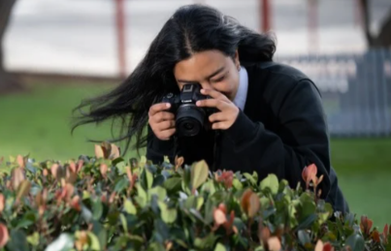

MUSIC - YEAR 10

Subject Description:
In this subject, students familiarise themselves with the three learning areas of VCE Music. They develop solo and group performance as well as rehearsal skills on one or more instruments. Students build their ability to overcome technical and expressive challenges relevant to their performances. Students will study vital listening, aural, theoretical, and analytical skills required for studying Music at a VCE level.

Assessment:
- Performances, including ensemble and group work.
- Listening tasks.
- Composition.
- Students will sit an examination for this subject.

Advice to Students:
There are no prerequisites for undertaking this subject, however, it is recommended that students have at least two years’ experience playing an instrument.
It is highly recommended that students have undertaken at least one Enhance Music subject and/or Instrumental Music lessons (or do so concurrently) to support their understanding of this class.
Teachers to see for advice regarding this subject:
Ms. Le, Ms. Nguyen, and Ms. Hutton

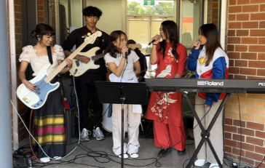

STREET ART - YEAR 10 (ART MAKING AND EXHIBITING)

Subject Description:
Street art is the type of art that inspires our day-to-day experiences in public and community spaces. This subject investigates how street art and similar types of art practice can inform, challenge, delight, and provide a sense of belonging through both the creative process and the experience of the viewer. Students engage in an artmaking practice that aims to enrich and inspire the community of HPSC.
Indoor and outdoor projects will be proposed and developed by students and could include murals, mosaics, aerosol stencilling, 2D and 3D installations, ‘wood blocking’, textiles, sticker art, zine production, digital projections, and 'land' art. Students develop artmaking ideas from their own experience of popular culture, humour, nostalgia, nature, human experience, and identity. Sustainable practices will be a consideration in student praxis.

Assessment:
- Folio based assessment: An ongoing studio process involving brainstorming, art trials and development, individual student projects, and collaborative projects in a range of street art forms.
- Written worksheets and research tasks.
- Written reflection and evaluation of student’s own art.
- Students will sit an examination for this subject.

Advice to Students:
There are no prerequisites for undertaking this subject. Students considering undertaking this subject should be confident, independent, and self-managed learners who are passionate about the creative process of art making and working in the community.
This subject continues to build important skills in Visual Art; however, it is not directly linked to VCE Art Making and Exhibiting studies.
Teachers to see for advice regarding this subject:
Ms. Fee, Ms. Long, and Mr. Horsfall

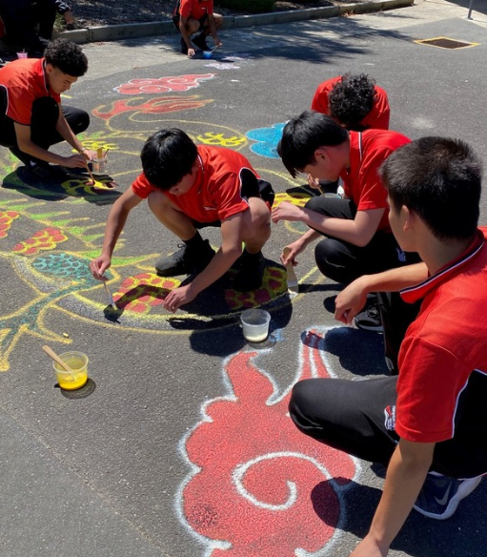

VISUAL COMMUNICATION DESIGN - YEAR 10

Subject Description:
Do you enjoy designing? Do you have a creative mind? This subject is recommended for anyone who is interested in the design industry. This course will give students the opportunity to explore aspects of the design fields of messages and interactive experiences as they learn about the use of the design elements and principles in conjunction with media, materials, and methods to produce visual communications. Students will learn to use industry standard software, such as Adobe Creative Cloud, and develop designs that utilise specialist equipment, such as laser cutters, to create original designs. Students will develop important knowledge and skills needed to undertake Visual Communication Design as a part of their VCE.

Assessment:
- Portfolio of final presentations.
- Visual communication analysis.
- Design process development work.
- Pitch presentation and evaluation.
- Students will sit an examination for this subject.

Advice to Students:
This subject will provide students with a foundation in the key concepts covered throughout VCE Visual Communication and Design. It gives students opportunities to improve the key skills and knowledge encountered in VCE. This subject is highly recommended to those who are planning to study VCE Visual Communication and Design in the following year.
Teachers to see for advice regarding this subject:
Ms. Grove

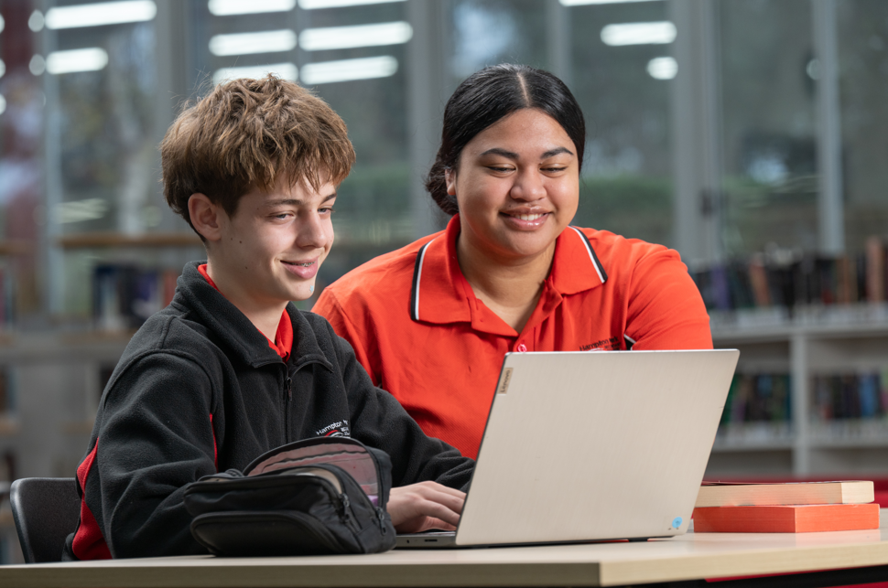
ENGLISH & ENGLISH AS AN ADDITIONAL LANGUAGE (EAL)
The study of English is central to the learning and development of all young Australians. It helps create confident communicators, imaginative thinkers, and informed citizens. It is through the study of English that individuals learn to analyse, understand, communicate, and build relationships with others and with the world around them. The study of English helps young people become ethical, thoughtful, informed, and active members of society.
What distinguishes English from other subjects is not only the skills it develops, but its central subject matter. The central concern of English is with the study and application of how language works in a range of contexts and media. English is further defined by the nature of the texts studied. English is essentially the study of language as a social and cultural form. English is also defined by the values it tries to create. English has been about the shaping of the 'self', by exploring humane values, imaginative life, and the development of aesthetic sensibility through engagement with literary texts. Today, this includes students understanding how their 'self' is located within social and cultural contexts and constructed through language and text.
PATHWAYS MAP FOR ENGLISH & EAL
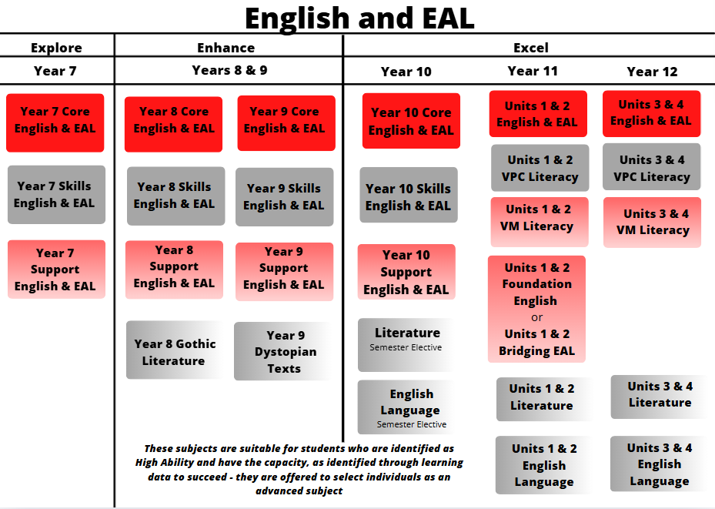
The acquisition of skills will determine the pathway students take in English. Pathways are individualised and are informed by data and learning progress

YEAR 10 CORE ENGLISH & EAL

Subject Description:
The big idea for English/EAL is communication. Students learn in four key areas: speaking, listening, reading, and writing. Students engage with a reading framework and learn public speaking skills. Students learn to write in three key genres: creative, persuasive, and analytical. Year 10 English/EAL aims to mirror the skills and demands students will experience in VCE English and VCE VM or VPC Literacy. Students engage with texts to develop their understanding and write in-depth analyses in response to a given prompt. They further develop their writing skills by producing a creative or persuasive piece and documenting the writing process. Students extend their skills in argument analysis by analysing a range of persuasive texts. They also learn to present their point of view on a recent and relevant issue.

Assessment:
- Text analysis essays and analysing argument essays.
- Creation of own texts in response to a specific context and audience to achieve a stated purpose.
- Written reflections and an oral presentation.
- Students will sit an examination for this subject.

Advice to Students:
Students must undertake this subject, if they are not undertaking English Skills or Support. To enter a university course, mainstream English students must achieve a minimum study score of 25 and EAL students must achieve a minimum study score of 30.

Teachers to see for advice regarding this subject:
Ms. Noble and Mr. Antil
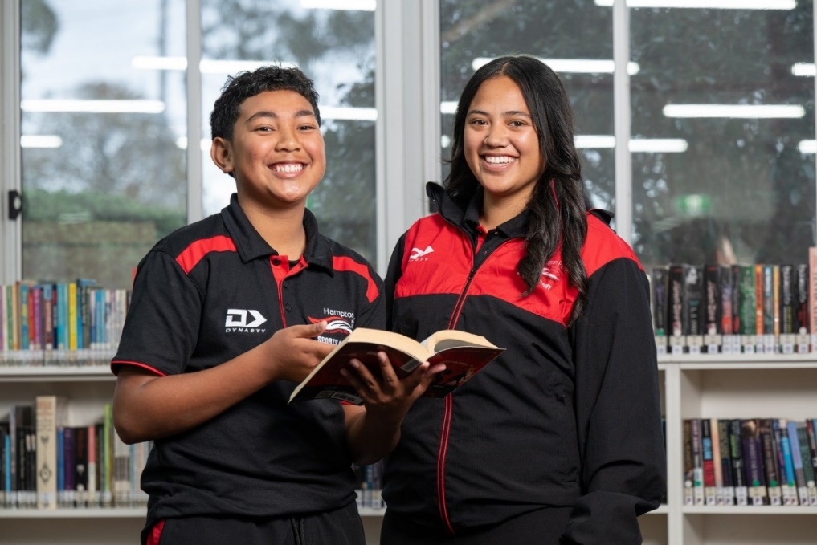
YEAR 10 ENGLISH SKILLS & EAL

Subject Description:
English Skills/EAL focuses on building strong foundations in reading, writing, speaking, and listening. The big idea for this subject is communication through literacy. Students participate in explicit, systematic phonics instruction to strengthen their decoding and spelling skills. Reading comprehension and fluency are developed through targeted practice and exploration of engaging texts.

Students study key areas of the English and EAL curriculum, text analysis (novel and film), persuasive writing and speaking, and narrative writing through the genre of horror.

Assessment:
- Oral Reading Fluency assessment
- Comprehensive phonics assessment
- Written responses to varied text types
- Persuasive and narrative writing pieces
- Oral presentations and reflections

Advice to Students:
English Skills is designed to help students strengthen their literacy skills and confidence in preparation for success in English and EAL and across all subjects. It provides additional time and targeted teaching to ensure students can participate fully in the English and EAL curriculum and progress toward VCE English, EAL, or VCE VM/VPC Literacy pathways.

Teachers to see for advice regarding this subject:
Mrs. Spence
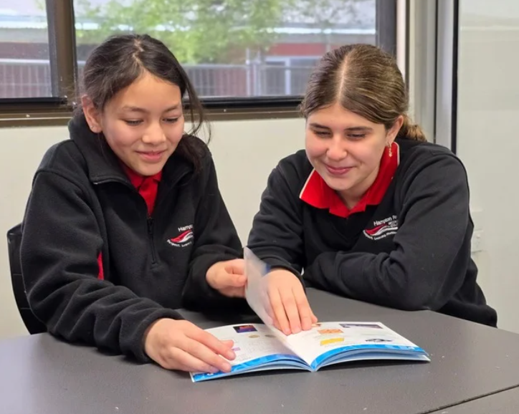
YEAR 10 ENGLISH SUPPORT & EAL
Subject Description:
English Support/EAL builds on foundational literacy skills to develop students’ confidence and independence in reading, writing, speaking, and listening. The big idea for this subject is growth in communication and comprehension. Students move beyond basic decoding to focus on vocabulary development, sentence structure, paragraphing, and cohesive writing. Reading comprehension and fluency are extended through the study of increasingly complex texts.

Students study the key areas of the English and EAL curriculum, including text analysis (novel and film), persuasive writing and oral presentation, and narrative writing. The focus is on applying and extending literacy skills to understand ideas, purpose, and audience.

Assessment:
- Reading comprehension and fluency assessment
- Written responses to studied texts
- Persuasive and narrative writing pieces
- Oral presentations and reflections

Advice to Students:
English Support is designed for students who are developing more advanced literacy skills but may still require additional guidance before moving into core English and EAL. This subject helps bridge the gap to ensure success across the curriculum and provides the skills needed to progress confidently toward VCE English, EAL, or VCE VM/VPC Literacy.

Teachers to see for advice regarding this subject:
Mrs. Spence
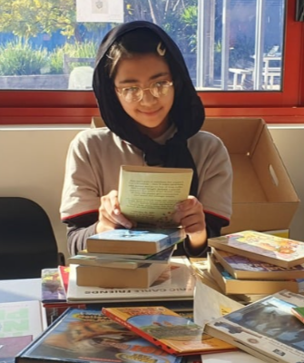

LITERATURE - YEAR 10

Subject Description:
The study of Literature fosters students’ enjoyment and appreciation of the artistic and aesthetic merits of stories and storytelling and enables students to participate more fully in the cultural conversations that take place around them. By reading and exploring a diverse range of established and emerging literary works, students become increasingly empowered to discuss texts. As both readers and writers, students extend their creativity and high order thinking to express and develop their critical and creative voices. Throughout this study, students deepen their understanding of themselves as readers. They expand their frameworks consider literary forms and features, engage with language, and refine their insight into authorial choices. Students immerse themselves in fiction and non-fiction texts, discovering and experimenting with a variety of interpretations in order to develop their own responses.

Assessment:
- A close analysis of selected passages.
- A creative response a text.
- An analytical response to a text.
- A comparative response.
- Students will sit an examination for this subject.

Advice to Students:
This subject introduces the study of Literature and will help prepare students for VCE Literature by focusing on some of the areas of study and methods of critical analysis by using a range of literary text-types. It is highly recommended that students study this subject prior to studying Literature Units 1 & 2. However, this unit is taken in addition to the Core English Units 1 & 2 for VCE studies.

Teachers to see for advice regarding this subject:
Mr. Antil

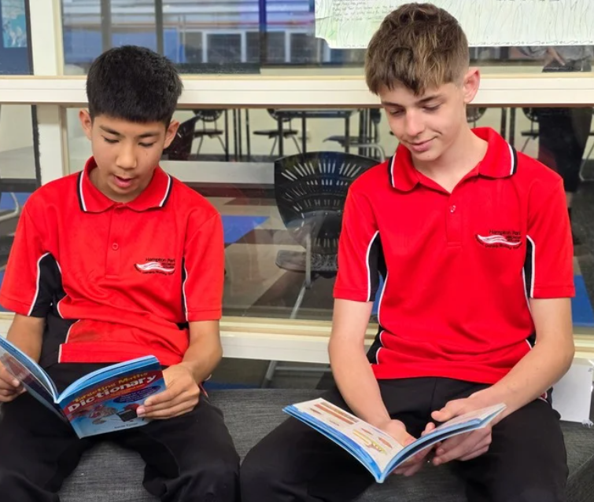

EVOLUTION OF ENGLISH LANGUAGE - YEAR 10 (ENGLISH LANGUAGE)

Subject Description:
Year 10 Evolution of Language is an elective subject for students in Year 10. This subject explores language from a different and original perspective. Students learn how English language, both spoken and written, is used in different contexts. Students also investigate language features used by speakers of English from diverse backgrounds. In this study, a range of written and spoken texts are explored, including YouTube clips, social media examples, and Memes. Students also learn how language is used to construct identities and they explore how language creates a sense of a shared community, such as Teen-speak, e-chat and youth subcultures. Students investigate the process of first language acquisition (e.g., ‘baby-talk’ and ‘toddler talk’) along with the evolution of English language over time. Some of the skills developed through this subject are word knowledge, language variation and change, texts in context, analytical skills, and research skills. “The English language is a work in progress. Have fun with it.” Jonathan Culver

Assessment:
- Short answer questions.
- A research essay.
- A case study.
- An analysis of spoken and written text
- Students will sit an examination for this subject.

Advice to Students:
This subject is taken in addition to Core English. Completion of this course will prepare students for the study of VCE English or VCE English Language. It is highly recommended that students study this subject prior to studying English Language Units 1 & 2.

Teachers to see for advice regarding this subject:
Mr. Antil

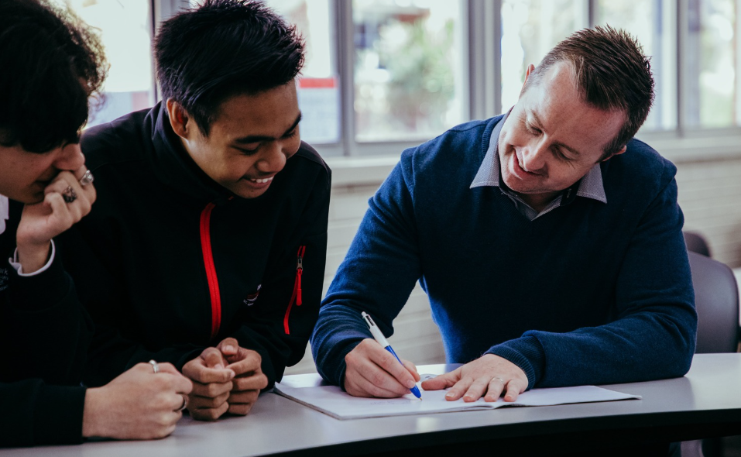

HEALTH & PHYSICAL EDUCATION

Health and Physical Education focusses on students enhancing their own and others’ health, safety, wellbeing, and physical activity and participation in varied and changing contexts. Research in fields such as sociology, physiology, nutrition, biomechanics, and psychology informs what we understand about healthy, safe, and active choices. Health and Physical Education oﬀers students an experiential curriculum that is contemporary, relevant, challenging, enjoyable, and active.

In Health and Physical Education, students develop knowledge, understanding, and skills to strengthen their sense of self and build and manage satisfying relationships. The curriculum helps them to be resilient and make decisions and take actions to promote their health, safety, and physical activity participation.
Integral to Health and Physical Education is the acquisition of movement skills, concepts, and strategies to enable students to participate in a range of physical activities conﬁdently, competently, and creatively. As a foundation for lifelong physical activity participation and enhanced performance, students develop proﬁciency in movement skills, physical activities, and movement concepts, and acquire an understanding of the science behind how the body moves.
PATHWAYS MAP FOR HEALTH & PE
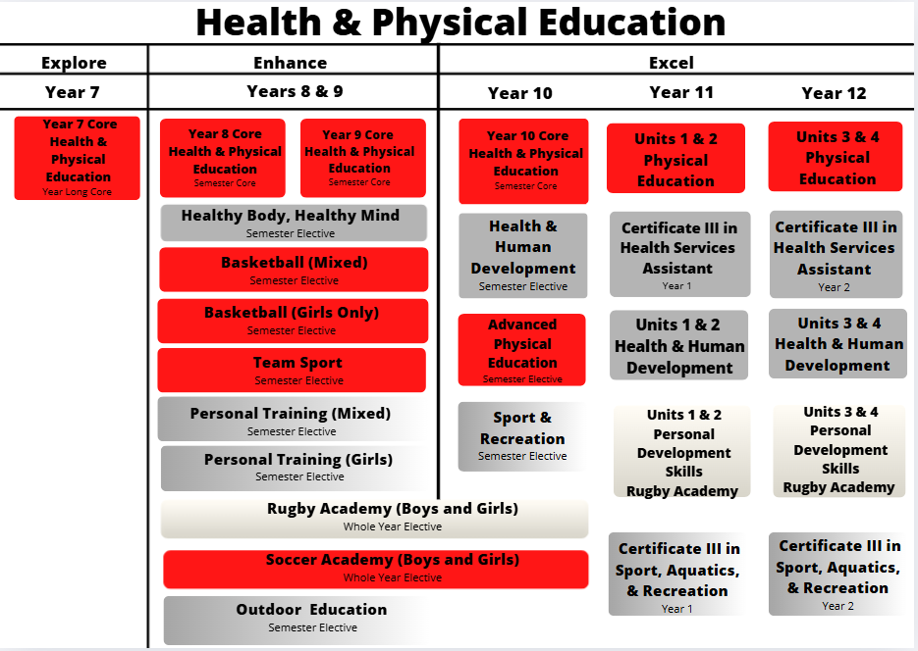

YEAR 10 CORE HEALTH AND PHYSICAL EDUCATION

Subject Description:
The Year 10 curriculum supports students to refine and apply strategies for maintaining a positive outlook and evaluating behavioural expectations in different leisure, social, movement, and online situations. In Year 10, students learn to apply more specialised movement skills and complex movement strategies and concepts in different movement environments. They also explore movement concepts and strategies to evaluate and refine their own and others’ movement performances. Students analyse how participation in physical activity and sport influence an individual’s identities and explore the role participation plays in shaping cultures.

Focus areas to addressed in year 10 include:
- Alcohol and other drugs (AD).
- Food and nutrition (FN).
- Health benefits of physical activity (HBPA).
- Relationships and sexuality (RS).
- Safety (S).
- Lifelong physical activities (LLPA).

Assessment:
- Personal analysis and goal setting.
- Harm minimisation booklet.
- CPR practical assessment.
- Students will sit an examination for this subject.

Advice to Students:
All Health and Physical Education subjects lead to a VCE PE Pathway, VCE VET Health Services Certificate, or VCE VM pathway. This subject combines both practical and theory classes like VCE Physical Education. This core subject runs for one semester and is comprised of practical and theory lessons each week.
Students MUST Purchase the College Physical Education uniform to participate in practical sessions.

Teachers to see for advice regarding this subject:
Ms. Porter, Mr. Van Pelt, and Miss. Newton



HEALTH AND HUMAN DEVELOPMENT - YEAR 10

Subject Description:
The Year 10 Health and Human Development elective aims to build the key knowledge and skills needed to succeed in VCE Health and Human Development. Students wishing to pursue the VCE subject are strongly encouraged to complete this elective, however it is not a pre-requisite. The topics and skills covered are grouped into three main components - Individual, national, and global health and wellbeing. Students who complete this elective develop a deep understanding of dimensions of health, human development, and data analysis.
Topics covered include:
- The dimensions and interrelationships of health and wellbeing.
- Individual health including nutrition and mental health.
- Global health, including human development and health in low-income countries.
- Data analysis and how to answer VCE style questions.

Assessment:
- Youth health advocacy project.
- Structured questions: Students will complete structured questions that cover the topics learnt during the semester. The questions will include short answer questions, case studies, and data analysis. This mimics a VCE SAC task.
- Students will sit an examination for this subject.

Advice to Students:
It is recommended that students wishing to complete VCE Health and Human Development choose Year 10 Health and Human Development. This subject prepares students for the demands, and key skills and knowledge required to succeed in VCE Health and Human Development.

Teachers to see for advice regarding this subject:
Ms. Raynes and Miss. Newton

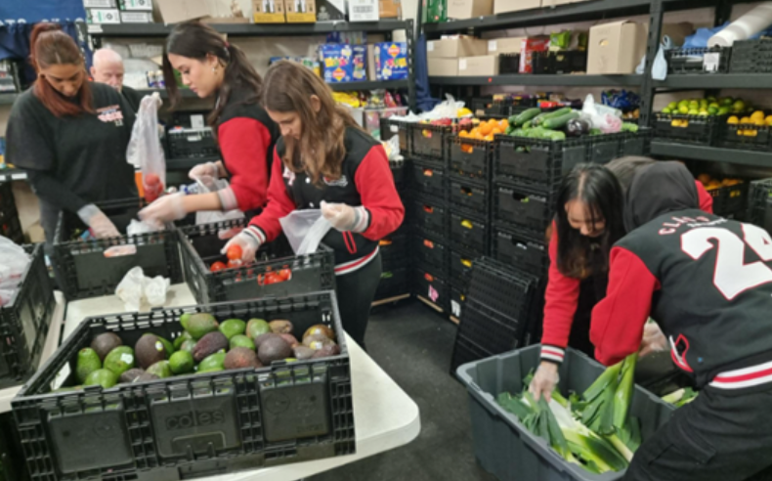

PHYSICAL EDUCATION - YEAR 10

Subject Description:
In the Physical Education elective, students are provided with the opportunity to develop a basic understanding and appreciation of the importance of physical fitness and nutrition for optimum sporting performance. Students will increase their knowledge of the theory and practice of performance in sport.
Topics covered include:
- Investigate sports injuries and management.
- Learn about body systems (respiratory, cardiovascular, muscular, and skeletal).
- Study the benefits of fitness.
- Study the use of energy systems in sport.
- Study psychological factors that affect sporting performance.
- Study biomechanics in sport and apply coaching principles for sporting success.
- Analyse games, movement patterns, and heart rate responses to exercise.

Assessment:
- Practical Laboratory Report: Collect and analyse information from, and participate in, a variety of physical activities to develop and refine movement skills from a coaching perspective.
- Reflection folio and training programme: Participate in a variety of training methods and design and evaluate training programmes to enhance specific fitness components.
- Students will sit an examination for this subject.

Advice to Students:
The VCE Physical Education elective aims to build the key knowledge and skills needed to succeed in VCE Physical Education. Students wishing to pursue the VCE subject are strongly encouraged to complete this elective, however it is not a pre-requisite. This subject combines both practical and theory classes, similar to VCE Physical Education.
Students MUST purchase the College Physical Education uniform to undertake this subject.

Teachers to see for advice regarding this subject:
Ms. Porter and Mr. Van Pelt

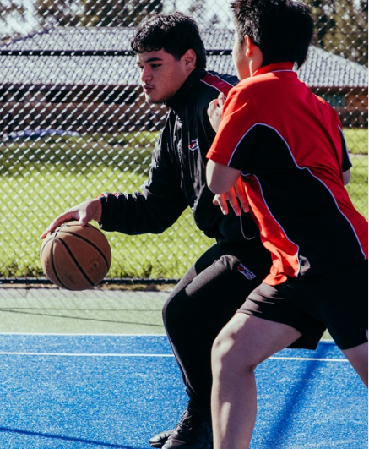

RUGBY ACADEMY (PHYSICAL EDUCATION) – Years 8, 9 and 10 Students

Subject Description:
The Rugby Academy aims to provide an opportunity for students who are passionate about rugby to develop their skills, fitness, and game play in a variety of Rugby codes (i.e., Touch Football, Rugby League, Rugby Union). Sessions per week are dedicated to developing sport specific fitness and conditioning, as well as improving skills, extending strategic understanding, and participating in match simulation. Additionally, students develop a holistic understanding of strategies for improving mental, social, emotional, and physical health, both inside and outside the classroom. This programme explores culture, identity, and what it means to actively contribute to a team through personal development. Students develop their leadership and teamwork skills, and throughout the unit are expected to represent the College at a variety of interschool sporting events. The Academy requires students to participate in Gala Days and has engaged a professional coach.

Assessment:
- Practical and fitness assessments.
- Umpiring and coaching.
- Performance and reflections in competitive events.

Advice to Students:
Rugby Academy is a year-long subject which is part of a three-year programme that prepares students for their chosen pathway. All Health and Physical Education subjects lead to a General VCE Physical Education or Health and Human Development pathway, VCE VET Sport & Recreation Certificate, or VCE VM Personal Development Skills pathway.
Students MUST purchase the College Physical Education uniform, as well as rugby boots and a mouthguard to undertake this subject.

Teachers to see for advice regarding this subject:
Ms. Louden and Mr. Hare
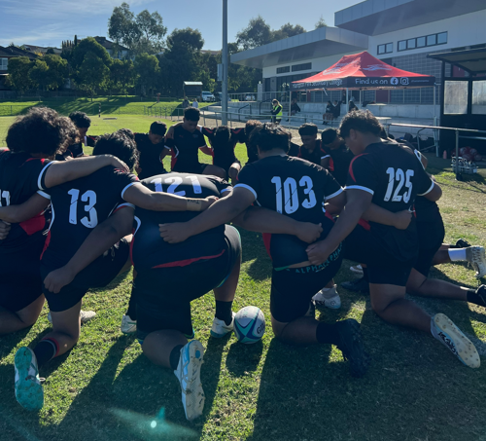

SOCCER ACADEMY (PHYSICAL EDUCATION) – Years 8, 9 and 10 Students

Subject Description:
The Soccer Academy aims to provide an opportunity for students who are passionate about Soccer to develop their skills, fitness, and game play in a variety of Soccer codes (i.e., Outdoor 11 aside, Indoor 6-aside and Futsal). Sessions per week are dedicated to developing sport specific fitness and conditioning, as well as improving skills, extending strategic understanding, and participating in match simulation. Additionally, students develop a holistic understanding of strategies for improving mental, social, emotional, and physical health, both inside and outside the classroom. This programme explores culture, identity, and what it means to actively contribute to a team through personal development. Students develop their leadership and teamwork skills and are expected to represent the College in a variety of interschool sporting events. The Academy requires students to participate in weekly trainings and Gala Days and competitive events as part of their assessments.
Assessment:
- Data analysis and individual training program.
- Umpiring and coaching.
- Performance and reflections in competitive events.
- Progress in skill development.
Advice to Students:
Soccer Academy is a year-long subject which is part of a two-year programme that prepares students for their chosen pathway. The Soccer programme is both a male and female subject with opportunities for students to participate in training sessions in mixed gender groups as well as gender-based groups. Students can participate with the group they best identify. All Health and Physical Education subjects lead to a General VCE Physical Education or Health and Human Development pathway, VCE VET Sport & Recreation Certificate, or VCE VM Personal Development Skills pathway.
Students MUST purchase the College Physical Education uniform, as well as football boots, mouthguard and shin guards to undertake this subject.

Teachers to see for advice regarding this subject:
Miss. Porter & Mr. Jessop
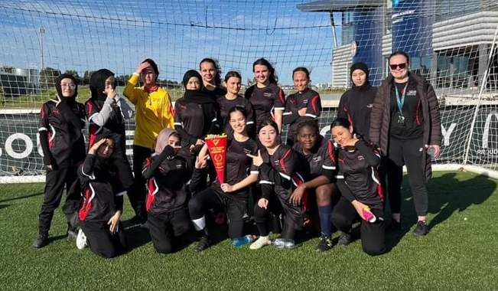

SPORT AND RECREATION - YEAR 10 (OUTDOOR AND ENVIRONMENTAL STUDIES & CERTIFICATE III SPORT, AQUATICS, AND RECREATION)

Subject Description:
If you are enthusiastic about physical fitness and sport, Sport and Recreation may be the pathway for you. In this subject, students complete an exciting range of sport-related units and develop a basic level of skill and knowledge for sports coaching across a variety of sports. Students develop knowledge of local sports industry and learn about the preparation of resources and equipment required to run sports and recreation sessions, as well as how to conduct these sessions, coach participants, provide first aid, and how to interact with the local community. There is a wide variety of sports covered, tailored to student needs.

Assessment:
- Plan and conduct a recreation session for junior year levels/local primary schools.
- Undertake Sporting First Aid introductory testing.
- Undertake a sports coaching assistant role for interschool sports for junior year levels/local primary schools.
- Students will sit an examination for this subject.

Advice to Students:
The Year 10 Sports and Recreation elective aims to build the key knowledge and skills needed to succeed in VET Certificate III Sport, Aquatics, and Recreation (offered at the College) and VCE Outdoor and Environmental Studies. Students wishing to pursue these senior subjects are highly recommended to complete this elective, however it is not a pre-requisite. This subject combines both practical and theory classes.
Students MUST purchase the College Physical Education uniform to undertake this subject.
Teachers to see for advice regarding this subject:
Mr. Hare and Mr. Jessop

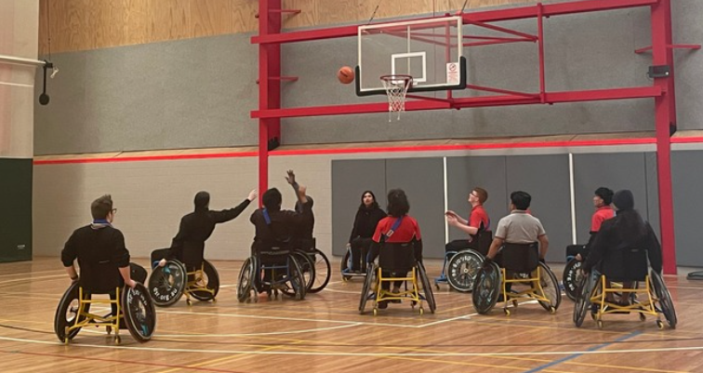

HUMANITIES
The Humanities include the study of Politics, Law, Economics, Business, Geography, History, and Philosophy.
The Humanities provide a framework for students to examine the complex processes that have shaped the modern world and investigate responses to different challenges including people’s interconnections with the environment.
In Politics, Law, Economics and Business, students explore the systems that shape society with a specific focus on the legal and economic systems. Students learn about Australia’s role in global systems and are encouraged to appreciate democratic principles and to contribute as active, informed, and responsible citizens.
In History, Geography, and Philosophy, students explore the processes that have shaped, and continue to shape, different societies and cultures, to appreciate the common humanity shared across time and distance, and to evaluate the ways in which humans continue to face different challenges.
PATHWAYS MAP FOR HUMANITIES
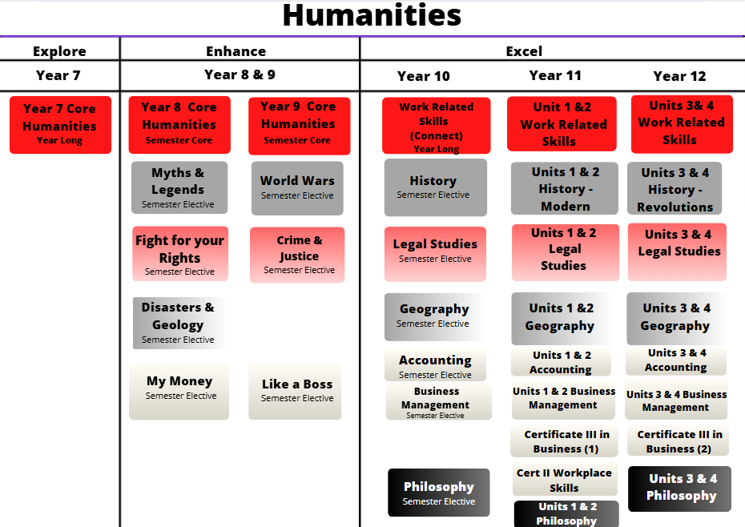

ACCOUNTING - YEAR 10

Subject Description:
Year 10 Accounting explores the financial recording, reporting, analysis, and decision-making processes of a sole proprietor small business. Students study both theoretical and practical aspects of accounting. They collect, record, report, and analyse financial data, and report, classify, verify, and interpret accounting information, using both manual methods and information and communications technology (ICT).

Assessment:
- Structured questions and a written report.
- A folio of exercises.
- A case study (with an ICT focus).
- Classroom presentation.
- Students will sit an examination for this subject.

Advice to Students:
It is highly recommended that students complete My Money prior to undertaking Year 10 Accounting. Students considering this subject should be curious about how financial and ethical considerations need to be understood and applied to create advantageous business situations and decisions for business owners. It is highly recommended that students undertake this subject to study VCE Accounting.

Teachers to see for advice regarding this subject:
Ms. Naidoo and Ms. Noble



BUSINESS MANAGEMENT - YEAR 10

Subject Description:
Business Management is an introductory course designed to provide students with an insight into what it is like to study VCE Business Management in Years 11 and 12. This course is intended to highlight the crucial skills and knowledge required to be successful in the VCE, with a focus on developing powerful study skills to prepare for formal assessments, including the ability to recall and use business terminology accurately and apply business concepts to real-life scenarios. In the first unit, ‘Introduction to Business Management’, students explore and classify the diverse types of organisations and businesses operating in the economy, understand the key business objective of making profits, and discuss how management functions (such as marketing, organising, and forecasting) are used to ensure success. In the second unit, ‘Business Stakeholders’, students consider a range of internal and external stakeholders in a business and how these stakeholders influence the decisions made by businesses. This involves consideration of the interests of shareholders, directors, and employees, along with the competing interests of customers, competitors, trade unions, and technological trends.

Assessment:
- Evidence of revision using study skills that are covered in the course.
- A case study analysis/media analysis.
- A business research report and the development of a business plan.
- Students will sit an examination for this subject.

Advice to Students:
There are no prerequisites for undertaking this subject. Students considering this subject should be mindful that the study of business management often involves analysing materials from real-life news sources such as newspapers and company websites. As such, students will need to be resilient in developing their reading and writing skills to support the application of business theories to case-study scenarios. Year 10 Business Management should be of interest to students who aspire to work in any type of organisation in the future, or who have an interest in starting their own business. It is highly recommended that students undertake this subject prior to studying VCE Business Management in years 11 and 12.

Teachers to see for advice regarding this subject:
Ms. Dixit, Ms. Riley, and Mr. Britto
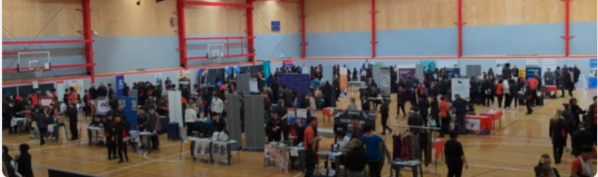

GEOGRAPHY - YEAR 10

Subject Description:
Year 10 Geography is aimed at preparing students for undertaking VCE Geography. The study of Geography allows students to explore, analyse and come to understand the characteristics of places that make up our world. The focus of this subject is on the topics of tourism, human population, and changes to the land. Students look at current local, regional, and global case studies and evaluate how each example is being managed. This subject involves excursions that enable students to develop a range of fieldwork and data collection skills.

Assessment:
- Analysis of geographic data and structured questions.
- Fieldwork and fieldwork reports.
- Case Studies.
- Students will sit an examination for this subject.

Advice to Students:
It is highly recommended that students complete Disasters & Geology prior to undertaking Geography. Students considering undertaking the unit should have an interest in business and economics. It is highly recommended that students undertake this subject prior to studying VCE Geography in Years 11 and 12.

Teachers to see for advice regarding this subject:
Ms. Riley, Ms. Strachan, or Mr. Andrews



HISTORY - YEAR 10

Subject Description:
History is a dynamic discipline that involves structured inquiry into the human actions, forces, and conditions (social, political, economic, cultural, environmental, and technological) that have shaped the past and present. In this subject, students focus on the ways in which traditional ideas, values and political systems were challenged and changed by individuals and groups in a range of contexts during the period 1945 to 2000. Students explore the causes of significant political and social events and movements, and their consequences for nations and people.

Students investigate one major global influence that has shaped Australian society, including the development of the global issues during the twentieth century.

Assessment:
- An inquiry research assignment.
- Analysis of primary sources and historical interpretations.
- An essay that explains and analyses a significant historical moment.
- Students will sit an examination for this subject.

Advice to Students:
It is highly recommended that students complete either Myths and Legends or World Wars prior to undertaking Year 10 History. Students considering this subject should be curious about historical facts and demonstrate a willingness to engage in research and critical thinking activities. It is highly recommended that students undertake this subject prior to studying VCE History in Years 11 and 12.

Teachers to see for advice regarding this subject:
Ms. Riley and Ms. Fiddes



LEGAL STUDIES - YEAR 10

Subject Description:
Legal Studies is an introductory course designed to provide students with an insight into what it is like to study VCE Legal Studies in Years 11 and 12. The course is intended to highlight the fundamental skills and background knowledge required to be successful in the VCE, including learning some the crucial legal terminology and applying legal concepts to case study scenarios.

The course covers topics such as crime and justice, how people sue each other in civil law, the process of making laws through parliaments and the courts, and how the law protects human rights in Australia. Students refer to the actual sources of law from the State and Federal parliaments and consider legal cases through an analysis of current news events and landmark court decisions.

Assessment:
- Structured questions and a folio of exercises.
- Written research reports.
- Media analyses.
- Students will sit an examination for this subject.

Advice to Students:
There are no prerequisites to undertaking this subject. Students considering this subject should be mindful that Legal Studies often involves analysing materials from news sources (such as newspapers), official information from the government, and other legal institutions. As such, students need to be resilient in developing their reading and writing skills to support the application of legal theories to case-study scenarios.

Year 10 Legal Studies should be of interest to students who aspire to work in any legal or business field in the future, including as lawyers, law enforcement officers, and in state and local government. It is highly recommended that students undertake this subject prior to studying VCE Legal Studies in Years 11 and 12.

Teachers to see for advice regarding this subject:
Ms. Noble and Ms. Ho
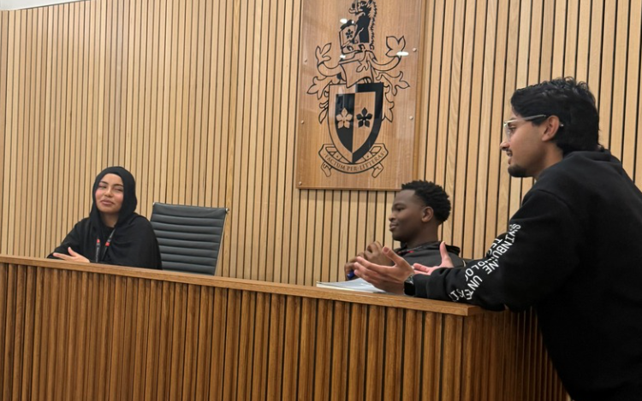

PHILOSOPHY - YEAR 10

Subject Description:
Philosophy is an introductory course designed to provide students with an insight into what it is like to study VCE Philosophy in Years 11 and 12. The course is focused on getting students thinking outside of the box about some big ideas. This subject teaches students critical thinking skills, how to structure a logical argument, and that most things in life are subjective. This assists students in other classes, such as English, History and Legal Studies. Philosophy invites students to consider the big questions in life, such as, “How are we here?”, “What created the universe?”, “What makes a person good or bad?”, “What is the meaning of life?”, and “How do I know that I know anything?”. Students leave this subject with more questions than they have answers! This subject is a fun way to think critically. It is run with debates, research, and discussion!

Assessment:
- Essays and research tasks.
- Debates.
- Short-answer responses and written reflections.
- Students will sit an examination for this subject.

Advice to Students:
There are no prerequisites for undertaking this subject. The only requirement is the willingness to think about big ideas and topics concerning the universe and life itself. We get into some heated debates and mental exercise. Philosophy is a fun way of thinking and a new way to consider the world around you.

Philosophy should be of interest to students who are excited by ethics, arguing, logic, and the universe. Philosophy is useful for career pathways such as law, teaching, economics, politics, history, and science. It is highly recommended that students undertake this subject prior to studying VCE Philosophy in Years 11 and 12.

Teachers to see for advice regarding this subject:
Ms. Phelan


LANGUAGES

Learning languages broadens your horizons about the personal, social, cultural, and employment opportunities that are available in an increasingly interconnected and interdependent world. The interdependence of countries and communities requires people to negotiate experiences and meanings across languages and cultures. A bilingual or plurilingual capability is the norm in most parts of the world.
For students who already speak one or more languages, there are opportunities in the Languages Domain for them to engage in subjects that make the most of those skills. Learning another language helps develop essential areas of the brain. Research shows that it also improves memory, concentration, creativity, and critical thinking skills.

Learning another language means more than just memorising unfamiliar words. Languages all use different systems, so when we learn a new language, we compare it with English. This deepens understanding of English and significantly improves English language skills. It also grants the skill to learn other new languages more easily.

To know more about the benefits of learning a new language, watch this YouTube video:
https://www.youtube.com/watch?v=dtBxBHBN8nk – Why learn a language?

LANGUAGES PATHWAYS MAP
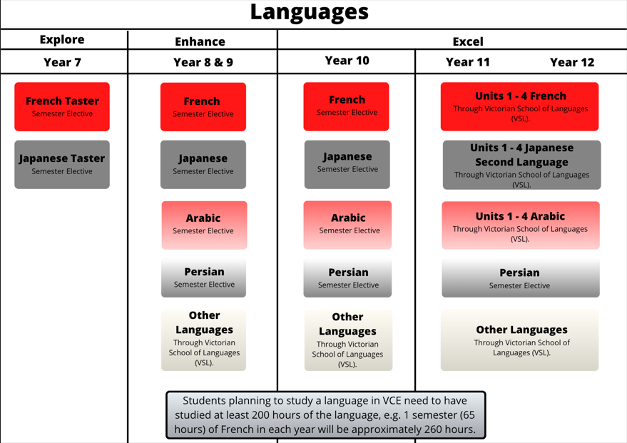
The subjects we can offer vary based on staff expertise and availability. Student choice determines the Languages that run.

ARABIC - YEAR 10

Subject Description:
Students acquire communication skills in Arabic. They develop an understanding about the role of language and culture in communication. Their reflections on language use and language learning are applied in other learning contexts. Arabic is the fifth most spoken language in the world. Learning it will help students to understand the rich culture of the Middle East with its unique ways of life, cuisine, literature, and art. Nations that speak Arabic contributed significantly to the development of global civilisation, including to the advancement of philosophy, medicine, and science. An understanding of Arabic allows the speaker to explore the worlds of architecture, astrology, navigation, mathematics, and literature in their first language. To know more about the benefits of learning Arabic, please visit Why learn Arabic? (https://www.youtube.com/watch?v=Ypu2am5-Kn0).

Intercultural capability and language skills developed enable students to:
- Reflect on how intercultural experiences influence attitudes, values, and beliefs.
- Recognise the importance of acceptance and appreciation of cultural diversity for a cohesive community.
- Demonstrate an awareness of and respect for cultural diversity within the community.
- Communicate in the language they are learning.
- Understand the relationship between language, culture, and learning.
- Understand themselves as communicators.

Assessment:
- Oral presentation.
- Reading and listening comprehension task.
- Short written piece in Arabic.
- Students will sit an examination for this subject.

Advice to Students:
Arabic is recommended to students who have a passion for languages and cultures. Learning a language is an ongoing process. If you are considering undertaking VCE Arabic, you should aim to study Arabic for a minimum of 200 hours (three semesters) before moving into VCE Units 1 & 2. To prepare yourself to perform at the highest level in Arabic at VCE, you should consider taking Arabic in Enhance and Year 10 in consecutive units. Students must undertake this subject to study VCE Arabic. It is highly recommended that students undertake Arabic to enhance the study of linguistics, literature, law, politics, travel, or international relations in the future.

Teachers to see for advice regarding this subject:
Ms. Eid

FRENCH - YEAR 10

Subject Description:

French is a young, vibrant, international language. Among its 275 million speakers, more than 96 million live in Africa, and it also represents the second most widely spoken native language and foreign language in Europe. By the year 2050, it is estimated that French will be the language most spoken in the world - the latest projection is that French will be spoken by 750 million people by 2050. France itself is known as a home of great food, wine, the arts, science, and fashion. A knowledge of French can provide you with enhanced vocational opportunities in many fields, including banking, international finance, commerce, diplomacy, translating and interpreting. In Melbourne there are now 120 French companies which have set up offices, subsidiaries, or headquarters here in fields such as infrastructure and transport.

French studies in Year 10 include cultural studies, excursions, and student-led projects (for example, a French café).

Assessment:

- Oral presentation.
- Reading and listening comprehension task.
- Short written piece in French.
- Students will sit an exam in this subject.

Advice to Students:

Learning a language is an ongoing process. If you are considering undertaking VCE French, you should aim to study French for a minimum of 200 hours (three semesters) before moving into VCE Units 1 & 2. To prepare yourself to perform at the highest level in French at VCE, you should consider taking French in Enhance and Year 10 in consecutive units. Students must undertake this subject to study VCE French. It is highly recommended that students undertake French to enhance the study of linguistics, literature, law, politics, travel, or international relations in the future.

Teachers to see for advice regarding this subject:
Ms. Eid and Ms. Attard
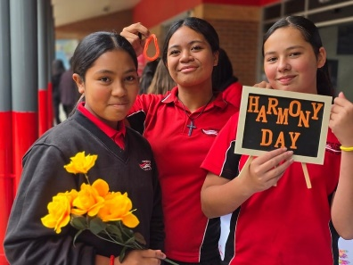

JAPANESE - YEAR 10

Subject Description:
Japanese is the official language of Japan, Australia’s northern neighbour in the Asia region. Japanese is also widely used by communities of speakers in Hawaii, Peru, and Brazil, and learnt as an additional language by large numbers of students in South Korea, China, Indonesia, and Australia. Japan holds the world’s third largest economy, moreover, it is Australia’s third largest trading partner. Australia and Japan are currently actively developing a deeper relationship in different spheres and have been close strategic and economic partners for more than 50 years. Japan has a multifaceted culture; on the one hand, it is steeped in the deepest of traditions dating back thousands of years, on the other hand, it is a society in a constant state of rapid flux, with continually shifting fads and fashions and technological development that continuously pushes back the boundaries of the possible.

In this subject, students learn Japanese greetings, how to introduce themselves, as well as other basic vocabulary. Students learn about the differences between the three Japanese scripts, Hiragana, Katakana, and Kanji. They learn about the culture of Japan and Japanese-speaking communities.

Assessment:
- Oral presentation.
- Reading and listening comprehension task.
- Short written piece in Japanese.

Advice to Students:
Learning a language is an ongoing process. If you are considering undertaking VCE Japanese Second Language, you should aim to study Japanese for a minimum of 200 hours (three semesters) before moving into VCE Units 1 & 2.
To prepare yourself to perform at the highest level in Japanese at VCE, you should consider taking Japanese in Enhance and Year 10 in consecutive units. It is highly recommended that students undertake Japanese to enhance the study of linguistics, literature, law, politics, travel, or international relations in the future.

Teachers to see for advice regarding this subject:
Ms. Attard
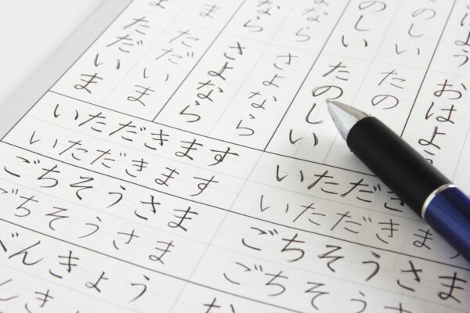

PERSIAN - YEAR 10

Subject Description:
Students acquire communication skills in Persian, which encompasses both Dari and Farsi. They develop an understanding of the role of language and culture in communication. Their reflections on language use and language learning are applied in other learning contexts. Persian, with its rich history and literary tradition, offers students insights into the vibrant cultures of Iran, Afghanistan, and Tajikistan. Learning Persian enables students to connect with their heritage, explore Persian literature and poetry, and appreciate the significant contributions of Persian-speaking nations to art, science, and philosophy. An understanding of Persian opens doors to exploring the rich traditions of storytelling, music, and the culinary arts, enriching students' global perspectives.

Assessment:
- Oral presentation.
- Reading and listening comprehension task.
- Short written piece in Persian.
- Students will sit an examination for this subject.

Advice to Students:
Learning a language is an ongoing process. If you are considering undertaking VCE Persian, you should aim to study Persian for a minimum of 200 hours (three semesters) before moving into VCE Units 1 & 2. To prepare yourself to perform at the highest level in Persian at VCE, you should consider taking Persian in Enhance and Year 10 in consecutive units. Students must undertake this subject to study VCE Persian. It is highly recommended that students undertake Persian to enhance the study of linguistics, literature, law, politics, travel, or international relations in the future.

Teachers to see for advice regarding this subject:
Ms. Attard

MATHEMATICS

Mathematics provides students with access to important mathematical ideas, knowledge, and skills that they will draw on in their personal and work lives. Mathematical ideas have evolved across societies and cultures over thousands of years and are constantly developing as digital technologies provide new tools for mathematical exploration and invention.
While the usefulness of mathematics for modelling and problem-solving is well known, mathematics also has a fundamental role in both enabling and sustaining cultural, social, economic, and technological advances and empowering individuals to become critical citizens.
Number and Algebra, Measurement and Space, and Statistics and Probability are common aspects of most people’s mathematical experience in everyday personal, study, and work situations. Equally important are the essential roles that algebra, functions and relations, logic, mathematical structure, and working mathematically play in people’s understanding of the natural and human worlds, and the interaction between them.
The mathematics curriculum focuses on developing increasingly sophisticated and reﬁned mathematical understanding, ﬂuency, reasoning, modelling, and problem-solving. These capabilities enable students to respond to familiar and unfamiliar situations by employing mathematics to make informed decisions and solve problems eﬃciently.
MATHEMATICS PATHWAYS MAP
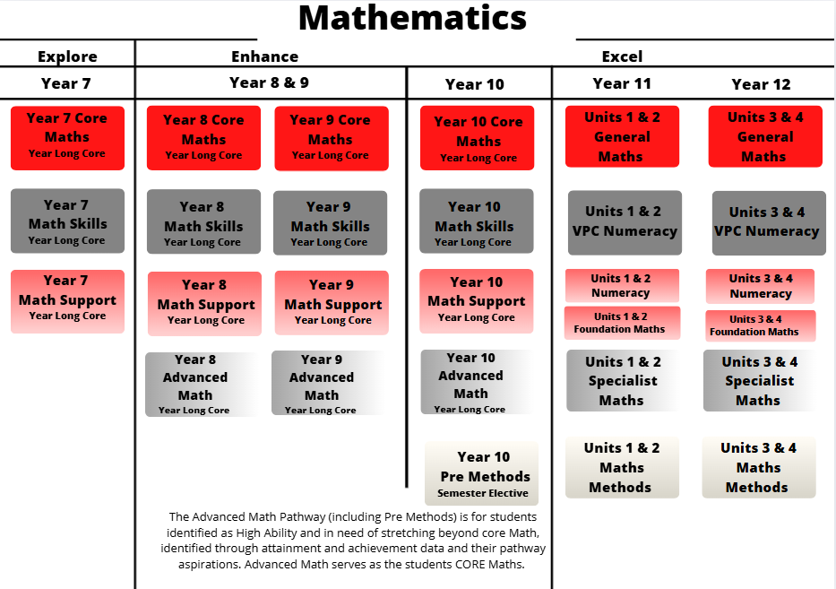

YEAR 10 MATHEMATICS

Subject description:
The Year 10 Mathematics curriculum focuses on developing increasingly sophisticated and refined mathematical understanding, fluency, reasoning, modelling and problem-solving. These capabilities enable students to respond to familiar and unfamiliar situations by employing mathematics to make informed decisions and solve problems efficiently. The proficiencies are fundamental to learning mathematics and working mathematically and are applied across all six strands: Number and Algebra, Measurement and Space, and Statistics and Probability.
Students are required to participate in one of four different Mathematics subjects in Year 10. Students are placed in a Maths program that suitably challenges them, supporting them to build upon their mathematics skills at their current learning level. Students may move between Maths programs, based on their progress and learning needs. High ability students that are interested in completing VCE Maths Methods are also required to complete at Pre-Methods elective in Year 10.

Year 10 Maths Skills
This subject focuses on building fundamental mathematics skills and provides extensive support to learners. Students learn how to work with numbers and money, recognize patterns, use measurement tools, navigate space, and collect data.

Year 10 Maths Support
This subject further builds upon fundamental mathematics skills and challenges students to apply their learning with scaffolds and support. Students learn how to use the operations, differentiate between fractions, decimals and percentages, and convert between measures, classify shapes, organise data, and calculate chance.

Year 10 Core Maths
This subject supports students to engage with the six strands of mathematics and apply their learning to a range of contexts. Students learn how to apply numbers to financial contexts, solve and graph algebraic equations, calculate surface area and volume, apply trigonometry to solve problems, conduct detailed statistical investigations that consider bias and calculate conditional probability.

Year 10 Advanced Maths
This subject extends high ability students beyond the Year 9 curriculum and focusses on problem-solving and extension tasks. Students learn how to perform operations using advanced numbers, investigate polynomials, graph a variety of algebraic functions, factorise expressions, solve problems involving surface area and trigonometry, calculate standard deviation in data sets and use factorial notation. This subject must be successfully completed to enter VCE Maths Methods.

Year 10 Pre-Methods Elective
This semester-based subject allows students to build upon their learning in Year 10 Advanced Maths to prepare them for complex problem solving in VCE Maths Methods and VCE Physics. This subject focusses heavily on algebraic problem solving and modelling, as well as graphing functions and using vector operations. This subject must be successfully completed to enter VCE Maths Methods.

SCIENCE

Science allows students to answer interesting and important questions about the biological, physical, and technological world through observation and experience. Science is a dynamic, collaborative, and creative endeavour arising from our world by exploring the unknown, investigating universal mysteries, making predictions, and solving problems.

The Science curriculum provides opportunities for students to develop an understanding of important scientiﬁc concepts and processes, the practices used to develop scientiﬁc knowledge, the contribution of science to our culture and society, and its applications in our lives. The curriculum supports students to develop the scientiﬁc knowledge, understandings, and skills to make informed decisions about local, national, and global issues.

Throughout the study of science, students experience the joy of scientiﬁc discovery and nurture their curiosity about the world around them. In doing this, they develop critical thinking skills and challenge themselves to identify questions, apply new knowledge, explain science phenomena, and draw evidence- based conclusions using scientiﬁc methods. The students also develop scientiﬁc literacy, including the capacity to investigate the world around them and the way it has changed and changes as a result of human activity.

SCIENCE PATHWAYS MAP
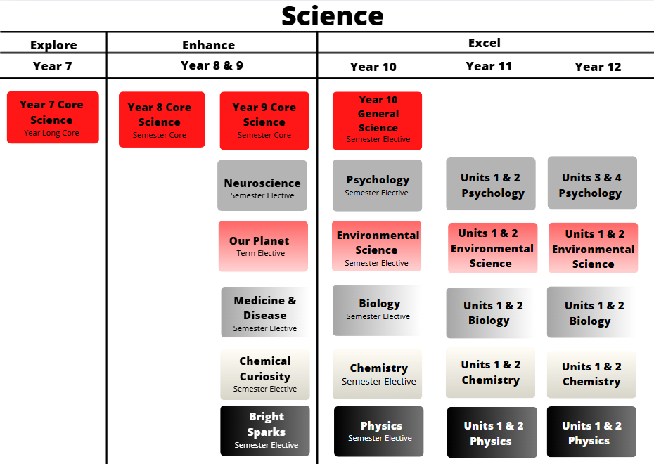

BIOLOGY - YEAR 10

Subject Description:
This class prepares students for VCE Biology by covering several core topics that are essential for Units 1-4 studies in Biology. This subject covers content relating to cell organelles and their functions with investigations and analyses of these organelles in action through the processes of photosynthesis and cellular respiration. Students explore how genetics plays a role in the evolution of our species, considering mutation, natural selection and interactions with other species on our evolution journey. Students complete a range of experiments during both units whilst working on skills that enable them to recall and apply their knowledge in assessments that align with the expected outcomes at a VCE level.

Assessment:
- Ongoing coursework, including practical work.
- Topic tests.
- Experimental report analysis.
- Case study analysis.
- Students will sit an examination for this subject.

Advice to Students:
It is highly recommended that students undertake this subject prior to studying Biology at a VCE level.

Teachers to see for advice regarding this subject:
Ms. Marshall and Ms. Peters

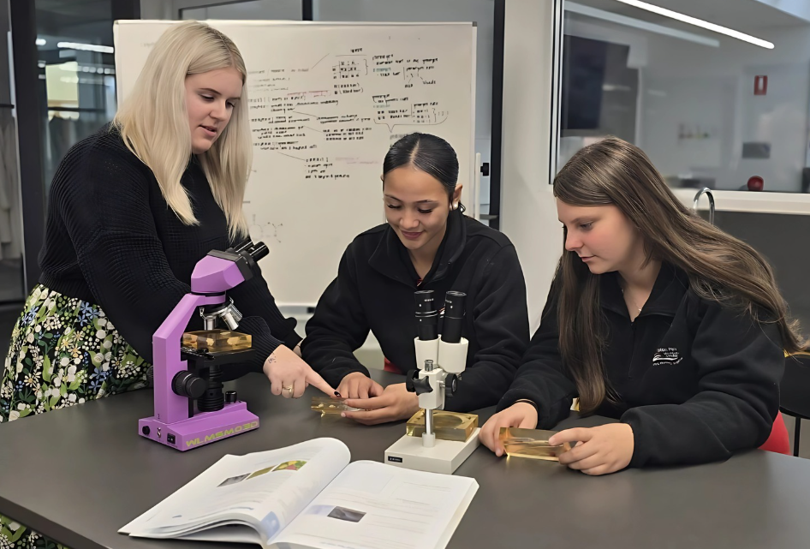

CHEMISTRY - YEAR 10

Subject Description:
Chemistry is sometimes called the ‘Central Science’ because it connects almost all the other sciences with each other. When someone knows Chemistry, they can better understand how Biology, Physics, Ecology, Environmental Science, and so many disciplines work together. In this subject, students use the fundamentals of chemical elements and reactions to perform investigations and discover how chemistry can apply to real world applications. This includes exploration of chemical properties, chemical equations and how different chemicals can interact or be modified.

Assessment:
- Ongoing coursework, including practical work.
- Written responses and topic tests.
- Student directed research investigations.
- Students will sit an examination for this subject.

Advice to Students:
It is highly recommended that students undertake this subject prior to studying Chemistry at a VCE level.
Students considering Chemistry should be confident, independent, and self-managed learners.

Teachers to see for advice regarding this subject:
Ms. Glenn & Ms. Naidoo



ENVIRONMENTAL SCIENCE - YEAR 10

Subject Description:
This subject prepares students for VCE Environmental Science and VCE Biology by covering several core topics that are essential for Units 1-4 in these areas. Environmental Science is an interdisciplinary, investigative science that explores the interactions and interconnectedness between humans and their environments and analyses the functions of both living and non-living elements that sustain Earth systems. In Environmental Science, Earth is understood as a set of four interrelated systems: the atmosphere, the biosphere, the hydrosphere, and the lithosphere. This study explores how the relationships between these systems produce natural environmental change over a variety of time scales and how these systems respond to change and disruption. Students investigate the extent to which humans modify their environments and the consequences of these changes in local and global contexts with a focus on biodiversity, pollution, food and water security, climate change, and energy use. Students complete a range of field work as a class whilst working on skills that enable them to recall and apply their knowledge in assessments that align with the expected outcomes at a VCE level.

Assessment:
- Ongoing coursework, including practical and field work.
- Topic tests.
- Experimental report analysis.
- Case study analysis.
- Students will sit an examination for this subject.

Advice to Students:
It is highly recommended that students undertake this subject prior to studying Environmental Science at a VCE level.

Teachers to see for advice regarding this subject:
Ms. Naidoo

PHYSICS - YEAR 10

Subject Description:
Physics helps students to understand the world around them and to satisfy their curiosity. Physics provides students with the opportunity to study nature at its most fundamental level, helping them understand many familiar and interesting questions about how the world works. Physics is a science that deals with matter and energy and their interactions in the fields of mechanics, acoustics, optics, heat, electricity, magnetism, radiation, atomic structure, and nuclear phenomena. Physics challenges the human imagination with concepts such as relativity and string theory, and it leads to great discoveries, such as computers and lasers that, in turn, lead to technologies that can change the way humanity lives. For example, Physics has the potential to achieve anything, from healing joints, to curing cancer, to developing sustainable energy solutions. An understanding of Physics underpins and complements many other areas of study, including Engineering, Chemistry, Biology, and Environmental Science. In this course, students learn the basic concepts of motion, forces, electricity, and nuclear physics. They learn the Scientific Method and conduct a variety of practical and theory-based experiences.

Assessment:
- Ongoing coursework, including engagement in practical work.
- Written responses and topic tests.
- Student led practical investigations.
- Students will sit an examination for this subject.

Advice to Students:
This is an introductory subject that does not assume a previous physics background. Students considering Physics should be confident, independent, and self-managed learners. However, students do need some basic mathematical skills such as applying and manipulating algebraic equations and Cartesian graphs to solve some physics problems. It is highly recommended that students undertake this subject prior to studying VCE Physics in the future.

Teachers to see for advice regarding this subject:
Ms. Glenn

PSYCHOLOGY - YEAR 10

Subject Description:
In this subject, students are provided with an opportunity to develop their scientific understanding and inquiry skills through their explorations of famous psychological studies. Students learn about mental health disorders such as schizophrenia, and they learn how the brain and nervous system work. Students explore what Psychology is and develop the key skills and knowledge required to prepare them for VCE Psychology. Students expand their understanding of the scientific process, which enables them to critically assess the strengths and limitations of research, make evidence- based conclusions, and gain an awareness of the ethical considerations of scientific exploration. Psychology provides many opportunities for further study pathways and careers such as working with children, adults, families, and communities in a variety of settings and specialist fields (educational, forensic, health, sport, and organisational or medical research).

Assessment:
- Topic tests.
- Student led investigations with presentations.
- Written assessment.
- Students will sit an examination for this subject.

Advice to Students:
There are no prerequisites for undertaking this subject. Students considering Psychology should be confident, independent, and self-managed learners. Year 10 Psychology is recommended for students who have a broad interest in science. It is highly recommended that students undertake this subject prior to studying VCE Psychology in the future.

Teachers to see for advice regarding this subject:
Ms. Dawson and Ms. Kios


GENERAL SCIENCE - YEAR 10
Subject Description:
Are you interested in how science skills can be applied in both research and non-research careers? In general science, students are given the opportunity to develop real-world application skills in science and practice applying these skills in the context of forensics. Students explore and utilise skills in biology, chemistry and psychology disciplines and appreciate their use in common scenarios. Students research careers within forensic science to see how each specific field is represented within this area and how science has evolved over time. After a detailed, teacher led, investigation into forensic evidence types, students choose an area of their own interest and work collaboratively with their peers to research, develop, and deliver a lesson to their class. After learning from their peers about forensic evidence, students apply their knowledge of how forensic evidence is used to help solve crimes, working through a mock crime scene. Finally, students consolidate their knowledge as they prepare a presentation on the forensic evidence of a famous crime of their choice. By enrolling in this subject, parents give permission for students to access materials that may be rated M or even MA due to the nature of some crimes explored. Students develop skills in data analysis, independent research of credible information, collaboration, and deductive reasoning.

Assessment:
- Digital presentation on a career field in science.
- Inquiry into a crime-scene investigation.
- Case study analysis on a famous crime.

Advice to Students:
There are no prerequisites for undertaking this subject. Students considering General science should be confident, independent, and self-managed learners. General science is recommended for students with a broad interest in science or students that are interested in vocational learning pathways.

Teachers to see for advice regarding this subject:
Ms. Peters and Ms. Marshall

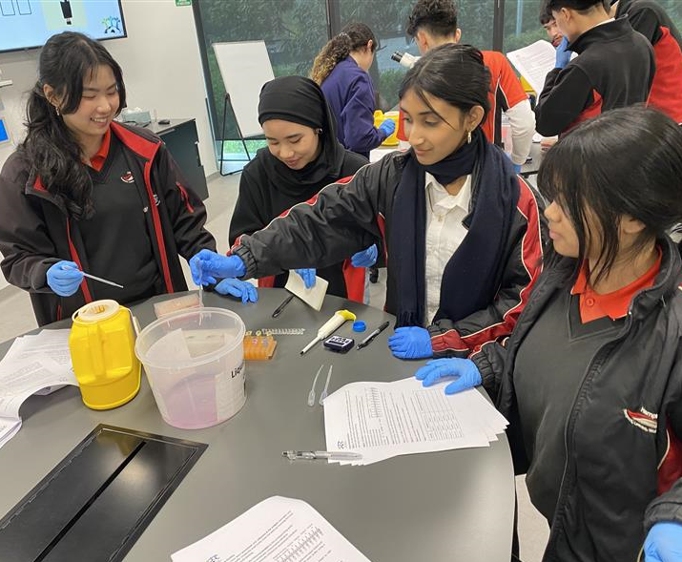

STEM

STEM is an acronym for Science, Technology, Engineering, and Mathematics. STEM enables students to apply knowledge from these subject areas to solve problems creatively using the scientiﬁc method, design process, and various mathematical skills. STEM encourages teamwork and high-level communication, which are both necessary skills in industry as workplaces become more collaborative and digitised. Working on STEM projects and learning tasks helps build resilience as not all endeavours will succeed the ﬁrst time. Processes must be modiﬁed and reﬁned to achieve success. Put simply, STEM helps to develop students into creative problem-solvers and lifelong learners. There is a key focus on Digital Technology and Design Technology in all STEM subjects.

Digital Technology is a major part of our lives and thus, our education. Our STEM subjects allow students to acquire a deep knowledge and understanding of digital systems, data and information, and the processes associated with creating digital solutions so that they can take up an active role in meeting current and future needs of society.

Design Technology uses design thinking, where students plan and manage projects from conception to realisation. They design processes to investigate ideas, generate and reﬁne ideas, plan and manage, and produce and evaluate designed solutions.
STEM PATHWAYS MAP
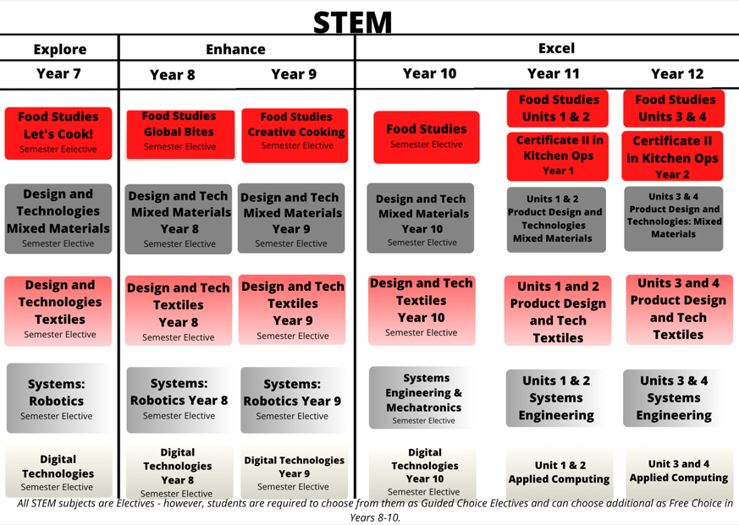

COMPUTER PROGRAMMING - YEAR 10 (APPLIED COMPUTING)

Subject Description:
Dr Dan Crow, a CS professor at Leeds University wrote an excellent summary of computational thinking and why it is necessary: “Will every job in the future involve programming? No. But it is still crucial that every child learns to code. This is not primarily about equipping the next generation to work as software engineers, it is about promoting computational thinking. Computational thinking teaches you how to tackle large problems by breaking them down into a sequence of smaller, more manageable problems".
In this subject, students learn the basics of programming and explore the pathways of the Microsoft Suite, Python, HTML, and Visual Basic.Net. After mastering these programs, they will then apply their understanding by solving problems using these programs.

Assessment:
- Demonstrating competency in a variety of computer programs.
- A presentation that communicates use of the design process and of a variety of computer programs to solve a set problem.
- A written report and structured questions.
- Students will sit an examination for this subject.

Advice to Students:
There are no prerequisites for undertaking this subject. It is highly recommended that students undertake this subject prior to studying Units 1 & 2 Applied Computing in the future.

Teachers to see for advice regarding this subject:
Mr. D’Auria and Ms. Vu

ENGINEERING AND MECHATRONICS - YEAR 10 (SYSTEMS ENGINEERING)

Subject Description:
In Engineering and Mechatronics, students build their skills in design, evaluation, computing, technology, engineering, and electronics. Engineering and Mechatronics focuses on the development of students’ skills in managing and manipulating electronic materials and resources. Students use a range of tools, equipment, and machines to design and produce a functional physical product or system. These materials and resources may include wood, plastics, or textiles, as well as components such as wheels and axles, pulleys and belts, gears, switches, lights, motors, connecting wires, batteries, coding, CAD, and printed circuit boards. This subject utilises robotics, telecommunications, and various systems to build an end product.

Assessment:
- Practical production tasks, including design, construction, fabrication, and customisation (including coding)
- Engineering logbook
- Documentation of the systems engineering process in a written report as well as a brochure or poster.
- Students will sit an examination for this subject.

Advice to Students:
There are no prerequisites for undertaking this subject. This subject is recommended for students who have a passion for experimenting and manipulating objects to make them functional and aesthetically appealing through using a variety of materials. It is highly recommended that students undertake this subject prior to studying VCE Systems Engineering.
Teachers to see for advice regarding this subject:
Mr. D’Auria

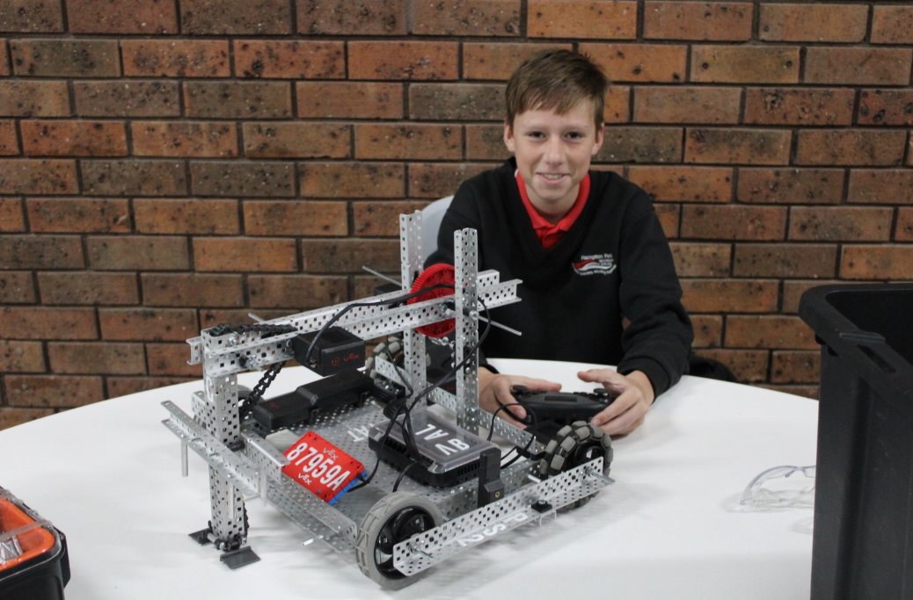

FOOD STUDIES - YEAR 10

Subject Description:
Year 10 Food Studies students investigate the challenges involved in providing interesting and healthy family meals. Students explore the different nutritional requirements across the lifespan and learn about menu planning for families. Students examine the types of foods that can be prepared for the different meals of the day, understanding cooking processes, safety, and hygiene. Students are involved in the Kitchen Garden and utilising fresh seasonal ingredients in the meals they produce. Students are exposed to real world situations where they use the design process to create a practical food solution. This subject prepares students for VCE Food Studies and VET Certificate II Cookery.

Assessment:
- Practical assessment tasks with records that reflect on these activities.
- Written research inquiry.
- Design and produce a practical food solution.
- Students will sit an examination for this subject.

Advice to Students:
There are no prerequisites for undertaking this subject. This subject is for students who enjoy challenging themselves, love food, and would like to learn about diverse cultures and cuisines. Students consolidate their understanding of their skills learnt in Explore and Enhance. It is highly recommended that students undertake this subject prior to studying VCE Food Studies or VET Certificate II Cookery.
Teachers to see for advice regarding this subject:
Ms. Zhao, Ms. Bush, and Ms. Ellis



PRODUCT DESIGN AND TECHNOLOGIES: MIXED MATERIALS OR TEXTILES -YEAR 10

Subject Description:
This is a subject for students who have a passion for design as well as students who might be looking to select Product Design and Technology (Mixed Materials or Textiles) in Years 11 and 12. In this subject, students develop their skills in using the design process, problem-solving, and creative and critical thinking. Students analyse and evaluate real-world case studies from relevant industries and unpack the necessary skills through the implementation of the design process. This course informs sustainable behaviours and develops technical skills that enable students to present multiple solutions to everyday life situations.

Assessment:
- Multimodal records of evidence of research, development, and conceptualisation of products and of reflection.
- Practical work: demonstrations of graphical and physical product concepts including prototyping and making final proofs of concept along with finished products.
- Students will sit an examination for this subject.

Advice to Students:
This subject requires a high level of planning, management, and critical thinking skills, as well as collaboration skills and a willingness to take on several roles within a team to achieve success. It is highly recommended that students undertake this subject prior to undertaking VCE Product Design & Technology. This subject also supports the skills required in other VCE Design Technology and Arts subjects.

Teachers to see for advice regarding this subject:
Ms. Long, Mr. Beveridge, and Mr. D’Auria
