
At Hampton Park Secondary College, we are rich in diversity, and through empowering and engaging students, we remain wholehearted in our pursuit of excellence.
SENIOR STUDIES STAFF HANDBOOK 2026

This handbook contains information related to the implementation of the:

- Victorian Certificate of Education (General VCE)
- Victorian Certificate of Education Vocational Major (VCE VM)
- Victorian Pathways Certificate (VPC)
- Year 10 Vocational Learning (10VL), and
- Vocational Education and Training (VET)

at Hampton Park Secondary College

WELCOME TO SENIOR STUDIES AT HAMPTON PARK SECONDARY COLLEGE
The Hampton Park Secondary College Senior Studies Staff Handbook, aims to ensure that:
- All staff are aware of the rules and expectations outlined by VCAA and administered by HPSC
- All staff have access to and understand clear and consistent practices and processes
- All students are treated fairly and in a consistent manner
- All students are supported and provided with equitable opportunities to achieve learning success; and
- All students attend school and timetabled classes regularly

Essential School Information
58-96 Fordholm Road
(P.O. Box 480)
Hampton Park Vic 3976
Ph: 03 8795 9400
Fax: 03 8795 9455
Email: hampton.park.sc@education.vic.gov.au Website: http://www.hpsc.vic.edu.au
Compass: http://hpsc-vic.compass.education

Senior Studies Personnel

For assistance and advice related to the implementation of Senior Studies (Years 10-12), please speak to members of the following teams:

Senior Studies Improvement Team - The Senior Studies Improvement Team review college wide implemented practices. Based on evidence, data and research, the team work together to improve practice by developing and refining initiatives to strengthen student success. Members liaise with experts and successful local schools, engage in learning walks and professional learning/reading to develop their understanding. For a copy of our senior school improvement recommendations, please refer to Compass, School Documentation, Senior Studies

- Kelly Krieg – Curriculum Design and Learning, Assistant Principal
- Georgie Kios – Senior School Improvement, Head of Freeman House, Assistant Principal
- Catherine Glenn - Student Achievement Leader, Senior School Improvement (Freeman House)
- Lizl Tregidga – Leading Teacher – Vocational Education and Applied Learning (Freeman House)
- Deb Edwards – Student Support Services Leader
- Wayne Haworth – Principal
- Coopted Members – as required (this includes Domain Leaders and other Teaching and Learning Leaders, VASS Administration, VET Coordination, and our Senior Student Engagement Leaders)

The Schools Leadership Team - with roles linked to Senior Studies
- Principal: Wayne Haworth
- Curriculum Design and Learning, Assistant Principal: Kelly Krieg
- Senior School Improvement, Assistant Principal: Georgianne Kios
- Student Achievement Leader, Senior School (Freeman House): Cat Glenn
- Senior Student Engagement Leader (Freeman House) Chris Marriott
- Senior Student Engagement Leader (Walton House): Naomi Dawson
- Senior Student Engagement Leader (Hollows House): Lisa Ho
- Senior Student Engagement Leader (Mabo House): Leesha Naidoo
- Vocational Education and Applied Learning, Leading Teacher: Lizl Tregidga
- VET Coordinator: Caz Jenkins
- VET Administrator: Doris McDonald
- Student Services Leader: Debbie Edwards
- Careers Team Members: Carly Pearson
Kerry Lee Jenkins

CONTENTS

Our College Vision
“At Hampton Park Secondary College we are rich in diversity, and by empowering and engaging students we remain wholehearted in our pursuit of excellence.”
This vision is underpinned by our values of Respect, Learning, and Working Together embedded in our whole school practice and supported by our approach to School Wide Positive Behaviours through the Berry Street Education Model.
Our College values are central in building active and informed citizens in a democratic, equitable and just environment that is characterised by cultural, economic, and social diversity.
WE BELIEVE LEARNING SHOULD BE:
- Transformative
- Deep and focused on value adding
- Inclusive of all learners (acknowledging diversity and being responsive to it) Respectful (of self and others)
- Collaborative and Co-operative
Our current Values Matrix
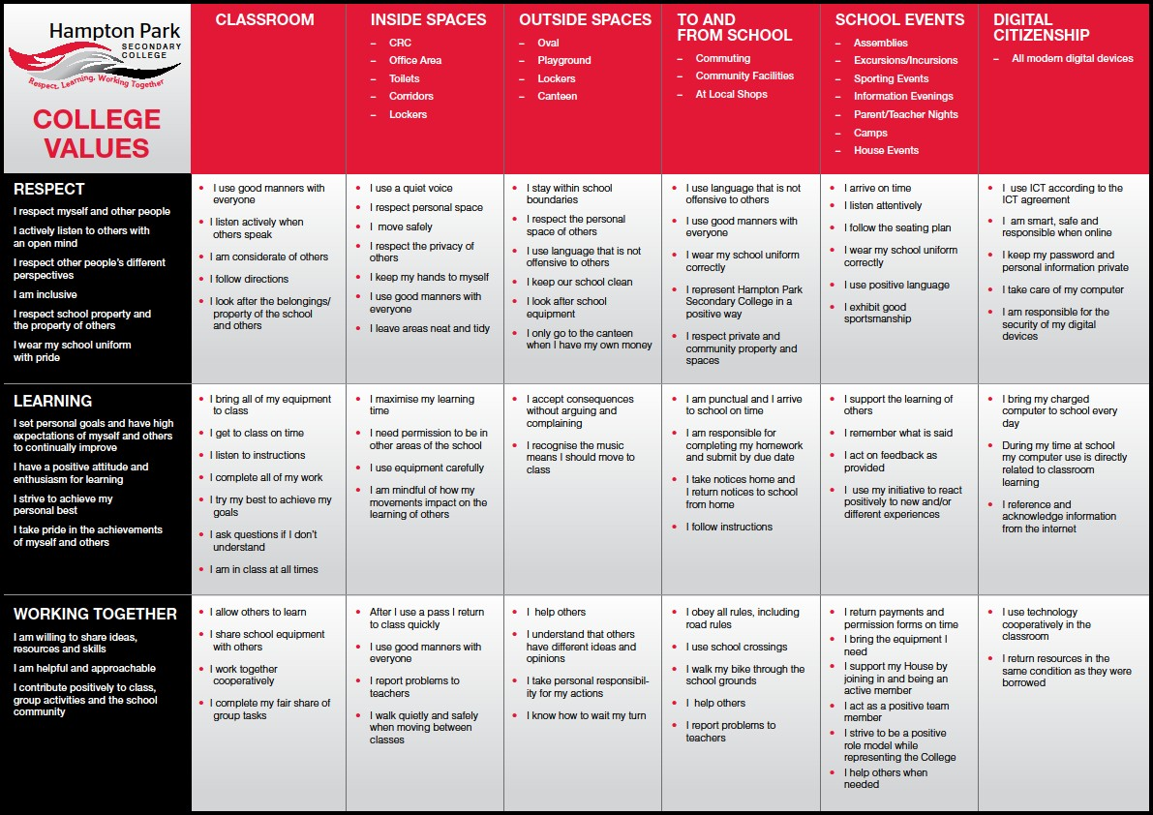

Our College Strategic Plan (SSP) and our Annual Implementation Plan (AIP)
Our 2026 AIP is being developed, and we are in the year of Review. The below relates to our 2025 AIP and will be updated when we have our goals for 2026, as identified in our Review.
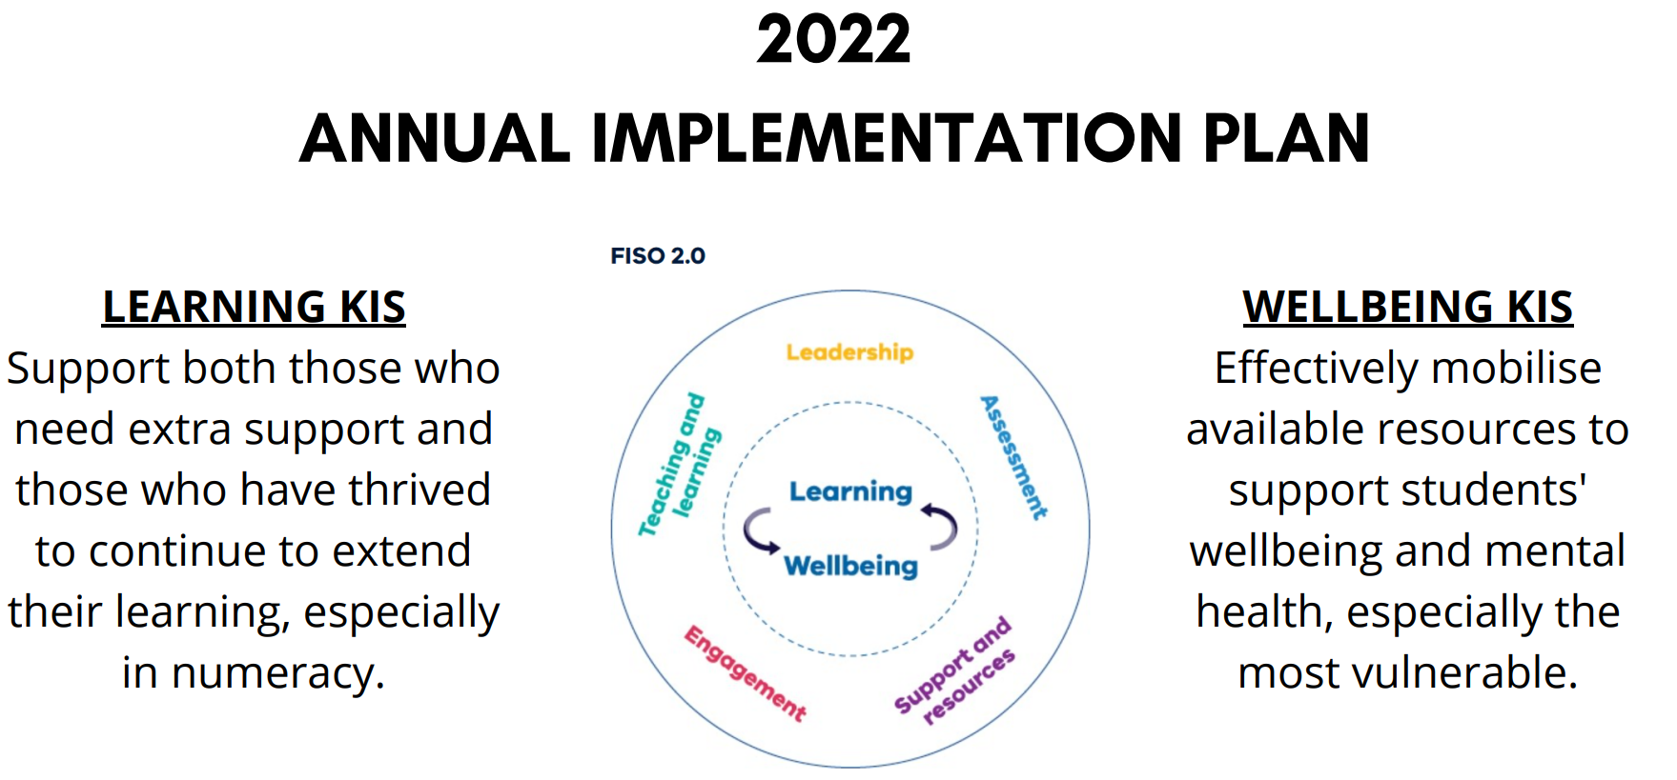
Our Goals and Targets linked to senior school improvement in 2025 are:
Goal 2: Improve student learning outcomes across the College.
- Maintain the VCE All Study Median score from 2024 at 29 for 2025
- The Senior Certificate completion rate to be greater than 95 per cent completion by 2025
Note: Our targets also link to student pathways, however, when completing this document, pathways data was not available. Our 2025 pathways targets, although not complete, in draft form are:
Improve the per cent of students with an exit destination to continuing education: (Note that these targets will be adjusted when Exit Destination Data becomes completely available by Census date in 2025)
- In Year 10 from X% in 2024 to 85% by 2025.
- In Year 11 from X% in 2024 to 85% by 2025.
- In Year 12 from X% in 2024 to 95% by 2025.
These targets shape our focus and our implementation strategies. The targets also guide the Senior Studies improvement team to develop whole school recommendations for improvement.
Below is an outline of our 4-year strategic plan goals and targets, shaped by recommendations and our 2022 achievements. The targets sit across the two goals within our strategic plan.
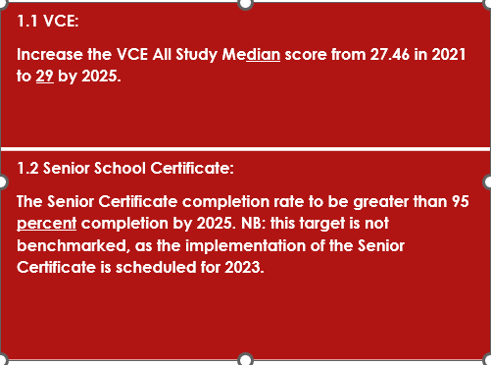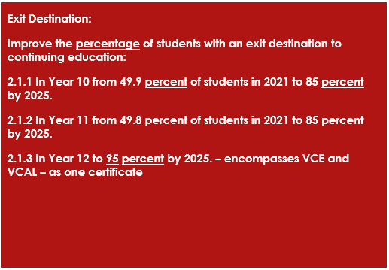

Our Teaching and Learning Framework
College Vison for Teaching and Learning: At Hampton Park Secondary College every student achieves personalised success through the delivery of consistent high quality teaching practice.
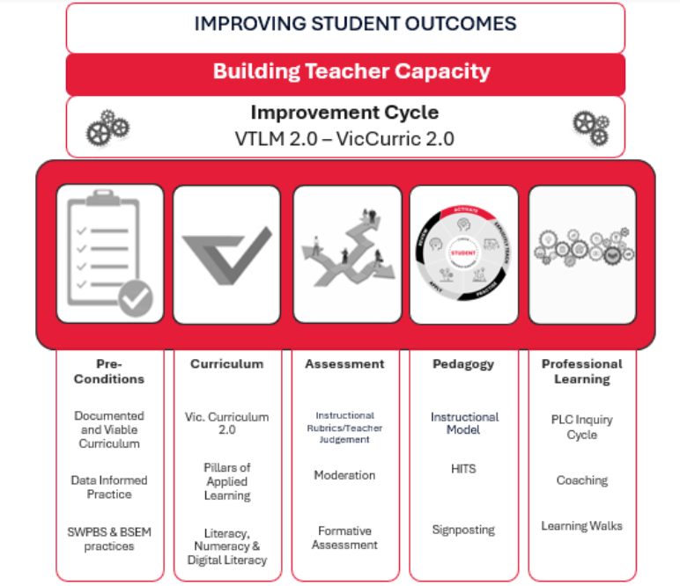
Our Teaching and Learning Framework captures our whole school areas of focus aligned with the priorities of the Department. Our framework is used by teachers as a reflective tool and helps ensure clarity in our direction.
At Hampton Park Secondary College all staff share the collective responsibility to continually improve the learning outcomes of our students. We strive to embed a high-quality curriculum and rigorous and consistent assessment and reporting practices.
Pedagogy and Instruction
Our Pedagogical approach is shaped and informed by the VTLM 2.0, to ensure best quality practice across the College, informed by the latest research on how students learn. Our approach is based on the Gradual Release of Responsibility (GRoR) framework embedded within the practice of Explicit Teaching. This approach purposefully shifts the cognitive load from teacher-as-model, to joint responsibility of teacher and learner, to independent practice and application by the learner.
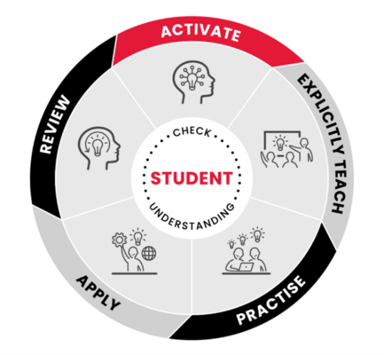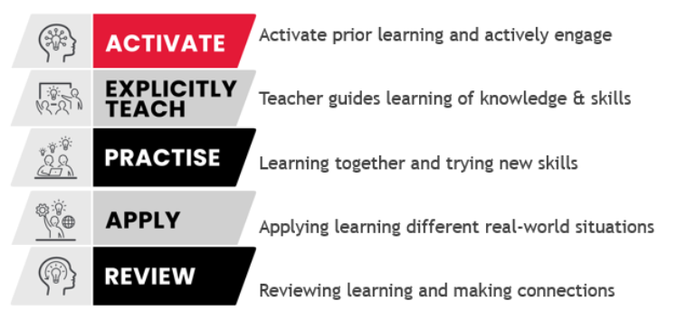

Our improved understanding of how students learn, has led to the evolution of our Instructional Model. Our student-centred model has 5 phases of learning – Activate, Explicitly Teach, Practise, Apply and Review – each linked directly to the VTLM 2.0 and High Impact Teaching Strategies (HITS). This intentional shift helps us lead targeted, sequential, teacher Professional Learning, grounded in the latest evidence and research.
The Instructional Model will be implemented across all classrooms from 2026, gaining consistency in practice through our collaborative PLC cycles. Our aim is for teachers to develop their understanding of the embedded HITS in each phase, to gain collective agreement on implementation and delivery of classroom practices, which are proven to improve student learning outcomes.
For further information about Teaching and Learning at Hampton Park Secondary College, please refer to our Curriculum Framework which is available on the website, Compass and is linked here - FINAL Curriculum Framework Policy 2026 - 2028.docx
Teacher Responsibilities - Teaching in the Senior School
As well as the responsibilities outlined above, which apply to all HPSC staff when working in the Senior School, Senior teachers and support staff are responsible for the following:
- Ensuring implemented teaching and learning practices are in line with our teaching and learning framework and support students to develop our college dispositions
- Accessing and understanding the current Study Design, amendments, the Administrative Handbook and the “VCAA Advice for Teachers and Assessment”. These documents are available at:
  - https://www.vcaa.vic.edu.au/curriculum/vce/vce-study-designs/Pages/vce-study-designs.aspx
  - Pages - VCE VM Study Designs
  - Pages - VPC Curriculum Designs (vcaa.vic.edu.au)
  - VCEAdministrativeHandbook2025.docx -Note, this handbook link will be updated when VCAA release the 2026 version
  - VPCAdministrativeHandbook2025.docx - Note, this handbook link will be updated when VCAA release the 2026 version
  - Advice for Teachers - each is listed on the VCAA website and is specific to each study/subject area
  - VCE Curriculum - Victorian Curriculum and Assessment Authority
- Teachers are required to read the VCAA bulletins regularly circulated, for important dates and information. VCAA bulletins can be accessed here
  - Pages - VCAA Bulletin
Subscription to the VCAA bulletin is found here Pages - Subscribe (vcaa.vic.edu.au)
- Teachers are encouraged to participate in regular Professional Learning and to liaise with Teacher Networks to enhance their knowledge of their subject content/assessment
  - Regular PL will be circulated by the Senior Studies Team and our Professional Learning Leading Teacher
  - Facebook teacher groups are a great way to further your knowledge
- Senior Teachers are encouraged to become VCAA examination assessors. This is great learning for teachers and helps strengthen classroom practice, as well as cohort achievement. At HPSC we value this learning opportunity, so we provide support to all teachers who take it in on. Our approach at HPSC is outlined here - become a VCE Assessor HPSC.docx. For information about becoming a VCE assessor, please see this link - Pages - Why be a VCE examination assessor (vcaa.vic.edu.au)
- Teachers are required to plan their SAC and assessment dates in advance and communicate them to the Senior Studies team when requested. Assessment task dates cannot be changed without discussion with the Senior School team. Notification must be given to students outlining the new arrangements, in writing – which can happen via Compass. SAC dates should be planned collaboratively where more than one class is running (for a subject area). For the 2025 SAC calendar please see Teams, or use the live link below https://hamptonparksecondary.sharepoint.com/:w:/s/AllHPSCstaff/EW1o0POzg6JDr-WkgxxfrtoBXoERvQbsojTRVgeqbK6Icg?e=Ckhhyb
- For our new SAC calendar (2026) please see below
  - 2026 Hampton Park Secondary College SAC Calendar.docx
- Teachers are required to meet published VASS deadlines and whole school assessment and reporting dates as published. For the 2025 dates see Compass, School Documentation, Senior Studies 2025. For the VCAA 2026 dates – which will be used to populate a HPSC schedule see here - 2026-ImportantAdministrativeDates.docx
- Teachers are required to read all communication sent by the Senior Studies team. This relates also to communicated requirements about the mid-year and end of year internal college examinations
- Teachers are required to read the HPSC Senior Studies handbook (this document), referring to it regularly, to ensure all practices are consistent with VCAA and HPSC expectations

Moderation and Assessment Consistency – please refer to our whole school moderation approach in our appendices and on Compass, School Documentation, Senior Studies 2026. Document is linked here - FINAL Assessment and Reporting Guidelines.docx

- When multiple classes run during a school year, all assessment tasks and coursework must be moderated
- Moderation is essential to ensuring teachers create an accurate understanding of student school-assessed results to statistically moderate to an accurate bell-curve. Information can be found on Compass, School Documentation, Senior Studies
- Teachers must ensure all students are treated in a fair and consistent manner, particularly in the case of assessment activities and tasks
- Under no circumstances, where multiple classes for a subject exist, should there be different arrangements between classes. This includes with the actual task, the time allowed for the task, supportive SAC materials such as cheat sheets and the date/s of the task (as set out in the SAC Calendar and on Compass)
- Where multiple classes run during the school year, SACs run on a Wednesday afternoon

Feedback
- It is the responsibility of all teachers to ensure work assessed is returned to students in a timely manner within three weeks from the date of the task
- Feedback should be constructive and qualitative and support students to understand what they have done well and where to next
- Where work is moderated, individual teachers cannot make comments about the marks given (or in some cases how these marks might have changed) by the group or individuals within the teaching team, to students or parents
- It must be noted in Units 3 & 4 SAC marks are NOT final as coursework scores are subject to Statistical Moderation by the VCAA and therefore may change
- Teachers are required to provide regular updates to Houses through Compass on student behaviour, learning engagement, achievement, and attendance. Teachers are also required to provide regular feedback to parents/guardians through Compass and our approved communication channels
- Feedback weeks form part of our feedback cycle. For information about feedback weeks please see Compass, School Documentation, Senior Studies. A link to the live document is here - Feedback Week at HPSC.docx

Assessment and Reporting
For all information about assessment and reporting, please refer to the regular emails sent, outlining the requirements. Information will also be circulated for all VET trainers regarding assessment and reporting. The Assistant Principals for Curriculum Design and Learning and Senior School Improvement communicate this information. For our Assessment and Reporting Guidelines please see Compass, our website and the document linked here - FINAL Assessment and Reporting Guidelines.docx

Accurate and timely reporting to VASS/general VASS information
VASS is a database through which schools maintain student details, assessment information and school details. For the smooth functioning of VASS and to ensure accuracy of data input and interpretation, Doris McDonald (M1), is the school’s VASS Administrator and is the only person at the administrator level. The Senior Studies Leaders have access to VASS and are the only other people in the College who should provide information about VASS.

As a Senior teacher it is imperative that:
- All teachers meet the deadlines required by the school for VASS data entry. The 2026 dates when finalised will be placed on Compass, School Documentation, Senior Studies. A link to the updated dates from VCAA is here 2026-ImportantAdministrativeDates.docx, until we populate our new HPSC version for 2026
- Staff understand late results may mean the school is required to meet additional payments. Late results impact our understanding of student eligibility, imperative at certain stages of the year
- Assessment schedules should be planned with VASS and assessment/reporting dates in mind
- VASS reports should be used and referred to by senior teachers to support assessment practices, teaching, and learning
- VASS reports should be used by senior teachers to set goals the following year in support teaching and learning success
More information will be provided about VASS and our focus on senior data throughout the year.
See the appendix for information and examples of how to complete your VASS data entry sheets.

Staff absences as a Senior Studies teacher
- Absences due to illnesses and other serious circumstances are clearly outside the control of teachers
- Where possible student work/tasks/activities should be uploaded to Compass or passed onto the Domain Leader to support student continuity in learning during staff absence

Classroom Expectations @ HPSC, when teaching in the Senior School
All teachers are committed to working in teams that prepare students for academic success.
Teachers should be prepared to deal with students who display the full spectrum of application and engagement levels. This will range from students who are self-directed, ready to work and fully motivated, to those students who are not. Our teaching and learning framework, supports all teachers at HPSC to meet the needs of all learners attending our college. To see our teaching and learning framework, see above.
At HPSC all teachers set consistent, high expectations, to support students to succeed at their highest level. Our School Wide Positive Behaviours approach through the Berry Street Education Model supports staff and helps students to redirect their behaviours, allowing them to engage in learning with success. The Berry Street Education Model is relevant to all staff and students and helps to ensure consistency, reducing variance from class to class and teacher to teacher. It focusses on raising the expectations of our students and making visible the learning behaviours necessary for success. For detailed information about our SWPB approach and the integration of Berry Street into our practices, please see our Staff Handbook.
To implement high expectations, teachers must hold students to account in the following ways:
- Checking students are prepared for each class with the correct equipment, including books and fully charged and functioning laptops
- Checking set homework tasks have been completed
- Checking set outcome tasks have been completed
- Upholding all college policies which support active engagement in learning – including our mobile phone policy, attendance policy, dress code policy and others. For all policies see Compass, School Documentation
- Upholding all college senior school policies/practices outlined in this handbook, developed in line with VCAA expectations
- Encouraging active participation in all learning activities in the classroom
- Supporting students to develop their self-efficacy towards completing tasks independently
- Referring students to Student Services, Careers and the House Team before issues escalate
- Communicating with students, house leadership team and caregivers when requirements are not being met
- Communicating with houses when support is required or concern about a student’s learning achievement/success
Please use the relevant Compass chronicles to communicate any concerns to House Leaderships Teams and please contact members of the relevant House Leadership Team or the Senior School improvement Leaders if assistance/guidance is required.

Senior teachers need to be aware of all VCAA Guidelines and Expectations. When uncertain of the Guidelines the teacher must seek support from the Senior School Improvement Leaders.

Senior School dates 2026
Each year, at the beginning of the school year, senior school dates (in line with VCAA and VASS), are circulated by Kelly Krieg Assistant Principal, Curriculum Design and Learning. Staff must ensure they are aware of these dates and backwards plan to ensure critical deadlines are met.
Staff need to be aware of the impact on students, their outcomes and on the administration in senior school when dates are not adhered to.
Finalised dates are sent to all staff and published on compass in Term 1 each year.
The dates will be made available and visible in School Documentation, Senior Studies.

The responsibility of Senior Students @ HPSC
All students who attend HPSC are provided with and are required to sign a “Statement of Commitment” at the beginning of the new year, as included in our Appendices below.

The Statement of Commitment outlines the learning behaviours necessary for successful outcomes. The learning behaviours are specifically directed, ensuring students are well-prepared to meet the challenges of adult life.

Students at Hampton Park are expected to make the most of the educational opportunities available to them, so students must:
- Abide by the College code of conduct
- Abide by VCAA rules governing all assessment tasks
- Always show respect to all members of the college staff and community
- Always behave in an appropriate manner
- Accept the consequences if they breach rules/cheat or collude
- Live out our values in action
Hampton Park students need to be committed to achieving their personal best and will:
- Complete holiday homework as directed
- Keep up to date with set learning tasks
- Submit work on time
- Prepare for and complete scheduled SACs when required (including after school hours)
- Attend before and after school revision sessions relevant to studies
- Attend redemption of time/learning as required
- Attend and use effectively all supervised study periods, maximizing all learning opportunities
To support the achievement of success, students are required to:
- Abide by the school Attendance Policy
- Abide by the School Dress Code Policy and Mobile Phone Policy
- Abide by the Senior Studies Policy
- Attend all scheduled classes on time and each day
- Not leave the school grounds during the school day
- Complete all set required coursework, outcome work, SAT’s, SAC’s, and examinations
- Communicate all absences and provide medical certificates as required
Statements of commitment are in each student’s file in their House, each year.
All students enrolled in Unit 3 and 4 subjects will also complete the VCAA authentication record. The authentication record is located in the appendices below.
Students are also required to check their VASS enrolment information at the beginning of the new school year and at various stages throughout the year. Signing this information states the student agrees they have been enrolled into the correct VCE/VET subjects and their personal details are accurate. It is the responsibility of all students to check this carefully.

Enablers to Senior Learning success at HPSC
Attendance Policy and Redemption of Time
At Hampton Park Secondary College we are strongly committed to ensuring our senior students achieve success. We know when students attend school every day, they are better positioned to learn with the support of their teacher. Therefore, we have increased our attendance requirement from 90% to 95%.
For our detailed attendance policy, please see Compass, School Documentation - School Documentation | Compass
Throughout the year, House Leadership Teams closely track the attendance and learning progress of their students (7-12). For any student below 95% (in one or more subjects), students are required to redeem their learning time. Redemption of time applies to students in Years 10-12. Redemption can take place on pupil free days, school holidays and before and after school. Redemption of time is further outlined in our attendance policy.
Letters home, phone calls, emails and Compass communication will happen regularly if a student is below the required 95% attendance. Houses will use a consistent tracking approach to determine those below 95%.
Any student requesting to go on a holiday during the school year will be required to meet with their House Leadership Team, together with their families, to discuss the impact of absence on senior school achievement and outcomes. It may be recommended that the student does not attend the holiday, preferring it to take place during the school holidays. The reason for the holiday will be closely considered. A student must complete a Student Absence Learning Plan if they are attending a holiday/will be away for an extended period. Please refer to the appendix for the student absence plan and please see here for our approach to holidays @ HPSC - HOLIDAY PROCESS.docx
Supervised Study Periods
At HPSC all Year 12 students engage in ‘supervised study’. Senior teachers are allocated a small group of Year 12 students to supervise and actively support across the timetable. Supervised study periods take place in our senior study centre and the CRC (Curriculum Resource Centre or the Library).
Supervised study provides us with the space to not only support our students, but to engage in tutoring, study skills workshops, tutorial sessions and sessions with our alumni.
Supervised study tutors have an active role, to build rigor and accountability when students are studying and to support our students to develop independence. Their role is to encourage collaboration amongst students studying the same subjects and encourage students to seek support. Supervised study tutors conference with all students in their group.
Study periods do not take place in Period 5. Any student who has a study in Period 5 is able to go home as communicated to all families and students.
Course Counselling

Course counselling is a critical whole school process to ensure our students choose the right pathway based on individual learning needs. Course counselling involves parents, students, the Careers Team, our House Leadership Teams, and Leading Teachers. Course Counselling is a continual process revisited at various stages throughout the school year based upon student performance. For detailed information about our process please see Compass, School Documentation, Course Counselling.
Whole school commencement
In 2022 we introduced a whole school commencement program to further support the learning success of our students. A united and consistent approach and the raising of expectations was a major focus across all classrooms. The aim was to ensure engagement and meaningful learning experiences to re-inspire and invigorate our learners in the last weeks of school.
For information about our commencement program please refer to Compass, School Documentation, Commencement.
Mid and End of Year Practice Exams at HPSC
All Year 10 – 12 students at HPSC engage in two exam schedules each year. The intention of our exam program is to support students with the transition into Year 12, whilst helping students understand where they are at, what they know and what they need to do next. The exam program also supports teachers, by providing them with insight into student knowledge and understanding. The exam program is a compulsory college program. Detailed information is circulated every year by the Assistant Principal for Senior School Improvement.

Our exam program is also used to gather imperative data across the college, to support pathway conversations. Exam timetables and supportive documentation will be circulated in advance by the Senior Studies Team.
Feedback weeks form part of our feedback cycle at HPSC, following on from our exams. For information about feedback weeks please see Compass, School Documentation, Senior Studies.

The GAT at HPSC
Students at HPSC in Year 11 engage in a formal trial GAT each year, assessed by external assessors.
Year 12 students engage in a trial GAT process and some multiple-choice questions, to further support their success.
All students in Years 10-12 should be exposed to GAT style questions within their classroom learning, to support their engagement and success.
Information will be circulated by the Senior Studies Team about the trial GAT/s and our processes to support successful engagement and outcomes.

General Information about Senior School Pathways offered at HPSC

Students in Year 11 and 12 graduate under one certificate, the Victorian Certificate of Education (VCE). The VCE recognises students equally. Students have more educational choices, a higher-quality curriculum and better workplace experiences – preparing them for further study, training at TAFE, or work.
The VCE is designed to be completed over a minimum of two years and includes VCE curriculum components, and for some, programs from VET qualifications/SBAT.
Students have two enrolment options under the VCE:
- The General VCE – including studies with school-based and external assessments that can provide a study score towards an Australian Tertiary Admissions Rank (ATAR).
- The VCE Vocational Major (VCE VM) – including studies with school-based assessments that do not provide a study score towards an ATAR.

A third pathway option is available for suitable students - The Victorian Pathways Certificate (VPC). The VPC is an accredited foundation secondary qualification under the Education and Training Reform Act 2006 (Vic) and aligned to Level 1 in the Australian Qualifications Framework (AQF). The VPC is designed for students in Years 11 and 12 who would benefit from a more individualised program at a more accessible level than a senior secondary program.

VCAA information about the Senior School Reform – see links below in live copy of this document
- Victorian Senior Secondary Certificate Reform - Victorian Curriculum and Assessment Authority
- Senior secondary schooling pathway reforms | vic.gov.au
- Where to Now? 2026: Your guide to senior secondary school pathways in Victoria

Pathways available under each enrolment option: 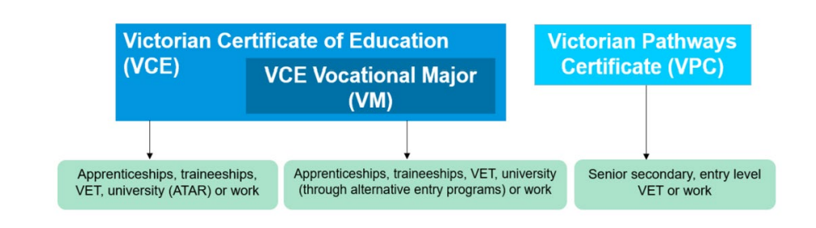

Information about Victorian Pathways Certificate (VPC)
What is the VPC?
- The VPC is a certificate for those who cannot, at this stage, participate in the General VCE or VCE VM
- The VPC is an accredited foundation secondary qualification
- The VPC can be a pathway to the General VCE or VCE VM

Who is the VPC for?

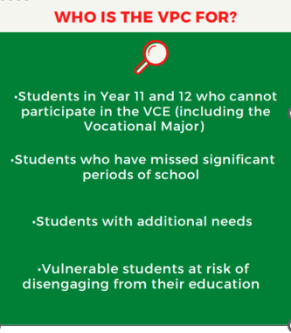
- The VPC is not suitable for whole cohorts and should only be accessed on a need’s basis
- The VPC is designed to be delivered in Year 11 and 12 and has a flexible duration depending on a student’s individual learning plan and the delivery setting.
- Students who require additional time to complete the minimum requirements of the VPC in line with an individualised program may commence units of the VPC prior to entering Year 11 or 12, most commonly Year 10
Which units should those recommended for the VPC be enrolled into?

A VPC learning program may include:
- VPC units
- VCE and VCE VM units at Unit 1, 2, 3 or 4 level, including structured workplace learning (SWL) for VET
- VET units of competency
- Or SBAT units of competency
VPC units may be completed in any order and in any year. The units can be delivered in a flexible manner and do not have to be delivered sequentially. There are no prerequisites for entry into any of the units.

The VPC has 4 studies. Each VPC study has 4 units.
- Literacy
- Numeracy
- Work Related Skills
- Personal Development Skills.
New units are also on offer which include:
- VPC Art and Design - VPC Art and Design Curriculum Design - Victorian Curriculum and Assessment Authority
- VPC Digital Literacy - VPC Digital Literacy Curriculum Design - Victorian Curriculum and Assessment Authority
- VPC Food Studies - VPC Food Studies Curriculum Design - Victorian Curriculum and Assessment Authority

Nominal duration
Each VPC unit requires 100 nominal hours, of which at least 50 hours need to be scheduled classroom instruction.
The VPC is designed to be delivered flexibly to suit the needs and circumstances of individual students. This can include face-to-face learning and activities such as work experience or supported industry engagement, volunteering and community involvement. There is no maximum time limit for completion of units. Students can enrol in the VPC at a time of year that best suits their learning needs, abilities and interests.

VCE and VCE Vocational Major units
The VPC can include any VCE and VCE VM units at Units 1–4 level. For the rules, regulations and policies governing
the delivery of the VCE, refer to the VCE Administrative Handbook 2025. Note, this handbook will be updated when the 2026 version is released by VCAA.

VET
The VPC can include credit from units of competency from nationally recognised VET qualifications. Training from a nationally recognised VET qualification may contribute towards the VPC through the following recognition arrangements:
- enrolment in a VCAA-approved VCE VET program or a school-based apprenticeship or traineeship (SBAT)
- enrolment in any other nationally recognised qualification at Certificate I or above (block credit recognition)
- successful completion of 90 nominal hours of units of competency from a nationally recognised VET qualification at Certificate I level or above provides one unit of credit towards the completion requirements of the VPC.
For the rules, regulations and policies governing the delivery of the VCE, including VCE VET programs, refer to the VCE Administrative Handbook 2025. Note, this handbook will be updated when the 2026 version is released by VCAA.

Successful completion of 90 hours of VET units of competency from a nationally recognised VET qualification at Certificate I level or above provides one unit of credit towards the completion requirements of the VPC.

When a student has met the requirements of the VPC, what have they achieved?
- A student who has met the requirements of the VPC must have achieved satisfactory completion of 12 units
- The 12 units must include:
  - at least 2 units of VPC Literacy (or units from the VCE English group, including VCE VM Literacy)
  - at least 2 units of VPC Numeracy (or units from the VCE Mathematics group, including VCE VM Numeracy)
  - at least 2 VPC Personal Development Skills units
  - at least 2 VPC Work Related Skills units.
- The remaining 4 units may include other VPC units and other curriculum, such as VCE units, VCE VM units and units of competency from nationally recognised VET
- The VPC may be completed in a minimum of 12 months
- VPC units have been designed to align to the VCE VM units to enable providers to deliver the VCE VM and VPC within the same classroom where required
Where does the VPC lead students?
- The VPC allows students to gain the skills, knowledge, values, and capabilities to make informed choices about pathways
- Through participation in the VPC, students will gain necessary foundation skills to allow them to make a post-schooling transition. Students can transition into:
  - A senior secondary qualification – VCE or the VCE VM
  - Entry level vocational education and training (VET) course; or
  - Employment

Do VPC students sit the GAT?
- All students studying at least one Unit 3 and 4 VCE subject (or a scored VCE VET subject) are expected to sit all or a section of the General Achievement Test (GAT)
- There is no requirement for VPC students to sit the GAT unless they are enrolled in VCE units 3 or 4 or a scored VET subject

Other information about the VPC:
- Students can transition into the General VCE or VCE VM or employment, VET or volunteer work if successful in their VPC completion
- Students can engage in workplace learning as above (SWL). SWL enhances motivation to achieve, ongoing connections to work and education. This can take 2 formats Work Experience and/or SWL.
- Work Experience is highly recommended for VPC students where the student is not doing a VET or if placement is in a different industry to their VET course. SWL is not a replacement for WRS, highly recommended, but not compulsory – if VET requires it though, it may need to be done

For more information about the VPC click on the link below in the live version of this document
Pages - About the VPC

Click below for the VPC Administrative Handbook
VPCAdministrativeHandbook2025.docx Note, this handbook will be updated when the 2026 version is released by VCAA.

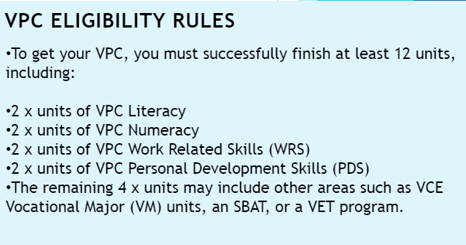

Information about the VCE Vocational Major (VCE VM)

What is the VCE VM?
- The VCE VM is a two-year (minimum), vocational and applied learning program replacing Senior and Intermediate VCAL
- It prepares students to move into apprenticeships, traineeships, further education and training, university (via non-ATAR pathways) or directly into the workforce

Why the VCE VM?
- The purpose of the VCE VM is to provide students with the best opportunity to achieve their personal goals and aspirations in a rapidly changing world by:
  - Equipping students with the skills, knowledge, values, and capabilities to be active and informed citizens, lifelong learners, and confident and creative individuals; and
  - Empowering students to make informed decisions about the next stages of their lives through real life workplace experiences

Who is the VCE VM for?
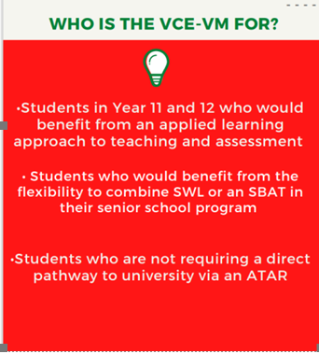

- The VCE VM is designed for students who do not need to receive a study score or ATAR and who are interested in moving into apprenticeships, traineeships, further education and training, university (via non-ATAR pathways), or directly into the workforce.
- Learning is developed based on real life situations and gives students in-demand skills needed for the future world of work
- Students apply what they have learnt by doing, experiencing, and relating acquired skills to the real-world – it is based on applied learning and the 5 pillars of applied learning

Which units should those doing the VCE VM be enrolled into?
- A student engaging in the VCE VM should be enrolled into the following units as a minimum:
  - VCE VM Literacy or VCE English units (including a Unit 3–4 sequence)
  - VCE VM Numeracy or VCE Mathematics units
  - VCE VM Work Related Skills units
  - VCE VM Personal Development Skills units, and
  - 2 VET credits at Certificate II level or above (180 nominal hours)
- There are specific program requirements for the VCE VM, which are in addition to the minimum requirements for satisfactory completion of the General VCE

When a student has met the requirements of the VCE VM, what have they achieved?
To complete the VCE VM, students need to successfully complete at least 16 units. This includes:
- 3 VCE VM Literacy or VCE English units (including a Unit 3 and 4 sequence)
- 2 VCE VM Numeracy or VCE Mathematics units
- 2 VCE VM Work Related Skills units
- 2 VCE VM Personal Development Skills units
- 3 other Unit 3 and 4 sequences of your choice
- VET at a Certificate II level or above (180 nominal hours).
The VCE VM can be tailored to the needs and interests of the student, to keep them engaged while developing their skills and knowledge. Students can also include other VCE studies and VET and can receive structured workplace learning recognition (SWLR)
Most students will undertake between 16-20 units over their two years
Where does the VCE VM lead students?
- The VCE VM allows students to gain the skills, knowledge, values, and capabilities to make informed choices about pathways.
- It prepares students to transition into:
  - Apprenticeships
  - Traineeships
  - Further education and training
  - University (via non-ATAR pathways) or;
  - Directly into the workforce
Do VCE VM students sit the GAT?
- Yes. All students studying at least one Unit 3 and 4 VCE subject (including a VCE VM Unit 3 and 4 subject) are expected to sit all the GAT. Students enrolled in a Unit 3 or 4 scored VCE or VET subject, are required to sit Part A and B. If a student is not completing a scored VCE or VET subject, they are only required to complete part A. Students are identified as required to sit part A and/or B from enrolments in VASS.

For further information about the VCE VM, click the link below in the live version of this document
Pages - About the VCE Vocational Major (vcaa.vic.edu.au)
For the VCE Administrative Handbook click the link below in the live version of this document
VCEAdministrativeHandbook2025.docx Note, this handbook will be updated when the 2026 version is released by VCAA.

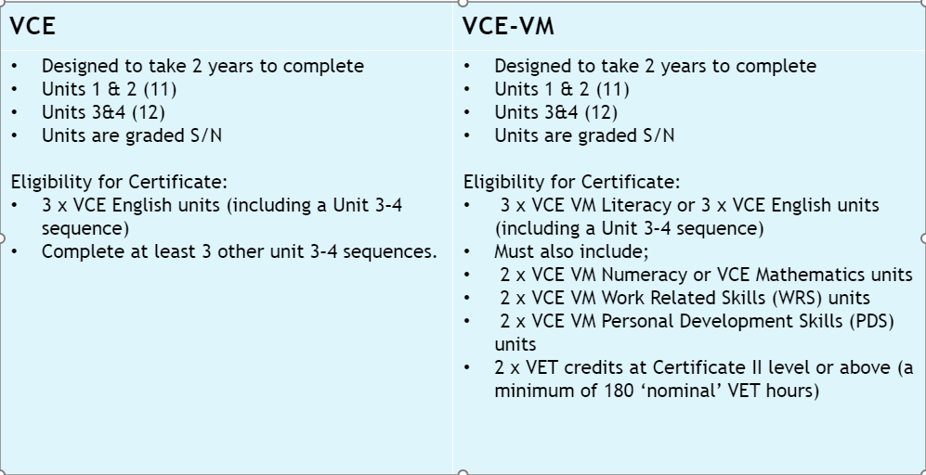

Information about the Victorian Certificate of Education (General VCE)

Where can the General VCE take students?
- Students who wish to study General VCE usually are those who need to achieve an ATAR and study scores to enter university and/or further study
- The VCE provides diverse pathways to:
  - Further study or training at University or TAFE and/or;
  - Employment

Which subjects can a student choose as part of the General VCE?
- The VCE course is made up of subjects such as English and Biology – structured as units.
- Most subjects are made up of four units: Units 1, 2, 3 and 4. A unit is one semester long.
- Most students study Units 1 and 2 of a subject in Year 11, and Units 3 and 4 in Year 12.
- You can study Units 1 and 2 of a subject as a sequence or as separate units, but these units alone don’t qualify for a study score. Completing Units 3 and 4 as a sequence in the same year qualifies for a study score
- Students can access a VET. It is best to access a scored VET if they want full ATAR contribution. Non-scored VETs only offer an increment to their ATAR.

To successfully complete the general VCE students need to:
- Successfully complete at least 16 units, including:
  - Three units from the English group, including a Unit 3 and 4 sequence
  - At least three sequences of Unit 3 and 4 subjects
- Most students study between 20 and 24 units, that’s five or six subjects, across Years 11 and 12
- You can complete your VCE over more than two years. For example, some students start the VCE in Year 10 with Units 1 and 2 of a subject and study Units 3 and 4 in Year 11

Which subjects should General VCE students choose?
Other than English, students can choose any subjects they wish in the VCE.
The best success comes when students choose subjects that:
- Interest them
- They are good at
- Will help them do what you want to do after school – such as apply for University or a TAFE course, or get a job in your chosen field

For more information about the General VCE, click the link below in the live version of this document
About the Victorian Certificate of Education | vic.gov.au

For the VCE Administrative Handbook, click the link below in the live version of this document
VCEAdministrativeHandbook2025.docx - Note, this handbook will be updated when the 2026 version is released by VCAA.

Information about Vocational Education and Training (VET)
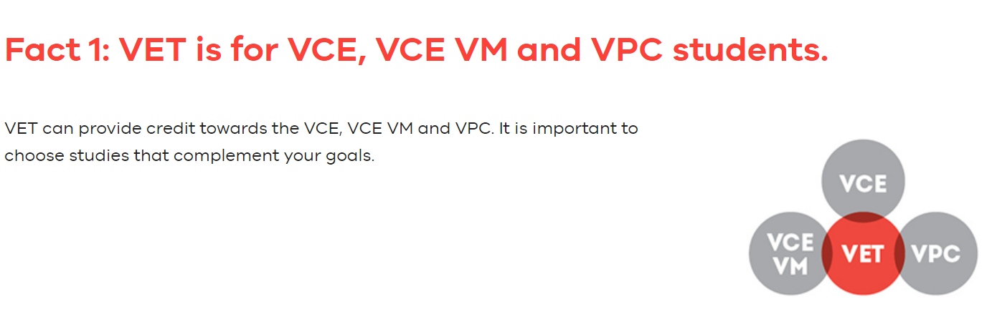
VCE VET programs are VET qualifications approved by the VCAA following consultation with schools, industry, and training providers. They lead to nationally recognised qualifications and provide an opportunity for students to receive credit towards their General VCE/VCE VM/or VPC.
Many VCE VET programs offer scored assessment, and some have mandatory structured workplace learning.
Please see the VCE VET programs - Victorian Curriculum and Assessment Authority (in the live version of this document), for a list of all VCE VET programs and if a program offers Units 1 and 2 and/or Units 3 and 4, or if they can be taken as scored or non-scored. Note, the chart says 2024 but is the only one available one on the VCAA website at this point.
See also this link in the live version of this document for all things related to VET - Pages - Get VET (vcaa.vic.edu.au)
HPSC offer several VETs onsite run by qualified trainers within our College.

VET in General VCE, including the VCE VM and the VPC
Students gain credit into their VCE, including the VCE VM, and the VPC by undertaking:
- VCE VET programs that have been developed by the VCAA in consultation with stakeholders including industry
- Approved apprenticeships and traineeships that are in the same industry areas as designated VCE VET programs
- Other VET qualifications, which provide credit into the VCE through block credit recognition
VET credit towards the VCE, including the VCE VM:
The following policies apply to VET credit towards the VCE, including the VCE VM:
- Students can accrue VCE credit achieved multiple VET qualifications at Certificate II level or above, up to a maximum of 180 nominal hours of completed units of competency (UoCs). This will give students two VCE units towards the VCE / VCE VM.
- Students who complete 180 nominal hours of UoCs in a Certificate II or above, then move into another Certificate III or above in the same industry* will accrue VCE credit at Unit 3–4 level for the next 180 nominal hours of completed UoCs.
- Students who complete 180 nominal hours of UoCs in a Certificate II or above, receiving VCE Units 1 and 2 credit, and then enrol in an approved apprenticeship or traineeship will accumulate VCE credit from the apprenticeship/traineeship in the following order: Units 3, 4, 1, 2, 3, 4. For example, a student completes 180 nominal hours of training in Certificate II in Kitchen Operations and receives VCE VET Hospitality Unit 1 and 2. The student then decides to move into a Certificate III in Carpentry SBAT. For their next 180 hours of training, they will receive VCE Units 3 and 4. Each additional 90 nominal hours of training would accrue VCE credit in the following order: Units 1, 2, 3, 4.

This policy applies to:
- All SBATs in Certificates III or above
- Certificate II traineeships that are in the same industry* as VCE VET programs drawn from Certificate II qualifications that provide VCE Units 1–4 credit (typically trade pathways or pre-apprenticeship qualifications).
VET credit towards the VPC
Students will gain VET credit into the VPC in the following way:
- 90 nominal hours-worth of completed UoCs from a Certificate I qualification or above will provide one credit towards the VPC
- Students can accrue credit across multiple VET qualifications, up to a maximum of 180 hours. This will give students two units towards the VPC
Successful completion of VET in the VCE, VCE VM, VPC can provide students with:
- A VCE (including the VCE VM), or VPC certificate issued by the VCAA, and a VET certificate issued by a registered training organisation (RTO)
- Two statements of results issued by the VCAA giving details of units completed in the VCE, VCE VM, VPC and UoCs completed in the VET qualification
- An enhanced ATAR, which can improve access to further education
- Pathways into employment and/or further qualifications or training
- Workplace experience gained through structured workplace learning and hands-on experiences
Employers value VET because it:
- Contributes to the development of entry level skills for their industry
- Provides students with a practical and focused introduction to workplace requirements
- Enhances the employability of students
- Enables industry to contribute to educational programs in schools
- Enables industry to participate in local community networks
Information from the VCAA Admin Handbook:
From 2023 there will be additional recognition arrangements for VET undertaken by VCE students.
- Students may accrue two units of credit following the completion of UoCs to the total of 180 nominal hours drawn from multiple VET qualifications.
- Students wishing to achieve a Unit 3–4 sequence from VCE VET programs other than the identified scored sequence will be required to complete 360 nominal hours of training if they either:
- complete 180 nominal hours of training from a single or from multiple qualifications and then change to another single qualification (from the same industry as any completed training) and complete a further 180 nominal hours of training, as long as that qualification contains a Unit 3–4 sequence
- complete 180 nominal hours of training from a single or from multiple qualifications and complete a further 180 nominal hours of training from an SBAT in a single qualification containing a Unit 3–4 sequence.

For further information about VET, click the links below in the live version of this document
- VET pathways in schools | vic.gov.au
- Pages - VCE VET programs
- How vocational education and training fits into Year 11 and 12 | vic.gov.au
Information about our 10 Vocational Learning (10VL) Program
At HPSC we run a Year 10 Vocational Learning program. This program is for suitable Year 10 students who need additional time to gain credit. 10VL students engage in Literacy, Numeracy, HPE, a Leadership subject, VET micro-credentialling through Taster programs in hospitality and trade (held on site), and the SEED Program, held at Foundation Learning Centre in Narre Warren – depending on individual needs and strengths
Each student’s timetable in 10 VL is personally built, and their program is bespoke, based on student need.
Information about Foundation Learning Centre (FLC/SEED Program)
This work ready program gives our Year 10 VL students (and others identified as suitable) the opportunity to attend FLC 1 day per week to undertake a specially tailored program with a focus on building skills to help them pursue their goals in education or work.
The SEED name stands for Successful Education & Employment Development and represents the growth of the students who undertake this program. The SEED Program caters to a variety of students with different requirements as well as collectively meeting the needs of the individual, class, and the home school.
The SEED Program primarily focuses on maintaining engagement, independent skills building and positive personal development, work readiness, aiding students with the tools, experiences, and qualifications to pursue their goals post program confidently and competently.
The SEED Program is designed to deliver the qualifications with creative and practical curriculum including activities, incursions, and excursions to keep students engaged and achieving outcomes.
Students enrolled in 10 VL at HPSC are provided with the opportunity to engage in the SEED program. In 2026, SEED students will attend FLC on Thursday each week.
For more information about SEED click the link below in the live version of this document
The SEED Program | Foundation Learning Centre
Information about School Based Apprenticeships (SBAT)
A School Based Apprenticeship or Traineeship (SBAT) offers students the option of combining their senior secondary education with part-time employment and skills training. The program is undertaken under a formal training contract with an employer and has a training plan registered with the Victorian Registration and Qualifications Authority (VRQA). The training must lead to a nationally recognised qualification, as determined by the VRQA.
An SBAT is an integral part of the student’s senior secondary program and study timetable. Regular school attendance is combined with a minimum of 1 timetabled day a week of employment and/or structured training. The student’s work and training should last at least 13 hours a week on average over each 4-month period — comprising 7 hours of employment and 6 hours of training.
Students enrolled in any senior program at HPSC, can access a SBAT if they chose to, and it aligns with their pathway. At HPSC all SBAT students attend their SBAT on a Tuesday and Thursday, each week. VCE VM and General VCE students can engage in an SBAT, in consultation with the school, Head Start or the SBAT provider.
The VCAA Admin Handbook states a student can undertake an SBAT only if the:
- training scheme is approved by the VRQA for delivery as an SBAT
- student is 15 years of age or over
- student is an Australian citizen or a permanent resident
- student is in relevant employment
- principal or principal’s delegate has signed the training plan which confirms the student is enrolled in a nationally recognised qualification that can be undertaken as an SBAT.

Information about Examinations
Under the VCE:
- There is one formal VCAA examination period in each academic year for scored students.
- The General Achievement Test (GAT) is conducted at the same time for both academic years (in Year 12, or for students studying Unit 3 and 4 studies).
- Each VCE unit involves 50 hours of scheduled classroom instruction. In addition, students undertake up to 50 hours of self-directed learning for each unit. Satisfactory completion of a VCE unit is based on successful completion of outcomes. Satisfactory unit completion is determined by the school, in accordance with VCAA requirements.
- VCE levels of achievement for Units 1 and 2 are determined by schools. Levels of achievement for VCE Unit 3–4 sequences, excluding VCE VM studies, are assessed using school-based assessment and external assessments (including examinations).

Each VCE study, excluding the VCE VM, has three graded assessment components: either one school-based
assessment and two external assessments, or two school-based assessments and one external assessment. Each of
the three graded assessment components contribute to a study score. Scored VCE VET studies have two types of
graded assessment components, comprising three school-assessed tasks and one external examination. Graded
assessments are reported on an 11-point scale with a range of A+, A, B+, B, C+, C, D+, D, E+, E or ungraded (UG).
For more information about SBATs click the link below in the live version of the document - School-based apprenticeships and traineeships | apprenticeships.vic.gov.au
1.5 VCAA expectations for satisfactory completion of the Victorian Pathways Certificate (VPC)
To be eligible to receive the VPC, students must satisfactorily complete a minimum of 12 units, including:
- At least two units of VPC Literacy (or units from the VCE English group, including VCE Vocational Major Literacy)
- At least two units of VPC Numeracy (or units from the VCE Mathematics group, including VCE Vocational Major Numeracy)
- At least two VPC Personal Development Skills units
- At least two VPC Work Related Skills units.

Students can also include units from VCE studies, VCE Vocational Major studies, and VET units of competency. More VPC units will be added over the coming years.
VPC students can receive VET credit for 90 nominal hours at the Certificate 1 or above level and receive structured workplace learning recognition (SWLR). Many students will undertake more than 12 units over the VPC.
The VPC is designed to be delivered in Year 11 and 12 and has a flexible duration depending on a student’s individual learning plan and the delivery setting. The VPC may be completed in a minimum of 12 months. All VPC units can be completed in any order and in any year. The units can be delivered in a flexible manner and do not have to be delivered sequentially.
VPC units have been designed to align to the VCE VM units to enable providers to deliver the VCE VM and VPC within the same classroom where required.
As stated in the VCAA Admin Handbook:
A student will receive an S (satisfactory) for VPC units when they have demonstrated achievement in all learning outcomes for the unit.
All VPC assessment activities should be reviewed by the teacher to verify their successful completion. The elements in the curriculum documents further describe the learning outcomes and are intended as a guide for teachers in the design of assessment tasks to ensure consistency in how learning outcomes are interpreted and assessed.
To be credited with a satisfactory unit result, a student must demonstrate achievement in all learning outcomes in that unit.
The curriculum components in a learning program must be assessed in accordance with the requirements and guidelines outlined in the curriculum documents for the units.
The VPC provider coordinates the assessment and collection of results for all curriculum components within the learning program. Students will receive an S or N (not yet completed) result for each unit.
Teachers assessing students who have particular needs must maintain the validity and reliability of assessment. Flexible assessment methods should be used to allow students to demonstrate the successful completion of learning outcomes without disadvantage.
Teachers should use a variety of assessment tasks that provide a range of opportunities for students to demonstrate achievement of each learning outcome. Students should be observed on more than one occasion and, wherever possible, in a range of contexts to make sure the assessment is consistent, reliable, fair and equitable.
For VCE units included in the VPC learning program, assessment must be in accordance with the VCE study designs.
1.6 HPSC expectations for satisfactory completion of the Victorian Pathways Certificate (VPC)
Students who study the VPC at HPSC, will be enrolled into the following units:
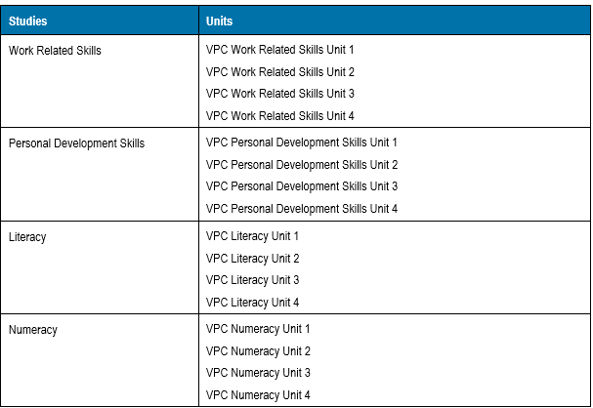
Students enrolled in the VPC at HPSC may also be enrolled in an SBAT or a VET depending on their individual learning needs and the pathway outcomes of the student.
Some students will also be supported with additional literacy and numeracy intervention and reading support, as well as learning support officer and multicultural education aide’s support. Our Tutor Learning Initiative is another mechanism of support for our VPC students, and we will continue to review how we deploy our Tutors to support VPC learning growth and achievement.
All students who are recommended for the VPC are met with, together with members of the House Leadership Team, Careers, and their parent/guardian. This is critical as VPC students and their families must understand the outcomes specific to this course, which are not equivalent to the VCE. All students and parents sign an agreement when they enter the VPC. All PSD students are automatically recommended for the VPC, in consultation with the interventions team.
1.7 HPSC expectations for the satisfactory completion of 10VL
At HPSC we strive to ensure all students are given the opportunity to achieve learning success.
Students in Year 10 can select to study units from within the VPC, as the units are designed to be flexible.
All students who have additional learning needs, are identified as PSD, or who fall under the learning intervention umbrella are eligible and recommended to engage in units from the VPC curriculum. Each student recommended will meet with their House Leadership Team, Careers, and their families, to support careful selection of subjects and to ensure a clear understanding of outcomes.
At HPSC 10VL students will be enrolled in:
- English Skills, Support or Core
- Math Skills, Support or Core
- The SEED program
- Taster micro-credentials - through Hospitality and Engineering
- Health and PE
- Leadership upskilling, through integrated projects
Early engagement in the 10VL provides our students with additional time to better familiarise themselves with the demands of senior schooling. Engagement in the SEED program and the taster micro-credentials enable students to become more work ready, further supporting their successful transition beyond HPSC. See above for further information about SEED.
HPSC Progression Criteria
2.1 GENERAL VCE PROGRESSION AT HPSC

Progression from Year 11 General VCE into Year 12 General VCE
- The VCE requires sixteen Units total. Eight Units must be from Unit 3 and 4 and these must be in a sequence (3 and 4), and one must be from the English group.
- Students must have at least three Units of English across Units 1- 4.
At HPSC students’ progress into the General VCE in Year 12 when they have a minimum of 10 satisfactory units. This must include at least 1 Unit of English.
Whilst students can progress with a minimum of 6 units, our aim is to set students up for success.
- If a student does not complete a minimum of 10 Units (8 or 9), this will be reviewed by the relevant House Leadership Team and a student/parent meeting is conducted, together with careers
- In this conversation a decision is made, based on the individuals’ circumstances as to the best pathway. Goals will be set for this student that they must adhere to and check ins need to occur regularly
- If a student only achieves 6-7 units, they may be provided with an opportunity to complete a 3-year VCE. This means they would be considered a year 11 student in the second year of VCE and year 12 student in their 3rd year of VCE
- A pathway change may also be considered, based on the required outcome of the student. Pathway changes are not simple and require careful consideration
2.2 VCE VM PROGRESSION AT HPSC

To be eligible to receive the VCE VM students must satisfactorily (over a 2-year period), complete a minimum of 16 units, including:
- 3 VCE VM Literacy or VCE English units (including a Unit 3–4 sequence)
- 2 VCE VM Numeracy or VCE Mathematics units
- 2 VCE VM Work Related Skills units
- 2 VCE VM Personal Development Skills units, and
- 2 VET credits at Certificate II level or above (180 nominal hours)
This aligns with the General VCE and requires our students to achieve more credits than they have needed in the past. Students must complete a minimum of three other Unit 3–4 sequences as part of their program.

Students who wish to progress into Year 12 VCE VM, must have the following:
- 9 Unit 1 and 2 VCE VM credits
- Of these 9 credits, the student must have
  - 1 credit for Literacy – as 3 credits for Literacy are needed to meet the requirements of the VCE VM – can include credit from VCE English. Without at least 1 credit for literacy, students cannot progress and an alternate program may need to be explored
  - 1 credit for Numeracy, which can include 1 credit from VCE Maths
  - 1 credit for WRS
  - 1 credit for PDS
  - 1 credit for VET – as students need 2 VET credits to meet the requirements of VM and 180 hours
  - 5 other credits which can come from other areas of VCE Gen, VCE VM and VET, which can be counted as general credit or industry specific credit – this could also include a credit for SWL

If a student has 8 credits or less and they do not have a credit for VET (90 hours), these students may engage in a 3-year pathway. This is individual to the student, based on need. These students may:
- Be enrolled in the VPC, to build their skills and micro credentials. These students could progress into VCE VM the following Year/s if they are below the required age in Year 12. It is thought most of these students would transition to work/TAFE after completing the VPC. If a student has many Ns, it may be that the VPC is best for this student as they will struggle in the VM
- Be enrolled in VCE VM Year 11 again, with the possibility of moving into and VCE VM Year 12 the following year if they meet the eligibility requirements
- All students in this situation, together with their parent, will engage in a promotion meeting. Promotion meetings will include the Head of House/Student Engagement Leader, and Careers to explore the options available. All notes will be kept on Compass
- Decisions about the student’s pathway will be shared with the Senior Studies Team
2.3 VPC PROGRESSION AT HPSC
To be eligible to receive the VPC, students must satisfactorily complete a minimum of 12 units, including:
- At least two units of VPC Literacy (or units from the VCE English group, including VCE Vocational Major Literacy)
- At least two units of VPC Numeracy (or units from the VCE Mathematics group, including VCE Vocational Major Numeracy)
- At least two VPC Personal Development Skills units
- At least two VPC Work Related Skills units.
VPC students can receive VET credit for 90 nominal hours at the Certificate 1 or above level and receive structured workplace learning recognition (SWLR). Many students will undertake more than 12 units over the VPC.
At HPSC, our VPC students need to achieve a minimum of 6 units to continue in the VPC, allowing them to gain an extra 6 units in the following year (if they are in Year 11).

If a student is in Year 12 studying the VPC they must meet the minimum requirements of 12 units to finish the course.

2.4 YEAR 10 PROGRESSION INTO YEAR 11 AT HPSC
Please note, this is NEW. We acknowledge that work must take place with teachers to ensure consistent implementation and understanding.

Students in Year 10 study 6 subjects, with the expectation they achieve an S in each of their subjects, each Semester. Students work towards achieving a total of 12 S’s each year (equivalent to the VPC).
To achieve an S students are expected to:
- Produce work that demonstrates achievement of what is being assessed
- Complete and submit the required tasks to a satisfactory standard, demonstrating the key knowledge and skills outlined within the band of achievement
- Submit work that is clearly their own, authenticated by the classroom teacher
- Adhere to the final deadlines set by the classroom teacher for all work
- Observe the school policy and rules regarding assessment, submission of work and attendance.
“The decision about satisfactory completion is based on the teacher’s judgment of the student’s overall performance on a combination of set work and assessment tools/tasks each Semester. Students should be provided with multiple opportunities to develop and demonstrate the key knowledge and key skills required for the subject, each Semester.
The assessment of levels of achievement is separate from the decision to award an S for satisfactory completion.
Year 10 results (S or N) contribute to satisfactory completion of the certificate and determine whether a student should progress into Year 11.
The student will receive an ‘N’ (not satisfactory) when one or more of the following occurs:
- The work does not demonstrate achievement of the required standards
- The student has failed to meet a school deadline for assessment tasks (which can include time granted through an extension for any reason or a special provision or both)
- The work cannot be authenticated, for example, through lack of attendance
- There has been a substantial breach of the school’s rules and procedures

To be eligible to progress into Year 11, students in Year 10 must satisfactorily complete a minimum of 10 S’s which must include:
- 2 Ss for English (or units from the VCE English group, including VCE Vocational Major Literacy)
- 2 Ss for Math (or units from the VCE Math group, including VCE Vocational Major Numeracy)
Students at Risk of a Not Satisfactory Unit Result
If a teacher believes a student is at risk of not being able to achieve a satisfactory result for an outcome and unit, in either the general VCE, VCE VM or the VPC, they need to action the following steps:
- Discuss their concerns with the student individually and reinforce their expectations
- Discuss the implications of receiving an ‘N’ result for an outcome at VCE/VCE VM/VPC
- Continue to issue compulsory academic support sessions to assist students in completing course requirements and to provide more one-to-one support to further students understanding of key concepts
- Contact the student’s parent/carer to discuss that their child is at risk of failing the outcome
- Complete the ‘At risk’ Compass chronicle to alert the House Leadership Team of any concerns. At risk Compass chronicles are required to be done as soon as a teacher has concern about a student’s engagement/achievement/lack of submission of work/attendance
House Leadership Teams track student achievement and progress. If students are receiving multiple ‘at risk’ posts, HLTs will contact the family of the student and will engage in a parent meeting/guardian to discuss progress and potential pathways. Notes of this conversation will be kept on Compass for future reference.

Study scores and ATAR calculations
3.1 VCE Study Score (for scored students)

When completing Unit 3 and 4 subjects for a score, students are working towards a Study Score for each of their subjects. The Study Score is a score out of 50 and is a ranking of all Victorian students completing the subject within VCE. The score for the student’s class work and exams are summed and then ranked. For example, if there are 1500 students completing English, then students will be ranked from 1500 down to 1. If 3 students get the top mark, then they will get the ranking of 1500, and the next student will be ranked 1497 and so on.
The study scores for these subjects are normally distributed with a mean of 30 and a standard deviation of around 7. This means that whilst it is possible for students to get scores in the 40’s, 95% of students will score between 16 and 44. Very few students get a score below 16 or a score above 44.
Students are then allocated Study Scores from this ranking, distributed as per the table below:
STUDY SCORE | > 45 | > 40 | > 35 | > 30 | > 25 | > 20
% OF STUDENTS | 2% | 9% | 26% | 53% | 78% | 93%

3.2 Australian Tertiary Admittance Rank (ATAR)
The Victorian Tertiary Admissions Centre (VTAC) will receive results from VASS. VTAC will use these scores to determine the ATAR for each VTAC applicant and the applicant will be notified of that ATAR by VTAC at the same time as the applicant receives their scores from the VCAA.
The ATAR is an overall measure of a student’s achievement in their Year 12 studies in relation to that of other students. The ATAR allows tertiary institutions to compare students who have completed different combinations of VCE studies. It is calculated by VTAC solely for use by institutions. The ATAR shows the position of a student relative to all students studying Year 12 or equivalent.

3.3 Calculation of the ATAR
Your ATAR is developed from an aggregate produced by adding your results for up to six studies:
- The scaled study score in English, EAL or Literature.
- The next best three scaled study scores permissible
- 10% of any fifth and/or sixth permissible subject scores that are available (called increments)
- If you have more than six results, the six permissible results that gives the highest ATAR is used.

Assessment: Satisfactory completion of Units
4.1 Satisfactory VCE Unit Result
For VCE Units, evidence of satisfactory achievement of outcomes is collected by the teacher through a range of tasks for the study. These outcomes are detailed in the VCAA study designs.
It is important to note the decision about satisfactory completion of a unit is separate from the assessment of levels of achievement, which contribute to students’ Study Score and therefore the Australian Tertiary Admission Rank (ATAR). Teachers assess for levels of achievement in units 3 and 4 and provide a score, which together with examination results, combine to give a student Study Score which is used to determine ATAR and then tertiary education pathways.
“The decision about satisfactory completion of outcomes is based on the teacher’s judgment of the student’s overall performance on a combination of set work and assessment tools related to the outcomes. Students should be provided with multiple opportunities to develop and demonstrate the key knowledge and key skills required for the outcomes for the unit.
The assessment of levels of achievement is separate from the decision to award an S for satisfactory completion of a unit. VCE unit results (S or N) contribute to satisfactory completion of the certificate and not to study score calculation.”
As stated in the VCAA Admin Handbook - For VCE units, excluding VM studies, final school-based assessment scores contribute to the calculation of a study score. Where the assessment item developed combines the demonstration of outcomes (S or N) and levels of achievement (scored assessment), best practice would support students who did not meet the outcome through the completion of the assessment item being afforded additional opportunities to demonstrate the outcome. For example, a teacher may consider work previously submitted, provided it meets the requirements, as a way of demonstrating the outcome. Students may not resubmit work to improve a school-based assessment score.
The student will receive an ‘S’ (satisfactory) for a unit if the teacher determines that the student has:
- Produced work that demonstrates achievement of the outcomes being assessed
- Completed and submitted all Outcome Tasks to a standard that demonstrates key knowledge and skills to a satisfactory level
- Submitted work that is clearly their own and can be authenticated by the classroom teacher.
- Adhered to the final deadline set by the classroom teacher for all coursework.
- Observed the school policy and VCAA rules in regard to assessment, submission of work and attendance.
4.2 Not Satisfactory VCE Unit Result
The student will receive an ‘N’ (not satisfactory) for the unit when one or more of the following occurs:
- The work does not demonstrate achievement of the outcomes
- The student has failed to meet a school deadline for the assessment task (which can include time granted through an extension for any reason or a special provision or both)
- The work cannot be authenticated, for example, through lack of attendance
- There has been a substantial breach of the VCAA’s rules and the school’s rules and procedures.

VCAA EXPECTATIONS
VCAA EXPECTATIONS

4.3 Satisfactory VCE VM Unit Result
Each VCE VM unit of study has specified learning outcomes. The VCE VM studies are standards-based. All assessments for the achievement of learning outcomes, and therefore the units, are school-based and assessed through a range of learning activities and tasks.
The student will receive an ‘S’ (satisfactory) for a unit if the teacher determines that the student has:
- Produced work that demonstrates achievement of the outcomes being assessed
- Completed and submitted all Outcome Tasks to a standard that demonstrates key knowledge and skills to a satisfactory level
- Submitted work that is clearly their own and can be authenticated by the classroom teacher.
- Adhered to the final deadline set by the classroom teacher for all coursework.
- Observed the school policy and VCAA rules in regard to assessment, submission of work and attendance.
Unlike other VCE studies there are no external assessments of VCE VM Unit 3–4 sequences, and VCE VM studies do not receive a study score. If a student wishes to receive study scores, they can choose from the wide range of VCE studies and scored VCE VET programs that contain both internal and external assessment components.
The VCE VM studies do not contribute to the ATAR. To receive an ATAR a student must complete a scored Unit 3-4 sequence from the English group and three other Unit 3–4 scored sequences. Students must achieve two or more graded assessments in these scored sequences.
4.4 Not Satisfactory VCE VM Unit Result
The student will receive an ‘N’ (not satisfactory) for the unit when one or more of the following occurs:
- The students has not completed the outcome work to a satisfactory level that demonstrates their key knowledge and skills of the outcome.
- The work cannot be authenticated, for example through lack of attendance.
- The work cannot be authenticated due to a substantial breach of rules (refer to plagiarism, cheating and colluding).
- The student has failed to adhere to set deadlines including if an extension of time has been granted for any reason, including special provision. and/or redemption of outcomes
4.5 Satisfactory VPC Unit Result
A VPC unit is satisfactorily completed once all modules within that unit have been completed. Completion of a module is based on the teacher’s decision that the student has demonstrated achievement of the learning goal(s) of that module.
Evidence of achievement of a learning goal must be ascertained through a range of assessment activities and tasks.
Teachers must develop courses that provide appropriate opportunities for students to demonstrate satisfactory achievement of modules. Students should be observed on more than one occasion and, wherever possible, in a range of contexts to make sure the assessment is carried out in line with the VPC assessment principles of valid and reliable, fair, flexible, and efficient assessment.
Teachers assessing students with particular needs, must maintain the validity and reliability of assessment. Flexible assessment methods should be used to allow students to demonstrate the successful completion of learning goals without disadvantage.
Schools will report a student’s result for each module to the VCAA as S (satisfactory) or N (not yet complete).
By reporting satisfactory completion of an S, the teacher is certifying that the student has achieved the learning goal(s) for the module according to the rules set out by the VCAA and the school.
To support students with additional opportunities to achieve a satisfactory result, teachers should:
- Assess students on an ongoing basis, integrating knowledge and skills with practical application over a period of time
- Use flexibility to meet the specific needs of students, ensuring that every student has the opportunity to demonstrate achievement at their own level and at their own pace, as appropriate to the purpose of the qualification
Each VPC study has two or four units. Each unit contains from one to three modules. The module specifies the learning goal(s) and describes their application. Students must demonstrate achievement of the learning goal(s) to satisfactorily complete the module.
Each VPC unit requires 100 nominal hours, of which at least 50 hours are scheduled classroom instruction.
The VPC is designed to be delivered flexibly to suit the needs and circumstances of the individual student. VPC units have been designed as standalone and can be completed in any order. The units can be delivered in a flexible manner and do not have to be delivered sequentially.
For VCE units included in the VPC learning program, assessment must be in accordance with the relevant VCE study design.
Students receive an S (satisfactory) for a module when the teacher determines that the student has:
- Produced work that demonstrates achievement of the learning goal(s)
- Submitted work that is clearly their own
Decisions about satisfactory completion are solely the responsibility of the school. Results for each module must be based on a judgment of satisfactory achievement or not yet completed for each learning goal(s).
4.6 Students at Risk of a Not Satisfactory Unit Result
If a teacher believes a student is at risk of not being able to achieve a satisfactory result for an outcome and unit, in either the general VCE, VCE VM or the VPC, they need to action the following steps:
- Discuss their concerns with the student individually and reinforce their expectations
- Discuss the implications of receiving an ‘N’ result for an outcome at VCE/VCE VM/VPC
- Continue to issue compulsory academic support sessions to assist students in completing course requirements and to provide more one-to-one support to further students understanding of key concepts
- Contact the student’s parent/carer to discuss that their child is at risk of failing the outcome
- Complete the ‘At risk’ Compass chronicle to alert the House Leadership Team of any concerns. At risk Compass chronicles are required to be done as soon as a teacher has concern about a student’s engagement/achievement/lack of submission of work/attendance
House Leadership Teams track student achievement and progress. If students are receiving multiple ‘at risk’ posts, HLTs will contact the family of the student and will engage in a parent meeting/guardian to discuss progress and potential pathways. Notes of this conversation will be kept on Compass for future reference.
A Guide to At Risk Chronicle Posts
When to use? | During an Area of Study (AOS)
Why would you use it? | You have concerns that student does not have ability to meet the learning outcome (LO).  Student has not been submitting work to show evidence for the LO.  Student is completing work, but you are unable to authenticate that the student completed the work.
Who receives notification | SEL / HoH / AP
Role of Teacher | Monitor students and discuss with students so that they are clear as to where they stand. Chronicle these discussions – the earlier the better!  Follow up with a discussion with the House Team.  If not submitting work; discuss with the student, issue consequences for not completing work, discuss with caregivers – Chronicle, chronicle, chronicle.  If authentication issue; give students opportunity to authenticate work; discussion, additional task under supervision of teacher.
Role of House Team | Monitor student (across subjects), discuss with student.
Redeeming Outcomes
  - Eligibility and process for redemption

Students can be assessed in a variety of ways to satisfy the teacher that they meet the outcomes for a unit. Outcome Tasks should be used to enable a student to demonstrate that they have met the Key Knowledge and Key Skills for each Outcome.

If a student has met the attendance requirements and has completed the Outcomes Tasks demonstrating key skills and knowledge, then the student will automatically achieve an S. If a student has not met the requirements of the outcome tasks the redemption process should be followed.
As stated by VCAA in the Admin Handbook:
If, in the judgment of the teacher, work submitted by a student does not meet the required standard for satisfactory completion, the teacher may consider other work relating to outcomes that has been undertaken and submitted by the student for the unit. This work may include class work, homework, additional tasks or discussions with the student that demonstrate their achievement of the outcome. The school may decide to delay the decision about satisfactory completion to allow a student to complete or submit further work.
A student may only submit further evidence or resubmit a school-based assessment for reconsideration, to redeem an N to an S for the outcome. Students may not resubmit to improve a school-based assessment score.
Redemption Process @ HPSC:
- Teacher to make a Compass Notification “Unsatisfactory Outcome (Provisional N) or Plagiarism Notification (VCE/VCE VM)
- The teacher must provide the student with the copies of the work or details of the redemption task and contact the caregivers. A redemption task is not required to be 'new’ work. Teachers must provide students with verbal notification of the ‘N’ result and provide feedback that clearly outlines what improvements need to be made and how students can achieve this to achieve a satisfactory outcome
- It is recommended a two-week redemption period is set in which students can make multiple submissions for feedback to meet the required outcomes. If after the two weeks the student is continuing to struggle, teachers are asked to seek the support of the Senior Studies Team to discuss further opportunities for the student to meet the required outcome.
- Teachers are permitted to assist a student during a redemption task to establish the student’s degree of understanding
- If a student meets the requirements of an S within the two-week period, the teacher must notify the student and note this on the original Chronicle post
- If a student does not meet the requirements of the redemption task within the two-week period, the teacher must create a Compass Chronicle entry “Unsatisfactory Outcome (N Result)”
- Students must be notified if they receive an N
- An SEL will then call parent/caregiver to notify them of N result and the implications of the result
- If a student receives an ‘N’ result for an outcome and therefore the unit, it is important that teachers maintain academic expectations within the classroom. Students must still complete course work, outcome tasks and the SACs for any subsequent outcome
5.2 Style of redemption task
- Students are still required to demonstrate key knowledge and skills in assessment criteria through the redemption task. When deciding on a redemption task, the teacher may consider submission or resubmission of already set work or other work relating to outcomes that demonstrates their understanding of the outcome. This work may include class work or homework, a discussion with the student or an additional task agreed upon by the subject teacher
5.3 Satisfactory and not satisfactory result upon redemption
- If a student completes redemption successfully, the score achieved on the original SAC must remain the same, but the student will receive an ‘S’ instead of an ‘N’ for the Unit of Study
Under specific situations, the House Leader may offer a student further redemption. The decision to offer further redemption will be made by the House Leaders in consultation with the classroom teacher
As stated by VCAA:
For the VCE (excluding the VCE VM) the teacher makes 2 separate judgements. The S or N decision for an outcome is separate from the decision that assesses the student’s level of achievement, which is used for the calculation of a study score and contribution towards an ATAR.

Chronicle posts to complete – Provisional N vs Unsatisfactory Result (N) post
 | Provisional N Chronicle Posts | Unsatisfactory Outcome (N result) Chronicle Post
When to use? | At the end of an AOS | 2 weeks after a Provisional N notification
Why would you use it? | A student has not met the LO by the end of the AOS | A student has not met the LO and has not completed the required tasks OR the redemption tasks that you have set.
Who receives notification | SEL / HoH / AP / Student / Caregivers | SEL / HoH / AP
Role of Teacher | Notify student & caregiver.  Make the due date clear and make work requirements clear.  Contact caregiver and chronicle discussion. | Notify Student & caregiver and Chronicle.
Role of House Team | Monitor student (across subjects) and discuss with the student. Assess the student's ability to meet the requirements of the subject and assess subject changes/course changes/pathways. Parent meeting if this is across subjects. | Contact Caregiver with implications of ability to achieve success. Possible meeting with caregiver. Chronicle.

5.4 Reporting a J result
If a student is no longer attending a unit but they have not officially withdrawn by signing a student exit form, the symbol J will be included on VASS.
The J result can only be used if the student:
- is no longer attending class
- has not submitted work for assessment.
The J result is recorded on the VCAA database but is not reported on the student’s Statement of Results. Units with a J result are made available to the Victorian Tertiary Admissions Centre (VTAC) and are treated as equivalent to those with an N result.

5.5 Lost, stolen, or damaged work
If a teacher or student has lost work or had work stolen or damaged, they must make a written statement explaining the circumstances. The statement must be signed, dated, and filed at the school. Schools must keep a record, but they are not required to report the loss, theft, or damage to the VCAA. The principal, acting on advice from the teacher, and based on records kept, shall determine the unit result for the student.
For further information about redemption of outcomes, see the Appendix.

School Assessment: School based assessment
School-assessed Coursework (SACs) - The school-assessed coursework (SAC) consists of a set of tasks that assesses each student’s level of achievement in Units 3 and 4 outcomes as specified in the study design. Schools provide a score for each component of coursework specified in the study design. The VCAA aggregates these scores into a single total score for each student, which is then statistically moderated against the examination scores in the study. The General Achievement Test (GAT) may also be used in statistical moderation.

Teachers must develop courses that include appropriate learning activities to enable students to demonstrate achievement of outcomes.

When developing SACs (and SATs), teachers need to ensure that the task allows enough scope for the highest achieving students to show their full range of knowledge and skills. This is important to avoid a ‘tie at the top’ scenario with statistical moderation.

6.1 Supervision Procedures for school-assessed coursework (SACs)
The following procedures are to be applied when SACs are completed under test conditions in the classroom – which is only for subjects where there is one class running. All other subjects with multiple classes, will engage in SACs on a Wednesday afternoon.

For single classes teachers must ensure:
- All desks are separated as best as possible and that the room is neat and tidy
- Only approved materials are permitted on a student’s desk. All other items (pencil case, books, water bottles etc) should be placed on the classroom floor/left in student lockers
- All permitted materials are to be checked by the supervising teacher
- Active supervision by completing regular room checks to ensure students are not communicating (speaking, making eye contact etc).
- Mobile phones and other electronic devices (e.g. smart watches) are not permitted. As per the Mobile Phone Policy any mobile phones brought into the classroom must be placed on the teacher’s desk, which will then be placed in an envelope and given to the House Office to be logged on Compass
- Where materials other than those permitted are identified, such materials are to be confiscated. The student is not permitted to finish the assessment task
- Undue assistance should not be provided to students while undertaking assessment tasks
6.2 School-assessed Tasks (SATs) and Authentication
- A SAT is a school-assessed task (SAT), which is set by the VCAA to assess specific sets of practical skills and knowledge. Teachers assess the student’s level of achievement based on a rating against criteria specified by the VCAA. Schools provide a score for each criterion. The VCAA aggregates these scores into a single total score for each student, which is then statistically moderated against the examination scores in the study. The GAT may also be used in statistical moderation. Specific subjects have SATs.
- Teachers must ensure that there is a sufficient range of topics within their class to distinguish a student’s work.
- Teachers must monitor and record each student’s development of work, from planning and drafting through to completion of the assessment task. This is to be monitored using a subject specific ‘School-assessed Task Authentication Record’ form. This requires regular sightings of the work by the teacher. Please note that these forms are different for each subject, and it is important that teachers read the provided information regarding subject specifications on the VCAA website. To access the forms, follow this link on the live version of this document Pages - VCE Study Designs (vcaa.vic.edu.au)
- Observations of individual work done in class should be recorded. The teacher and student must sign and date each recorded observation. The teacher will only assess the work that has previously been authenticated in class as documented within the Authentication Records form.
- If the folio is not submitted and work can’t be authenticated the folio will be given a ‘0’ result and an ‘N’ (Not Satisfactory). This will result in an ‘N’ for the overall outcome, and therefore an ‘N’ result for the Unit. If the SAT folio is unsatisfactory, however, the student completed all work requirements, and met all the key skills and assessment criteria, the student will be given an ‘S’ for the unit outcome and their original score will remain.

6.3 SAC Authentication
Teachers are responsible for the administration of assessment tasks and the completion of work requirements. Teachers may ask students to further demonstrate their understanding of the task during the unit or upon submission. If any part of the task cannot be authenticated the matter must be dealt with as a breach of rules (see Cheating, Plagiarism and Colluding section).
Students must ensure that all unacknowledged work submitted for an assessment task is their own. Students must also observe and apply the VCAA authentication rules for school-based assessment. Students must sign an authentication record for work done outside class when they submit the completed SAC (See Appendix).
The VCAA authentication rules for school-based assessment state that a student must:
- Make sure that all work submitted for assessment is their own
- Not plagiarise the work of someone else
- Not cheat
- Acknowledge all resources used, including texts, websites, and other source material, as well as the name and status of any person who aided and the type of assistance provided
- Not receive undue assistance from another person, including their teacher, in the preparation and submission of work.

Unacceptable forms of assistance include:
- Use of or copying another person’s work, including their teacher’s work, or other resources without acknowledgement
- Use of or copying sample answers provided by their teacher or another person
- Corrections or improvements made or dictated by another person, including their teacher
- Not submit the same piece of work for assessment in more than one study, or more than once within a study
- Not circulate or publish a piece of work that is being submitted for assessment in a study in the academic year of enrolment
- Not knowingly assist another student in a breach of rules.

In considering if a student’s work is their own, teachers should consider if the work:
- Is atypical of other work produced by the student
- Is inconsistent with the teacher’s knowledge of the student’s ability
- Contains unacknowledged material
- Has not been sighted and monitored by the teacher during its development.

6.4 Avoiding authentication problems
A significant amount of class time should be spent on a task so teachers are familiar with each students’ work and can monitor this regularly. It is a VCAA requirement that assessment tasks are modified from year to year to maintain assessment integrity.

Where commercially produced tasks are being used for a SAC, teachers must ensure that the tasks meet the requirements of the study design and that they have been sufficiently modified to enable student work to be authenticated.
Our attendance requirement has been increased to support teacher authentication of student work. Where a student submits work and there is a question it is not their own, teachers must follow the breach of rules (see Cheating, Plagiarism and Colluding section).
6.5 School-assessed coursework completed outside of class
As outlined above all students must sign a VCAA provided authentication record (see Appendix) for work done outside class when they submit a completed task.

A SAC/SAT must be submitted between Monday-Friday with 5pm being the latest deadline permitted. Students are permitted a 30 minute submission buffer e.g. to accommodate for any technical difficulties.

6.6 Scheduling Assessment Tasks
Students must be clearly informed, in advance, of all assessment dates.
VCE teachers are required to notify the Senior School Leadership Team before the beginning of each school year their planned assessment dates. This information is then collated and published for students and parents through Compass.
Teachers also need to ensure that the conditions under which assessment tasks are conducted, including resources permitted are communicated to students.
6.7 Rescheduling an assessment task for an entire class
If teachers wish to reschedule an assessment task because their students are not ready to be assessed, or due to other circumstances, they should provide adequate notification to all students in the class or classes.
An extension of time for all students in a class should be given only on the condition that they are all given adequate notice and that no student in the class or in another class is advantaged or disadvantaged.
6.8 Rescheduling an assessment task for an individual student
An extension of time for an individual student should be granted only in special circumstances. Students wishing to apply for an extension of time must collect, complete, and submit, an application form (see Appendix) to their Senior Learning Leader a minimum of 24 hours prior to the assessment. Students granted an extension of time must complete the SAC within a week of the original assessment date under the supervision of the Subject Teacher.
To be granted an extension of time, the students HLT may conduct an interview with the student and request evidence of work requirements/preparation completed prior to the assessment.
Moderation of School Assessed Coursework
Moderation involves processes where teachers work with colleagues to collaboratively examine students’ work and reach consensus on an assessment of the work against common standards. Moderation not only ensures consistent judgement when assessing student work but helps build teachers’ knowledge and common understandings of the standards and assessment tasks which enable students to demonstrate achievement of the Standards.
7.1 Whole school moderation processes - see Appendix and Compass, School Documentation, Senior Studies 2024 (to be updated for 2025)
7.2 Ranking information - see Compass, School Documentation, Senior Studies 2024 (to be updated for 2025)

Special Provisions within the VCE/VCE VM/VPC
VCAA Special Provision aims to provide students in defined circumstances with the opportunity to participate in and complete their VCE/VCE VM/VPC.
Special Provision is available to students completing the VCE/VM/VPC for classroom learning, school-based assessment and VCE external assessments. Specific eligibility requirements apply for each type of Special Provision.
8.1 Internal and External Special Provision
Teachers are not to grant students any form of special provision without this being approved by Senior School Leaders and/or House Leadership Team and/or the Inclusion Team.
Students who have been granted internal Special Provision will work with the Senior School Leaders, House Leadership Team, and the Inclusion Team to apply for external provisions.
For VCE external assessments, the VCAA is responsible for determining eligibility and for granting provisions in the form of Special Examination arrangements and the Derived Examination Score.
Students who have not previously received internal provisions may still apply for external provisions with VCAA.
For all information on provisions see this link in the live version of this document - Pages - VCAA Special Provision
8.2 Eligibility for Special Provision – in the classroom and in external assessment
Students may be eligible for Special Provision if at any time they are affected in a significant way by:
- An acute or chronic physical or mental illness.
- Factors relating to personal circumstance.
- An impairment or disability, including a learning disorder.
If a student is granted either internal or external Special Provisions, teachers will be notified by the Senior School Leaders, House Leadership Team or the Inclusion Team of appropriate modifications that need to be made to student learning.
A Compass chronicle will be completed outlining the provisions the student is eligible for. Students will also be asked to apply for provisions based on circumstances throughout the school year via a microsoft form.
8.3 Management of students requiring Special Provision
Refer to the Appendix for an outline of staff roles and responsibilities when it comes to identifying student needs, putting in place the appropriate provisions and then supporting students with these provisions.
8.4 Derived Examination scores
During the examination period, students may apply to VCAA through the Senior School Leaders or the House Leadership Team, for a derived examination score. Students eligible for a derived examination score would include but is not limited to:
- Those significantly affected by illness during the examination period.
- Those significantly impacted by factor relating to their personal circumstances and environment.
Students wishing to apply for a derived exam score will need to provide documentation from an appropriate professional (e.g. doctor) that supports their claim. For information on derived scores see the link below in the live version of this document - Pages - Derived Examination Score (DES) (vcaa.vic.edu.au)

Plagiarism, cheating or colluding
9.1 VCAA Guidelines
It is important to state in this policy that at the VCE level all cases of plagiarism, collusion or cheating may be very different in nature and that the process outlined below for incidents is a guide for students, teachers, and parents. All cases will be assessed by the relevant House Leadership Team who will have ultimate authority in deciding on the appropriate course of action.
If a student is undertaking an assessment under test conditions as a SAC, they must comply with VCAA examination rules (see Appendix).
A student must ensure that all unacknowledged work submitted for assessment is genuinely their own. If required, a teacher may ask the student to demonstrate their understanding of the task.
9.2 Suspected plagiarism, cheating or colluding
If a student is suspected of plagiarism, cheating, or colluding with school-assessed coursework but the classroom teacher did not witness cheating or cannot prove plagiarism or collusion, the student may be required to submit further evidence to demonstrate their knowledge and understanding of the task.
Students may be required to:
- Provide evidence of the development of their work
- Discuss the content of the work with the teacher and answer questions and or verbally demonstrate their degree of understanding
- Provide samples of other work completed that demonstrate understanding of the original task
- Complete, under supervision, a supplementary assessment task related to the original task
9.3 Actions required
If an Excel student is found by the Subject Teacher to have plagiarized or colluded the procedures outlined in the Hampton Park Secondary College Plagiarism Policy must be followed. The following steps are to be actioned as per the policy:
- The student will be interviewed by the Subject Teacher and the Subject Teacher will record the incident onto a Compass Chronicle as Plagiarism Notification. An electronic letter and SMS will automatically be sent to inform the parent/carer. The subject teacher should also call the parent/carer to explain the incident
- The student will be interviewed by a panel with the purpose of gathering the facts of the incident. The panel will include the Subject Teacher or the Domain Leader, the Student Engagement Leader or House Leader, and the College Principal or Principals delegate
9.4 Possible Outcomes
- The student may be allowed to resubmit or resit a SAC/SAT and the task will be graded
- The student may be allowed to resubmit or resit the SAC/SAT but they will receive an official mark of ‘UG’ (Ungraded) or 0 for the SAC/SAT. The student can still achieve an ‘S’ result for the Unit
- The student may be awarded an N for the outcome, therefore obtaining an N for the unit
- Consequences for each incident (first, second, third incidents) are outlined in the Hampton Park Secondary College Plagiarism Policy included in the Appendix
Excel ASSESSMENT POLICY

Attendance Requirements
All students enrolled in a VCE/VM and VPC program are required to have a 95% attendance in all subjects unless reasonable and valid grounds exist for them to be absent.

At the discretion of the Principal, or relevant House Leadership Team, there may be unique situations where attendance is approved outside of the Hampton Park Secondary College Attendance Policy.

10.1 Attendance calculation
Students are expected to attend over 95% of timetabled classes.

10.2 Monitoring Attendance

Classroom teachers and the House Leadership Team aims to keep students informed when their attendance is becoming a concern.

The House Administration Officers will enter all notes and certificates on Compass so that all records are up to date and accurate for Classroom Teachers, Mentors and Student Engagement Leaders to view. The relevant House Assistant will record phone messages on Compass each day and contact parents/carers daily to inform of student absences and will follow the Hampton Park Secondary College Attendance Policy.

Student Engagement Leaders will maintain an attendance log, regularly reviewing the attendance of all students in each year level. Student’s whose attendance is dropping below 95% will be required to attend redemption time.
Attendance letters will be generated and posted home regularly, and parent meetings will take place for those below the required 95%.
When a parent/carer meeting occurs, where possible, an unexplained attendance letter will be generated to be signed to account for the absences.
All students who are below the required 95% attendance are required to redeem their learning time.
10.3 When to issue an ‘N’ result based on attendance

If a student has not been attending/has sporadic attendance/attendance is poor in a subject/unit and they have not participated in any redemption time, an ‘N” result for that subject should be considered, as authentication cannot happen.
If an N is deemed appropriate, in consultation with the House and the Student Achievement Leader/Engagement Leader, the classroom teacher is required to communicate this ‘N’ result to the student’s parent/carer via a Compass notification and a phone call for this ‘N’ result.
According to VCAA policy an ‘N’ result cannot be given for not meeting attendance. The ‘N’ result is assigned to the Outcome when most of the absence occurred as the teacher would be unable to authenticate the work.
All students with attendance challenges and where Ns are being considered, must be discussed with the Senior Achievement Leader, Assistant Principal for Senior School Improvement and the relevant Student Engagement Leader/s.
For our updated attendance policy please see Compass, School Documentation, Attendance.
10.4 Parent/Carer Expectations
Parents/Carers of students who are absent are required to phone the school or log the details on Compass before 10.00am to explain their child’s absence.
If a student is absent and the school has not been previously notified, a daily SMS message will be sent to contact parents. Parental approval notes are recorded as Not Present (parent explained) and is not an approved absence and therefore will count towards unapproved attendance.
When a student is absent, it is required in the senior years, that a medical certificate is provided. This will ensure the absence is VCE approved. House Administration Officers will tick the VCE approved absence box in Compass when a medical is provided. This is for students in Years 10-12.

10.5 Student expectations

It is the student’s responsibility to catch up on any work missed because of an absence. All lessons are documented on Compass. The student can also email or discuss work missed with the subject teacher and put in place a plan to complete this work.
It is the student’s responsibility to ensure that they have over 95% attendance in all subjects/units.
If the student has an attendance percentage of less than 95%, redemption of learning time is required. HLTs will track and monitor student attendance, letting students and families know when redemption is required.
10.6 Arriving late and leaving early
Students must arrive to school and class on-time. If students are late, they must sign in at their House Office. If students are late to school without a valid reason, they may receive reflection time to be completed that day and if they arrive late to class without a valid reason, they will receive consequences from the classroom teacher. Please see our consistent approach to managing late to class arrivals and late to school in our general Staff Handbook.
Students are not permitted to leave school grounds without permission regardless of if they are 18 years of age and drive to school.
Any student that does drive to and from school must provide the House with their car model and license plate. Students who need to leave school early must provide a signed parent/guardian note, and where possible, evidence of the appointment. The students then must see one of the House Team members before they sign out.
10.7 Teacher Expectations
It is a subject teacher’s responsibility to keep accurate attendance records. Teachers must mark the Compass roll at the beginning of the lesson and record when students are absent or late and the number of minutes late.
If a student is absent on the day of a scheduled assessment, the classroom teacher must record on Compass ‘Attendance - SAC Absence’. If a medical certificate is received by the relevant House Team, they will notify the classroom teacher. The classroom teacher can then organise an alternative time for the student to complete the assessment task. The SAC can be marked. If a medical is not received, an alternative time needs to be arranged but the SAC will not receive a score.

EXCEL ASSESSMENT POLICY

Reasons for Absence

11.1 Absences due to illness

Students who are absent due to illness must provide the original documentation to the House Assistant within 48 hours of their return to school (normal school day, no formal assessment). Please note, scanned or emailed documents will not be accepted.
The House Leadership Team will review this documentation and if valid, will approve this on Compass. Students who submit documentation that is not approved, will be informed by the House Leadership Team.
If the absence took place on the day of an assessment, the classroom teacher must check for this approval on Compass. If the student has not had their attendance approved, they are not permitted to complete the assessment.
When a student has been absent from school for prolonged periods or has been unable to complete all school-based assessment tasks because of illness or other special considerations, teachers in consultation with the Senior School Leaders and House Leadership Team may grant special provisions.
11.2 Absences during a school-based assessment
If a student misses a SAC due to illness, they must provide the appropriate documentation (e.g. medical certificate) to the House Assistant 24 hours upon their return to school. The medical certificate must be obtained on the day of the assessment task. Backdated medical certificates will not be accepted for an assessment task.
If the provided documentation is approved, students will need to arrange a time with their teacher to complete the assessment. Students will be issued with an alternative SAC task and must be prepared to complete the SAC on the day of their return if requested by the teacher.
If a student misses a SAC and is not able to provide the appropriate documentation, they will receive a 0 for the SAC.
When a student is absent for an assessment task (SAC or Redemption) and their absence has been approved, the teacher is to arrange an alternative time for this to be completed.
If a student is absent on the day of a SAC catch-up or the Redemption and do not have appropriate documentation for this will receive an ‘N’ result for the outcome and unit.
11.3 Absences due to co-curricular activities

Students who attend sports days, co-curricular and student leadership meetings, wellbeing sessions or are out of class but with permission, must ensure they communicate with the classroom teacher in advance to notify them of this. The student may be asked to provide evidence of this to ensure their attendance is approved.

When events have been set up and the HAO is informed, students will be marked as school event or the relevant code. This will be accounted for in the students attendance percentage.

11.4 Absences due to a family holiday
Family holidays, extended family travel overseas and planned absences are not accepted during VCE studies. Wherever possible, holidays should be scheduled within the term breaks.
If a SAC is scheduled to take place during their absence, this is to be rescheduled to an alternative data prior to leaving. For any student who is going on a holiday and is in the senior years, our school process is to be followed. Notes will be kept on Compass.
11.5 Absences due to cultural observances
There are 2 main cultural observances that are school approved. These are Eid Ul Fitr and Eid Al Adha. Please see Appendix for specific information on these cultural observances and when they take place throughout the year. Other cultural observences, may be considered by the school as approved, please consult with the Senior School Team.
Students who participate in these cultural observances must bring a note from home explaining this. It must be provided to the House Assistant prior to the holiday in order for it to be school approved.
Any notes that are received upon the student’s return to school will not be accepted.

Students who are missing timetabled classes due to bereavement leave must notify the House Assistant. A member of the House Leadership Team will contact the family to discuss the duration of the leave and the approval process for the leave.

The House Leadership Team will then ensure a support plan is in put in place for this student upon their return to school.

11.6 Absences due to bereavement

Students who are missing timetabled classes due to bereavement leave must notify the House Team. A member of the House Leadership Team will contact the family to discuss the duration of the leave and the approval process for the leave.

The House Leadership Team will then ensure a support plan is in put in place for this student upon their return to school.

Unscored Pathway
Students who wish to obtain their VCE Certificate but do not wish to acquire an ATAR for entrance into tertiary education, may choose to undertake an ‘unscored’ VCE pathway.
If a student completes an unscored pathway, they will not be required to sit end of year exams. They will not receive an ATAR or a study score for any of their subjects.
The classroom teachers’ results will not be affected by students completing an unscored pathway.
If required, a student completing an unscored pathway can be assessed outside of the Assessment Policy.
Once a student is entered into an unscored VCE pathway, they are not able to revert to a scored VCE.
It is important to note students may select to be unscored in some subjects only, based on the requirements of their pathway and transition beyond secondary school.
All students enter the VCE as scored. No teacher is to assume a student is unscored, until communication has been received by the students HLT. A students word is not enough and we need to ensure all are treated as scored until told otherwise.
12.1 Eligibility for an unscored pathway
A Year 12 student who would like to complete an unscored pathway/is required to undergo a careers counselling conversation with their House Leadership Team and the Careers Team. Once careers counselling has concluded and it is deemed that the student has genuine reasons for pursuing an unscored pathway, both the student and parents will discuss this with a member of the House Leadership Team.
All parties must reach agreement and sign the appropriate documents which includes a letter agreeing to an Unscored Pathway and a Statement of Commitment.
The House Leadership Team will then notify subject teachers.
Unscored students are required to complete the same work as those scored, simply, they do not complete external assessment. SACs are part of the unscored student’s assessment regime.
12.2 Not satisfactory result for units
If a student has failed to meet the VCAA and Hampton Park Secondary College requirements in different subjects, a program review will occur in which an unscored pathway will be discussed.
Students will be required to undergo a careers counselling process with the Careers Team. The student and parents will be required to meet with a member of the House Leadership Team to discuss this.

Internal Examinations
13.1 Internal Examinations
The Exams are a compulsory part of our educational program and help support our learners to achieve success. They provide valuable feedback to teachers about the skills and knowledge students have attained and their areas for growth and improvement. The more practice our students have, support their preparation for the GAT and the end of year external Year 12 VCAA exams.
HPSC runs 3 sets of internal run exams.
- Year 10, 11 & 12 Mid-Year exams
- Year 12 Practice Exams (last week of term 3)
- Year 10 & 11 End of Year exams

At HPSC, students’ complete exams in nearly all Year 10, 11 & 12 subjects (including internal VET).
The only subjects that are exempt from exams are:
- Year 10 Applied Learning classes
- Year 10 VET tasters
- Year 11 & 12 VCE VM PDS
- Year 11 & 12 VCE VM WRS
- Year 11 & 12 VPC classes
- Internal VET subjects, which are not scored in the final year (year 2).
13.2 Creation and Printing of Internal Exams
- Teaching teams are expected to create exams for each subject requiring an exam
- Exams must be forwarded to the Domain Leader, with a completed exam printing sheet.
- Domain Leaders check exams and forward to the Office Manager (or delegate) for printing.
- Exams must be submitted to the Office Manager (or delegate) at least 15 working days before the beginning of the examination period.
13.3 Length of Exams
Year 10, 11 and 12 Mid-Year Exams:
- Year 12 English: 195 minutes (15 minutes reading time & 180 minutes writing time)
- Year 10 & 11 English: 135 minutes (15 minutes reading time and 120 minutes writing time)
- Year 11 & 12 VCE-Vocational Major Literacy: 70 minutes (10 minutes reading time and 60 minutes writing time)
- Year 11 & 12 VCE-Vocational Major Numeracy: 70 minutes (10 minutes reading time and 60 minutes writing time)
- All other mid-year exams are 90 minutes (10mins reading time and 80mins writing time)
Year 12 Practice exams
- There are no practice exams for any year 12 VCE Vocational Major or VPC subjects.
- Year 12 practice exams will only run for VCE and Year 2 scored VET subjects.
- All exams should match the length of VCAA exams
Year 10 and 11 End of Year Exams:
- All Year 11 VCE end of year exams should match the length of year 12 VCAA exams.
- Year 11 VCE-Vocational Major Literacy: 80 minutes (15 minutes reading time and 65 minutes writing time)
- Year 11 VCE-Vocational Major Numeracy: 80 minutes (15 minutes reading time and 65 minutes writing time)
- Year 10 English: 135 minutes (15 minutes reading time and 120 minutes writing time)
- All other year 10 exams are 90 minutes (10mins reading time and 80mins writing time)
13.4 Classes & Student Attendance during Examination Periods
During examination periods all year level-based classes are cancelled for the exam period, except for Year 10 applied learning classes and Year 11 & 12 VPC classes. Internal VET classes may run during the examination period, this is in consultation with the Senior School Team, Daily Organisation and at the request of the VET teacher.
Although exams are an integral part of the HPSC teaching and learning program, the importance of external VET or SBAT is recognised. Students who have external VET or SBAT must prioritise this over the internal exams.
As classes are cancelled, students are only required at school for their exam. If a student chooses to attend school during the examination period, they must sign in at the CRC to study.
Any accelerated students, who has a cancelled class during the examination period must go to the CRC whilst the accelerated class is not running during the examination period (i.e. a year 10 or 11 accelerating in a unit 3 or 4 subject during year 12 practice exams, or a year 9 student accelerating in a year 10 or a unit 1 or 2 subject during year 10 & 11 exams).
Any Year 9 student accelerating in a Year 10 or a unit 1 or 2 subject during Year 10 & 11 exams are expected to attend their usual Year 9 classes, around their exams.
Any year 10 or 11 student accelerating in a subject, has a school approved absence for the day of their exam and are not expected to attend classes on the day of the exam.
13.5 Exam Absences
- If students are absent on a day of an exam, they must obtain a medical certificate. If there are exceptional circumstances regarding an absence, contact the House Team to discuss.
- Where possible, exams will be rescheduled, however due to timing it is not always possible.
- If the exam cannot be rescheduled during the exam period, students may complete the exam an alternate time (study or supervision of the classroom teacher or set as a homework task)
13.6 Rescheduling Exams
Students may be granted the rescheduling of an exam for the following reasons:
- If a student has a VET course (external) or SBAT at the same time as an exams
- If a student has a clash of exams
- If a student has 3 exams on one day
- If a student has another school event scheduled for the same time as an exam
Approved Documentation
14.1 School approved documentation
For an absence to be ‘school approved’ students must provide the House Administration Officer with the appropriate documentation. This includes a medical certificate, court notice or funeral notice.

APPENDIX 1 – STATEMENT OF COMMITMENT
Statement of Commitment – Enhance and Excel Students (Years 8-12)

At Hampton Park SC, we are proud of our diverse community, and through empowering and engaging students, we remain wholehearted in our pursuit of excellence. We live out our values of, Respect, Learning and Working Together, every day.

Respect | Learning | Working Together

As an Enhance/Excel student at Hampton Park SC, we ask that you commit to our school values and our college expectations, demonstrated through the following actions:
- working in partnership with my teachers, peers, and House team to achieve my best.
- maintaining 95% attendance, bringing a medical certificate when absent.
- arriving to school and classes on time, to maximise my learning outcomes.
- attending redemption of time, should I need to, if my attendance is below 95%.
- bringing laptop, books, and resources to every class.
- enacting school wide positive behaviours, supporting my learning and the learning, safety, and wellbeing of others.
- seeking support as needed from classroom teachers, careers and additional college supports.
- completing all homework (including holiday homework) and Learning Tasks on time.
- wearing my uniform with pride – either full College uniform or full sport uniform.
- using my own locker, with a school approved combination lock.
- communicating with my teachers, via email, COMPASS, and teams, within school hours, to support my learning.
- following a study timetable – a minimum of 1 hour homework each night, eg.reading, completing, and revising work.
- following College and Department policies to ensure the safety of myself and others – eg.policies on smoking, mobile phones, bullying, and when using technology.

Excel students ONLY (Year 11 and 12 students)
As a Senior School student aspiring to reach towards your chosen destination your commitment is to:

- attend after school SACs or events.
- ensuring redemption work/redemption of time is completed.
- complete and follow a study timetable -
- VCE students: 1-3 hours per weeknight, up to 6 hours on a weekend during peak VCAA periods (SACs/exams)
- VCE VM and VPC students:
  - attend VET/SBAT on time and follow all requirements of the provider.
  - complete class tasks, homework, and communicate with teachers about due dates and extensions.
  - attend work placement on time and follow all requirements of the employer.
- ensure part time work and/or extracurricular commitments are organised around school and study commitments.

As a college we support every individual reach towards your potential with
- a team around the learner including House team; Student Engagement Leader; Mentor teacher; wellbeing team; and careers team.
- Homework Club, accessible each week, to further develop your understanding, knowledge, and skills.
- additional teachers for English and Math, Learning Support Officers and Tutors for extension or learning support.
- Lunchtime Clubs for fun and to explore your interests, strengths, and skills.
- a variety of inter sport, House, and school activities to develop strength, confidence, ability and connection to House/school.
- Breakfast club to support a healthy and nutritional start to the day.
- a school nurse and health promotion nurse.
- technology support.
- a guaranteed and viable, choice curriculum with highly qualified and passionate educators.

Together, with your commitment, we look forward to going on this journey with you.
Wayne Haworth
Principal
………………………………………………………………………………………………………………………………………………………………………..
Please complete the information below, outlining your commit to our college and our vision and values.

I ________________________________________________commit to the college values and expectations outlined above. I promise to be my best every day and I will strive to reach my potential by making the most of what the college has to offer.

Name: …………………………………………………… Date: ……………………… Student Mobile: ………………………………………….
Student personal email: …………………………………………………………… Student signature: ………………………………………
APPENDIX 2 – VCAA TEACHER CHECKLIST
VCE study development and delivery
Teachers must provide learning experiences and assessment opportunities that are in accordance with the currently accredited VCE study designs.
1 | In developing a course of study, I have:  - used the current study design  - selected a text from the current text list, where applicable  - prepared a range of tasks that enable students to  - develop the listed knowledge and skills  - demonstrate the listed outcomes.
2 | Where a student has been identified as needing special provision for classroom learning and school-based assessment, I have liaised with the VCE coordinator.
Satisfactory completion
The decision about satisfactory completion of outcomes is based on the teacher’s judgment of the student’s overall performance on a combination of set work and assessment tools related to the outcomes.
1 | I have explained clearly the work a student must do to achieve an S for a unit and the conditions under which the work is to be done.
2 | I separate S and N judgments from levels of achievement (scored assessment), basing the decision about satisfactory completion on my judgement of the student’s overall performance on a combination of set work and assessment tasks related to the outcomes.
3 | I have provided students with opportunities (including additional opportunities, where appropriate) across the learning program to develop and demonstrate the key knowledge and skills required for the outcomes of the unit.
4 | Where the work submitted by the student does not demonstrate the outcome, I have considered other work, including class work, homework, additional tasks or discussions with the student, that demonstrate their understanding of the outcome, when making an informed decision on whether an outcome is met.
5 | In the case of lost or stolen work, I retain a written statement explaining the circumstances.
6 | I know the school-based process to delay satisfactory completion and apply it where appropriate.
School-based assessment
School policies and procedures, including the conditions and rules under which school-based assessment will take place, must be communicated to students and parents at the beginning of the academic year or when a student enrols in any VCE unit at the school.
1 | To the best of my knowledge, the school-based assessment I deliver does not include any existing commercially produced, publicly available school-based assessment material, nor have I included previous year’s school-based assessment. Where I have used existing resources to create school-based assessment it has been suitably modified to make sure I can authenticate student work.
2 | I use the Authentication Record for School-based Assessment form (or similar) to monitor and record student progress on school-based assessment work conducted outside of class time.
3 | I have not marked or provided comment on any draft submitted for school-assessed coursework unless it is a requirement of the VCE study design and/or for authentication purposes.
4 | When assessing student work, I use performance descriptors or an assessment rubric/marking guide.
5 | If there is more than one class in my study, I follow the internal school practices regarding cross-marking and/or internal moderation.
6 | After assessment is submitted and marked, I follow school-based procedures in relation to the provision of feedback to students.

APPENDIX 3 - AUTHENTICATION
School Assessed Task Authentication Form - SATS
These forms are subject specific. You can download them from VASS or from the VCAA website.
https://www.vcaa.vic.edu.au/Documents/vce/School-basedAssessment/AuthRecSAC.pdf
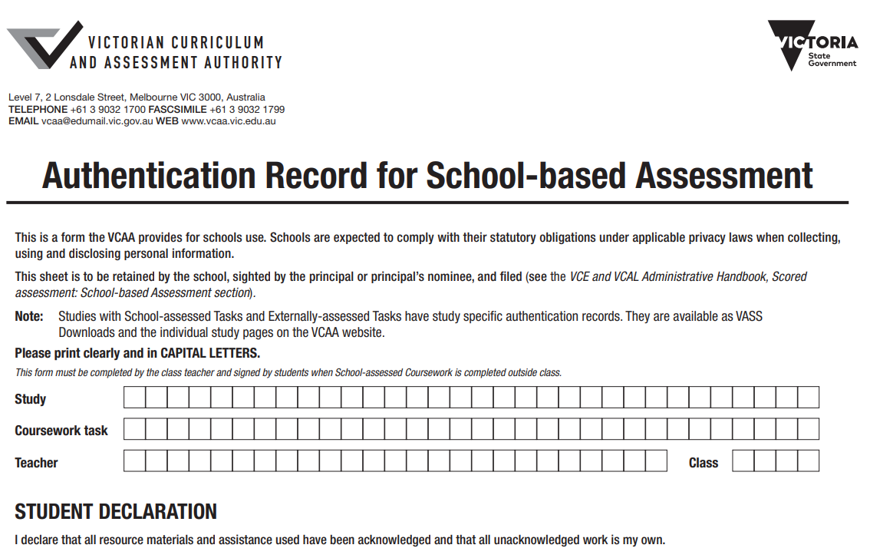
Authentication information from VCAA
Principals are responsible for the administration of the VCAA’s rules and instructions in their school. One of these rules is that students must make sure that all work submitted for assessment is genuinely their own.
Teachers may consider it appropriate to ask students to demonstrate their understanding of the task at, or about the time of, the submission of their work. If any part or all of the work cannot be authenticated, the matter must be dealt with as a breach of rules.

Rules for authentication of school-based assessment
Students must observe and apply the VCAA authentication rules for school-based assessment. Students must sign an authentication record for work done outside class when they submit the completed task.
The VCAA authentication rules for school-based assessment state that a student must:
- make sure that all work submitted for assessment is their own
- not plagiarise the work of someone else
- not cheat
- acknowledge all resources used, including:
- texts, websites and other source material
- the name and status of any person who provided assistance and the type of assistance provided
- not receive undue assistance from another person, including their teacher, in the preparation and submission of work.
Acceptable levels of assistance include:
- incorporating ideas or material derived from other sources (for example, by reading, viewing or note taking), but which have been transformed by the student and used in a new context
- prompting and general advice from another person or source, which leads to refinements or self-correction or both
Unacceptable forms of assistance include:
- use of or copying another person’s work, including their teacher’s work, or other resources without acknowledgement
- use of or copying sample answers provided by their teacher or another person
- corrections or improvements made or dictated by another person, including their teacher
- not submit the same piece of work for assessment in more than one study, or more than once within a study
- not circulate or publish a piece of work that is being submitted for assessment in a study in the academic year of enrolment
- not knowingly assist another student in a breach of rules.
In considering if a student’s work is their own, teachers should consider if the work:
- is atypical of other work produced by the student
- is inconsistent with the teacher’s knowledge of the student’s ability
- contains unacknowledged material
- has not been sighted and monitored by the teacher during its development.

Work completed outside of class – VCAA Admin Handbook
Most work for the assessment of unit outcomes and school-assessed coursework (SACs) will be completed in class; however, this does not preclude normal teacher expectations for students to complete research and learning activities that contribute to gaining key knowledge and skills outside of class time.
Additional work and study undertaken outside of class time will be required as part of the student’s regular learning program. The setting and marking of work with a formative focus provides students with the opportunity to develop their knowledge and skills, and for teachers to provide diagnostic feedback.
A task for the assessment of unit outcomes may require preliminary preparation and activities associated with the task (for example, gathering necessary research data). The amount of work to be completed as homework is decided by the teacher, taking into account the nature, scope and purpose of the task. Students should be advised just before beginning the task that some information or data might be collected outside the classroom.
For SACs undertaken outside of class time, teachers must monitor and record each student’s progress through to completion. This requires regular sightings of the work by the teacher and the keeping of records in the Authentication Record for school-based assessment form which is available to download on VASS.

APPENDIX 4 - EXTENSION
Extension Application

REQUEST FOR EXTENSION OF TIME FOR SCHOOL ASSESSED COURSEWORK (SAC)

Extensions of time will only be approved due to extenuating reasons by the House Team.
Extensions will be evaluated on individual case information.

DATE:
STUDENT NAME:
SUBJECT (Unit):
SUBJECT TEACHER:
SAC NAME:
ORIGINAL DATE:
NEW SCHEDULED TIME:

REASON FOR REQUEST FOR EXTENSION:

____________________________ Approved: Yes / No
Student signature

__________________________ By House Leader/
acknowledged by Subject Teacher Student Engagement Leader

APPENDIX 5 - PARTNERSHIPS

VCE Partnership Form
This form needs to be downloaded from VASS (a sample is attached below). It must include all party in order to submit it. Our VASS Administrator will let you know if you need to form a Partnership.

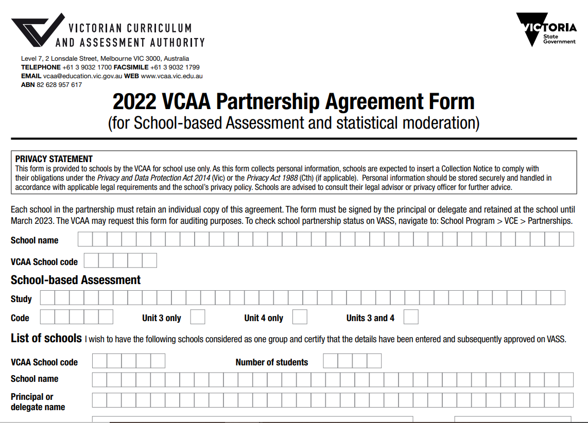
As per information from VCAA
The VCAA recommends that schools with fewer than five enrolments in any VCE Unit 3–4 study form a small group partnership with another school for the statistical moderation of school-based assessments. It is up to the school to initiate the formation of the partnership and ensure that is operates effectively.
Successful partnerships have consistent interaction between schools. Schools may use any method of interaction which is appropriate. These include telephone, fax, post, email and face-to-face meetings.
A small group partnership agreement form is obtained through VASS and must be:
- completed for each study for which a partnership has been formed
- endorsed by the school principal of each school in the partnership
- retained by the school until March of the following year.
It may be requested by the VCAA for audit purposes.
For further information about small group partnerships, see here in the live version of this document - Pages - Small group partnerships for school-based assessment (vcaa.vic.edu.au)

APPENDIX 6 – SPECIAL PROVISION
Internal VCE Special Provision Process
Step 1:  Identifying needs |  | A student may be eligible for special provisions under the categories of:  - Mental Health  - Hearing  - Vision  - Physical disability  - Medical condition (including ASD and ADHD)  - Specific learning disorder (SLD)  - Language disorder (LD) |  | If the student is already identified by the school, they must begin step 2.  If the student has not been previously identified as having an additional need the staff member must:  - Contact House Leadership Team  House Leadership Team to act on all integration referrals made and advise of appropriate team support.
Step 2:  Internal Special Provision Application |  | Microsoft Forms emailed to all students and provided via compass at the beginning of the school year |  | Students are to complete the form either independently or together with their HLT
Step 3:  Review |  | Panel to review application |  | Documentation to be approved for appropriate provisions and letter generated for student/parents.  If not approved, further advice provided in letter to student/parent.

Step 4:  Implementation |  | Student will have a snapshot created and provisions uploaded to compass.  Chronicle called - Special Provision for classroom learning and school-based assessment |  | Student Engagement Leader to notify teachers and provide them with the student snapshot for category 1 students.  Inclusion Team to notify teachers and provide them with the student snapshot for category 2 students.  Teacher meeting to be held to discuss student’s condition and provisions to be implemented in conjunction with the snapshot. Teachers to implement provisions in class. Email can also be sent to all teachers via Compass to alert them of provisions

Step 5:  Monitoring |  | Student will be monitored by House Leadership Team with regular support sessions. |  | House Leadership Team to provide a support session monthly to complete support session template and pin to student’s Compass profile.
End of Year Review |  | Student to participate in an end of year review reflecting on their progress throughout the year. |  | SEL to complete the end of year review with student and update the Internal Special Provision Application documentation and pin this to student’s Compass profile.
Step 6:  Examinations |  | At the beginning of Year 12 a ‘Special Examination Arrangement Application’ must be completed and submitted to VCAA by the beginning of March. |  | If the student has been receiving special provisions throughout Year 11:  - SEL to meet with each student at the beginning of Year 12 and complete ‘School-based evidence’.  - SEL to liaise with Inclusion Team and House Leadership Team to arrange for evidence to be collected.  - SEL to seek Principal statement.  - SEL to submit application to VCAA.  This can also be completed by the HOH or AP depending on who works closely with the student  If the student has not previously been identified as requiring special provisions the following steps must be followed:  - House Leadership Team is to consult with the student and families.  - House Leadership Team is to advise of appropriate team support to complete the referral process e.g., Inclusion Team and/or Wellbeing Team.

APPENDIX 7 – EXAM RULES
VCAA Examination Rules

Students are required to observe the following rules for the conduct of VCE written examinations and the GAT conducted by or on behalf of the VCAA, as well as the day-to-day rules of their school and of the venue.
VCAA rules shall apply with appropriate and reasonable modifications to students who have disabilities or other impairments.
All supervisors are issued with directions for the administration of VCE written examinations and the GAT and are required to report all alleged breaches of these rules to the VCAA.
Supervisors have the right to check any authorised materials that are taken into a VCE written examinations and the GAT.
- Students must not cheat or assist other students to cheat, including taking any action that gives or attempts to give them or another student an unfair advantage in a VCE external assessment.
- Students must not allow, induce or assist any other person to present for a VCE external assessment in their place.
- Students must not present for a VCE external assessment in another student’s place.
- Students must not present for a VCE external assessment under the influence of alcohol or drugs.
- Students must obey and observe all instructions or directions given by their supervisor.
- Students must provide reasonable assistance to any investigation by the VCAA in relation to a suspected breach of VCAA rules.
- Students attending a VCE external assessment may bring only the materials and equipment approved for that external assessment into the examination room.
- Students must not possess mobile phones and electronic devices that are capable of storing, receiving or transmitting information or electronic signals, such as recorded music and video players, organisers, dictionaries and computerised watches, during a VCE external assessment.
- Students detected with any device defined in rule 8 must, upon the direction of a supervisor, surrender that device for inspection. Any confiscated device may be retained, pending any investigation into an alleged breach of VCAA rules. Students must provide reasonable assistance to the VCAA or its agents to enable the interrogation of the device.
- Students must not bring into or possess in the examination room any drinks or food, except under special circumstances as approved and directed by the VCAA. Bottled water is permitted in the examination room under approved conditions.
- Students must not communicate with any other student while the VCE external assessment is being conducted.
- Students must not cause any nuisance, annoyance or interference to any other student during a VCE external assessment.
- Students must not remove or tear out any part of a bound reference, answer book, question/task book or question and answer book except where permitted, for example, formula sheets.
- Students must not remove any response material, used or unused, from the examination room.
- Students must not begin to write or mark their paper or response material in any way, or use a calculator, until advised by a supervisor that writing may commence.
- Students must raise their hand if they wish to communicate with a supervisor.
- Students must not leave their place until permitted by a supervisor.
- Students will not be permitted to leave the VCE external assessment before 30 minutes have elapsed from the start of writing time.
- Students will not be permitted to leave in the last five minutes of the VCE external assessment.
- Students must cease writing when instructed to do so by a supervisor.
- Students must remain silent and seated in their place at the end of the VCE external assessment until response materials have been collected and checked, and an announcement is made permitting students to leave the examination room.
- Students must not communicate with an assessor, before, during or after a VCE external assessment, except when communication is necessary for the conduct of the assessment.

Students arriving late

Written examination, up to 30 minutes
A student arriving late for a written examination, up to 30 minutes after the scheduled start of writing time, will be admitted to the examination room. The student is allowed the full writing time but is given no allowance for reading time.

Written examination, after 30 minutes
A student arriving late for a written examination, after 30 minutes from the scheduled start of writing time, but before the scheduled finish of writing time, may be admitted only if all the following conditions are met:
- The principal of the host school, or the principal's delegate, recommends the student's admittance.
- The student is admitted into the room on the understanding that their response materials may not be accepted by the VCAA. The student must be advised of this condition and must sign acceptance of this requirement on a statutory declaration.
- The student completes a statutory declaration immediately following the conclusion of the examination declaring:
  - the reason for being late to the examination
  - the time of admittance to the examination room
  - they have not seen or read the examination question book prior to their admittance
  - they have not received any information about the contents of the examination question book
  - they understand that their response materials may not be accepted by the VCAA.
- Appropriate arrangements can be made to enable the student to complete the examination and that it can be completed without disruption to other students.
The student is allowed the full writing time but is given no allowance for reading time.

APPENDIX 8 – FAQS EXAMS
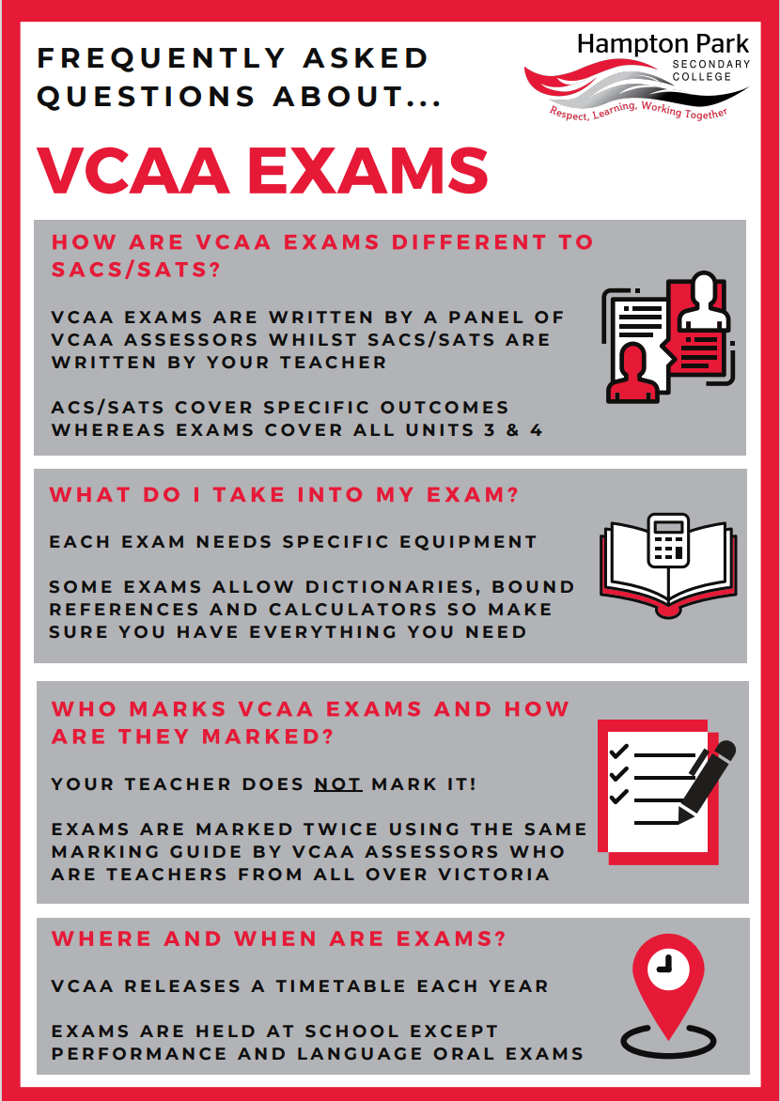

APPENDIX 9 – APPROVED OBSERVENCES

Approved Religious Observance Days
Eid Ul Fitr
Eid Ul Fitr is also known as the ‘Festival of Breaking the Fast’. It is a religious holiday celebrated by Muslims worldwide that marks the end of Ramadan, the Islamic holy month of fasting. The day of Eid, therefore, falls on the first day of the month of Shawwal. The date for the start of any lunar Hijri month varies based on when the new moon is sighted by local religious authorities, so the exact day of celebration varies by locality. In Australia, it is decided by the Australian National Imams Council. This announcement is dependent on the citing of the new Moon (this could be 1 or 2 days before Eid). Eid Ul Fitr is celebrated over 3 days.
The predicted dates for the first day for Eid Ul Fitr are outlined below. Please be mindful that this is a guide and does not confirm the date. Confirmation comes from the National Imams Council.
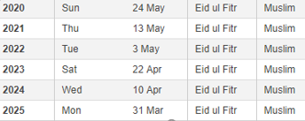
Eid al Adha
The same process above is applied to Eid al Adha. Eid al-Adha follows from the annual pilgrimage to Mecca in Saudi Arabia. This pilgrimage applies to Muslims worldwide, as they are required to perform the Hajj once in their lives. Some Muslims in Australia may travel to Mecca prior to Eid al-Adha to make this pilgrimage. This celebration is over a 4-day period.
The predicted dates for the first day for Eid Ul Adha are outlined below. Please be mindful that this is a guide and does not confirm the date. Confirmation comes from the National Imams Council. Please note that due to the moon citing, the predicted date does not always coincide with the actual announcement.
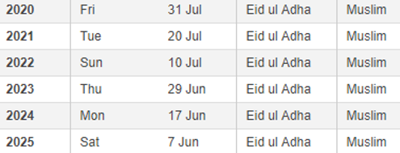

APPENDIX 10 – SACS AND SATS

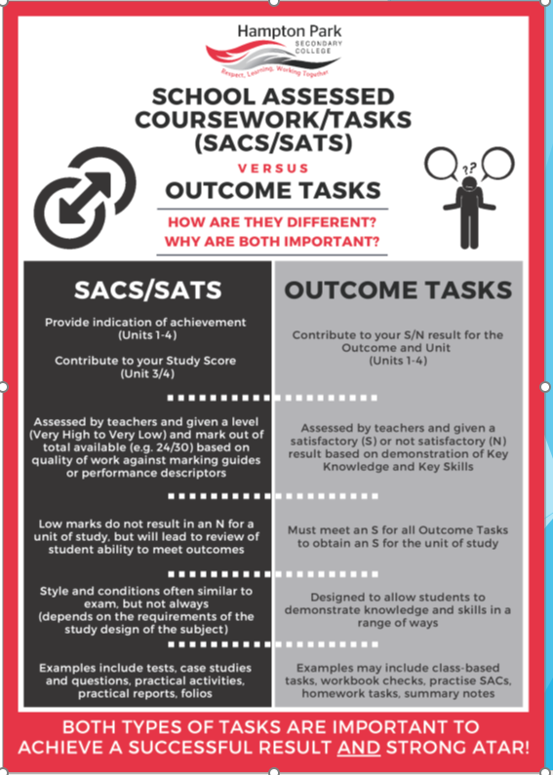

APPENDIX 11 - REDEMPTION

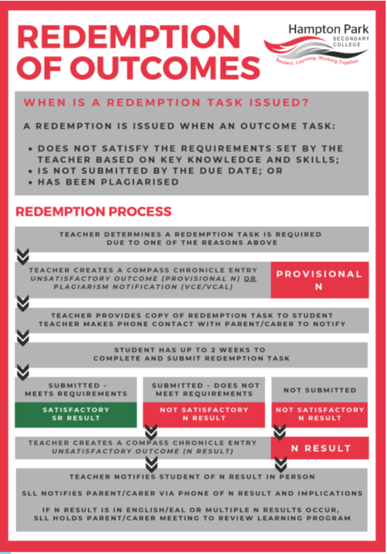

APPENDIX 12 –FAQS COMPLETION

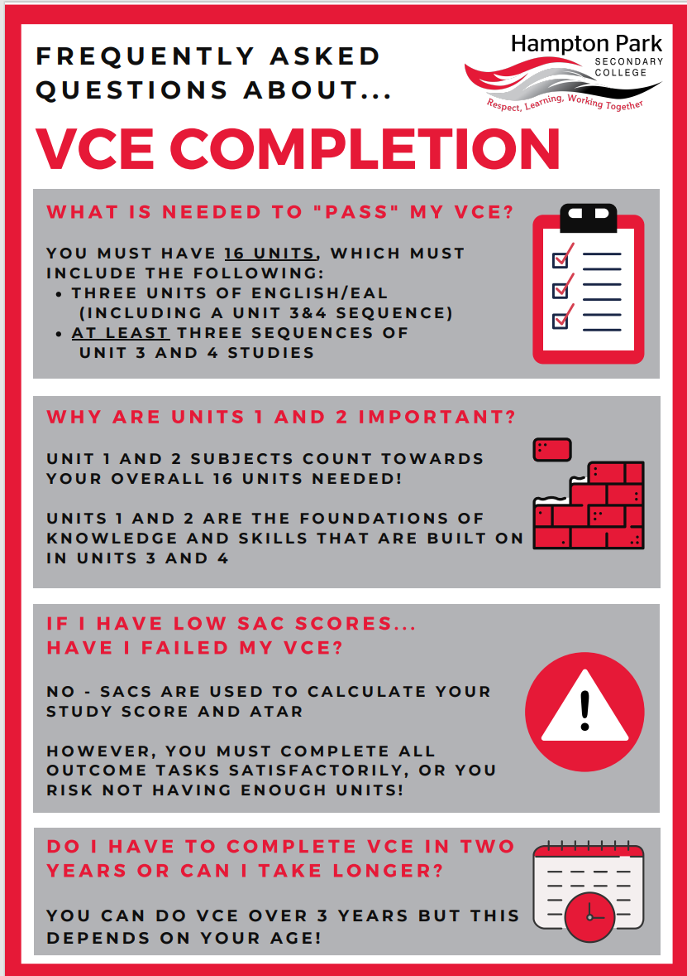


APPENDIX 13 – AT RISK

Identifying Students ‘At Risk’ in their learning – Focus on Year 10-12 Students
Hampton Park Secondary College Policy and Procedures
Introduction
This policy and the procedures outlined below apply to all Year 10-12 Students who are enrolled in VCE, VCE VM, VPC and VET studies at Hampton Park Secondary College. It also applies to all teachers and other staff employed at the College who teach and administer these studies. It covers information about identifying students who are at risk of not passing a VCE, VCE VM, VPC or VET unit, which may impact on their satisfactory completion of their certificate and therefore their successful pathway beyond school.
‘At Risk’, for this purpose, does not apply to students who are identified as having or experiencing wellbeing-related risks, rather, focusing solely on learning risk.
Why must students be identified as ‘At Risk’?
At Hampton Park Secondary College we are rich in diversity and by empowering and engaging students we remain wholehearted in our pursuit of excellence.
It is therefore the responsibility of all staff to ensure our students are progressing in their senior learning and are on track to achieve success in their chosen pathway, reaching personalised excellence. Early identification and communication of any student who is struggling in their learning, helps:
- House leadership teams, our student support services team, our domain leaders, our careers team and our teachers to work together and support students in need
- Strengthen our partnerships with families, allowing us to share information as soon as possible, in support of the child and together develop a plan to ensure success for their child
- Pathway discussions and the adjusting of individual pathways based on relevant and up to date learning data. Pathways can be understood by all stakeholders and are realistic, suited to the individuals’ strengths, abilities and interests
- Identify those students who may not achieve an outcome, supporting them as required
- Curriculum Teams to identify teaching and learning trends for students, to proactively support individuals and cohorts, as well as to inform teaching practice
Students who do not achieve the outcome for the identified unit, may, over time accumulate enough units that can impact whether they are awarded their overall certificate at the end of their final year – which is critical information to know sooner, rather than later.
If a student has not been flagged as ‘at risk’ and the appropriate communication has not happened by the classroom teacher, whereby the student also does not meet the outcome, we are unable to support the student and intervene where required. This may result in the student being given additional opportunities to show their learning, as we have not fulfilled our duty or requirements.
In short, identifying an individual or a cohort of students who may be ‘At Risk’ enables the school to assess our students’ learning progress at key stages during the year and implement any interventions that may be required.
Process for identifying students deemed to be ‘At Risk’
A student who is ‘At Risk’ has been identified by the teacher as being at risk of not passing a VCE, VCE VM, VPC, or VET unit, which that teacher is delivering.

- Identify the student ‘At Risk’.
Reasons a student may be identified as at risk, may include the following:
- High levels of absenteeism, below 95%, impacting authentication and the understanding of the student who has missed key concepts and skill development
- Not demonstrating the key knowledge and skills required to achieve an outcome
- Either completing a repeated number of redemptions or not attending redemptions or catch-ups which have been scheduled to support the student in showing their understanding
- Did not pass a SAC or SAT following teacher assessment of the outcome and is required to redeem the SAC through additional learning opportunities
- Is struggling to show understanding, despite multiple modes and attempts to demonstrate their knowledge and skills

- Complete a Compass Chronicle.
- VCE/VCE VM/VPC/VET teachers must complete a Compass Chronicle using the Academic Progress Check – Students ‘At Risk’.
- Teachers need to provide a description in the comment box outlining why the student has been identified as at risk e.g.: “Student is at risk of not achieving Unit 3 Business Management, AOS 1 outcome because… This needs to be resolved by X which is the school deadline for S/Ns.”
- Recording the information in the correct system, using the correct form is critical. Teachers must not email the HLT directly or use other Chronicle templates such as General Attitude/Behaviour Observation or General Academic Observation templates to record their concerns.

- Relevant SEL meets with the student/and or HOH
- The relevant SEL will meet with the student to discuss the concerns expressed by their teacher and, if appropriate, contact the student’s parents/guardians for further follow up
- The student must be made aware of any implications of not demonstrating the outcome, which should also be outlined to the parent/guardian
- This information will also be taken into the students learning conversation at the appropriate time, with their parent/guardian and the careers team, to ensure the student understands the best pathway based on their learning progress

- HLT to respond to the teacher via the Chronicle
- The relevant SEL will respond to the Teachers Compass Chronicle, including any next steps or commitments agreed with the student
- If teachers do not receive a response to their Compass ‘At Risk’ Chronicle from the HLT in a reasonable and timely manner, they are encouraged to discuss, in person, with the House Leader, to alert them to the concerns they may have about the student

- Teacher updates or closes off the ‘At Risk’ notification
- Teachers are expected to update or close-off any Compass Chronicles about the student, alerting the HLT that the matter has been resolved and the student is no longer at risk
- It is likely that this procedure may need to be repeated for each situation or event in which an individual student may be ‘At Risk’
- While this may be an arduous task, completing the Chronicle is a protective measure for students, teachers and the school

Table outlining situations/examples of why a student may be identified as At Risk in their learning
Situation | What Teacher needs to do | Escalation contact
Student is not attending class regularly – below 95% | Complete ‘At Risk’ Chronicle in Compass. | SEL/HOH to support where required. SAL can provide support if required (GLC)
Student did not attend a SAC/SAT date and did not alert the teacher | Complete ‘At Risk’ Chronicle in Compass indicating student has missed the SAC.  Contact the student by email or in person.  If rescheduling the assessment complete an Extension, Redemption, Absence and Change of Date form in Compass Chronicle. | SEL/ HOH to support where required. SAL can provide support if required (GLC)
Student did not demonstrate the knowledge and skills for the outcome in classwork or the assessment | Complete ‘At Risk’ Chronicle in Compass.  If organising the first redemption, complete an Extension, Redemption, Absence and Change of Date form in Compass Chronicle. | SEL/ HOH to support where required. SAL can provide support if required (GLC)
Either completing a repeated number of redemptions or not attending redemptions or catch-ups which have been scheduled. | Complete ‘At Risk’ Chronicle in Compass. | SEL/ HOH to support where required. SAL can provide support if required (GLC)
Attending class but refusing to submit or complete classwork. | Complete ‘At Risk’ Chronicle in Compass | SEL/HOH meet with the Student/Family. Pathways discussion with Careers may be required. SAL can provide support if required (GLC)
Students not attending VET subject | Complete ‘At Risk’ Chronicle in Compass | SEL and phone call home, meet with Student and family as required  HOH to support where required/SAL (GLC)
Breach of school and VCAA rules for school-based assessments. | Complete ‘Breach of Rules’ chronicle  Provide evidence for investigation  Await for further information from the Senior Team  Inform student of this process | Investigation takes place by Senior Team and relevant Senior SEL. SAL can provide support if required (GLC)  HOH to support where required  Phone call home needs to be made to make aware of the process

APPENDIX 14 - PLAGARISM

PLAGIARISM POLICY
Aim:
This policy is developed as an educational guide for students, teachers, Domain Leaders, Student Engagement Leaders, and parents/ carers and members of the school community. No policy, however comprehensive, can predict all of the incidents that might occur in this area of concern. Any staff member who suspects that a student (Years 7-12) has plagiarised, colluded, or cheated must report the incident as soon as practical once the breach is known. The staff member must then file the incident onto Compass using the Chronicle titled Plagiarism Notification (7 - 10) or Plagiarism Notification (VCE and VCE VM). Additionally, any student or students who observe plagiarism, collusion, or cheating must report the incident immediately to the subject teacher.
Rationale:
According to the Oxford dictionary “plagiarism” means “the wrongful appropriation or purloining, and publication as one’s own, of the ideas, or the expression of the ideas (literary, artistic, musical, mechanical, etc.) of another”.
Plagiarism is an act of fraud. It involves knowingly stealing someone else’s work and lying about it afterwards.
Students must strive for their personal best and seek honest feedback on their work in order to learn and improve. Cheating and plagiarism interfere with the assessment and feedback process that is necessary to promote academic growth.
Hampton Park Secondary College students are expected to demonstrate honest and ethical behaviour in completing all of their course work and assessment tasks.
All academic work, written or otherwise (including oral and visual presentations), submitted by students to their teachers is expected to be the result of their own thought, research, or creative ideas and to be expressed in their own words.
In cases where students feel unsure of what plagiarism and/or collusion mean, they are strongly recommended to speak with their teachers on the matter before submitting their work. Teachers are more than happy to offer guidance to students regarding how much information can be legitimately taken from other sources and how it can be used properly.
When a student's assignment involves researching outside sources of information, the student must carefully acknowledge exactly what, where, and how they has used these sources. Most subjects use either the Harvard or Oxford method of citation, with the exception of Psychology, which uses the APA system. Subject teachers will outline the expectations of the chosen referencing system used in each subject. Students can access the librarian located in the Resource Centre for additional support.
Teacher’s work cohesively to ensure students are properly taught how to use citations within their work, how to reference their work, and how to create a bibliography.
The following steps will be taken to ensure all students are thoroughly educated about Plagiarism:
- A Student Declaration of Authenticity will be added to every common assessment task at Years 7-12.
- A plagiarism workshop will form part of each year levels Start Up Program.
- All subject teachers will raise the issue of Plagiarism within classes, in particular when the requirements of an assessment are discussed and explain how to avoid it.

This policy is intended to address incidents of plagiarism, collusion or cheating that may occur. Plagiarism, collusion, and cheating are defined at HPSC as:
- Copying directly from paragraphs, sentences, a single sentence or significant parts of a sentence without acknowledging the source.
- Copying someone else’s work in part or in whole and presenting it as their own.
- Using material directly from books, journals, or digital sources without reference to the source.
- Copying images or text from the Internet and presenting them as their own work.
- Taking the ideas of others without reference to the source.
- Handing in work of which another person such as a sibling, friend, parent, tutor or subject expert has substantially contributed.
- Re-submitting their own work again, that has already been submitted for a previous assessment at any other time. Copying from your own work is the same as copying from someone else's work.
- Using words, ideas, designs or the workmanship of others in practical and performance tasks without appropriate acknowledgement or copyright permission.
- Paying someone to write, draw, create or prepare material.
- Bringing prepared or prohibited materials into an examination room, CAT, SAC, or test.
- Seeking the assistance of another student during an examination, SAC, or test.
- The sharing of information and resources online and via social media platforms is also subject to this plagiarism policy. Any information intended for, or likely to have the effect of, facilitating an unfair advantage for another student is considered misconduct and may breach this policy.
All teachers have a duty of care to ensure that students know the Plagiarism Policy. To the best of their ability, teachers should discuss the Plagiarism Policy with their students. Teachers may also wish to use supporting resources such as the Plagiarism Task document and student planner to help explain Plagiarism before the commencement of each major assessment task. Teachers should ensure that students are aware of what Plagiarism is and of the consequences that are applied if an incident occurs.
The role of parental support in children’s achievement and ethical development:
Parental and family support of academic achievement and ethical development is fundamental to students’ long-term success. The following behaviours are encouraged from parents and families in promoting true student achievement and personal best:
- Realistically assess your child’s abilities. Help her/him to work in a quiet space in the home to complete set tasks, homework, and personal study so that she/he will be successful and challenged without undue stress.
- Do not push your child beyond their limits with your expectations or aspirations. Many times, students make poor decisions because the pressure to excel is greater than their ability to meet expectations.
- Teachers are available for extra help at lunchtime and after school, and opportunities such as online learning sites and homework tutorial club are available for individual assistance.
- If you suspect your child is experiencing difficulty in a class, or in their studies, please contact the teacher or the school. The sooner the problem is identified; the sooner steps can be taken to support your child’s learning in a positive manner.
- If you are contacted because your child has been caught plagiarising, please remember that this is a learning experience; help your child to accept the consequences for his/her inappropriate actions.
Evaluation: This policy will be reviewed as part of the school’s review cycle. Feedback from students, staff and parents will be discussed. Improvements and recommendations will be made accordingly.
Explore and Enhance Students (Years 7 – 9)
First incident – If the student is found to have plagiarised, colluded, or cheated by the Subject Teacher then the following actions will occur:
- The student will be interviewed by a panel with the purpose of gathering the facts of the incident. The panel could include the Subject Teacher, the Domain Leader and if necessary, Student Engagement Leaders.
- The Subject Teacher will record the incident onto Compass Chronicle, which will automatically email an electronic letter and SMS to inform the parent/carer. The subject teacher should also call the parent/carer to explain the incident.
- The student must resubmit the work and will be awarded the opportunity to receive a grade for a resubmitted assessment task.
- The student will be warned of the consequences that will apply if they plagiarises again.

Second incident – If the student is found to have plagiarised, colluded or cheated for a second time regardless of the subject, then the following actions will occur:
- The student will be interviewed by a panel with the purpose of gathering the facts of the incident. The panel will include the Subject Teacher, the Domain Leader and if necessary, Student Engagement Leaders.
- Subject teacher will record the incident onto Compass Chronicle.
- The parent/carer is contacted via phone or email and a formal Plagiarism Letter is sent home explaining the incident.
- The student must resubmit the work and will be awarded the opportunity to receive a satisfactory outcome for the subject, however the student will receive an official mark of ‘UG’ (Ungraded) for the assessment item.

Third incident (and all subsequent incidents) – If the student is found to have plagiarised, colluded or cheated for a third time, regardless of the subject, then the following actions could occur:
- The student will be interviewed by the Domain Leader and Sub School Leader / Principal class member to gather the facts.
- Subject teacher will record the incident onto Compass Chronicle.
- A parent/carer meeting will be held with the Domain Leader and Sub School Leader.
- A formal Plagiarism Letter, in addition to the parent/carer meeting is sent home explaining the incident.
- The student may receive a consequence at the discretion of the panel.
- The student will have an official mark of ‘N’ for the assessment item.

Special considerations:
Students who are funded under the Program for Students with Disabilities (PSD) or who have been identified from the annual National Consistent Collection of Data (NCCD) on School Students with Disability and who are still learning the mainstream curriculum will follow the guidelines below.
If an incident of Plagiarism arises involving a student who falls under the categories outlined above within Years 7 to 10, the following actions will occur:
- Subject teacher will liaise with a member of the Inclusion Team to discuss the incident.
- The Student receives a warning from the Sub School Leader or Student Engagement Leader.
- The Subject Teacher will record the incident onto Compass Chronicle.
- The Inclusion Coordinator will inform the parent/carer via phone or email about the incident.
- The student will not be required to re-submit the original parts to the task and it will be marked by the teacher.
- The student will be warned of the consequences if they plagiarises again.

If a second incident occurs regardless of the subject, the following actions may occur:
- The student will be interviewed by the Subject Teacher and a member of the Inclusion Team.
- Subject teacher will record the incident onto Compass Chronicle.
- The Inclusion Coordinator will inform the parent/carer via phone and a formal Plagiarism Letter will be sent home explaining the incident.
- The student must resubmit the work and will be awarded the opportunity to receive an original grade for the resubmitted assessment task.

If a third incident (and all subsequent incidents) regardless of the subject, then the following actions may occur:
- The student will be interviewed by the Subject Teacher and a member of the Inclusion Team.
- Subject teacher will record the incident onto Compass Chronicle.
- The Inclusion Coordinator will inform the parent/carer via phone and a formal Plagiarism Letter will be sent home explaining the incident.
- The student may receive a consequence at the discretion of the panel.
- The student must resubmit the work and will be awarded the opportunity to attain a satisfactory outcome for the subject, however, will receive an official mark of ‘UG’ (Ungraded) for the assessment item.

Excel Students (10-12)
Students must provide evidence that the work submitted is their own and/or was completed in accordance with VCAA requirements.
VCAA states:

Principals are responsible for the administration of VCAA rules and instructions in their school. One of these rules is that a student must ensure that all unacknowledged work submitted for assessment is genuinely his/her own. The teacher may consider it appropriate to ask the student to demonstrate his/her understanding of the task at or about the time of submission of the work. If any part or all of the work cannot be authenticated, then the matter must be dealt with as a breach of rules.

In order to obtain the necessary evidence, students may be required to:
- Provide evidence of the development of the work.
- Discuss the content of the work with the teacher and answer questions to demonstrate their knowledge and understanding of the work.
- Provide samples of other work.
- Complete, under supervision, a supplementary assessment task related to the original task.
- Attend an interview or complete a test to demonstrate understanding of the work.
- Sign the ‘Declaration of Authenticity’ for an assessment task.
General Guidelines:
It is important to state in this policy that at the VCE/VCE VM level all arising cases of plagiarism, collusion, or cheating may be very different in their nature, and that the process for incidents as outlined below for incidents is a guide for students, teachers, and parents/carers.
All cases will be assessed by the Senior School Team and Principal leading the Senior School. The Senior School Team and the College Principal will have ultimate authority in deciding on the course of action, which may include consequences, that are applied based on each individual incident of plagiarism, collusion, or cheating.
If the incident of plagiarism, collusion, or cheating involves a second student who has willingly shared their own work with the first student, it will be considered that this student has enabled the incident of plagiarism or cheating to occur and will thus incur the same penalty as the student originally found in breach of this policy.
The VCAA provides opportunity for HPSC to determine the consequence depending on the severity of the incident. If a VCE/VCE VM student is found by the Subject Teacher to have plagiarised, colluded, or cheated then the following actions will occur:
- The student will be interviewed by the Subject Teacher and the Subject Teacher will record the incident onto Compass Chronicle. An electronic letter and SMS will automatically be sent to inform the parent/carer. The subject teacher should also call the parent/carer to explain the incident.
- The student will be interviewed by a panel with the purpose of gathering the facts of the incident. The panel will include the Subject Teacher or the Domain Leader, the Student Engagement Leader or House Leader, and the College Principal/Principal delegate.
- Consequences for each incident will typically follow the sequence below, however, adjustments will be made if warranted by the severity of the incident:

- First Incident
The student may be provided with an alternative assessment task. This task should be completed within the two-week Redemption period and will be scored. If it meets the required standard, the student will be awarded a satisfactory completion for the Outcome being assessed. An official letter will be sent to the parents/carers to explain the panel decision.

- Second Incident
The student may be provided with an alternative assessment task. This task should be completed within the two-week Redemption period, but this task will not be scored. The student will be awarded a “UG” (Ungraded) for the assessment. If it meets the required standard the student will be awarded a satisfactory completion for the Outcome being assessed. The parents/carers will be invited to attend the panel meeting. An official letter will be sent to the parents/carers to explain the panel decision.

- Third and subsequent Incidents
The student will be interviewed by the Domain Leader, Senior School Leader and Principal with parents/carers in attendance. The panel will decide on an appropriate course of action based on the evidence provided. There is an option for the student’s work not to be assessed leading to an unscored/ungraded assessment, an N for the Outcome, and an N for the Unit of work.

APPENDIX 15 - MODERATION

Moderation Practices at HPSC Year 7-12
Supporting accurate Assessment and Teacher Judgement
As outlined in Professional Practice Note 15:
‘Moderation is the practice of teachers or students sharing and developing their understanding of what learning looks like by examining examples of different types and quality of students’ work and comparing these with formal standards and success criteria (the Victorian Curriculum F-10 Achievement Standards)’.
The practice gives teachers and students the collaboration structure and processes to look closely at evidence (student work samples) to establish:
- What is to be learned?
- How is learning progressing?
- What will be learned next?
The purpose is to make consistent, valid, evidence-based decisions about where students are at along the learning continuum and why, supported by evidence.
Moderation can be used:
- Before assessment to build agreement around what achievement of standards looks like and plan the teaching and learning program
- As assessment to establish student understanding, monitor progress, and adjust a learning program
- After assessment to support consistency of teacher judgement and alignment with curriculum standards

Moderation links to AITSL standard 5 – required for all teaching staff
- 5.4 Interpret student data
- 5.3 Make consistent and comparable judgements

Moderation Process at Hampton Park Secondary College
Moderation is part of our assessment practice for all studies and subjects and is built into our meeting calendar each week and at the end of units. For single teacher subjects, teachers seek internal partnerships to support this process and external partnerships as required by the VCAA (Year 11 and 12).
As outlined in the Professional Practice Note 15 (linked above):
Before Moderation, teachers meet to:
- Review the rubric created for the skills being assessed (in the assessment task)
- Decide whether the assessment task developed reflects the objectives of the learning program, relates to the Victorian Curriculum F-10 and will identify student understanding
- Adjust the assessment task if required, to reflect the skills outlined in the rubric – which has been created from the standards
- Decide on the timing of the assessment – which week/lesson
- Decide on the delivery of the assessment – to ensure consistency across all classes
- Modify the assessment task and create prompts/scaffolds for those identified by the inclusion team
- Create an exemplar of what is being looked for – to support quality and consistent assessment

During moderation, teachers meet to:
- Collaboratively discuss student work
- Each teacher shares one piece of work and the rubric assessment, explaining why they have made the judgements they have made
- Teachers mark the pieces of work collaboratively against the rubric to develop a shared understanding of judgements
- Collectively discuss strengths, gaps, patterns and trends across the cohort and within the assessment

After moderation, teachers meet to:
- Discuss, based on student assessment whether the instructional strategies were successful
- Determine whether the rubric was successful
- Adjust the rubric/assessment and teaching strategies for the next time the assessment is implemented
- Adjust the learning sequence as required to include the updated assessment task and rubric, as well as adjusted learning strategies and resources to support success, close gaps and stretch those who need it

Additional VCE Requirements:
- VCE teachers can apply for additional moderation time, outside the meeting calendar, based on their SAC/SAT schedule and need
- Teachers apply for additional time using a shared spreadsheet which is circulated at the start of each Semester, by the Assistant Principal for Curriculum Design and Learning
- The spreadsheet is reviewed by the Daily Organiser and Operations Team, regularly. On the spreadsheet, the Team highlights in green if the dates are approved. If the dates are not approved, they are highlighted in red with, in the comments section, alternatives
- It is best practice for single-class subject teachers to form a partnership with another marker to moderate. However, where this is not possible, the Domain Leader can support or a teacher who has previously taught the subject
- Wherever practical, redemptions should be double marked
- Subjects with more than one class should meet to establish a rank and avoid students receiving the exact same rank – to ensure spread of students
- When developing SACs/SATs, ensure the task allows enough scope for a spread of scores and for the highest achieving students to show their full range of skills and knowledge. This is extremely important to avoid a ‘tie at the top’ scenario with statistical moderation.
- Students must be made aware that grades are subject to statistical moderation from VCAA

Resources:
- professionalpracticenote15.pdf
- Team teaching moderation (aitsl.edu.au)
- Moderating student work (aitsl.edu.au)
- How to Organise an Assessment Moderation | The English Classroom

VCE Moderation Approach FAQs
Do all subjects require Moderation?
- We strongly encourage all subjects to moderate.
- Whether the class is stand alone, or if there are many classes of the same subject, we encourage collaboration and sharing
- If you require the support of another teacher – if you are the sole teacher – please place this into the spreadsheet if you teach Year 11 and 12.

Where is the spreadsheet to nominate times/dates for Moderation?
Moderation dates Semester 1 and 2 2025 - to be updated for 2026 when we have our new calendar
Please use your hspc email account to access the calendar.
Note there are 3 tabs at the bottom:
- Blackout dates to be avoided
- Semester 1 dates
- Semester 2 dates

What do I/we need to consider when considering our dates?
Before deciding on your proposed dates, we please ask that:
- Each Team identifies two suitable Moderation days for each Semester (1 preferred and 1 back up).
- Teams place the days, preferred periods and team members required into the embedded spreadsheet, next to their relevant subject/s
- Teams work together to find a common space and add this to the spreadsheet
- Teams check the VASS dates shared at the start of each year, to ensure moderation takes place before critical dates. ALL Assessment and Moderation MUST be complete before the VASS cut-off date in November
- Teams check the black-out dates for Moderation, Tab 1 of the Spreadsheet, based on whole school events. Please note, Sport Dates have not yet been included, so things could shift
- Teams indicate whether they would like support, from a surrounding school, or within with a Y/N – I will contact local schools to see whether we can work together if you request
- Teams work to ensure the dates provided give 2 weeks warning, to ensure staffing requirements are met
- Teams consider when other teams have asked for Moderation, to ensure a spread across subjects
- Teams consider the impact on classes – to not interrupt learning

If you are a sole teacher, please see whether the Year 10/11/12 Teacher of the same/similar subject is available to support moderation. Moderation is done in Teams. Partnering schools can also be invited into Moderate if this is the preferred option.
All information about Moderation is also included in our Senior Handbook – HPSC Senior School Staff Handbook FINAL 2025.docx

APPENDIX 16 – VASS SHEETS – HOW TO COMPLETE

Completion of VASS sheets
S and Ns (Providing the Unit Result)
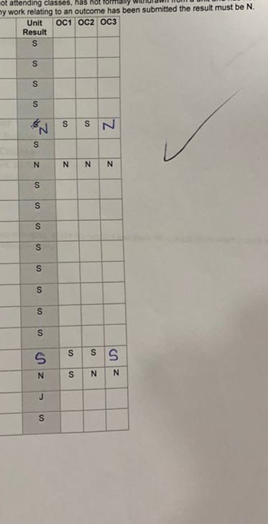

Unit result out of the Maximum marks to be awarded
These need to be checked very carefully to ensure accuracy. You also want to make sure here you have moderated your results and you have an accurate ranking to support student achievement.

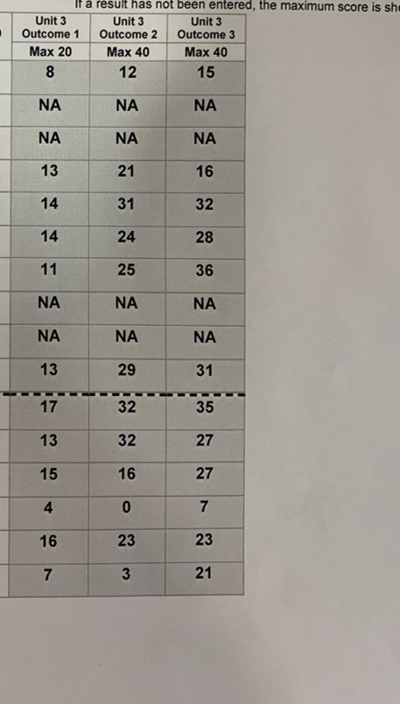

Indicative grades and the anomalous grades check
Indicative grades for all VCE external assessments, apart from the Music Composition externally assessed task, must be submitted before the relevant external assessment period. The primary purpose of collecting these indicative grades is to support the quality assurance procedures for marking the external assessments. They assist in identifying possible anomalous marking of individual student responses. Indicative grades will also be used in the calculation of the DES.
The indicative grade is the school’s prediction of a student’s actual level of achievement on the examination. Indicative grades are a letter grade, from A+ to E/UG (ungraded) or NA (not assessed); note that plus (+) can be used, but minus (-) is not available for input. Class teachers of the same study at the school should confer on the comparability of the indicative grades given to their students.
The rank order and level of spread of the indicative grades for the school cohort in the study are of prime importance. The indicative grades for the school cohort are moderated by the VCAA to make sure that they are statistically reliable. If they are not statistically reliable, they will not be used.

Strategies for arriving at an indicative grade
The VCAA has no preferred position on how a school arrives at a set of indicative grades, except to advise that there should be coherence in the process. All teachers at the school should be provided with advice by the principal on the definition and purpose of the indicative grade, and a suitable means of arriving at a set of indicative grades for the school cohort.
Examples of strategies used by schools include:
- setting practice examinations, which must be held at a time that allows entry of the indicative grade on VASS by the due date
- ranking the students by performance in school-based assessment and then applying an appropriate grade
- basing the grade on prior knowledge of the relative ability of the student in the study.
The VCAA recommends that schools use the indicative grades feedback report on VASS to assist with determining indicative grades. This report shows if the school’s indicative grades for the previous year were generally aligned with the final grades. The indicative grades feedback report is available on VASS by selecting the School Admin tab and following the sequence: School Admin > School Statistics > Indicative Grades Feedback.
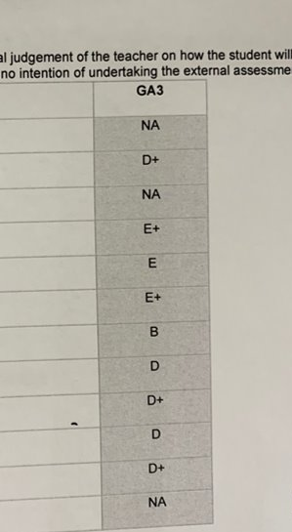
APPENDIX 17 – THE GAT
THE GAT – VCAA ADVICE
The General Achievement Test (GAT) is a pen-and-paper test of general knowledge and skills taken by students in the course of completing their senior secondary studies.
The GAT plays an important role in the quality assurance of VCE assessments and also provides students with an opportunity to demonstrate they meet the Victorian Literacy and Numeracy Standards expected at a senior secondary level. GAT results are also used in the calculation of the Derived Examination Score (DES).
No special study is needed. Past study of subjects like English, Mathematics, Science and History prepares students for the GAT by building their general knowledge and skills in writing, numeracy and reasoning.
The GAT is structured into Section A and Section B, with a range of question difficulties.
Marks are not deducted for incorrect answers.
Time allocations are provided for each component to make sure students attempt all sections of the GAT. Even if one section is not completed within the suggested time allocation, students should move on to attempt the next section. Students can return to any incomplete questions at the end of the test.
Section A is comprised of:
- a two-part writing task – 30 minutes
- 50 numeracy multiple-choice questions – 45 minutes
- 50 reading multiple-choice questions – 45 minutes
Section B is comprised of:
- an extended writing task – 30 minutes
- 25 mathematics, science and technology multiple-choice questions – 45 minutes
- 25 arts and humanities multiple-choice questions – 45 minutes

Who sits the GAT?

Both Sections A and B
- Students enrolled in one or more VCE or scored VCE VET Unit 3–4 sequence, including students not planning to undertake scored assessment even if they have met the standards in a previous year.

Section A only
- Students enrolled in one or more VCE Vocational Major Unit 3–4 sequence and are not enrolled in any VCE or scored VCE VET Unit 3–4 sequences
If a student has already met the standards in a previous year and they are enrolled in VCE Vocational Major but not in any VCE or scored VCE VET Unit 3–4 sequences, they will not be expected to sit Section A. However, they may opt to do so if they wish.

Victorian Literacy and Numeracy Standards
Section A of the GAT assesses whether students have demonstrated the literacy and numeracy skills typically expected of someone completing their secondary schooling – giving another indication of their readiness to move onto further education, training or employment.
The Victorian Literacy and Numeracy Standards are derived from Australian Core Skills Framework (ACSF). For more information, go to the VCAA website.

External assessments
The GAT is used as part of a final check on external assessment scores. If there is a significant statistical difference between the final score for an external assessment and the score predicted by the GAT and school indicative grades, the external assessment will be assessed again by the chief assessor. Scores may go up or stay the same, but they will not go down as a result of this final check.
APPENDIX 18 - COMMENCEMENT
A supportive guide for all Staff @HPSC
Rationale:
The Whole School Commencement Program aims to:
- Start the 2024 academic year early to set the tone for new learning.
- Enable students to be introduced to their subjects for 2024.
- Increase students’ motivation and engagement that new subjects and learning brings.
- Provide a smooth operation of the school by not running two overlapping timetables.
- Support the establishment of rigor and a strong tone with regards to attendance.
- Give students a head start on Area of Study One/Outcome One (or the first unit of work for Year 10).

Structure and Staffing:
- Six periods for each class + two Mentor sessions from Wednesday 22/11 to Tuesday 5/12 (10 school days).
- The 2024 provisionally allocated teacher will take the class – staffing may still be subject to change.
- Where the 2024 teacher is not yet at the school, a replacement with similar methods/experience will take the class. This may include using teachers of Year 7 students who have not yet started.

Teachers Commencement Checklist. Getting ready
On Friday 3rd November, teachers will receive their indicative allotment.
From Wednesday 15 November:
- Teachers are encouraged to use student data to develop an understanding of their students learning needs/and the needs of their classe/s. Staff should refer to:
- Maestro – our Data Analytics Dash - Maestro App (analyticsforschools.com.au)
- Compass – specifically reviewing previous Learning Habit and Semester Report data
For information about Maestro to inform your understanding of ALL students, please refer to Compass, School Documentation, Data Analytics.
For basic instructions on how to navigate Maestro – see here - Navigating Maestro.docx
The Data Wall Placemat can be used to develop a data profile of your classes as you prepare for commencement - My Personal DATA WALL.docx
Teachers are then encouraged/expected to plan for:
- An introduction to what the subject is about (overview/course outline/study design), key skills and knowledge, types of activities/assessment including Rubric/Marking Guide/ Exemplar and resources, etc. Think about how you can get the subject off to a great start with a strong plan.
- The Hidden Curriculum, that is, think about the routines, expectations, classroom rules, including attendance requirements and arrival to class on time – setting a strong tone. For our late to school and late to class process, please see here Late to School flow chart (2).docx, Late to class flow chart (2).docx
- Delivering learning that connects to the core curriculum, with material stored on Compass in School Resources. Speak with your Domain Leader if the information is not available – as it may be in Teams. Seek ideas and feedback from colleagues to support this preparation.
- Year 10 to 12 teachers, familiarise yourself with the Study Design for VCE/VCE-VM/VPC in your subject/area – some subjects have new ones, so ensure you are prepared for that

Note: All teachers are to trial the use of the updated Typical Lesson Outline that aligns to our Pedagogical Model.
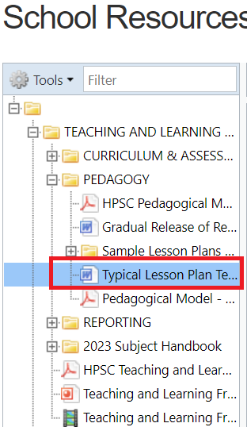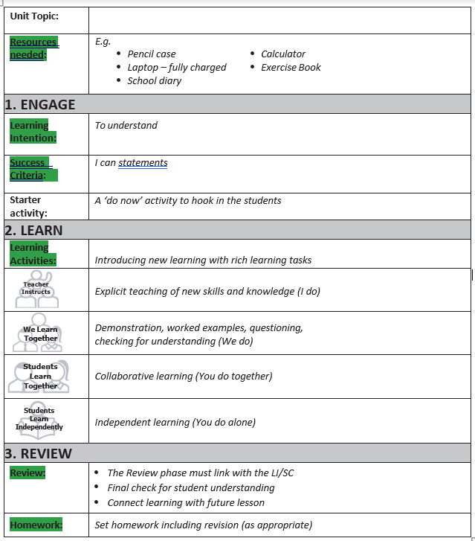

Remind students, during commencement students are beginning their new subjects. Commencement constitutes the first two weeks of the first unit of work for the subject. The learning undertaken during commencement will not be repeated, therefore, students must attend.

Suggested Lesson breakdown for Commencement Lessons:
Lesson 1 | Focus: Connection and Introduction. Get to know your students with an ice breaker activity and tell them a bit about yourself and why you’re passionate about teaching this subject. Introduce them to the subject – if possible, capture their curiosity by showing samples of work from previous students. Go over the expected resources (books, equipment, laptop, e learning resources that will be used, etc.), course outline and assessments including SACs/SATs/CATs. Remind students that if they miss a Commencement lesson it is their responsibility to catch up on the work and homework from that lesson. Remind students that Commencement is the official start of the subject; learning completed in Commencement will not be repeated at the start of the new year.  Begin Learning for the first Unit/Outcome | Example only  Learning Intention:  - To understand the curriculum and assessment of this subject  - To understand the requirements for the first Outcome/CAT  Success Criteria:  I will know that I am successful if I can:  - Explain what we learn about in this subject  - Understand how I will be assessed and what resources I need to be successful.  - Explain what our first Outcome/CAT will require me to do
Lesson 2 | Continue Learning for the first Unit/Outcome  Utilisation of the Pedagogical Model | Determined by each teacher/teaching team, based on the first unit of work/outcome for the subject
Lesson 3 | Continue Learning for the first Unit/Outcome  Utilisation of the Pedagogical Model | Determined by each teacher/teaching team, based on the first unit of work/outcome for the subject
Lesson 4 | Continue Learning for the first Unit/Outcome  Utilisation of the Pedagogical Model | Determined by each teacher/teaching team, based on the first unit of work/outcome for the subject
Lesson 5 | Continue Learning for the first Unit/Outcome  Utilisation of the Pedagogical Model | Determined by each teacher/teaching team, based on the first unit of work/outcome for the subject
Lesson 6 | Continue Learning for the first Unit/Outcome  Utilisation of the Pedagogical Model  Focus – Introduce Readiness Task and Holiday Homework  Introduce the Readiness Task, outlining the parameters of the task, how it will be assessed and when it’s due. This should be a rich, engaging task that thrusts the students into the subject.  Reinforce the importance of this task and students fully applying themselves.  Student success in this task will be reviewed by the Senior Team – as we track and monitor results, as well as student readiness for their chosen subjects | Example only  Learning Intention:  - To understand the purpose and requirements of the Readiness Task  - To understand the purpose and requirements of the holiday homework  Success Criteria:  I will know that I am successful if I can:  - Start working on the Readiness Task independently

Readiness Task: Years 10-12 (Excel Students)
The Readiness Task in 2024 will ONLY take place for students in Years 10-12 Students (our Excel Students).

The task is a formal assessment task and will take place in Week 1 of the new year.

Please note, the VCE VM is a VCE Certificate, hence, when we refer to Excel Students it is all encompassing of General VCE and VCE VM at Year 11 and 12. The expectations are the same for these students, as is the rigor required/expected.

The readiness task is a compulsory task for all students in Years 10-12 (however, see below for specifications to 10VL/VPC).

In Years 7-9 there will be no formal readiness task, however, all teachers are required to establish high expectations and a positive climate for learning. Teachers are highly encouraged to set holiday homework, but the formal readiness task process will not be followed in the new year.
The purpose of the Readiness Task is to:
- Act as the first agreed formative assessment task for the subject to give an early indication of each student’s academic ability within the subject and
- Act as a trigger point to assess students ‘readiness to learn’ in their chosen subject areas - assessing their learning habits and seriousness towards the VCE, the VCE VM, VET and the VPC
- Determine the student’s suitability to undertake the subject/s chosen
- Determine the student’s suitability to the pathway selected during course counselling
- Support Houses and the Senior Improvement Team to identify students ‘at risk’ in their learning, furthering conversations with the student and family – early intervention
- Set the tone for students/families/guardians regarding the expectations of Senior School, which includes requirements around:
  - Homework
  - Study Habits
  - Time management
  - Completion of tasks by set dates/due dates
  - Standard of work required in the senior years
  - Support classroom teachers to identify areas of priority for each student/learning needs for each student
The Readiness Task has two components in Years 10-12:
- Component One – Holiday Homework – connected to the Readiness Task, designed to support students to prepare for application in the readiness task. It is also designed for the student to show commitment towards learning in the senior years

- Component Two – The Readiness Task – designed for students to apply what they have learnt through commencement and their set holiday homework. The Readiness Task is an individual task, to be completed during class time under SAC conditions

Examples of possible Holiday Homework to prepare students for their Readiness Task and first Area of Study:
  - Summary of key concepts e.g., Cornell notes taken from Edrolo
  - Reading and annotating of English Texts
  - Annotating a Text/Multiple Texts
  - Reading of a case study and annotating
  - Reading an Examiner’s Report/Practice Exam/Practice style questions – as a part of something bigger
  - Research Task
  - Edrolo Task which connects to learning

Holiday Homework is DUE first lesson back for the subject – and must be submitted via a suitable method, such as Compass Learning Tasks

Examples of possible Readiness Tasks:
- Case study and questions answered using notes and resources
- Writing prompt with response
- Exam style short answer questions
- Multiple Choice Test
- Problem based task
- Mini poster
- Written report

Readiness Tasks should reflect the nature of the work required in Outcome Assessments for the subject, depending on your subject’s nature.

Readiness Tasks are to take place in the first week back in the new year, during class.
Requirements around Holiday Homework Completion:
Responsibility of Student
- Follow the instructions as provided by the teacher
- Seek clarity/feedback as required
- Ensure punctual submission of the required homework task by the first lesson back in the new year
- Complete the holiday homework to the best of their ability
- Plan how they will manage their time to complete all homework/study over the holidays – dedicating adequate time to each task
Responsibility of Teacher
- Set the tone for the holiday homework and its importance
- Set homework that allows students to engage in a readiness task that assesses the skills and knowledge of students in the subject area
- Provide clear instructions about the homework task and requirements
- Provide clear feedback to students who seek it, to support success with the task/s
- Provide adjustments for students who need extra support (DIP, PSD, IEP, etc.) - scaffolding the task/s- and recording the adjustments
- Develop short video demonstrations/supportive material to help students engage and complete the tasks
- Follow up with students to ensure they understand the task and its requirements, as well as deadlines
- Provide clear submission methods and dates to all students in the class
- Create a submission space for students to upload their task – via Compass Learning Tasks
- Submit a Compass Chronicle titled ‘Didn’t Complete Holiday Homework’ by the end of Week 1 COB Friday
- Communicate to families concerning observations/or positive engagement via Compass
Responsibility of House Leadership Team
- Track student submission of holiday homework through Compass Chronicle
- Follow up with the students who have not submitted holiday homework and where patterns are emerging
- Place students, as required, on success plans/student agreements – if they are struggling across the board – in liaison with families – this information will be provided to House Teams by the Freeman House Team
- Make sure the students and families are aware of the expectations regarding holiday homework
Requirements around the Readiness Task:
Responsibility of Student
- Attend all lessons of commencement to support the successful completion of the readiness task
- Follow the instructions as provided by the teacher for the Readiness Task
- Prepare for the readiness task, by completing holiday homework
- Seek clarity/feedback as required to complete the task
- Complete the Readiness Task to the best of their ability
Responsibility of Teacher
- Set the tone for the Readiness Task and its importance
- Create a Readiness Task that reflects the academic rigour required to do well in the subject
- Communicate with the class about the dates for the readiness task and expectations
- Develop a readiness task that assesses the skills and knowledge of students in the subject area
- Provide adjustments to the readiness task for students who need extra support (DIP, PSD, IEP etc.) - scaffolding the task/s- and recording the adjustments
- Follow up with students to ensure they understand the task and its requirements, as well as deadlines
- Provide clear submission methods and dates to all students in the class
- Create a submission space for students to upload their task – via Compass Learning Tasks
- Provide adjustments for students who need extra support (DIP, PSD, IEP, etc.) - scaffolding the task/s- and recording the adjustments – If you believe a VCE (not VCE VM) student requires an adjustment to the Readiness Task, you MUST first contact Freeman House to determine if the student is eligible for adjustments and what adjustments are allowed for that student under VCAA Special Consideration rules.
- Communicate to families concerning observations/or positive engagement via Compass
- Follow SAC rules – Readiness tasks must be collected at the end of each lesson and (in almost all cases), be completed on paper
- Submit a chronicle for the student if they have not completed their Readiness Task, once the task has been administered

Responsibility of House Leadership Team
- Track student submission of Readiness Task through Compass Chronicle
- Follow up with the students who have not submitted holiday homework/readiness tasks and where patterns are emerging
- Place students, as required, on success plans/student agreements in liaison with families - if the student is identified as ‘at risk in learning’
- Make sure the students and families are aware of the expectations regarding holiday homework
- Organise and run afterschool ‘redemption’ time
Redemption of Readiness, Year 10-12 (Excel Students) - including VCE VM
The Redemption of Readiness at Year 10 to 12, is for students who:
- Have completed the Readiness Task, but, the quality is well below/below the expected level for a student at the beginning of that year level, for that subject
- Have not completed their Holiday Homework
- Have completed the holiday homework, but, the quality is well below/below the expected level for a student at the beginning of that year level, for that subject
- Have not completed their Readiness Task in Week 1 of the new year– not sitting the formal task
Redemption of Readiness will take place formally after school on Wednesdays and Fridays until all tasks are redeemed by each student.
If a student is required to complete Redemption of Readiness, the Teacher needs to complete a chronicle entitled ‘Redemption of Readiness’ by the end of Week 2 COB Monday 5th February. This allows for all classes to have had 2 periods to check homework and the quality of the task/engage in the formal readiness task.
The first Redemption of Readiness will take place on Friday 9th in Freeman House, F3-6. An event will be created for this Redemption of Readiness by KRK. Information will be provided to all Senior SELs about how to add students to this event/s.
Supervision of the Redemption of Readiness is to be determined – with further information to come.
When attending Redemption of Readiness, students:
- Will be required to complete the work, submitting it via the compass learning task/s or, if handwritten, submitting it to the supervising teacher once completed.
If a student does not attend, further follow up will be required.
Note: Year 8 and 9 teachers should set a small amount of holiday homework.
Furthermore, for Years 8 and 9 students who do not complete their holiday homework/do not complete their holiday homework to an acceptable standard, teachers are asked to follow up as they would with any other piece of outstanding work. Additionally, it is expected that students will receive feedback on their holiday homework and that the holiday homework will be referred to as a part of learning in the first Unit of Work.
Teachers can use the Homework not completed chronicle, to report this back to Houses.
VPC Teachers: Specific Information

Structure and Staffing:
- Year 11 and 12 VPC classes will run during Commencement, as well as 10 VL
- As part of the VPC/10VL program, students will be doing either:
  - An SBAT on a Tuesday and Thursday (starting early Dec) - which is at school or off the grounds, depending on the SBAT, or
  - The 10VL program and SEED – as described previously
- Students engaging in FLC will only attend FLC once during commencement for an orientation session. The other week of commencement will have a bespoke program developed, and further information will be provided.
Focus:
- Staff should, at the beginning of Commencement, introduce what the subject is about (overview), types of activities/assessment (i.e. Readiness Task, the ALAT), resources etc.
- Staff should, at the beginning of Commencement, introduce key terms of the VPC subject such as modules, learning areas, and applications.

Activities:
- Each VPC subject is to have a Readiness Task that encapsulates aspects from the first module for Unit 1/Unit 3.
- The Readiness Task is to be completed with enough time for you to provide feedback to students/families/Houses in relation to the student’s capabilities within the VPC – during Week 1 of Term 4

Holiday Homework:
- Optional for VPC classes and is at the discretion of the VPC teacher.

VET Teachers: Specific Information

Structure and Staffing:
- Internal VET classes will run as per the timetable – Students will undertake their internal VET during commencement
- With regards to external VET, these will not run until the new year, so students will be expected to attend school as usual during commencement
- Where possible, the new teacher will take the class

Focus for Internal VET Teachers, with the students:
- Understanding the expectations of VET and the rigor of learning/attendance/work output/assessments
- Completing registrations as required e.g. portals
- Completing VET administration tasks
- What a VET is and what it means
- Hours required and credits

Activities and Assessments:
Each subject is to have the following information provided to students:
- Explanation of the requirement of a VET program including the Units of Competency (UoC)
- Complete the pre-course requirements such as the LLN – if they have not completed one prior
- Plan for activities that commence work on selected UoCs to begin demonstrating competency.

Holiday Homework:
- Completion of commencement task set as homework

Assessing Student Readiness for VET:
- Each student should complete the Pre-Course requirements during Commencement to determine the student’s level of entry and readiness for the subject.
- Any concerns of a student’s ability to complete the course should be flagged using Compass.
- The Senior SELs, together with the Senior Improvement Leader will track compass and work with the VET Administrator to support conversations as required with students and families
Flagging students ‘At Risk in Learning’ - Year 8-12
Commencement is a time to re set the tone for learning and what we expect @ Hampton Park Secondary College. It is a serious learning time. Teachers play an active role in setting the tone and monitoring student application, effort, and achievement.
Chronicle entries should be completed, using the ‘At Risk in Learning – Commencement' chronicle, if a teacher notices:
- Students immediately not engaged
- Students not completing learning tasks as required
- Students not focussed or learning habits not being demonstrated to the required level
- Students struggling with the learning in the tasks/subject area
- Students not prepared for learning
Year 12 Study Periods
Year 12 Study is now fully staffed. This provides an excellent opportunity to embed higher expectations as to how students utilise their study time and enables students to access skilled senior teachers.
In 2024, all study periods will be held in M1.
The Senior Improvement Team will meet with all Year 12 Study Teachers to outline the expectations of Study and to set the tone. The Senior Team will also visit each Study class during commencement to outline the responsibilities of all students and to support in setting the tone.
As preliminary information, for all Staff who are allocated a Year 12 Study:
- Supervised study is a compulsory school program and contributes towards a student’s attendance
- Each assigned teacher has been allocated a small group to supervise and actively support – spread across the timetable. The supervised study code is 12STUDY
- Each teacher’s role is an active one, helping to build rigor and accountability when students are studying and supporting them to develop independence. Teachers are asked to encourage collaboration amongst students studying the same subjects and support them to ask for help from their classroom teachers
- Teachers are asked to check in with each student, each session and talk to them about their study, recording conversations on the spreadsheet below. Teachers are asked to keep a running dialogue in the boxes, date their entry and initial. This data will be shared with the Houses and classroom teachers, so everyone can see how students are progressing Study Periods data base.xlsx. Please begin data entry during commencement.
- The Study Skills website which you can see via the link below we are continuing to add to. Domain Leaders will support in the inclusion of materials, subject specific - Home | Hampton Park Secondary College (kellykrieg.wixsite.com) The hope is, when students say ‘I have nothing to do’ they can be directed here to engage in independent skill development. Please note this is a work in progress
- Further supports are being explored, including tutoring and seminars run by external providers

Supportive Resources to assist in Teaching and Learning during Commencement
Edrolo
2024 Edrolo classes will be activated for Commencement. You should have received an activation email. Any issues email kriscollopy@edrolo.com. A reminder that Edrolo is a user pay model so students must pay for their Edrolo Standard subscription ($35/subject) via the website to unlock access.
It is imperative that teachers urge students to pay for the resource, a letter outlining how to do will be emailed to Year 10 and 11 students and their parents.
Edrolo textbooks are also paid for via their website and they are sent to the school for pick up.
A list of the subjects where Edrolo is subscribed is as per below.
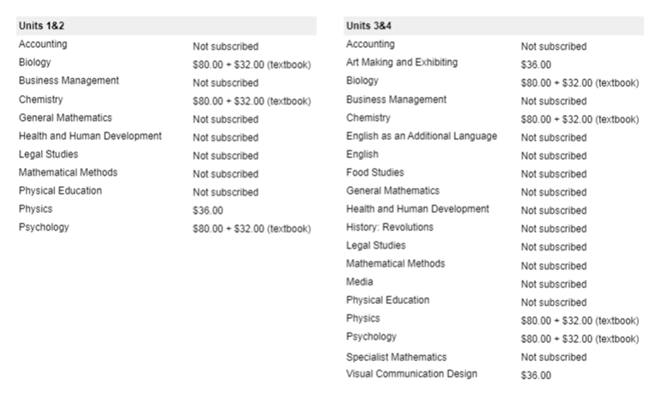
Education Perfect
EP will be available for Commencement Years 8 – 10, all subjects. Our contact is jess.mikecz@educationperfect.com
Subject Change Process
Extensive information will be provided to all students regarding the subject change process this year. Please note, the process will be different to the past.
Our focus is on maintaining the integrity of course counselling and ensuring the conversations had are supported. Please do not talk to students about subject changes until guidance is provided.
Any questions please see Kelly Krieg – Assistant Principal – Senior School Improvement.

APPENDIX 20 – SAC COVER SHEET

Student’s Name: _________________________

Teacher’s Name: _________________________
Student Number
Figures
Words
UNIT 2 SUBJECT
SAC ASSESSMENT #: Description
Reading Time: # minutes
Writing Time: # minutes
QUESTION AND ANSWER BOOK
Number of questions | Number of questions  to be answered | Number of  marks
Section A – Multiple choice | # | #
Section B – Short answer | # | #
Total |  | #

Permitted Materials (Change according to the requirements of your Subject)
Students are permitted: pens, pencils, highlighters, erasers, sharpeners and rulers.
- Students are not permitted: blank sheets of paper and/or whiteout liquid/tape.
- No dictionary is allowed in this examination
- No bound reference is allowed in this examination
Materials Supplied
- Question and answer book
Instructions
- Write your name and your class teacher’s name in the spaces provided on this page.
- Write your student number in numerals and words in the space provided above on this page.
- Write your name on any additional sheets used.
Students are NOT permitted to bring mobile phones and/or any other unauthorized electronic devices into the examination room.

STUDENT DECLARATION OF AUTHENTICITY
This SAC is my own and has been completed according to the stated requirements. I have not used other sources without acknowledgement
Student’s Signature
APPENDIX 21 – EXAM COVER SHEET
Student’s Name: _________________________

Student Number
Figures
Words
Year 12 End of Year EXAM 2024
Subject Name
Reading Time: #
Writing Time: #
QUESTION AND ANSWER BOOK
Questions | Number of questions  to be answered | Number of  marks
Section A – Multiple choice
Section B – Short answer
Total

Permitted Materials - (Change according to the requirements of your Subject)
Students are permitted: pens, pencils, highlighters, erasers, sharpeners, and rulers.
- Students are not permitted: blank sheets of paper and/or whiteout liquid/tape.
- No dictionary is allowed in this examination
- No bound reference is allowed in this examination
Materials Supplied
- Question and answer book
Instructions
- Write your name and your class teacher’s name in the spaces provided on this page.
- Write your student number in numerals and words in the space provided above on this page.
- Write your name on any additional sheets used.
Students are NOT permitted to bring mobile phones and/or any other unauthorised electronic devices into the examination room.

STUDENT DECLARATION OF AUTHENTICITY
This SAC is my own and has been completed according to the stated requirements. I have not used other sources without acknowledgement Student’s Signature
APPENDIX 22 - GLOSSARY
Glossary of Command Terms from VCAA
This glossary of command terms provides a list of terms commonly used across the Victorian Curriculum
F–10, VCE study designs and VCE examinations.
The glossary can be used by:
- teachers across Foundation to Level 10 and VCE to develop internal assessment tasks and prepare students for tests and examinations
- examination panels in the development of assessment items for external examinations.
The glossary may be used in classrooms by teachers across all F–10 curriculum areas and VCE studies to help students better understand the requirements of command terms in the context of their discipline. Students may benefit from using the glossary in the context of questions and tasks they are working on as opposed to learning the terms in isolation.
It is important that the command terms are not interpreted in an overly prescriptive way. Teachers are reminded that study-specific nuances may elicit different kinds of responses to a given term as the term may carry a particular meaning within a discipline that is not necessarily represented in the glossary. For example, an 'evaluate' question will require a different response in Mathematics than it will in History.
The list of terms in the glossary is not intended to be exhaustive or limiting; other terms may be used if required and/or appropriate, allowing study-specific questions to be constructed. Additionally, not all terms in the glossary will be suitable for use in all disciplines and studies. Reference to the relevant curriculum and VCE study design is paramount when developing internal and external assessments.
When using command terms in the construction of assessment items, questions, tasks and marking rubrics, the following definitions may be useful in considering what the term requires students to do.
Term | Explanation
account of | Describe a series of events or transactions.
account for | State reasons for; report on.
analyse | Identify components/elements and the significance of the relationship between them; draw out and relate implications; determine logic and reasonableness of information.
apply | Use; employ in a particular situation or context.
assess | Make a judgment about, or measure, determine or estimate, the value, quality, outcomes, results, size, significance, nature or extent of something.
calculate | Determine from given facts, figures or information; obtain a numerical answer showing the relevant stages in the working; determine or find (e.g. a number, answer) by using mathematical processes.
clarify | Make a statement or situation more comprehensible.
compare | Recognise similarities and differences and the significance of these similarities and differences.
construct | Make, build, create or put together by arranging ideas or items (e.g. an argument, artefact or solution); display information in a diagrammatic or logical form.
contrast | Show how things are different or opposite.
deduce | Draw a conclusion from given information, data, a narrative, an argument, an opinion, a design and/or a plan.
define | Give the precise meaning and identify essential qualities of a word, phrase, concept or physical quantity.
demonstrate | Show ideas, how something can be done or that something is true by using examples or practical applications, or by applying algorithms or formulas.
describe | Provide characteristics, features and qualities of a given concept, opinion, situation, event, process, effect, argument, narrative, text, experiment, artwork, performance piece or other artefact in an accurate way.
discuss | Present a clear, considered and balanced argument or prose that identifies issues and shows the strengths and weaknesses of, or points for and against, one or more arguments, concepts, factors, hypotheses, narratives and/or opinions.
distinguish | Make clear the differences between two or more arguments, concepts, opinions, narratives, artefacts, data points, trends and/or items.
evaluate | Ascertain the value or amount of; make a judgment using the information supplied, criteria and/or own knowledge and understanding to consider a logical argument and/or supporting evidence for and against different points, arguments, concepts, processes, opinions or other information.
examine | Consider an argument, concept, debate, data point, trend or artefact in a way that identifies assumptions, possibilities and interrelationships.
explain | Give a detailed account of why and/or how with reference to causes, effects, continuity, change, reasons or mechanisms; make the relationships between things evident.
extract | Select relevant and/or appropriate detail from an argument, issue or artefact.
extrapolate | Infer and/or extend information that may not be clearly stated from a narrative, opinion, graph or image by assuming existing trends will continue.
identify | Recognise and name and/or select an event, feature, ingredient, element, speaker and/or part from a list or extended narrative or argument, or within a diagram, structure, artwork or experiment.
infer | Derive conclusions from available information or evidence, or through reasoning, rather than through explicit statements.
interpret | Draw meaning from an argument, point of view, description or diagram, text, image or artwork and determine significance within context.
investigate | Observe, study or carry out an examination in order to establish facts and reach new conclusions.
justify | Show, prove or defend, with reasoning and evidence, an argument, decision and/or point of view using given data and/or other information.
list | Provide a series of related words, names, numbers or items that are arranged consecutively.
name | Provide a word or term (something that is known and distinguished from other people or things) used to identify an object, person, thing, place etc.
outline | Provide an overview or the main features of an argument, point of view, text, narrative, diagram or image.
persuade | Induce (someone) to do something through reasoning or argument; convince.
predict | Give an expected result of an upcoming action or event; suggest what may happen based on available information.
propose | Suggest or put forward a point of view, idea, argument, diagram, plan and/or suggestion based on given data or stimulus material for consideration or action.
recall | Present remembered ideas, facts and/or experiences.
recommend | Put forward and/or approve (someone or something) as being suitable for a particular purpose or role.
recount | Retell a series of events or steps in a process, usually in order.
state | Give a specific name or value or other brief answer without explanation or calculation.
suggest | Put forward for consideration a solution, hypothesis, idea or other possible answer.
summarise | Retell concisely the relevant and major details of one or more arguments, text, narratives, methodologies, processes, outcomes and/or sequences of events.
synthesise | Combine various elements to make a whole or an overall point.

FAQ sheet 1 - Supporting Senior Learning at HPSC
To further support you all with the implementation of Senior Learning at HPSC, we have developed this FAQ sheet in response to the questions shared and points raised after our first Senior Teachers meeting in 2022. Please, if you have any further questions, contact a member of the Freeman Team or your House Leadership Team who will point you in the right direction.
Q. Who do I speak to about Senior Studies and/or students in the senior years?
- The Freeman House Team are responsible for Senior School improvement
- Each House has an SEL who is responsible for the Year 10-12 Students in their House
- Each House Leader can support you with Senior Learning and will contact the Freeman Team if they are not sure
- Our Senior Achievement Leader (GLC), can support teachers and each House with Senior Learning
- See the list at the front of this document for all who are involved in Senior School Improvement
Also note:
- If your question is around Domain based teaching practice, it would be worth contacting your Domain Leader
- All Learning Specialists can lend assistance if the question is around helping you to develop your pedagogical practices, as well as how to support the building of Learning Dispositions
Q. Where do I find the current Senior School policy documentation?
- Go to Compass and click on the people icon on the tool bar at the top
- Scroll down to School Documentation
- Scroll down to Senior Studies
- Click on Senior Studies Policy 2026 - Note, this is a fluid document and will be regularly updated
For other information, go to the VCAA website. All Staff need to be familiar with this information as below, including the MOST UP TO DATE study designs.
VCE Administrative Handbook – VCEAdministrativeHandbook2025.docx
VPC Administrative Handbook - VPCAdministrativeHandbook2025.docx
VCE Curriculum information - Pages - VCE Curriculum (vcaa.vic.edu.au)
VCE VM Curriculum information - Pages - About the VCE Vocational Major (vcaa.vic.edu.au)
VPC Victorian Pathways Certificate - Pages - VPC Curriculum Designs (vcaa.vic.edu.au)
Q. What if a student has not completed their readiness task/homework tasks as required?
- For all information about Commencement, which includes readiness tasks and homework, please see Compass, School Documentation, Commencement or speak to Kelly Krieg
Q. What is my responsibility regarding the readiness tasks?
- Please do a compass chronicle if a student has not completed the task as outlined in the documentation
- Please update the compass chronicle if a student does complete the task as required
- Please continue to communicate through compass as required
Q. When do I identify a student is ‘at risk’ in their learning?
- See our At-Risk Process, hyperlinked in this document
- If you believe a student is at risk in their learning, complete a compass chronicle using the Academic Progress Check – ‘Students at risk’.
- Students are identified as at risk if:
  - They are not completing work and you are concerned they may not meet an outcome, as you have not seen enough
  - The standard of work/understanding across tasks shows the student may not meet an outcome
  - The skills shown raise concern, across tasks, and you are worried the student may not meet an outcome
  - The student is not submitting work as required across the board, which makes authentication challenging
  - The student is showing patterns of attendance that mean you may not be able to authenticate the work completed – you have not seen enough to verify understanding, as required by VCAA
Note - If a student has not passed a SAC, this does not automatically constitute them as ‘at risk’. The student can show an understanding of the required outcome in several ways and should be given the chance to do so. The SAC is designed to give a numerical value for those students who are working towards an ATAR. The SAC is not the only way a student meets an outcome, nor should it be.
Q. What do I do if a student/I believe a student, has breached the rules as outlined by VCAA?
- Document this via Compass chronicle, under academic, plagiarism notification
- Please include all relevant information in the chronicle
- Please read the relevant sections in our Policy and Process Handbook
- If you have any questions, see the relevant SEL, KIG, or GLC
Q. What is the difference between the unsatisfactory outcome (provisional N result) and the unsatisfactory outcome (N result)?
- Read the relevant sections in our Policy and Process Handbook
Q. When are the deadlines that I need to be aware of as a Senior Teacher?
- A SAC calendar has been developed, as has a VASS reporting timeline
- SACs will appear on compass
- All is shared with Senior Teachers regularly
- Dates are hyperlinked in our Policy and Process Handbook
- Dates are included on Compass, School Documentation, Senior Studies 2026
Q. When am I running my SACs?
- As outlined, a shared SAC calendar has been developed and is on Teams
- Freeman House will manage the SAC calendar each Term - GLC
- Multiple classes of a subject will have their SAC at a common time – Wednesday afternoon
- For all single classes, SACs can run in the classroom under exam conditions
Q. What is my responsibility when it comes to VASS?
- You will receive information from Kelly Krieg and Doris McDonald when it comes to anything related to VASS
- Class lists and student results will need to be checked by you, as classroom teachers, very carefully. It is critical you follow all steps as required and all results checked are accurate
- If you have any questions about VASS, you need to see Doris McDonald in M1 – VASS Administrator
- See VASS appendix items in our Policy and Process Handbook
Q. Where can I access past exams and examiners reports, to share with my students?
- External assessment reports are here - Pages - Examination specifications, past examinations and external assessment reports (vcaa.vic.edu.au)
- Please use these reports to inform your teaching and to support students in their learning
- Please read the exam specifications for your subject through the link above. Notice 18 of the VCAA bulletin lists the subjects, which you can access here - Pages - VCAA Bulletin

Q. Where can I get help with the delivery of my subject area?
- Please see your Domain Leader, alternatively, see the Freeman House Team for any guidance or support
- Please access the VCAA PL as advertised here - Pages - Professional Learning programs (vcaa.vic.edu.au)
- Any further supports will be emailed by the Senior Team, as received, this includes all information in the VCAA bulletins
FAQs Sheet 2 - Senior Studies and Senior Learning
Q. Can we have a list of the unscored students?
With regards to students who are going unscored, it is critically important we have evidence. A student saying, they are going unscored is not enough.
The process for a student who is ‘confirmed’ unscored is as follows:
- A parent meeting takes place with the House and the family, together with the student, careers, and wellbeing (if required). The purpose of the meeting is to explore the most suitable pathway based on circumstance, situation, and the individual needs of the student
- If it is decided an unscored pathway is the most suitable, paperwork is signed, by the student and the family, agreeing to this pathway option. Paperwork is stored in the students file for future reference
- A compass post is made, and an email is sent, by the relevant House Leadership Team only when it is confirmed a student is unscored – this is when you know and have confirmation of the student’s pathway
What is critically important to note is, even if a student is an unscored student, they are still required to complete all work and all assessments to the same level as all others. The same rigor and expectations are applied. The only difference is the student will not sit their end of year exams for a score and therefore, they will not achieve an ATAR.
As stated in our Senior Policy and handbook – Section 7.4 - Students must still meet the same requirements as scored students to obtain a satisfactory result for an outcome and the overall unit of study. A student who does not meet these requirements will receive an ‘N’ result and may be ineligible to successfully complete their VCE.
For further information about an unscored pathway and our process please refer to section 7 of our Senior School Handbook and Policy on Teams.
Q. What does unscored mean?
Please see below from VCAA about an unscored pathway and what it means.
Pages - Qualifications: VCE (vcaa.vic.edu.au)
Q. Will we be given time for moderation?
Yes, absolutely. As a school we highly value and understand the importance of moderation. We will provide time to teachers to effectively moderate through the meeting calendar.
Q. How do we support SBAT students who miss scheduled classes? Students who have VET at the same time as VCE classes - how can they be supported when they miss at least 1 lesson every week. Especially when they have work from multiple classes to complete in their study periods.
If a student misses a class due to their SBAT/VET, it is the student’s responsibility to catch up on any learning missed. We appreciate independence is still developing so alternatively, you might encourage the student to use their Study time in the CRC to catch up on missed learning – perhaps looking at their study periods and identifying the tasks to be worked on/when.
Any issues with a student who is not catching up, please refer them to their House Leadership Team for follow up and use compass to communicate where the student is at.
Extending deadlines and being flexible may need to be considered, as the absence is genuine.
We will continue to look at VET blocking when we review our timetable each year.
Q. Will there be time to work on moderation and senior school improvement, as a whole school?
For now, we are focusing on moderation and developing our practices at Years 11 and 12. Once we have learnt from our approach, we will shift our focus to all years.
The role of the senior school improvement team is to review the data, visit other schools and engage in research, to then develop a set of recommendations for our entire school.
It is envisaged, once we have clear recommendations, we will have a clear plan for how we can improve senior learning outcomes across the entire school, and the roles we each play. We know it is what happens from the junior years that leads to the results in the senior years.
Q. Can we have a link to the new VCE curriculum?
It is linked below, for your reference. Information will be regularly circulated as soon as it comes out from the VCAA and from the DET. PL will be provided for those teaching within the VCE VM and VPC in the coming months, once staffing has been established.
- Pages - Victorian Senior Secondary Certificate Reform (vcaa.vic.edu.au)
- Pages - About the VPC (vcaa.vic.edu.au)
- Pages - VCE VM Study Designs (vcaa.vic.edu.au)
- Pages - About the VCE Vocational Major (vcaa.vic.edu.au)
- Pages - General Achievement Test (GAT) (vcaa.vic.edu.au)
Q. How many subjects, exam assessed, does a student do in the VCE VM?
To be eligible to receive the VCE VM, students must satisfactorily complete a minimum of 16 units, including:
- 3 VCE VM Literacy or VCE English units (including a Unit 3–4 sequence)
- 2 VCE VM Numeracy or VCE Mathematics units
- 2 VCE VM Work Related Skills units
- 2 VCE VM Personal Development Skills units, and
- 2 VET credits at Certificate II level or above (180 nominal hours)

Students must complete a minimum of three other Unit 3–4 sequences as part of their program. Units 3 and 4 of VM studies may be undertaken together over the duration of the academic year to enable these to be integrated.

The VCE VM can be tailored to the needs and interests of the student, to keep them engaged while developing their skills and knowledge. Students can also include other VCE studies and VET and can receive structured workplace learning recognition. Most students will undertake between 16-20 units over the two years.

Q. Are students permitted to repeat a VCE subject?

The advice from VCAA is below:

There is no penalty for repeating VCE units. Repeating a study at the Unit 3 and 4 level may improve your study score and enhance your chances of getting into a tertiary course. However, you cannot count a unit more than once towards satisfactory completion of the VCE. It is necessary to repeat Unit 3 of VCE studies as well as Unit 4 to gain a study score.

Although this is the recommendations from VCAA, each individual case needs to be carefully considered. Every decision made, must be made in the best interest of the student. For some students, repeating may not be the best option. If a student has questions about repeating, please direct them to their House Leadership Team as it is important a conversation is had, reviewing all available learning data. Careers may also be involved, considering the students pathway and the best ways for them to reach their destination.

Q. Do unscored students sit Mid-Year Exams?

We encourage all learners, and it is an expectation that all learners, sit their Mid-Year Exams.

Not only do exams support students to build their stamina and to understand timing/how to approach an exam, but they also give teachers (and learners), valuable feedback and insight into where our students are at, the skills they are showing and have developed and areas for future improvement. Exams also teach students many critical life skills, scored or unscored.

For all students, an exam can support the informing of an outcome. Whilst it is never used in isolation, it can inform part of an outcome, scored or unscored.

In the case where a student has special needs/extenuating circumstances, in liaison with the student, wellbeing and their house, special arrangements will be explored on a case-by-case basis. We appreciate there are reasons why exams may not suit all learners and hence, any concerns should be discussed with the student’s house leadership team.

If a student misses an exam, it is expected they catch it up. The exam team will look at exam catch up sessions in the coming week/s.

Q. What happens to a student who is below the 95% required attendance rate? Can they redeem this time?

The HLT (relevant SEL), will speak with the student and contact home, to reiterate and support your messaging, whilst communicating the important of coming to school.

All students in Years 10-12 who are below 95% have the chance to redeem any learning time missed. They can do this before and/or after school each day and SELs are closely monitoring this. Students also have the chance to spend student free days and into the holidays, to make up for learning time missed. Our focus however is on supporting students to be self-regulated and independent, building positive attitudes around attendance. Any redemption of time, in this vein, is active learning time, where students are applying themselves and ‘learning’, not simply ticking off hours.

If a student is sick and provides a medical certificate, this is deemed a VCE approved absence, and this does not impact their percentage attendance.

It is important to note, attendance alone does not mean a student will meet an outcome. The student still needs to show an understanding of the outcome and the skills required.

The focus on attendance is to ensure our students have every possible opportunity to build their understanding and knowledge, to gain support from teachers and peers and to authenticate and validate all learning.

Q. Can we have an update on how the at-risk students have been followed up - e.g. I’ve done a post with all the details included can I be told how this is followed up/what the conversation involved?

A reply post should be made on the compass chronicle by the relevant House Leadership Team and SEL. If this has not happened, please have a conversation with the student’s house to get an update. We do want to work in partnership, together with you, so please continue to seek information. It may be conversations are still happening and hence, a response has not yet been given.

Q. How will VET fit into the new VCE?

VET can still form part of a student s VCE or VCE VM pathway. See below the information from the DET about VET in the new certificate
- VET in the VCE and VCE Vocational Major | Victorian Government (www.vic.gov.au)
- Pages - VET in the VCE, VCE VM or VPC (vcaa.vic.edu.au)

Q. What's the next step for students who are chronicled as At Risk, have been spoken to by SEL, had parent contacted and yet still not changing work output or attendance?

Follow-up conversations should continue at the House level with these students and their families, together with careers and wellbeing as required. It may mean we need to review the student’s pathway and shift them to either unscored or perhaps a 3-year pathway based on the units they have achieved/will achieve. It may also mean the student is not suited to this subject which needs to be part of the review.

If you have concerns about any students, please work together with the relevant house, to best support the student and their outcomes and continue to seek clarification.

Q. Is there support for staff who have not taught VCE before, or those who are new to subjects in VCE?

You can get support from any of the following:
- Your Domain Leader
- The Senior SELs
- Georgie Kios, Kelly Krieg, Cat Glenn and Lizl Tredidga (10VL)
- Members of the TLT
- Past VCE Teachers (see your Domain Leader)

The other thing you can do is consult the VCAA for PL and further information, included on/in the below:
- Pages - VCE (vcaa.vic.edu.au)
- Pages - Professional Learning programs (vcaa.vic.edu.au)
- Pages - VCAA Bulletin
- Pages - Notices to schools (vcaa.vic.edu.au)

Each Domain also has organisations where you can get support such as ACHPER, Home Economics Victoria, The Mathematical Association of Victoria – see your Domain Leader who should be able to point you in the right direction.

Q. Will all students need to complete VCE English under the new program?

See above about the VCE, VCE VM and the VPC. In short, yes.

Q. Can VCE staff get support with ranking and predicting scores?

Yes. Ranking and predicting scores will be part of our Senior Studies meetings.

